Question 2:

When the program is compiled then we get two warnings:

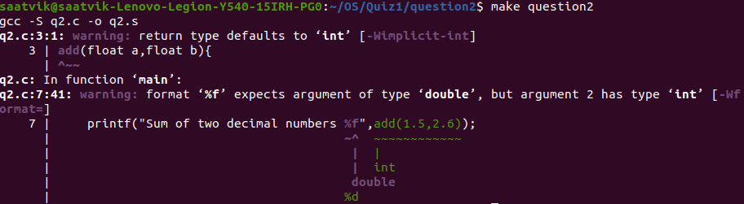

The first warning states that return type type defaults to int.

As we haven’t defined a return type for add function , thus while compiling the return type default to int because there is a conversion taking place in the compiled code from the float to int while reutrning the value back to the main function of our C program.

This type conversion is being done with the help of the **cvttss2sil instruction1** which is converting the truncating scalar single-precision floating-point values to doubleword integer. Thus we have this default type coversion into int.

The conversion can be seen in the following screenshot of the assembly code of the C program

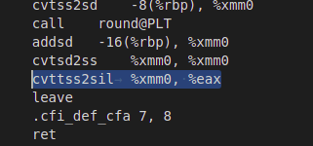

To make things clearer further we can add a float return type to the add function and see that the highlighted line doesn’t appear in the assembly code of the C program.

C Program now becomes:

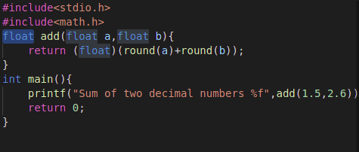

When the make command is run, we get no warnings



The assembly code has no **cvttss2sil instruction**

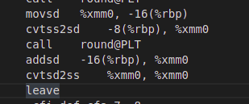

Now the second warning, the second warning is due to use of string formatter “%f” but the add function return an integer instead of float.