# InkSpire API Documentation

InkSpire is a platform for inspiring writings and ideas, providing a full-featured API to manage users, articles, comments, and likes.

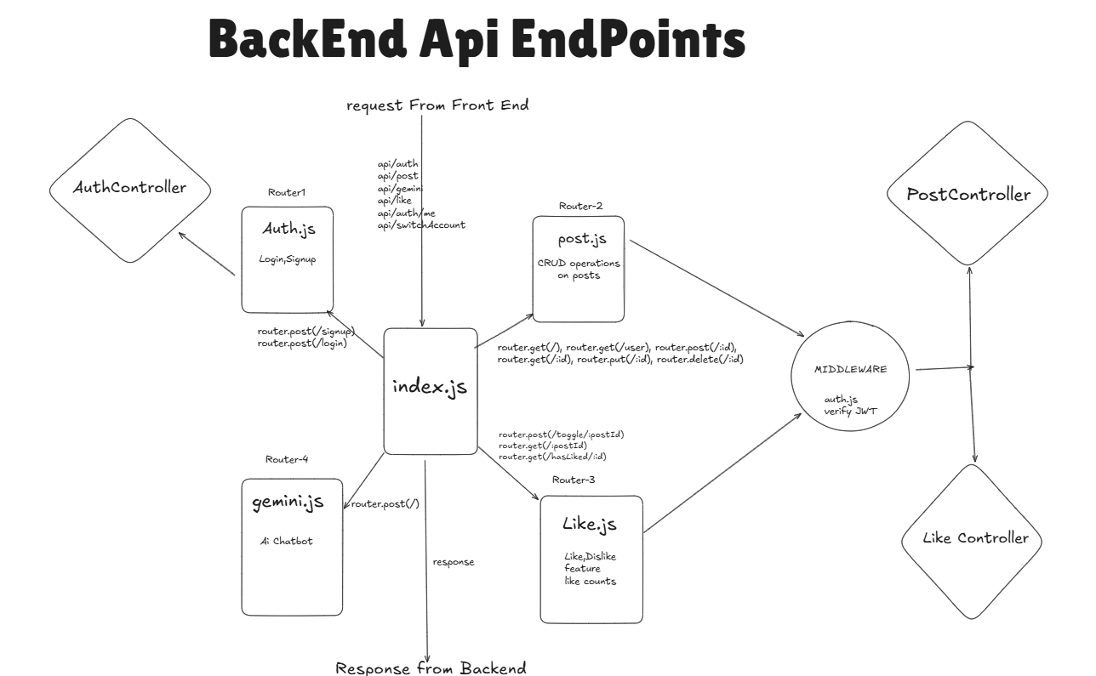

## Base URL

http://localhost:4444/api

## Authentication

All authenticated routes use JWT stored in HTTP-only cookies (token).

## 1. Authentication

### Register a New User

POST /auth/signup

Request Body:

{ "username": "string", "email": "string", "password": "string" }

Response:

{ "message": "User registered successfully", "user": { "id": "number", "username": "string", "email": "string" } }

### Login

POST /auth/login

Request Body: { "email": "string", "password": "string" }

Response: { "message": "Logged in successfully", "user": { "id": "number", "username": "string", "email": "string" } }

### Logout

POST /auth/logout

Response: { "message": "Logged out successfully" }

## 2. Articles

### Get All Articles

GET /post

Response: [ { "id": "number", "title": "string", "content": "string", "author": { "id": "number", "username": "string" }, "createdAt": "ISO 8601 timestamp" } ]

### Get Articles By UserId

GET /post/user

Response: Same structure as above.

### Get Single Article

GET /post/:id

Response: Same structure as above.

### Create Article

POST /post

Request Body: { "title": "string", "content": "string" }

Response: { "message": "Article created successfully", "article": { "id": "number", "title": "string", "content": "string", "author": { "id": "number", "username": "string" }, "createdAt": "ISO 8601 timestamp" } }

### Update Article

PUT /post/:id

Response: Same as create.

### Delete Article

DELETE /post/:id

Response: { "message": "Article deleted successfully" }

## 3. Likes

### Check Like Status

GET /like/hasLiked/:postId

Response: { "liked": true }

### Toggle Like

POST /like/toggle/:postId

Response: { "liked": true }

### Get Like Count

GET /like/:postId

Response: { "likes": 42 }

## 4. Error Responses

All endpoints may return standard HTTP status codes with an error message:

400 – Bad Request  
401 – Unauthorized  
403 – Forbidden  
404 – Not Found  
500 – Internal Server Error

Error Example: { "message": "Description of the error" }

## 5. Flow Diagram

┌───────────────┐  
 │ Client App │  
 └───────┬───────┘  
 │  
 ▼  
 ┌─────────────────┐  
 │ Auth Routes │  
 │ /signup /login │  
 └───────┬─────────┘  
 │ JWT Cookie  
 ▼  
 ┌───────────────────────┐  
 │ Middleware: Verify JWT │  
 └───────┬───────────────┘  
 │  
 ┌────────────┼─────────────┐  
 │ │ │  
 ▼ ▼ ▼  
Articles API Likes API User API  
(/post) (/like) (/auth/me)

