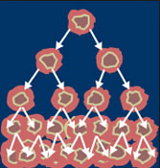



**DATABASE MANAGEMENT SYSTEM**

**Submitted by:**

* **Durr-e-Nayab 551**
* **Kashuf Hameed 557**
* **Saba Bibi 563**
* **Shanza Tariq 538**
* **Anoosha Fatima 536**

**Submitted to:**

* **Ma’am Iffat Anjum**

**Report: Cancer Database Management System**

**Dated: 20-MAY-2019**

**CANCER DATABASE**

**INTRODUCTION:**

*“Cancer is a group of diseases involving abnormal cell growth with the potential to invade or spread to other parts of the body. These contrast with benign tumors, which do not spread.”*

In this database we illustrate different stages of a cancer, its symptoms, treatments and factors that cause cancer.

**CARCINOMA:**

Stage 0: This is used to describe cancer in situ, which literally means “in place.” Cancers at this stage are identified according to the location where they initially emerged and multiplied. However, the resulting tumor has not yet spread to nearby tissue.

**EARLY STAGE:**

This describes a small cancerous tumor that has spread to nearby tissue but not beyond – such as the blood stream or lymph system.

**STAGE II &III:**

These stages are known as “regional spread” cancers. They indicate that the cancer has expanded and will have embedded itself more deeply into the surrounding tissue.

**METASTAIC CANCER:**

When cancer spreads from the initial site to other organs or areas of the body, it is referred to as “distant spread” cancer, advanced cancer, or metastatic cancer.

There are some factors that cause cancer:

**MUTATION:**

Cancer is a genetic disease, resulting from a step-wise accumulation of mutations in genes that normally control cell growth. The majority of gene mutations involved in cancer are somatic, meaning that they are found only in that individual's cancer cells.

Mutation can be caused by many factors some of them are illustrated here:

* Somatic mutation
* Germ line mutation

**INFECTIOUS AGENT:**

Infectious agents, such as viruses and bacteria, are the causes of several common cancers. Infection with the bacterium Helicobacter pylori predisposes to gastric cancer.

**HORMONES**:

Hormones can cause breast cancer.

**CHRONIC INFLAMMATION:**

Chronic inflammation may be caused by infections that don’t go away, abnormal immune reactions to normal tissues, or conditions such as obesity. Over time, chronic inflammation can cause DNA damage and lead to cancer.

We also describe treatment of cancer.

**PROBLEM IDENTIFICATION AND SOLUTIONS:**

In Pakistan, biopsy is usually used for the diagnosis of cancer, in which a part of tumor is taken from patient’s body .This method has some consequence: for example, sometime, after biopsy, the rapid and abrupt growth of tumor can occur which can be fatal.

To avoid this we are aimed to develop such tools and software through which we could diagnose the cancer without biopsy.

**SCOPE:**

In order to prevent and control Cancers, there is need to establish the cancer recod. To data we do not have any National Cancer Registry which can provide the true nature of problem to formulate health policy. Ministry of NHSRC has designed PHRC (Pakistan Health Research Council) to establish a cancer recod by affiliating all major public and private sector hospitals of the country.

To date 08 hospitals are sending their data on quarterly basis to PHRC since May 2015.

**OBJECTIVE:**

The main objective of this database is:

* The small amount of the data storing into the spreadsheet is fine, however it turn into larger amount of data then spreadsheet solution will not work.
* But in our case, we want to store the data about cancer which is in huge amount. When we want to recode the cancer data into spreadsheet which will creates problem of speed.
* When we want to retrieve the data it is very difficult to find it from the multiple spreadsheet files.
* When user doing data entry in files then it might be possible to incorrect data use due to no validation present like you can enter wrong spelling, wrong dates and wrong amount.
* So the data accuracy is hard to maintain. But data cannot be secure in case of file and spreadsheet.
* Data duplication is also possible. To solve all problems we need database. We can easily store a large amount of data in the database.
* Data is accessible to everyone so any one can add or update the data in the database.
* We can easily retrieve the data and no data redundancy is occurs.
* Data can be validates based on the business rules.

**Business Rule:**

* A symptom may have many cancer types.
* A cancer type may have many symptoms.
* A cancer type has a patient.
* A patient has a cancer type.
* A cancer type has a treatment.
* A treatment may have one or more cancer types.
* A patient has a treatment.
* A cancer type may have one or more mutations.
* A mutation can cause only one cancer type.
* A mutation is caused by one or more factors.
* A factor may cause one or more mutation.

**TREATMENT**

**FACTOR**

**MUTATION**

**CANCER TYPE**

**PATIENT**

**SYMPTOMS**

Causes

Have

Has

Causes

Has

Have

**Enterprise Data Model**

**Conceptual Data Model**

Has

Causes

Has

Causes

Have

**FACTOR**

Factor_ID

FactorName

FactorDescription

M_ID

**TREATMENT**

TreatmentNo

Therapy

Medication

TreatmentCharges

Type_ID

P_ID

**CANCER TYPE**

Type_ID

Name

Stage

Description

Image

**PATIENT**

Patient_ID

DateAdmitted

DateDischarged

DateOfBirth

Gender

History

Phone

CNIC

Address

**SYMPTOMS**

Symptom_ID

SymptomName

Type_ID

SymptomDescription

Have

**MUTATION**

Gene_ID

Type_ID

ChromosomalLocation

MutationType

MutationEffect

GeneName

CellType

SYMPTOM

|  |  |  |
| --- | --- | --- |
| Symptom_ID | SymptomDescription | SymptomName |

CR-SYMPTOM

|  |  |
| --- | --- |
| Symptom_ID | Type_ID |

CANCER TYPE

|  |  |  |  |
| --- | --- | --- | --- |
| Name | Type_ID | Stage | Location |

CR-PATIENT

|  |  |
| --- | --- |
| Type_ID | Patient_ID |

PATIENT

|  |  |  |  |  |  |  |  |  |
| --- | --- | --- | --- | --- | --- | --- | --- | --- |
| Patient_ID | DateAdmitted | DateDischarged | DateOfBirth | Gender | Address | Phone | CNIC | History |

PT-TREATMENT

|  |  |
| --- | --- |
| Treatment_ID | Patient_ID |

TREATMENT

|  |  |  |  |  |  |
| --- | --- | --- | --- | --- | --- |
| Treatment_ID | Stage | Therapy | Medication | Diagnosis | TreatmentName |

CR_TREATMENT

|  |  |
| --- | --- |
| Treatment_ID | Type_ID |

MUTATION

|  |  |  |  |  |  |  |
| --- | --- | --- | --- | --- | --- | --- |
| Type_ID | Celltype | ChromosomalLocation | MutationEffect | MutationType | Gene_IID | GeneName |

|  |  |
| --- | --- |
| Gene_ID | Factor_ID |

|  |  |  |  |
| --- | --- | --- | --- |
| Factor_ID | FactorName | FactorDescription | M_ID |

M_ FACTOR

FACTOR

**Logical Data Model**

**Queries:**

|  |  |  |
| --- | --- | --- |
| **Name** | **Uses** | **Function** |
| **Where** | Use in symptom, cancer type and patient to get specific results | Use a WHERE clause to limit the results |
| **Order By** | Use in symptom, cancer type and patient to sort the result | Records are sorted in ascending and descending |
| **Between** | Use between symptom and cancer type to get a range | Between is used to get result in a range |
| **Sum** | Use in treatment to get the sum of the charges | Sum function returns the sum of a set of numeric values |
| **Count** | Use in treatment and patient | Count function returns the number of records in a select query. |
| **Concatenation** | Use in patient, mutation, mutation factor and cancer type | Concatenation multiple strings together into a single string with the  & operator. |
| **Delete** | Use in symptom, cancer type, Patient, treatment | A DELETE query is an action query (SQL statement) that deletes a set of records according to criteria (search conditions) you specify. |
| **Update** | Use in treatment, patient, mutation and cancer type | An Update Query is an action query (SQL statement) that changes a set of records according to criteria (search conditions) you specify. |
| **Insert** | Use in cancer type, mutation, patient, factor and treatment | Pick the procedure you need based on what kind of object you want to change. |

**Queries:**

There are many queries here some of them.

**WHERE CLAUSE:**

**Example:**

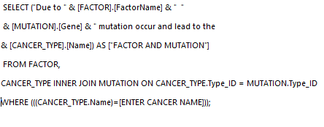

**2nd example:**

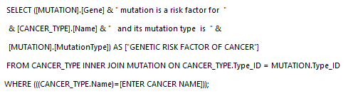

**Between:**

**Example:**

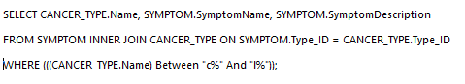

**Sum:**

**Example:**

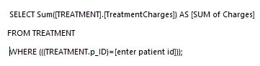

**Count:**

**Example:**

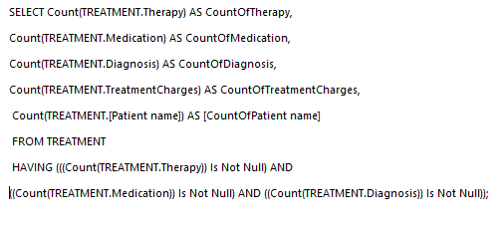

**Concatenation:**

**Example:**

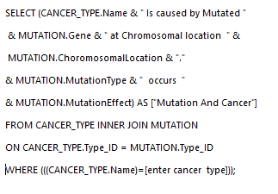

**Delete:**

**Example:**

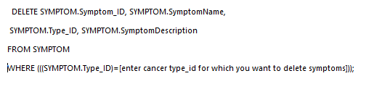

**2nd example:**

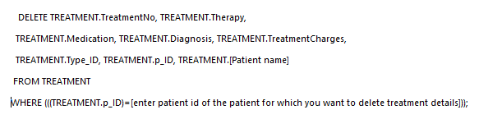

**Update:**

**Example:**

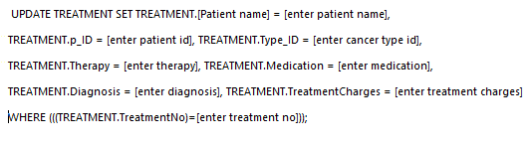

**2nd example:**

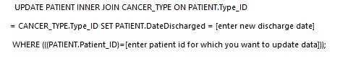

**Insert:**

**Example:**



**2nd example:**

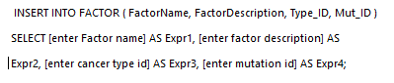

**Forms:**

**Examples:**

Some examples of forms.

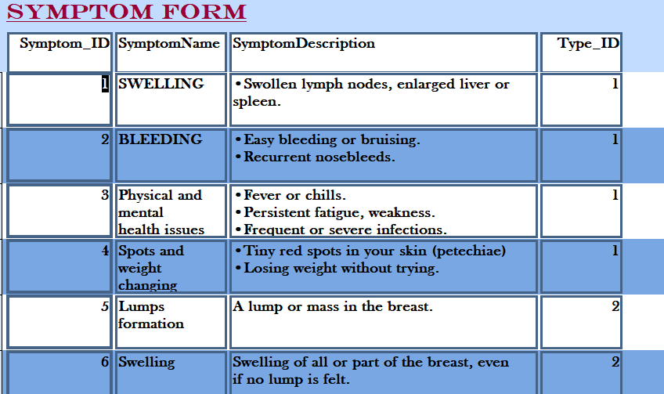

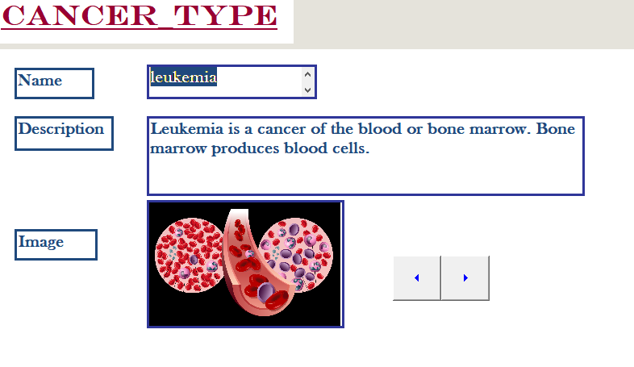

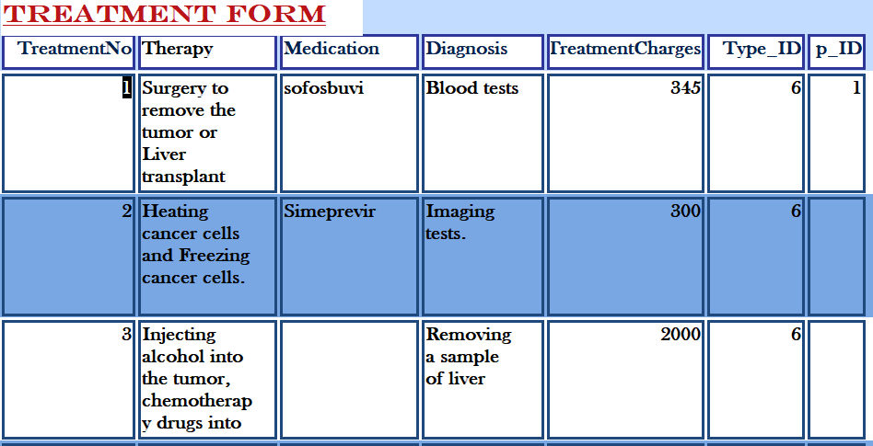

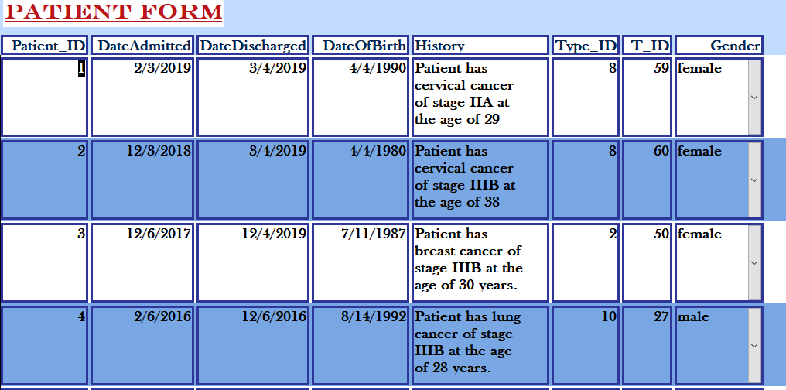

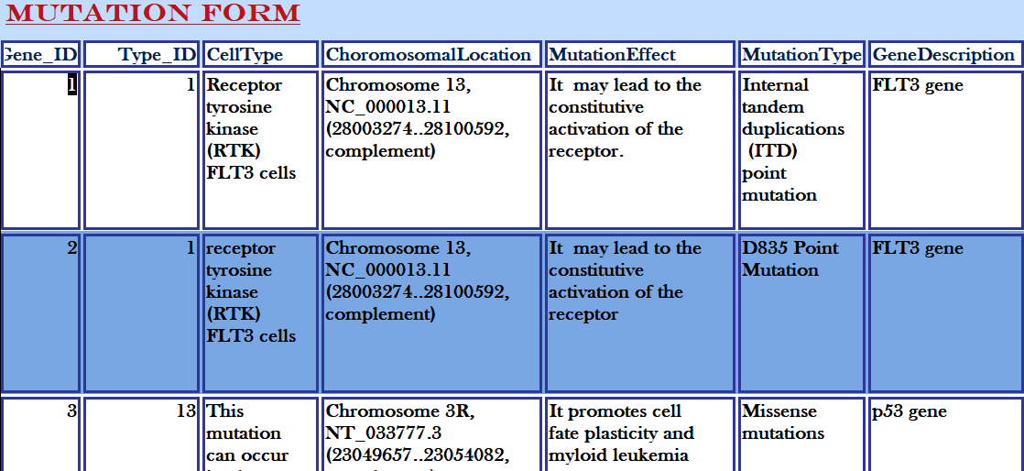

**Reports:**

Here some examples of reports.

