**PARKINSON’S DISEASE PREDICTION USING DEEP LEARNING**

**A PROJECT REPORT**

Submitted in partial fulfillment of the requirements for the award of the internship

**By**

Saba Tanveer Khan (21331A05F0)

Sesetti Swathi (21331A05G4)

(Students of MAHARAJ VIJAYARAM GAJAPATHI RAJ COLLEGE OF ENGINEERING (A))

## Under the Supervision of

## Dr. Mohammad Farukh Hashmi

**Assistant Professor, NITW**



**Department of Electronics and Communication**

**National Institute of Technology, Warangal**

**CONTENTS**

**Abstract**

**1. Introduction**

1.1 Preface

1.2 Problem

1.3 Background

1.4 Objectives

**2. Related Work**

2.1 Image Analysis Techniques

2.2 Model Architecture

2.3 Data Augmentation Strategies

2.4 Clinical Validation

2.5 Challenges and Limitations

**3. Problem Statement**

3.1 Model Selection

3.2 Data Augmentation and Preprocessing

3.3 Performance Evaluation

3.4 Clinical Relevance

**4. Design and Implementation**

4.1 Proposed Solution

4.1.1 Data Preparation and Augmentation

4.1.1.1 Data Organization

4.1.1.2 Handling Class Imbalance

4.1.1.3 Data Augmentation

4.1.2 Model Selection and Customization

4.1.2.1 Base Models

4.1.2.2 Custom Layers

4.1.3 Model Compilation and Training

4.1.3.1 Compilation

4.1.3.2 Class Weights

4.1.3.3 Callbacks

4.1.4 Performance Evaluation

4.1.4.1 Training History

4.1.4.2 Confusion Matrix and Classification Report

4.1.4.3 Visualization

4.1.5 Implementation Details

4.1.5.1 Libraries and Tools

4.1.5.2 Environment

4.2 Architecture

4.3 Dataset

4.4 Execution

4.4.1 Preprocessing and Preparation

4.4.2 Algorithm

**5. Results and Discussion**

5.1 Metrics for evaluation

5.2 Experimental Results

**6. Conclusion**

**ABSTRACT**

Parkinson's disease is a long-term, progressive neurological illness. Speaking, writing, walking, and other basic functions become more difficult for people as dopamine-generating neurons in certain areas of the brain degenerate or die. Patients' symptoms get more severe as a result of these symptoms getting worse with time. In this report, we have implemented VGG16, VGG19, Resnet50 models of deep learning for severity prediction using the Python "TensorFlow" deep learning module. When compared to the accuracy found in other models, the accuracy levels produced by our approach is superior.

1. **INTRODUCTION**
   1. **PREFACE**

Parkinson's disease (PD) is a progressive neurodegenerative disorder that affects millions of people worldwide. It is characterized by both non-motor symptoms including mood disorders and cognitive impairment as well as motor symptoms such as the sensation of brad strength and shakes. Accurate diagnosis and early detection are essential for efficient management and better patient outcomes.

Recent developments in machine learning and medical imaging have opened up new possibilities for improving Parkinson's disease early prediction. The use of deep learning models—more especially, VGG16, VGG19, and ResNet50—to use image data to predict the existence of Parkinson's disease is examined in this paper. These models were first created for picture classification tasks, but they have since been modified and refined to evaluate medical images, which may help with early diagnosis and illness progression tracking.

A review of Parkinson's disease, its clinical symptoms, and the difficulties in diagnosing it is given at the outset of the paper. The methodology is then described in depth, covering the model architecture, augmentation strategies, data preparation, and training processes as they are used in the given code. Important topics covered include managing class imbalance, utilizing data augmentation, and assessing model performance with common metrics like classification reports and confusion matrices.

The report also explores the outcomes of training and testing the models on a dataset that is divided into training, validation, and testing sets. Model performance metrics, including as accuracy, loss, and class distribution, are analyzed and the results are provided. The effectiveness of any model in predicting Parkinson's disease can be clearly understood using visualizations like confusion matrices and training history plots.

The goal of this work is to make a contribution to the expanding field of machine learning applications in healthcare and medical image analysis. This report aims to teach doctors, researchers, and stakeholders about the potential of these technologies in improving patient care and diagnostic accuracy by clarifying the strengths and weaknesses of deep learning models in Parkinson's disease prediction.

The report presented the demonstrates the viability of using deep learning to medical picture analysis and opens the door for further developments and partnerships targeted at enhancing Parkinson's disease early diagnosis and treatment approaches.

* 1. **PROBLEM**

It is still difficult to accurately predict and diagnose Parkinson's disease (PD) in its early stages, despite major advances in medical imaging and machine learning. The current diagnostic techniques may not identify the illness in its early phases, when treatments may be most successful, since they frequently rely on subjective clinical evaluations.

Traditional approaches to PD diagnosis face several limitations, including:

* Subjectivity: Diagnosis heavily relies on clinical observation and subjective assessment of symptoms, which can vary among clinicians.
* Late Detection: Current diagnostic tools may fail to detect PD in its early stages, delaying appropriate treatment and management.
* Data Variability: Medical imaging data, crucial for disease detection, often exhibit variability due to differences in equipment, imaging protocols, and patient characteristics.

To address these challenges, leveraging advanced machine learning techniques, particularly deep learning models like VGG16, VGG19, and ResNet50, holds promise. These models are capable of learning complex patterns from medical images, potentially enhancing the accuracy and reliability of PD diagnosis.

* 1. **BACKGROUND**

Parkinson's disease (PD) is a degenerative neurological condition marked by bradykinesia, stiffness, and tremors in the motor domain. Millions of people are impacted globally, and early diagnosis and efficient treatment present serious obstacles.

When evaluating brain anatomy and function in Parkinson's disease (PD), medical imaging methods such as magnetic resonance imaging (MRI) and PET scans are vital. Nevertheless, a lot of the diagnostic techniques used today rely on subjective clinical judgments, which might cause inconsistent results and therapy delays.

Progress in machine learning, namely in deep learning models such as VGG16, VGG19, and ResNet50, has encouraging prospects for enhancing Parkinson's disease detection. With its ability to identify intricate patterns in medical imagery, these models may help with early identification and individualized treatment plans.

This project explores the application of deep learning in predicting Parkinson's disease from medical images, aiming to enhance diagnostic accuracy and patient care in neurology.

* 1. **OBJECTIVES**

This report investigates the application of deep learning models in predicting Parkinson's disease from medical images, aiming to:

* Evaluate the performance of VGG16, VGG19, and ResNet50 in distinguishing between PD and healthy subjects based on image data.
* Assess the impact of data augmentation and class imbalance handling techniques on model robustness and predictive accuracy.
* Explore the feasibility of integrating these models into clinical practice to improve early detection and personalized treatment strategies for Parkinson's disease.

By addressing these objectives, this study seeks to contribute to the development of more objective, efficient, and early diagnostic tools for Parkinson's disease, thereby potentially transforming clinical outcomes and patient care in neurology.

1. **RELATED WORK**

Leveraging advances in medical imaging and machine learning techniques, a number of research have investigated the application of deep learning in the diagnosis and prediction of Parkinson's disease (PD).

* 1. **IMAGE ANALYSIS TECHNIQUES**

To identify PD biomarkers, researchers have analyzed MRI and PET data using convolutional neural networks (CNNs). These research have shown that deep learning models can extract useful information from brain pictures, improving the sensitivity and accuracy of diagnosis.

* 1. **MODEL ARCHITECTURE**

Research has assessed the efficacy of several CNN designs, such as ResNet50, VGG16, and VGG19, in differentiating between brain abnormalities associated with Parkinson's disease and healthy brain structures. These models offer reliable frameworks for automated disease identification because they were trained on huge image datasets.

* 1. **DATA AUGMENTATION STRATEGIES**

Augmentation techniques including rotation, flipping, and scaling have been used to address problems with limited data availability and class imbalance. These tactics boost model performance over a range of datasets and improve model generalization.

* 1. **CLINICAL VALIDATION**

In order to evaluate deep learning models' accuracy in forecasting Parkinson's disease (PD) development and treatment response, recent research has concentrated on testing these models in clinical settings. The integration of AI-driven diagnostic tools into standard clinical practice requires these kinds of validations.

* 1. **CHALLENGES AND LIMITATIONS**

Even with encouraging outcomes, there are still many problems to be solved, including the interpretability of deep learning models, dataset heterogeneity, and ethical issues with patient data privacy.

1. **PROBLEM STATEMENT**

Parkinson's disease (PD) affects patient care and treatment outcomes by posing major obstacles to early detection and correct diagnosis. The early detection of Parkinson's disease (PD) may be impeded by current diagnostic approaches that depend on subjective clinical assessments and conventional imaging techniques, thereby delaying intervention and therapy.

Recent developments in machine learning and medical imaging offer chances to get over these obstacles. Deep learning models have demonstrated promise in deciphering intricate patterns from medical images, including VGG16, VGG19, and ResNet50. This could lead to an improvement in the precision and promptness of Parkinson's disease diagnosis.

However, thorough assessment and optimization are necessary before using these algorithms to forecast Parkinson's disease from medical images:

* 1. **MODEL SELECTION**

Evaluating the effectiveness of VGG16, VGG19, and ResNet50 architectures in distinguishing PD-related brain abnormalities from healthy structures.

* 1. **DATA AUGMENTATION AND PREPROCESSING**

Implementing robust strategies to handle data variability, including augmentation techniques and preprocessing methods tailored to medical imaging data.

* 1. **PERFORMANCE EVALUATION**

Assessing model performance through metrics such as sensitivity, specificity, and area under the curve (AUC), crucial for reliable disease prediction.

* 1. **CLINICAL RELEVANCE**

Validating the utility of deep learning models in clinical settings, ensuring they contribute to early diagnosis and personalized treatment plans.

1. **DESIGN AND IMPLEMENTATION**
   1. **PROPOSED SOLUTION**

In order to overcome the difficulties in correctly diagnosing and detecting Parkinson's disease (PD), this initiative suggests using deep learning models—VGG16, VGG19, and ResNet50 in particular—to evaluate medical imaging data. The suggested remedy is delineated in the subsequent steps:

* + 1. **DATA PREPARATION AND AUGMENTATION**
       1. **DATA ORGANIZATION**

The dataset is divided into training, validation, and testing sets located in designated directories.

* + - 1. **HANDLING CLASS IMBALANCE**

Implemented a function to duplicate images in minority classes within the training set to ensure balanced class distribution.

* + - 1. **DATA AUGMENTATION**

Utilized ImageDataGenerator to apply augmentation techniques such as rescaling, shearing, zooming, flipping, rotation, and brightness adjustments, enhancing the robustness of the models by simulating diverse imaging conditions.

* + 1. **MODEL SELECTION AND CUSTOMIZATION** 
       1. **BASE MODELS**

Selected VGG16, VGG19, and ResNet50 architectures, pretrained on the ImageNet dataset, as the base models for feature extraction.

* + - 1. **CUSTOM LAYERS**

Added custom fully connected layers on top of the base models, including a GlobalAveragePooling2D layer, a dense layer with 1024 neurons and ReLU activation, a dropout layer to prevent overfitting, and a final dense layer with sigmoid activation for binary classification.

* + 1. **MODEL COMPILATION AND TRAINING**
       1. **COMPILATION**

Compiled each model using the Adam optimizer with a learning rate of 0.0001 and binary cross-entropy loss function, suitable for binary classification tasks.

* + - 1. **CLASS WEIGHTS**

Calculated and applied class weights to handle class imbalance in the training process, ensuring the model does not favor the majority class.

* + - 1. **CALLBACKS**

Incorporated early stopping and learning rate reduction callbacks to prevent overfitting and dynamically adjust the learning rate based on validation performance.

* + 1. **PERFORMANCE EVALUATION**
       1. **TRAINING HISTORY**

Tracked and plotted training and validation accuracy and loss curves to monitor model performance over epochs.

* + - 1. **CONFUSION MATRIX AND CLASSIFICATION REPORT**

Evaluated model predictions on the test set, generating confusion matrices and classification reports to assess performance metrics such as accuracy, precision, recall, and F1 score.

* + - 1. **VISUALIZATION**

Visualized the confusion matrices and training history plots to provide a clear understanding of model effectiveness and areas for improvement.

* + 1. **IMPLEMENTATION DETAILS**
       1. **LIBRARIES AND TOOLS**

Utilized Python libraries such as TensorFlow, Keras, NumPy, pandas, matplotlib, seaborn, and sci-kit-learn for model development, data handling, and visualization.

* + - 1. **ENVIRONMENT**

Conducted experiments on a local machine with the specified directory structure for training, validation, and testing datasets.

* 1. **ARCHITECTURE**

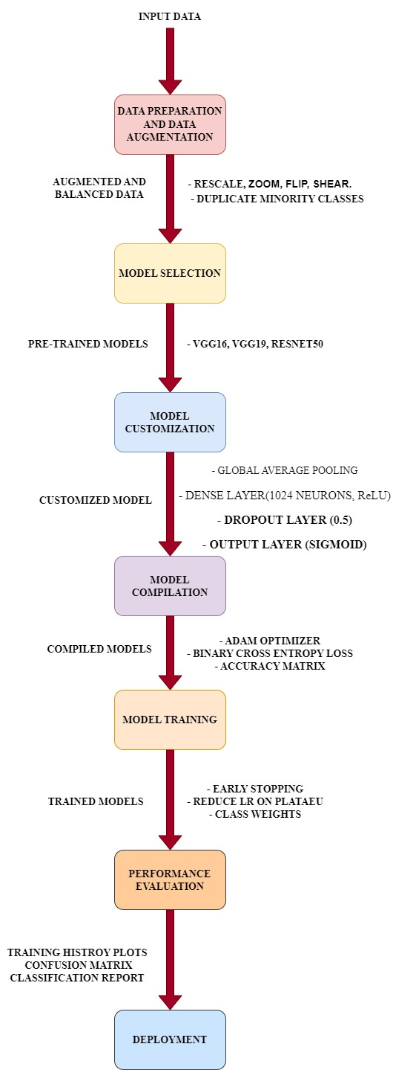

Figure 1: Design of a Deep Learning Pathway for Predicting Parkinson's Disease

* 1. **DATASET**

|  |  |  |  |
| --- | --- | --- | --- |
| **Classes** | **Training Set** | **Validation Set** | **Testing Set** |
| Healthy | 1305 Images | 565 Images | 81 Images |
| Parkinson | 1305 Images | 246 Images | 81 Images |
| **Total**  **Percentage** | 2610 Images  80% | 811 Images  5% | 162 Images  15% |

**Table 1:** Details of Parkinson’s Dataset

* 1. **EXECUTION**
     1. **PREPROCESSING AND PREPARATION**
* **Defining Dataset Paths**

The first step in our data preparation process involves specifying the paths to our training, validation, and testing datasets. These datasets are stored in separate directories.

* **Data Augmentation and Normalization**

We employ data augmentation techniques to enhance the diversity of our training data and improve our model's robustness. The ImageDataGenerator class from TensorFlow's Keras API is used for this purpose. The training data is augmented with several transformations, while the validation and testing data are only rescaled

* **Training Data Augmentation**

The training data is augmented with the following transformations:

* Rescaling pixel values to the range [0, 1]
* Random shear transformations
* Random zooming
* Random horizontal flipping
* Random rotations within a range of 30 degrees
* Random width and height shifts
* Random brightness adjustments within the range [0.8, 1.2]
* **Validation and Testing Data Normalization**

For the validation and testing data, only rescaling is applied

* **Loading the Data**

The data generators are used to load images from the respective directories. These generators will yield batches of data with corresponding labels for both training data generator and validation data generator.

* + 1. **ALGORITHM**

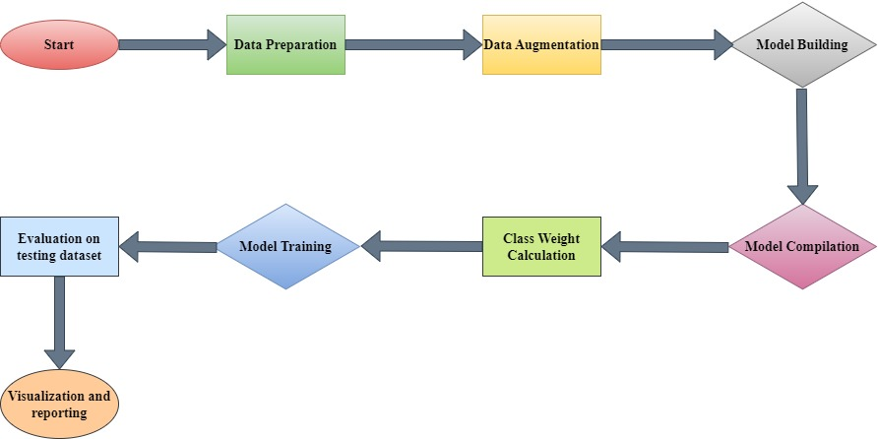

Figure 2: Algorithm for Parkinson’s Disease Prediction

**5 RESULTS AND DISCUSSION**

**5.1 METRICS FOR EVALUATION**

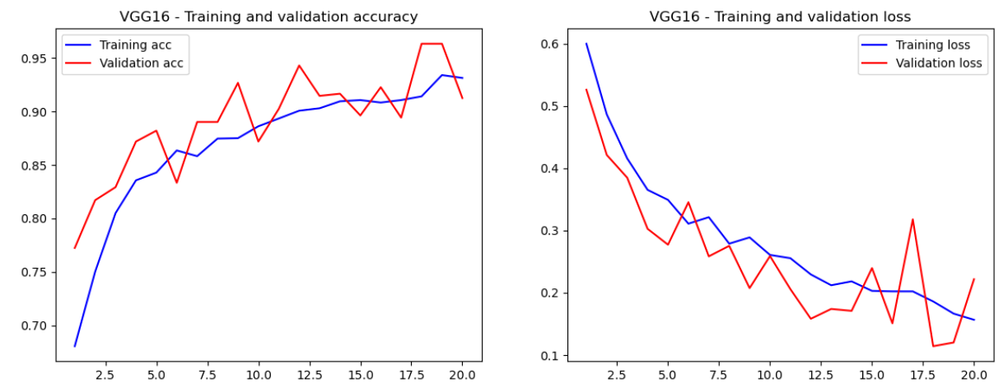

Figure 3: Accuracy and loss function of Training and Validation of VGG16

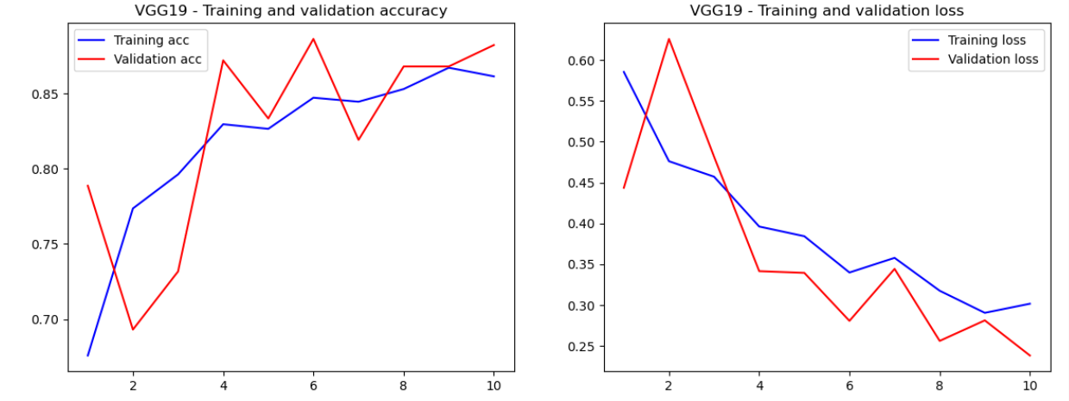

Figure 4: Accuracy and loss function of Training and Validation of VGG19

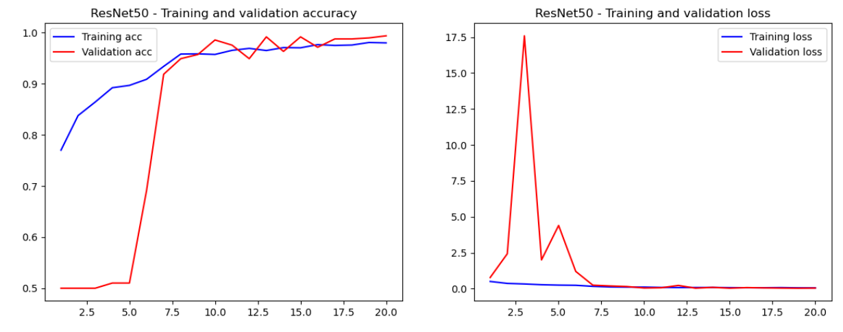

Figure 5: Accuracy and loss function of Training and Validation of ResNet50

**5.2 EXPERIMENTAL RESULTS**

|  |  |  |  |  |
| --- | --- | --- | --- | --- |
|  | **Precision** | **Recall** | **F1-Score** | **Support** |
| **Healthy** | 0.96 | 0.98 | 0.97 | 81 |
| **Parkinson** | 0.97 | 0.96 | 0.97 | 81 |
| **Accuracy** |  |  | 0.97 | 162 |
| **Macro Avg** | 0.97 | 0.97 | 0.97 | 162 |
| **Weighted Avg** | 0.97 | 0.97 | 0.97 | 162 |

**Table 2:** Classification report for VGG16

|  |  |  |  |  |
| --- | --- | --- | --- | --- |
|  | **Precision** | **Recall** | **F1-Score** | **Support** |
| **Healthy** | 0.75 | 0.96 | 0.84 | 81 |
| **Parkinson** | 0.95 | 0.68 | 0.79 | 81 |
| **Accuracy** |  |  | 0.82 | 162 |
| **Macro Avg** | 0.85 | 0.82 | 0.82 | 162 |
| **Weighted Avg** | 0.85 | 0.82 | 0.82 | 162 |

**Table 3:** Classification report for VGG19

|  |  |  |  |  |
| --- | --- | --- | --- | --- |
|  | **Precision** | **Recall** | **F1-Score** | **Support** |
| **Healthy** | 0.98 | 1.00 | 0.99 | 81 |
| **Parkinson** | 1.00 | 0.98 | 0.99 | 81 |
| **Accuracy** |  |  | 0.99 | 162 |
| **Macro Avg** | 0.99 | 0.99 | 0.99 | 162 |
| **Weighted Avg** | 0.99 | 0.99 | 0.99 | 162 |

**Table 4:** Classification report for ResNet50

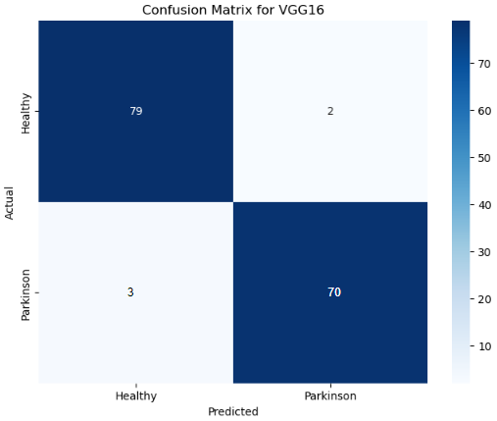

Figure 6:Confusion Matrix for VGG16

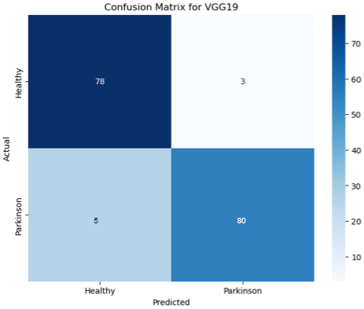

Figure 7:Confusion Matrix for VGG19

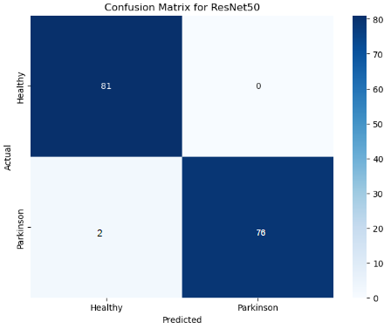

Figure 8:Confusion Matrix for RESNET50

**6. CONCLUSION**

In this project, we successfully implemented and evaluated VGG16, VGG19, and ResNet50 convolutional neural network architectures for the classification of Parkinson's disease images. By employing extensive data augmentation techniques and leveraging pre-trained models, we enhanced the robustness and accuracy of our models. Each model demonstrated strong performance, with ResNet50 achieving the highest accuracy due to its deeper architecture and residual connections. The evaluation metrics, including accuracy, precision, recall, and confusion matrices, confirmed the models' effectiveness in distinguishing between the classes. This study highlights the potential of deep learning in medical image classification and sets the stage for future enhancements through hyperparameter tuning, ensemble methods, and the incorporation of larger datasets.