1. Write a program to calculate compound interest.

#include<stdio.h>

#include<math.h>

int main()

{

float p,r,t,CI;

printf("enter the principal (amount):");

scanf("%f" ,&p);

printf("enter the rate:");

scanf("%f" ,&r);

printf("enter the time:");

scanf("%f",&t);

CI=p*(pow((1+r/100) ,t));

printf("the final amount after applying compound interest=%.2f\n",CI);

return 0;

}

Output: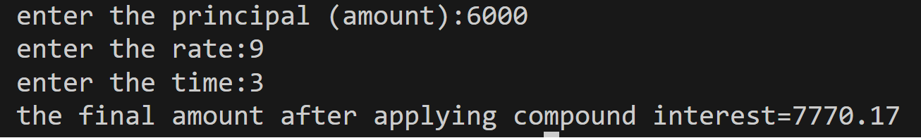

1. Write a program to find the sum of even numbers up to n.

#include <stdio.h>

int main()

{

int n;

printf("enter the number");

scanf("%d", &n);

int e = 0;

int i;

for (i = 2; i <= n; i = i + 2)

{

e = e + i;

}

printf("the sum of number is %d", e);

return 0;

}

output: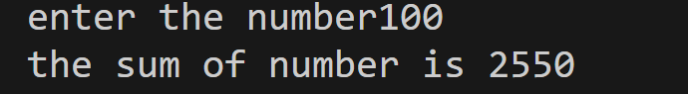

1. Write a program to show the factorial of n.

#include<stdio.h>

int main()

{

int n;

printf("enter the factorial number");

scanf("%d",&n);

int fact=1;

int i;

for (i=1;i<=n;i++)

{

fact=fact*i;

}

printf("The factorial number is %d",fact);

return 0;

}

Output: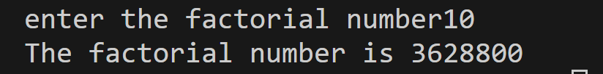

4.Write a program to calculate the volume of the sphere.

#include<stdio.h>

int main(){

int r;

printf("enter the radius");

scanf("%d",&r);

float v=4*3.14*r*r*r/3;

printf("the volume is %.2f",v);

return 0;

}

Output: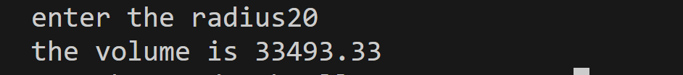

5. Write a program to swap two variables.

#include<stdio.h>

int main()

{

int x,y;

printf("the value of x");

scanf("%d",&x);

printf("the value of y");

scanf("%d",&y);

int temp=x;

x=y;

y=temp;

printf("After swapping:x=%d,y=%d",x,y);

return 0;

}

Output: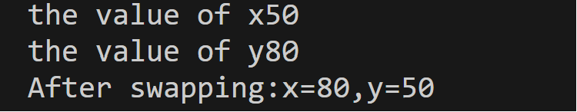

6.Write a program to show tables of even numbers up to n.

#include <stdio.h>

int main ()

{

int i, j, n;

printf ("Enter a positive integer: ");

Scanf("%d", &n);

for (i=2; i<=n; i+=2)

{

printf ("Table of %d:\n", i);

for (j=1; j<=10; j++)

{

printf ("%d x %d = %d\n", i, j, i*j);

}

printf ("\n");

}

return 0;

}

Output:

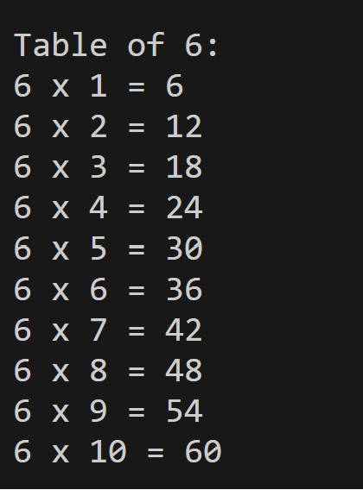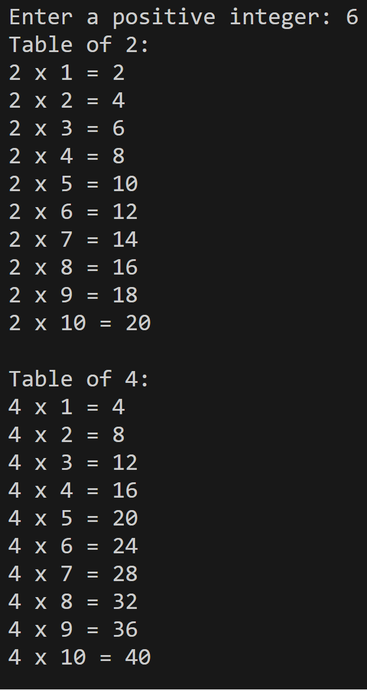

7. Write a program to calculate maximum height,total flight time,horizontal range in projectile motion.

#include <stdio.h>

#include <math.h>

int main()

{

float u, a, t, hmax, R;

float pi = 3.14159265;

float g = 9.8;

printf("Enter the initial velocity (in m/s): ");

scanf("%f", &u);

printf("Enter the angle of projection (in degrees): ");

scanf("%f", &a);

float rad = a * pi / 180;

float sin_a = sin(rad);

float cos_a = cos(rad);

hmax = (u * u * sin_a * sin_a) / (2 * g);

t = (2 * u * sin_a) / g;

R = u * cos_a * t;

printf("Maximum height: %.2f m\n", hmax);

printf("Total flight time: %.2f s\n", t);

printf("Horizontal range: %.2f m\n", R);

return 0;

}

Output: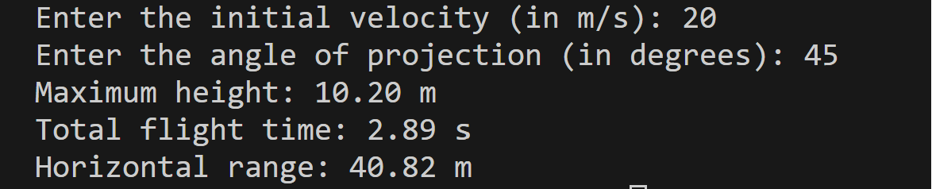

8. Write a program to calculate power via force, distance, time.

#include <stdio.h>

int main()

{

float force, work, distance,time,power;

printf("enter the force(in newton):");

scanf("%f", &force);

printf("enter the distance(in metres):");

scanf("%f",&distance);

work = force * distance;

printf("enter the time (in second):");

scanf("%f",&time);

power = work/time;

printf("the power is %.2f watts.\n",power);

return 0;

}

Output: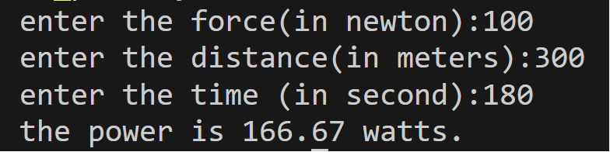

9. Write a program to convert a decimal number to its binary, octal, and hexadecimal.

#include <stdio.h>

int decimal_to_binary(int decimal) {

int binary = 0, base = 1;

while (decimal > 0) {

binary += (decimal % 2) * base;

decimal /= 2;

base *= 10;

}

return binary;

}

int main() {

int decimal;

printf("Enter a decimal number: ");

scanf("%d", &decimal);

printf("The binary representation of %d is %d.\n", decimal, decimal_to_binary(decimal));

printf("The octal representation of %d is %o.\n", decimal, decimal);

printf("The hexadecimal representation of %d is %X.\n", decimal, decimal);

return 0;

}

Output: 