# SNS Topic Configuration – Event Announcement System

## Overview

As part of developing the Event Announcement System, I configured Amazon Simple Notification Service (SNS) to send email notifications to users whenever a new event is created. SNS acts as the messaging layer that supports publish/subscribe communication between the backend services and subscribers.

## SNS Topic Setup

I created a Standard SNS topic in the same AWS region where my Lambda functions were deployed (eu-west-2). The topic was named: EventAnnouncements. I left all other settings at their default values. After creating the topic, I accessed the details page to retrieve the Topic ARN, which I later used in my Lambda functions to publish notifications.

*Figure 1: Opening the Amazon SNS Console from the AWS Management Console.*

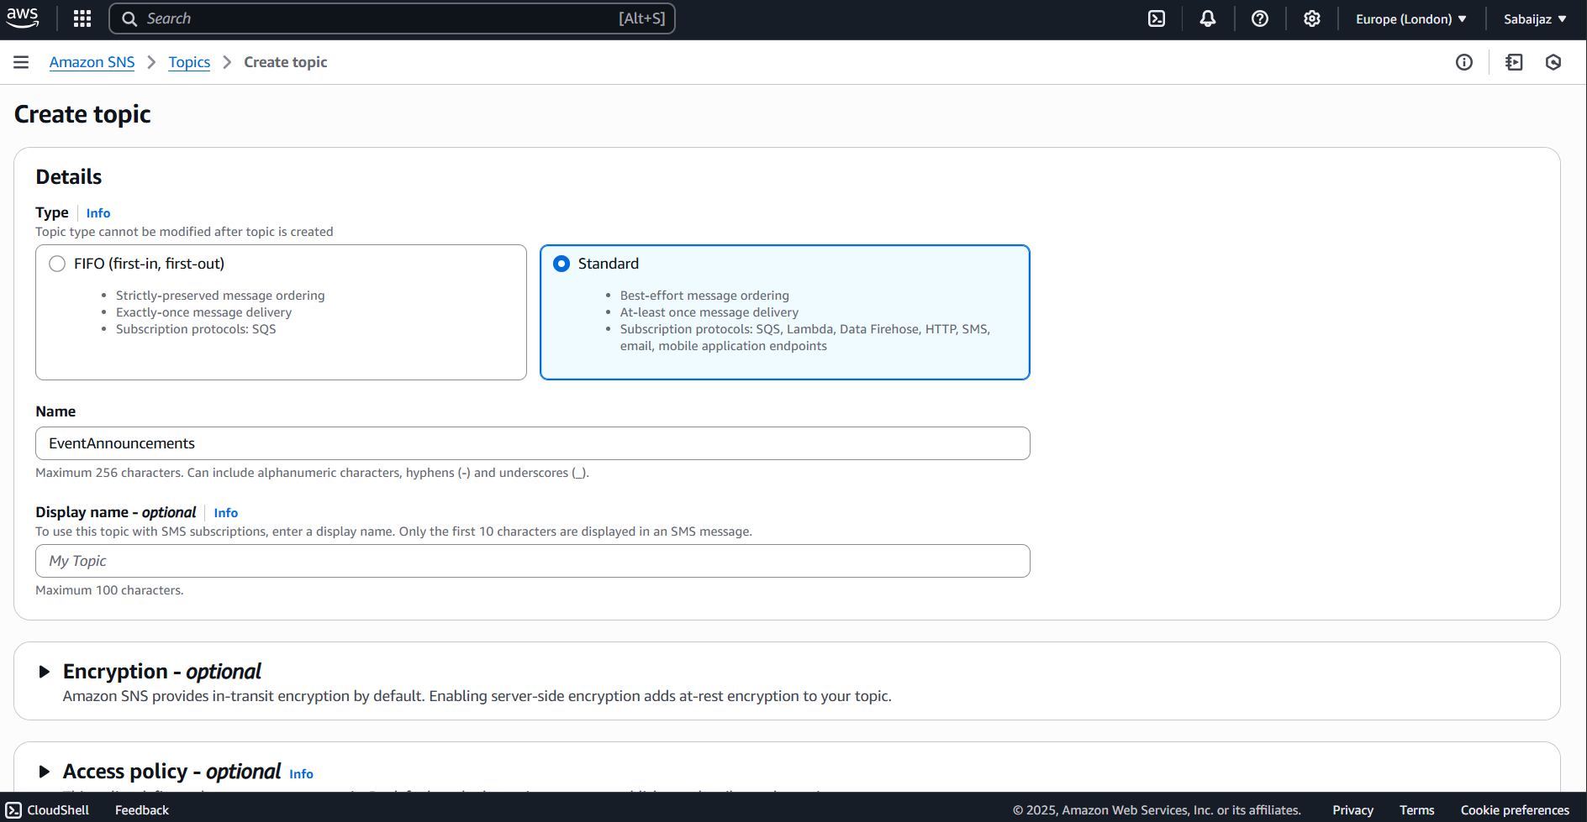

*Figure 2: Creating the SNS topic in AWS Console.*

## Topic ARN Example

Below is the ARN I used in my Lambda functions:

[arn:aws:sns:eu-west-2:528757807079:EventAnnouncements]

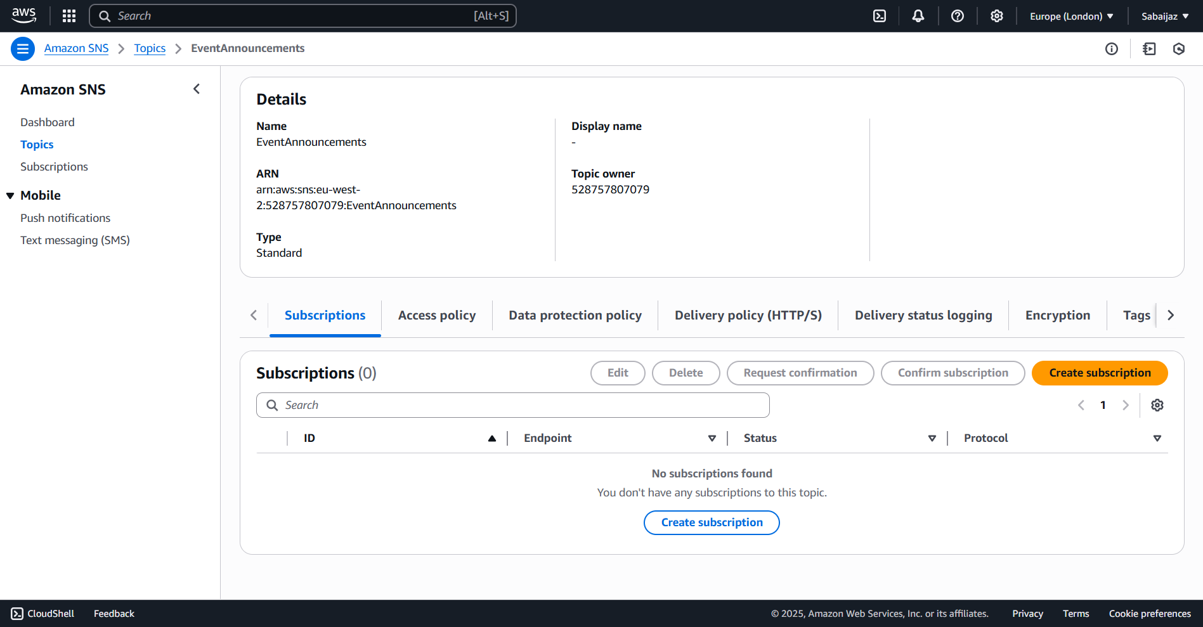

*Figure 3: Viewing the SNS Topic ARN on the topic details page.*

Once integrated, the SNS topic successfully delivered notifications to all subscribed users when a new event was created. I verified this by subscribing multiple test email addresses and confirming delivery of the email alerts.