# **Frontend Deployment with AWS Amplify**

## **Overview**

To make the Serverless Cloud Dictionary application accessible via the web, I set up and hosted its frontend using AWS Amplify. This process involved preparing the React application locally, pushing it to a dedicated GitHub repository, and configuring Amplify to build and deploy the project automatically.

## **Process Breakdown**

1. **Clone the Source Code**

I began by cloning the project repository from GitHub and navigating to the frontend directory:

git clone <https://github.com/techwithlucy/ztc-projects-intermediate.git>

cd ztc-projects-intermediate\projects\intermediate\project4

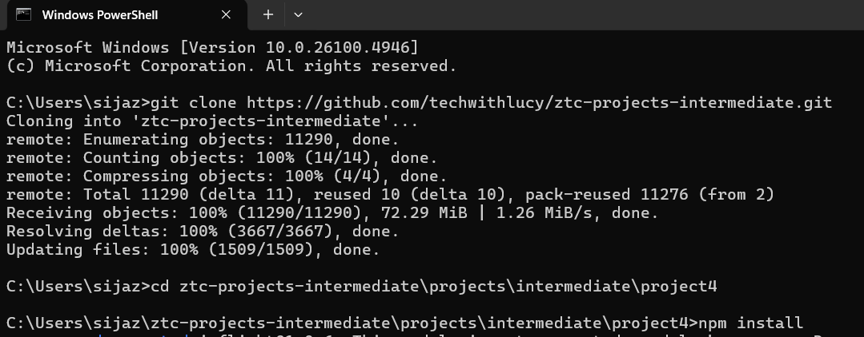

Figure 1: Cloning the repository and navigating into the project folder.

1. **Install and Test Dependencies**

I installed the required npm dependencies and verified that the React application was running locally:

npm install

npm start

Once started, the app was accessible at <http://localhost:3000>.

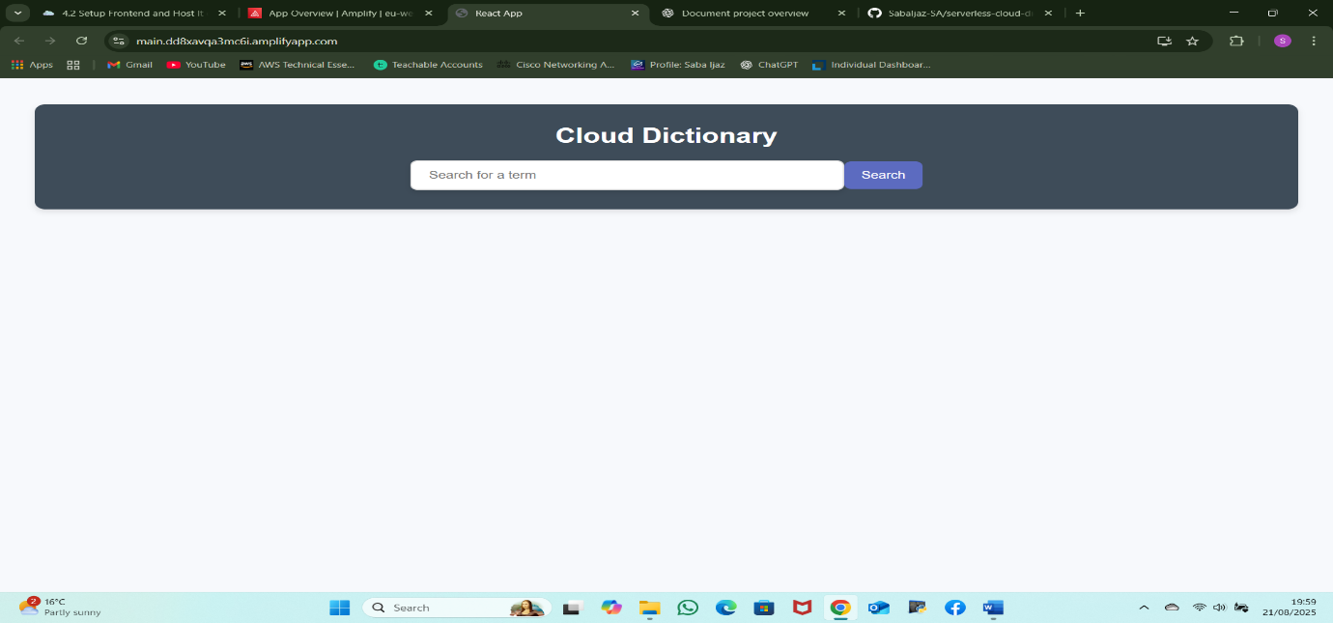

Figure 2: React application running locally in the browser at http://localhost:3000.

**3. Create a new GitHub Repository**

I set up a fresh GitHub repository (e.g., *serverless-cloud-dictionary*) to host the frontend code. The repository was created without a README or .gitignore file to avoid conflicts.

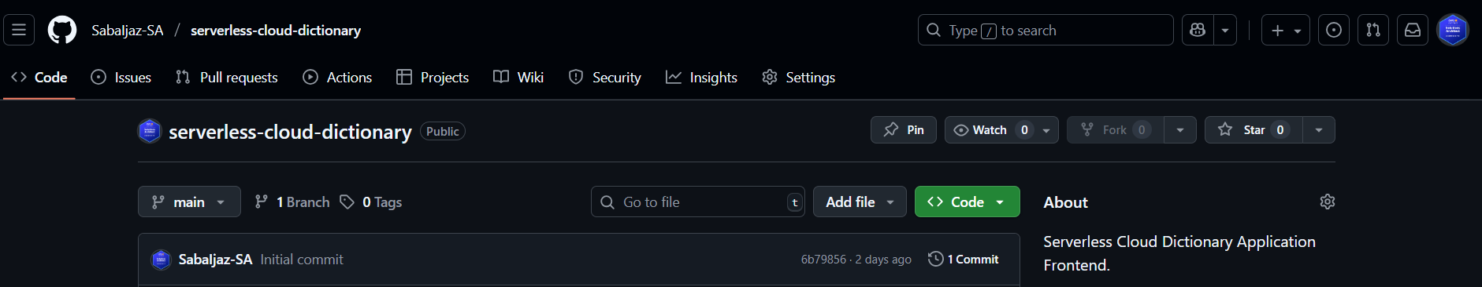

Figure 3: New GitHub repository created for the frontend project.

**4. Push Local Code to GitHub**

The local project was then version-controlled and pushed to GitHub:

git init

git add .

git commit -m "Initial commit"

git remote remove origin

git remote add origin <https://github.com/SabaIjaz-SA/serverless-cloud-dictionary.git>

git branch -M main

git push -u origin main

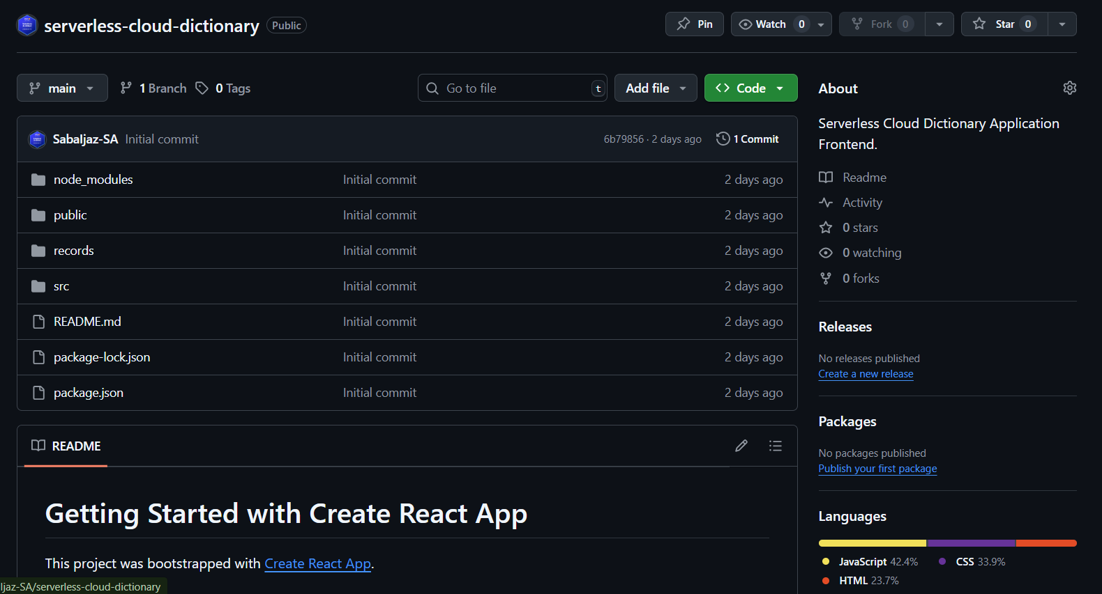

Figure 4: Successful push of the frontend code to the new GitHub repository.

**5. Deploy on AWS Amplify**

* Logged into the AWS Management Console and opened Amplify.
* Selected Deploy an App → GitHub as the source.
* Connected the new repository and branch.
* Accepted Amplify’s auto-detected build settings for React.
* Clicked Save and Deploy.

Figure 5: Connecting GitHub repository to AWS Amplify.

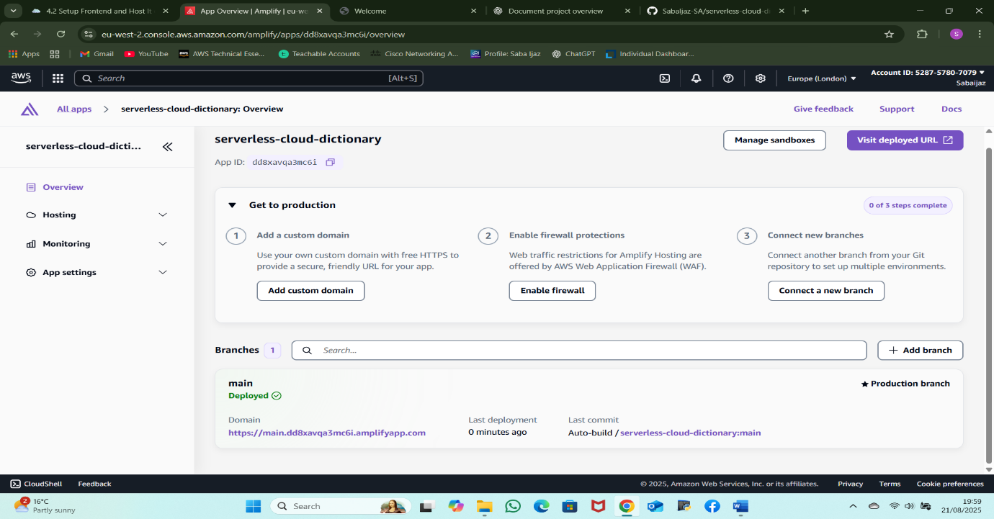

Figure 6: AWS Amplify built and deployed the app.

Amplify handled the build and deployment automatically. After a few minutes, a live URL <https://main.dd8xavqa3mc6i.amplifyapp.com> was generated, making the dictionary application accessible online.

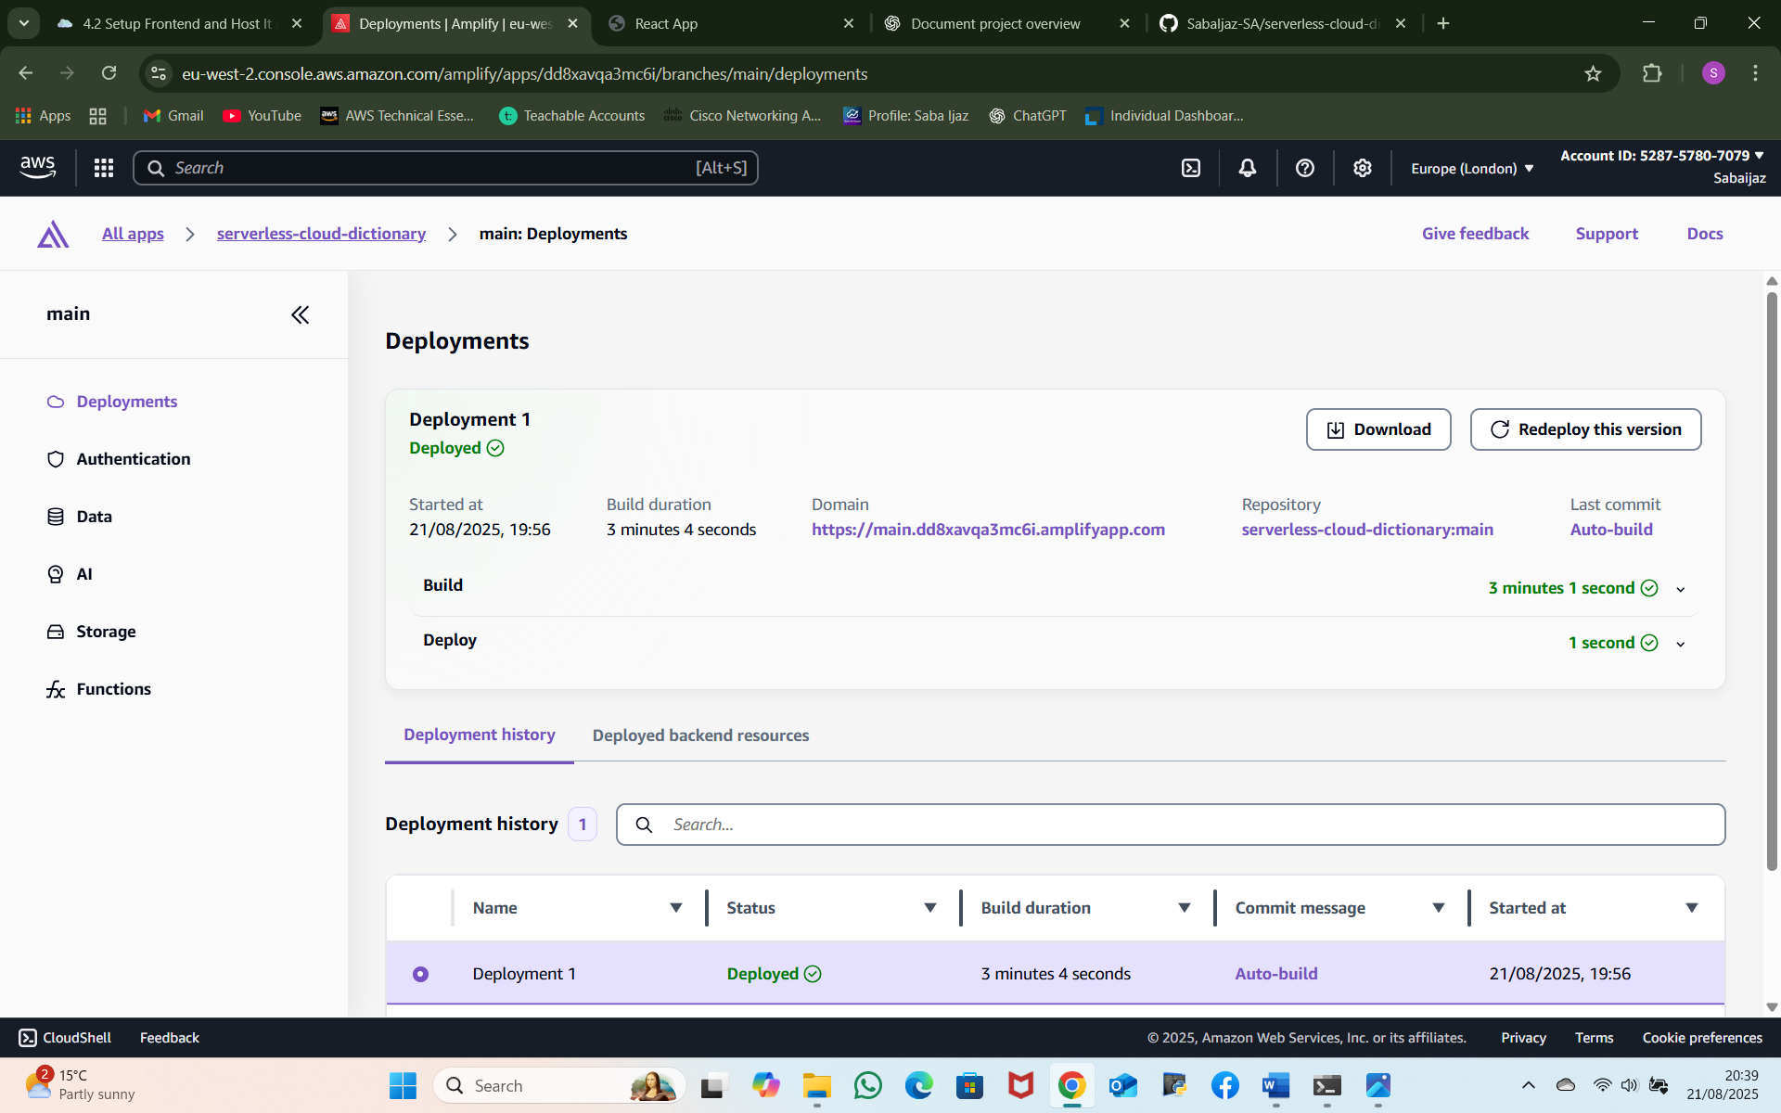

Figure 7: Application successfully deployed with live Amplify URL.

**Result**

The frontend of the Serverless Cloud Dictionary Application is now continuously deployed using AWS Amplify. Any changes pushed to the GitHub repository are automatically rebuilt and published, ensuring a seamless workflow from development to deployment.

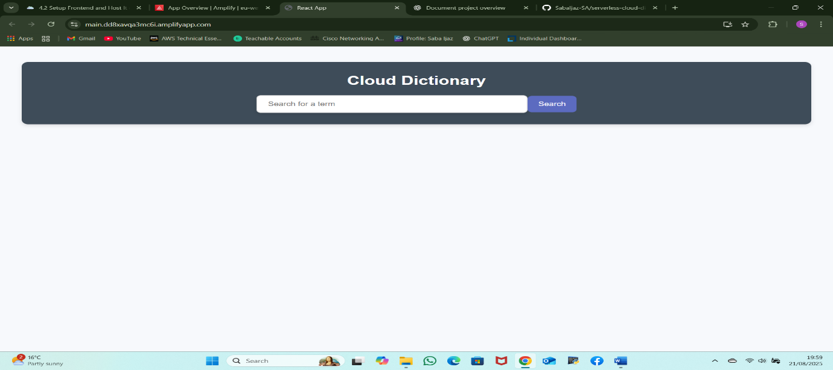

Figure 8: Final deployed application running via AWS Amplify URL.