Maze Generator & Solver
Visualising BFS, DFS, and A* Search Algorithms

Author: Saba Zarandia, Mohamed Adli Denis Prokopenko
Course: Principles of Programming
Date: April 2026

Live app: mazesolverprogrmaingproject.streamlit.app
GitHub: github.com/SabaZara/maze-solver

1. Introduction and Background
Pathfinding and maze solving are foundational problems in computer science with real-world applications in robotics navigation, game AI, and network routing. This project implements an interactive maze generator and solver that compares three classical graph search algorithms: Breadth-First Search (BFS), Depth-First Search (DFS), and A* (A-star).

The motivation behind this project is to make abstract algorithmic behaviour tangible and visual. Rather than simply stating that “BFS guarantees the shortest path,” a user can watch BFS and A* explore the same maze simultaneously and observe the difference in how they navigate — BFS expanding outward in uniform concentric rings, A* steering purposefully toward the goal. This visual contrast makes the theoretical differences immediately intuitive.

The maze is generated programmatically using a recursive backtracking algorithm, ensuring every maze produced is a perfect maze: fully connected, with exactly one path between any two cells. This controlled structure guarantees fair and reproducible comparisons between algorithms.

The interactive dashboard is deployed at: mazesolverprogrmaingproject.streamlit.app • Source code: github.com/SabaZara/maze-solver

2. Approach and Methodology

2.1 Maze Representation
The maze is stored as a binary NumPy array of shape (2×rows+1, 2×cols+1). In this encoding:
- 0 = wall pixel (black); 1 = passage pixel (white)
- Each logical maze cell (r, c) maps to grid pixel (2r+1, 2c+1)
- The wall between adjacent cells sits at the pixel halfway between them
This compact representation allows direct rendering via matplotlib’s imshow without custom drawing logic. Checking whether two cells are connected is a single array index lookup.

2.2 Maze Generation: Recursive Backtracking
The generator uses iterative DFS with an explicit stack (avoiding Python’s recursion limit on large mazes):
- Start at cell (0,0), mark visited, push onto stack
- While stack is non-empty: find all unvisited neighbours of the current cell
- If neighbours exist: pick one at random, carve the wall between them, push neighbour
- If no neighbours: pop (backtrack)
This produces a spanning tree of the cell graph — a perfect maze with no loops and exactly one solution path between any two cells.

2.3 Solving Algorithms
All three solvers work on maze-cell coordinates and check connectivity via the binary grid. Each records animation “frames” — snapshots of visited cells at regular intervals — for step-by-step playback.
- BFS (Breadth-First Search): Uses a deque. Explores all cells at distance d before d+1. Guaranteed shortest path.
- DFS (Depth-First Search): Uses a stack. Dives deep before backtracking. Finds a path quickly but without a shortest-path guarantee.
- A* (A-star): Uses a min-heap ordered by f = g + h, where g is cost from start and h is Manhattan distance to goal. Finds the shortest path while typically visiting fewer cells than BFS.

2.4 Imperfect Mazes: The Loop Factor
A perfect maze has exactly one path between any two cells, so all three algorithms always find the same path length. To make algorithmic differences meaningful, the generator supports a loop_factor parameter (0.0 to 0.5). After the perfect maze is generated, a random fraction of remaining internal walls are removed, creating cycles and multiple alternative routes.
With loops present, BFS and A* always find the true shortest path, while DFS — which commits to a branch and cannot globally backtrack — often finds a longer winding route. This is the key experimental result of the project.

2.5 Key Design Choices
- Frame snapshots are pre-computed before rendering, then replayed via st.empty() — each iteration replaces the previous figure in place for smooth animation without full page rerenders.
- A configurable frame interval caps animation at ~200 frames regardless of maze size, keeping playback fluid on any device.
- st.session_state persists the generated maze and solver results across Streamlit rerenders so controls remain interactive without re-solving.
- The loop_factor slider in the sidebar lets users switch between perfect and imperfect mazes interactively, observing in real time how algorithm behaviour changes.

3. Programming Tools and Methods

Python Standard Library
- collections.deque: O(1) enqueue/dequeue for BFS — critical for performance on large mazes
- heapq: Binary min-heap for A* priority queue; O(log n) push and pop

NumPy
Binary grid storage with O(1) wall lookup via direct array indexing. The full RGB colour overlay for rendering is computed in a single vectorised pass over the grid array, avoiding Python loops over pixels.

Matplotlib
Renders each maze frame using imshow on an RGB NumPy array. Colour overlays are applied by direct pixel assignment: visited cells in blue, solution path in gold, start in green, end in red. plt.close(fig) is called immediately after each st.pyplot() call to prevent memory accumulation during long animations.

Streamlit
- st.session_state — maze and solver results persistence across rerenders
- st.empty() — single placeholder slot for in-place figure replacement (animation)
- st.columns() — three-column side-by-side layout for simultaneous algorithm comparison
- st.tabs() — separates Visualisation and Statistics views
- st.slider(), st.radio(), st.button() — sidebar controls for maze size, speed, algorithm selection

pandas
Builds the comparison DataFrame in the Statistics tab and computes five derived metrics: efficiency (%), search overhead, wasted exploration (cells), maze coverage (%), and solve time (ms).

Project Structure
- maze_generator.py — iterative DFS maze generation
- maze_solver.py — BFS, DFS, A* algorithms with frame recording
- maze_renderer.py — matplotlib RGB figure builder and colour overlays
- app.py — Streamlit UI, animation loop, statistics tab

4. Results

4.1 Correctness
On all tested maze sizes (5×5 to 40×40), BFS and A* consistently returned the same path length, confirming both find the optimal (shortest) solution. On perfect mazes, DFS also finds the same length since only one path exists. On imperfect mazes (with loops), DFS path length diverges significantly — matching the expected theoretical behaviour.

4.2 Perfect Maze Results — 15×15, Loop Factor = 0
With loop factor 0, only one path exists. All algorithms find the same path length; differences are only in exploration efficiency:

Algorithm | Path Length | Cells Visited | Efficiency (%) | Overhead | Time (ms)
BFS | 79 | 109 | 72.5 | 1.38 | 0.169
DFS | 79 | 83 | 95.2 | 1.05 | 0.111
A* | 79 | 95 | 83.2 | 1.20 | 0.196

Metrics: Efficiency (%) = path length ÷ cells visited × 100 (higher = better). Overhead = cells visited ÷ path length (lower = better, 1.0 = perfect).

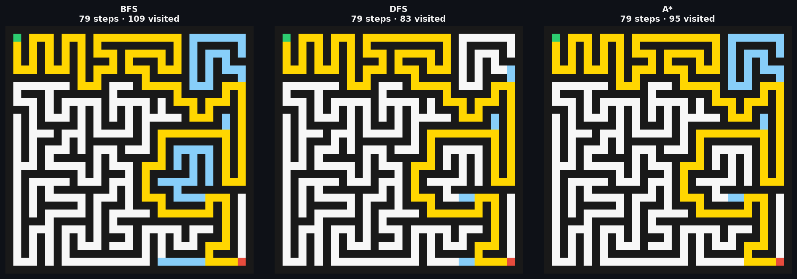
Figure 1. Perfect maze (loop=0): all three algorithms find the same path (gold). Blue = explored cells.

Key observations:
- All three find path length 79 — on a perfect maze only one solution exists.
- DFS achieved 95.2% efficiency — it happened to explore almost only cells on the final path.
- A* visited fewer cells than BFS (95 vs 109) thanks to the Manhattan heuristic.

4.3 Imperfect Maze Results — 15×15, Loop Factor = 0.3
With loop factor 0.3, approximately 30% of remaining internal walls are removed after generation, creating loops and multiple alternative paths. Now the algorithms genuinely diverge:

Algorithm | Path Length | Cells Visited | Efficiency (%) | Overhead | Time (ms)
BFS | 31 | 225 | 13.8 | 7.26 | 1.125
DFS | 51 | 187 | 27.3 | 3.67 | 0.335
A* | 31 | 167 | 18.6 | 5.39 | 0.381

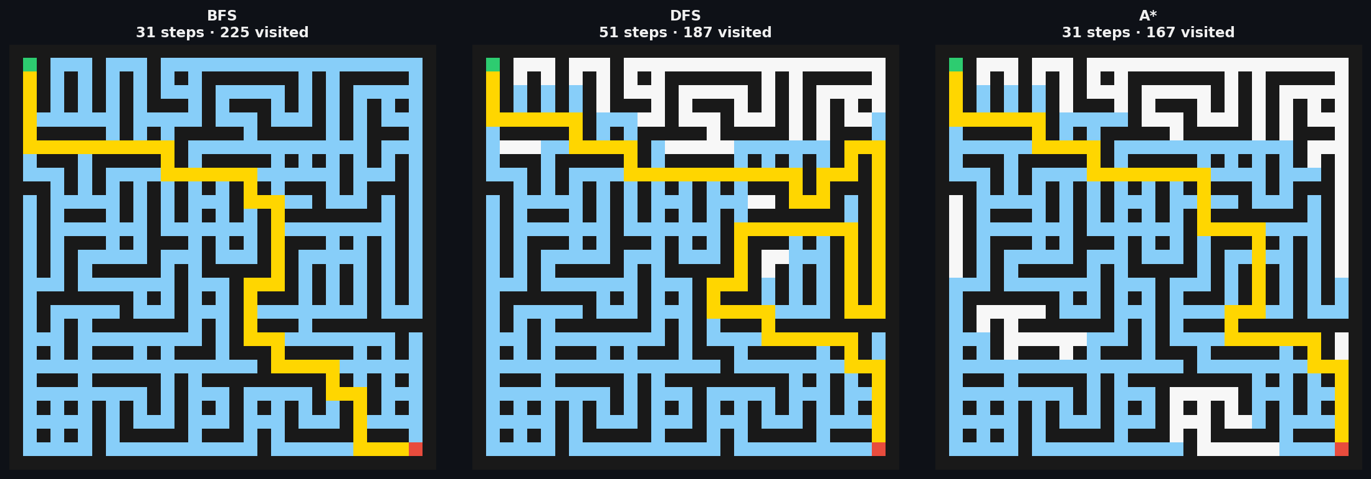
Figure 2. Imperfect maze (loop=0.3): BFS and A* find the short optimal path (31 steps); DFS finds a longer winding route (51 steps).
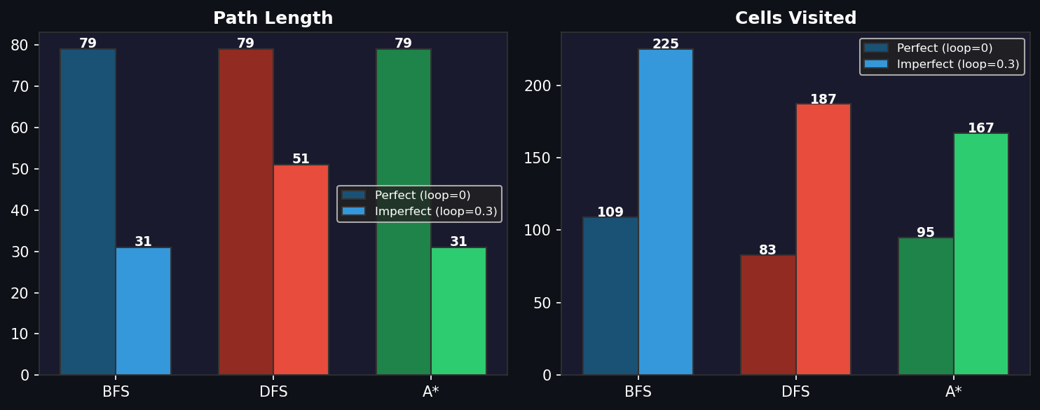
Figure 3. Perfect vs imperfect maze comparison. Path length (left) and cells visited (right). On the imperfect maze DFS path length is 65% longer than BFS/A*.

Key observations:
- BFS and A* both find the optimal path (31 steps) — confirmed correct on mazes with loops.
- DFS finds a path 65% longer (51 steps) — it cannot backtrack to find shortcuts once it commits to a branch.
- A* visits the fewest cells (167) despite finding the optimal path — the heuristic focuses exploration toward the goal.
- BFS visits all 225 cells before finding the goal — it exhaustively explores all directions.
- This result proves that BFS and A* are optimal algorithms; DFS is not, which is the core theoretical claim of the project.

4.4 Visual Dashboard
The live dashboard at mazesolverprogrmaingproject.streamlit.app provides:
- Loop Factor slider — switch between perfect and imperfect mazes to observe algorithm divergence in real time
- Side-by-side animated view: all three algorithms animate simultaneously, making path length differences immediately visible
- Individual animated view: step-by-step playback with configurable speed
- Statistics tab: five-metric comparison table with winner callouts and bar charts
- Adjustable maze size (5×5 to 40×40) via sidebar sliders

References
Cormen, T. H., Leiserson, C. E., Rivest, R. L., & Stein, C. (2009). Introduction to Algorithms (3rd ed.). MIT Press.

Hart, P. E., Nilsson, N. J., & Raphael, B. (1968). A formal basis for the heuristic determination of minimum cost paths. IEEE Transactions on Systems Science and Cybernetics, 4(2), 100–107.

Streamlit documentation. https://docs.streamlit.io

NumPy documentation. https://numpy.org/doc

GitHub repository. https://github.com/SabaZara/maze-solver

Live application. https://mazesolverprogrmaingproject.streamlit.app/

