Software Requirements Specification
For
General Ledger
Version 1.0 approved
Prepared by Aiman Siddiqui
SabaPervez

FAST National University of Computer and Emerging Sciences
21st May 2020
Table of Contents
Table of Contents ii
Revision History ii
1. Introduction 1
1.1 Purpose 1
1.2 Document Conventions 1
1.3 Intended Audience and Reading Suggestions 1
1.4 Product Scope 1
1.5 References 2
2. Overall Description 2
2.1 Product Perspective 2
2.2 Product Functions 2
2.3 User Classes and Characteristics 3
2.4 Operating Environment 3
2.5 Design and Implementation Constraints 4
2.6 User Documentation 4
2.7 Assumptions and Dependencies 4
3. External Interface Requirements 4
3.1 User Interfaces 4
3.2 Hardware Interfaces 7
3.3 Software Interfaces 7
3.4 Communications Interfaces 7
4. System Features 7
4.1 Secure Login to interface 7
4.2 Authority to Administrator 8
5. Other Nonfunctional Requirements 8
5.1 Performance Requirements 8
5.2 Safety Requirements 8
5.3 Security Requirements 9
5.4 Software Quality Attributes 9
5.5 Business Rules 9
6. Other Requirements 10
6.1 Portability Requirements 10
Appendix A: Glossary 10
Appendix B: Analysis Models 11

Revision History
Name | Date | Reason For Changes | Version

Introduction

Purpose
The general ledger holds account data that is expected to set up the organization's fiscal summaries, and exchange information is isolated by sort into records for resources, liabilities, proprietors' value, incomes, and costs (1).
This project is based over general ledger managing software for some company. The ultimate motivation for this project is that every company either it would be a manufacturing company or it would be a shoe company, each and every one of them have an accountant to manage all the accounts and details and make reports accordingly. This task is generally done on excel sheets, but we wanted to make it an online service which will increase the monitoring of the higher authorities from anywhere.
This is a first version of the product and the release number is 1.0.

Document Conventions
- Font: Arial.
- Font Style: None.
- Font Size: 11px.
- Font Color: Black.
- Special Significant information is written in bold.
- Every requirement statement has its own priority. Detailed requirements do not inherit the priorities of higher level requirement.
- DB: Database.
- ER: Entity Relationship.
- SRS: System Requirement Specification.

Intended Audience and Reading Suggestions
Different type of readers for whom the document is intended to be written are Developers; that can use this document to further modify the software and enhance it per need, Project Leader; that can use this document to recommend changes and guide their fellow software developers, Users; to understand the software and demand further changes in the software as per the document states and needs, Higher Authorities; to check and verify the problem stated. The rest of SRS contains description of the product, references, functionalities, features, user cases, interfaces, etc.

Product Scope
We will probably expedite the whole general ledger one stage. i.e.: by sitting at home and by just having a web association you'll approach every one of your records. We will build up this web application for every one of the associations out there and on the off chance that you are a startup and can't bear the cost of a record administrator so you simply need to utilize this web application to complete all you record work in simply matter of seconds. You can get to every one of your records from anyplace and its progressively solid since all the work will be advanced so less odds of extortion and greater unwavering quality from our end. This web application will be valuable for everybody out there whether you are an understudy or an expert you can utilize this to deal with your records. We'll set our benchmarks as indicated by universal level.

References
- https://searcherp.techtarget.com/definition/general-ledger-GL
- https://getbootstrap.com/
- Fundamentals of Database Systems, 7th Edition by Ramez Elmasri, University of Texas at Arlington and Shamkant B. Navathe, University of Texas at Arlington

Overall Description

Product Perspective
A general Ledger management system stores the following information in the databases:
- Voucher Type
- GL Master
- Department
- Users
- Balance Nature
- Account Code
- Accounting year
- Activity log
- GL Details

Product Functions
The major functions of the product are following:
• Create
• Update
• Query
• Delete
• Clear
These all will be applied to the following
❖ Account
❖ Department
❖ Volunteer type
❖ User
❖ Transaction

• Maintaining activity log
• Reporting in different ways
• Maintaining chart of accounts.

User Classes and Characteristics
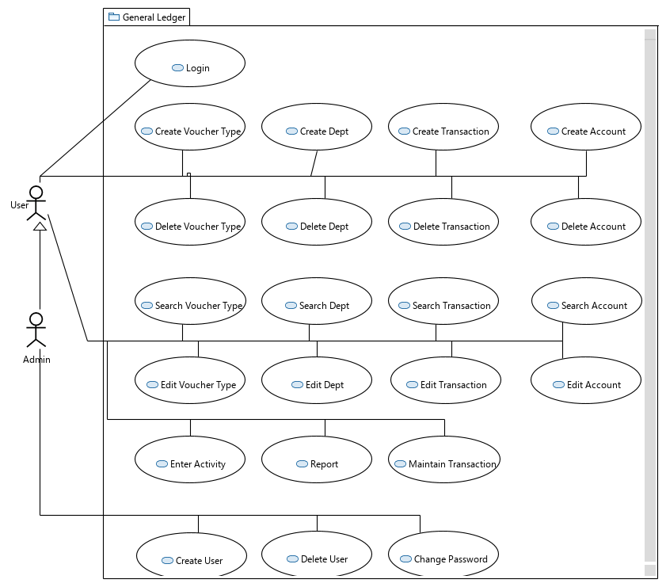

Operating Environment
User should have internet connection, HTML and CSS supported browser and XAMP.

Design and Implementation Constraints
The issue comes for the dynamically updating the data on the screen which will require a lot of cycles from the server and database to get the data from there and display it on the screen.
Each type of account ha specific number of limit for accounts therefore we will have to design it in such way that there is some limit for each type.
We will be facing difficulties in the connection of the front end with the databases with the help of the server as we only know the basic knowledge.
The company will be responsible for maintaining the security measures for accessing the admin account. The admin account should not be accessed by any other user.

User Documentation
We will provide installation and configuration manual to system administrator and user manual to all users.

Assumptions and Dependencies
- Bootstrap
- JQuerry
- Data Modeler
- SQL Developer
- Forms

External Interface Requirements

User Interfaces
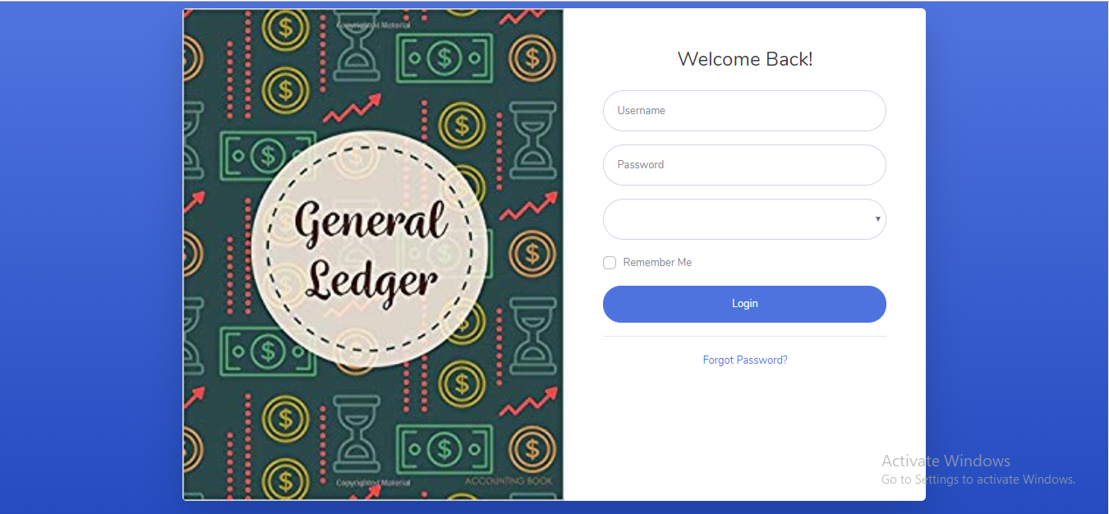
- Front-end Software: HTML5, CSS, JS, jQuerry, Bootstrap.
- Back-end Software: PHP, mySQL.

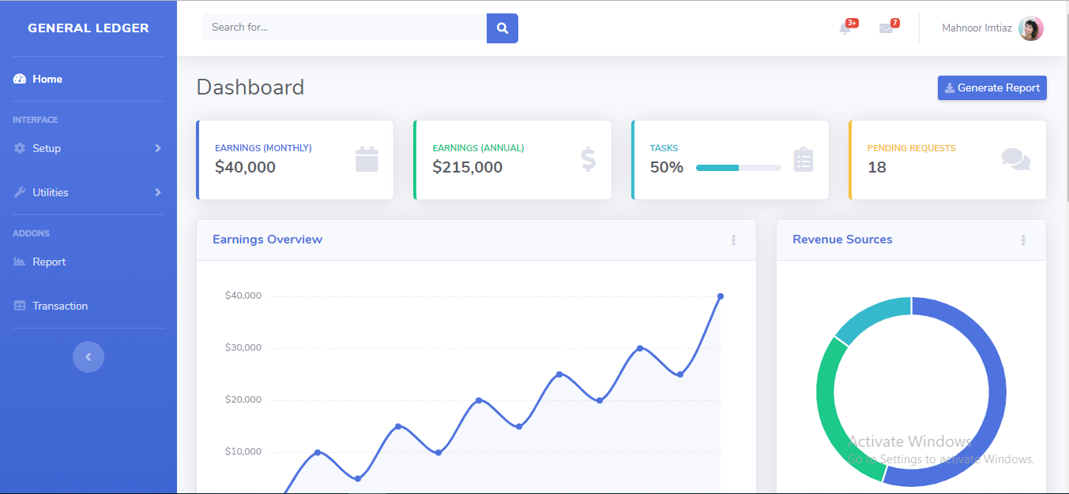

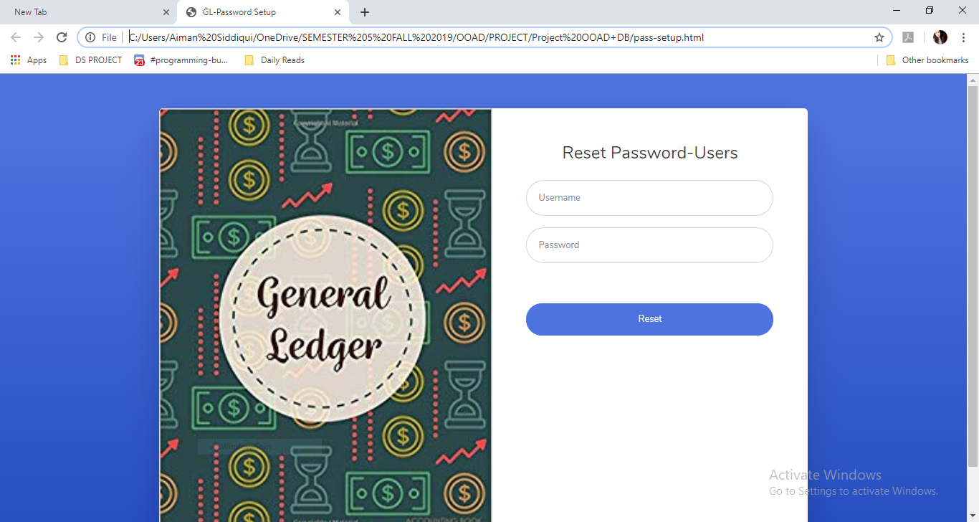
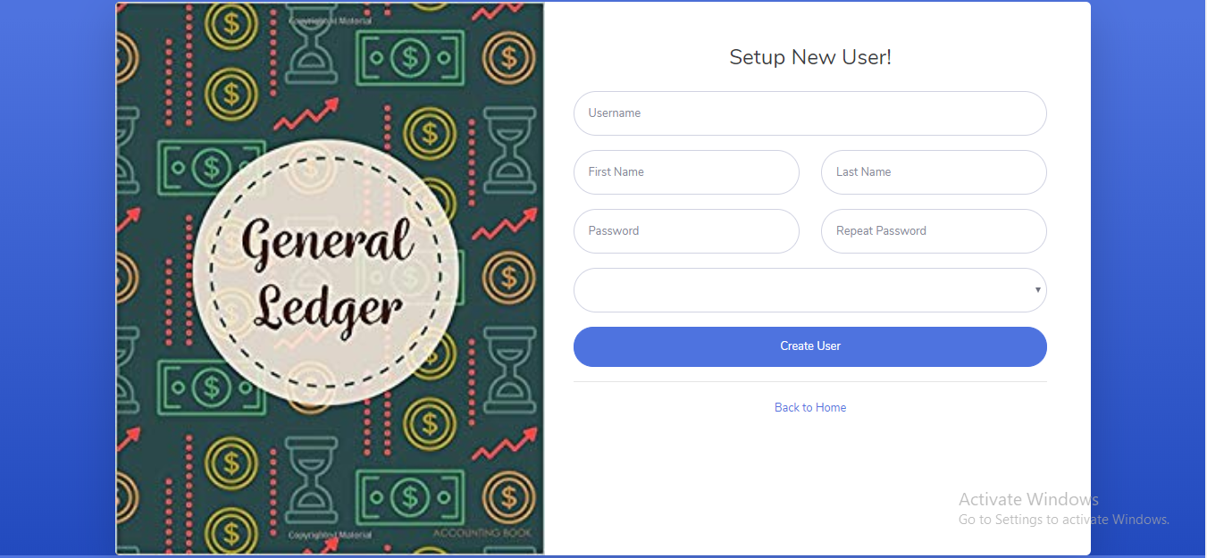

Hardware Interfaces
- Windows.
- A browser which supports HTML5 and JavaScript.

Software Interfaces
Following are the software used for the general ledger management system:
- OS: We have picked Windows working framework for its best help and ease of use.
- DB: To save the account records, transaction records and user data we have chosen mySQL database.
- Development: To implement the project we have chosen JS language for its more interactive support.
- Editor: For better management and handling of project, we have used Sublime Text.

Communications Interfaces
This venture bolsters a wide range of internet browsers. We are utilizing straightforward electronic forms for creation, modification and deletion of users, accounts, department, voucher types, etc. and for the account transactions and voucher creations too.

System Features

Secure Login to interface
4.1.1 Description and Priority
There is a user-password based system. Each user will have a unique password. If the password matches only then you can login else wise you cannot.
Priority: 9
Benefit: 9
Penalty: 9
Cost: 9
Risk: 9

4.1.2 Stimulus/Response Sequences
Whenever the user will access the website, he/she will be shown the login page from which they can access their screens by user-password.
4.1.3 Functional Requirements
- Database table of users.
- Input Boxes.
- Login button.
- Validation.

Authority to Administrator
4.2.1 Description and Priority
There is an administrator of the system who can manage everything. He is the one who can create users and change their passwords.
Priority: 8
Benefit: 8
Penalty: 9
Cost: 7
Risk: 9

4.2.2 Stimulus/Response Sequences
Whenever the admin will access the website, he/she will be shown the login page from which they can access their screens by admin-password.
4.2.3 Functional Requirements
- Database of admin from table of users.
- Input Boxes.
- Login button.
- Validation.
- Creation page of Users.
- Change Password Page.

Other Nonfunctional Requirements

Performance Requirements
Since this software is going to web – based, it requires an incredible server machine with high band web get to. Server machine should have an amazing CPU and rapid web get to so it can handle various clients simultaneously. Another exhibition prerequisite is the extra room. Higher extra room implies more client and greater workspace per client so higher the capacity, better the exhibition. Execution prerequisite by the client side is, web application ought to be created as a lightweight web application so it can chip away at practically any stage even with slower web associations.

Safety Requirements
In the event that there is broad harm to a wide segment of the database because of calamitous disappointment, for example, a circle crash, the recuperation strategy reestablishes a past duplicate of the database that was upheld up to chronicled stockpiling (regularly tape) and reproduces an increasingly current state by reapplying or re-trying the activities of submitted transactions from the sponsored up log, up to the hour of disappointment.

Security Requirements
Security frameworks need database stockpiling simply like numerous different applications. Nonetheless, the uncommon necessities of the security market imply that merchants must pick their database accomplice cautiously.
Additionally privileges of the client ought to be confined with the goal that client cannot damage to framework by the projects they run or by the directions they keep running on terminal.

Software Quality Attributes
- Availability: Users should be available and for a transaction, there should be a full transaction with no debt.
- Correctness: Only administrator should be able to create users and change passwords. Users’ accounts can perform other tasks.
- Maintainability: The administrator should be able to modify anything about the users and also check the user accounts.
- Usability: The transactions, vouchers, and account type should be able to overcome the needs of the users.
- Adaptability: This software provides adaption to any type of business.
- Reusability: The voucher type once created can be used to generating multiple transactions. It does not need to be created again and again. Additionally if we talk about broad perspective, this software can be used for multiple businesses.
- Flexibility: This application is a web based application and is responsive therefore can be accessed from desktops, laptops, tablets, mobile devices, etc.

Business Rules
There is a hierarchy of the users which are basically employees of the company. In this hierarchy, the most authorized person is the administrator who has privileged functionality access than that of the other normal users.

Other Requirements

Portability Requirements
Fundamental motivation behind creating web-based IDE is to improve the compactness of software improvement process. To improve Portability, software should keep running on assortment of stages and assortment of association speeds.
As clarified in the exhibition prerequisites segment, software ought to be lightweight so that it can keep running on a machine with moderate web association. To make the web application lightweight, straightforward libraries and apparatuses ought to be utilized at creating stage, For example, utilizing JavaScript and HTML5 rather than Apache Flex. Portability likewise means running on most number of various stage without an extra exertion. To accomplish this, web application ought to be created by utilizing the normal advancements and instruments which are given by all regular web programs and working framework, for example, HTML5, JQuery.

Appendix A: Glossary
- HTML5: Hypertext Markup Language.
Hypertext Markup Language is the standard markup language for documents designed to be displayed in a web browser. It can be assisted by technologies such as Cascading Style Sheets and scripting languages such as JavaScript.

- JS: Java Script.
JavaScript, often abbreviated as JS, is a high-level, interpreted scripting language that conforms to the ECMAScript specification. JavaScript has curly-bracket syntax, dynamic typing, prototype-based object-orientation, and first-class functions.

- DB: Data Base.
a structured set of data held in a computer, especially one that is accessible in various ways.

- Admin: Administrator.
An administrator is a person who ensures that an organization operates efficiently.

- ER: Entity Relationship.
The ER or (Entity Relational Model) is a high-level conceptual data model diagram. Entity-Relation model is based on the notion of real-world entities and the relationship between them.

- SRS: System Requirement Specification.

- CPU: Central Processing Unit.
The CPU is the brains of the computer where most calculations take place.

- PHP: Hypertext Preprocessor.
Hypertext Preprocessor is a general-purpose programming language originally designed for web development.

- SQL: Standard Query Language.
SQL is a standard language for storing, manipulating and retrieving data in databases.

- CSS: Cascaded Style Sheet.
CSS, or Cascading Style Sheets, is a presentation language created to style the appearance of content—using, for example, fonts or colors.

Appendix B: Analysis Models
ER Diagram:

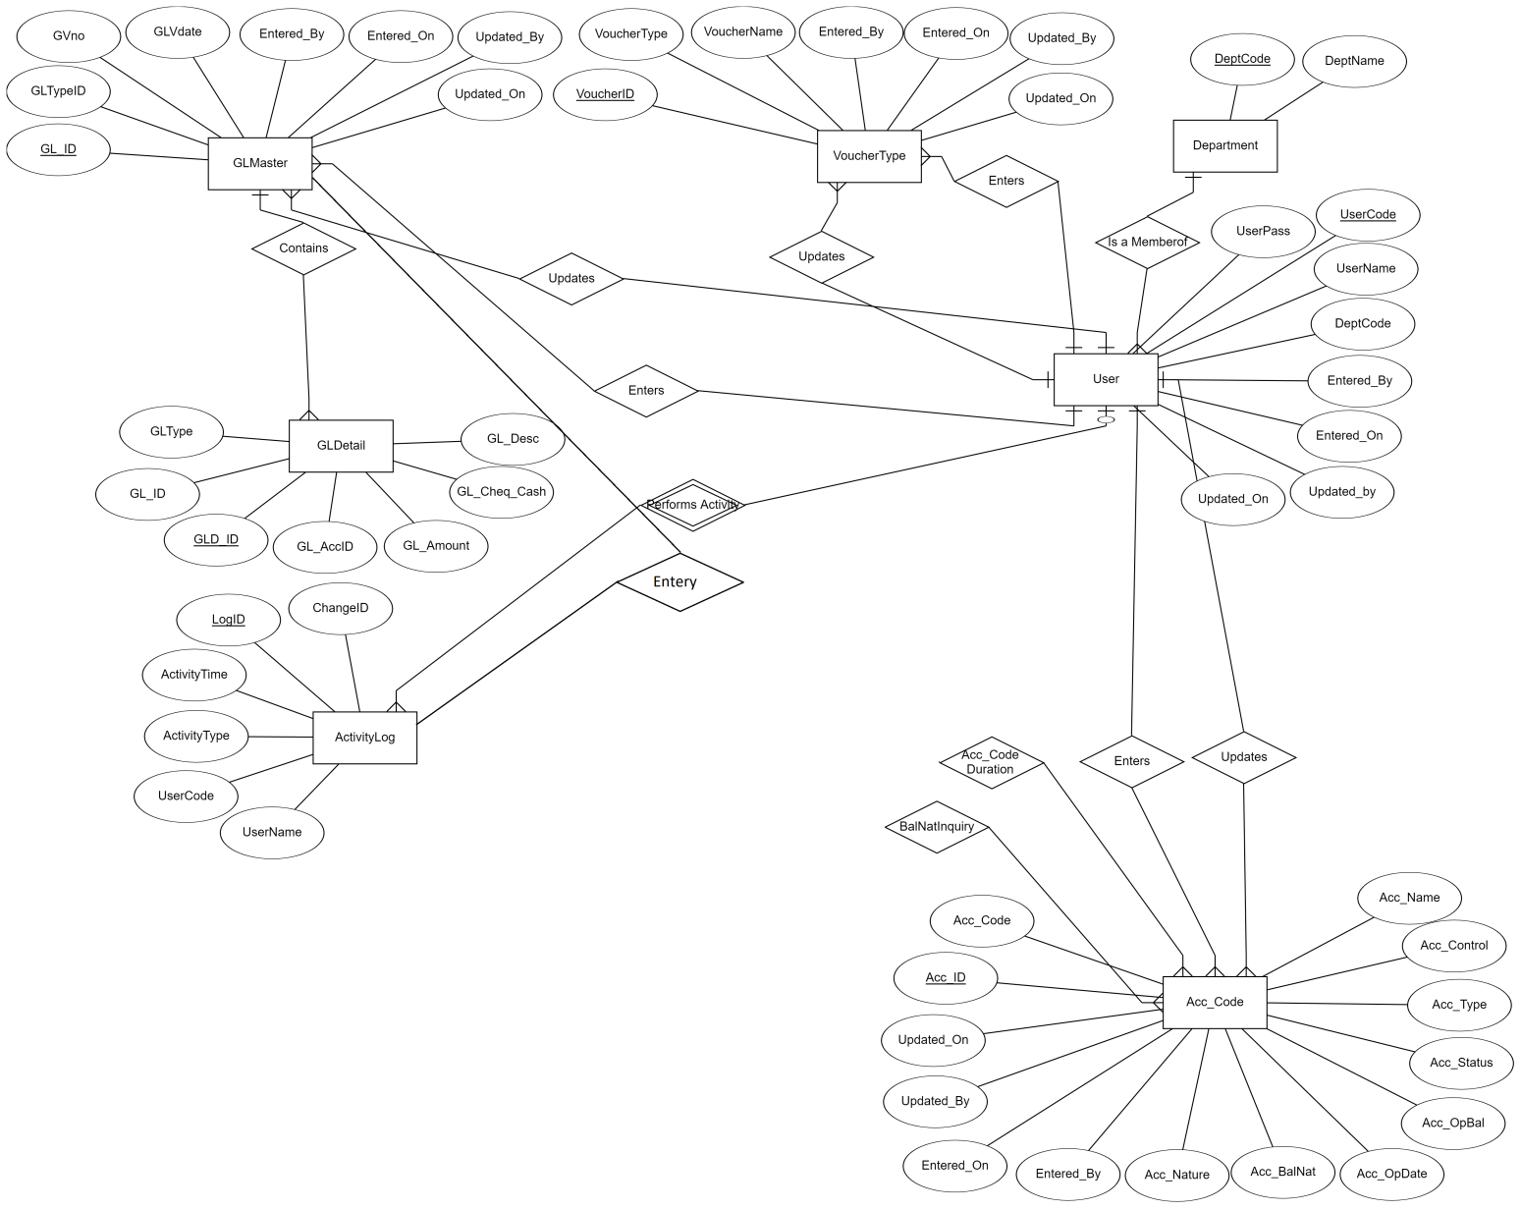

Activity Diagram:

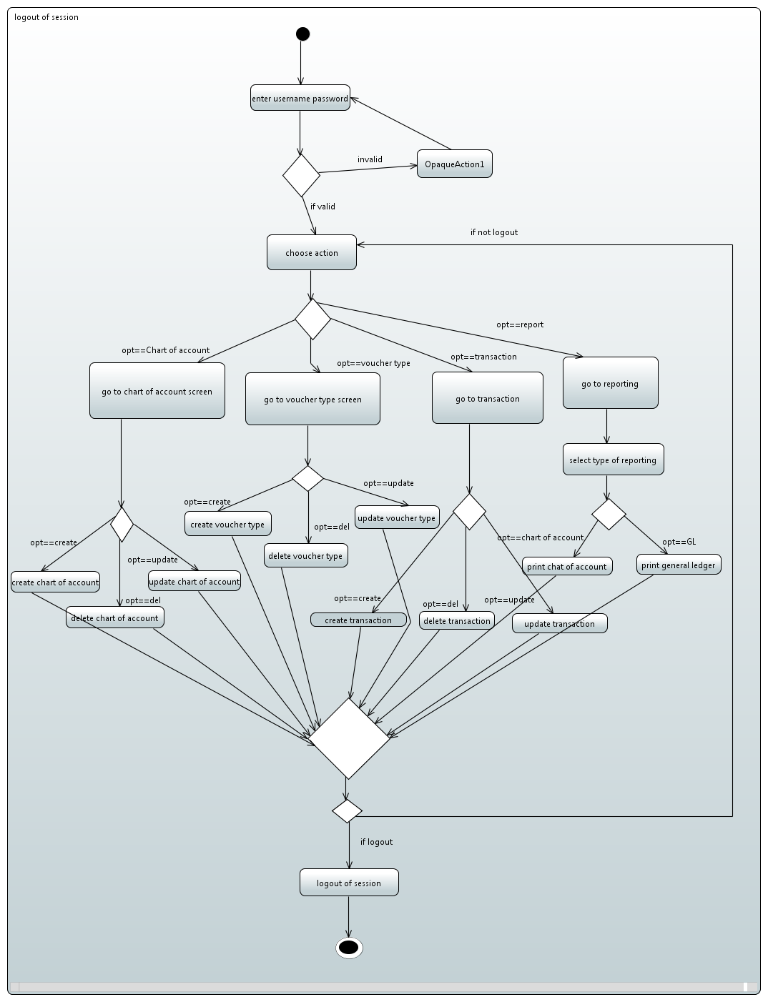

Component Diagram:
