**Digital Signals Processing   
Final Problem Set**

December 2023

**2 Questions**

**2.1 Complex Algebra 1**

Identify the set of complex numbers that satisfies the condition $z^{*}=z^{-1}$

$0i-1;$

$-\left|0+\dot{ı}\right|$

$-\frac{1}{n}\left|0+n\dot{ı}\right| , where n is any real number$

**2.2 Complex Algebra 2**

Simplify the function

$$x[n]=\frac{e^{j\frac{π}{2}}+e^{-j\frac{π}{2}}}{2}-\frac{e^{jθn}-e^{-jθn}}{j}$$

$$⟶\frac{\left[\cos\left(\frac{π}{2}\right)+j\sin\left(\frac{π}{2}\right)\right]+\left[\cos\left(\frac{π}{2}\right)-j\sin\left(\frac{π}{2}\right)\right]}{2}-\frac{\left[\cos\left(θn\right)+j\sin\left(θn\right)\right]-\left[\cos\left(θn\right)-j\sin\left(θn\right)\right]}{j}$$

$$⟶\frac{\left[0+1j\right]+\left[0-1j\right]}{2}-\left[\frac{\left[\cos\left(θn\right)+j\sin\left(θn\right)\right]-\left[\cos\left(θn\right)-j\sin\left(θn\right)\right]}{j}×\frac{-j}{-j}\right]$$

$$⟶\frac{\left[0+1j\right]+\left[0-1j\right]}{2}-\frac{2\sin{(θn)}}{1} = \frac{0}{2}-2\sin{(θn)} = -2\sin{(θn)}$$

**2.3 Periodic Signals**

Compute for the minimum period $P$ in samples of the signal $e^{j(M/N)2πn}$ for:

$$P=\frac{N}{gcd(M,N)}$$

(a) $e^{j2πn}$ M=1; N=1 $⟶P=\frac{1}{gcd(1,1)} = 1$

(b) $e^{j(1/3)2πn}$ M=1; N=3 $⟶P=\frac{3}{gcd(1,3)} =3$

(c) $e^{j(56/9)2πn}$ M=56; N=9 $⟶P=\frac{9}{gcd(56,9)} = 9$

**2.4 Signal Operations 1**

Compute the moving average of the signal $y[n]$ from an input signal

$$x[n]=δ[n]+2δ[n-1]+3δ[n-2]$$

. Whereas $y[n]$ is defined as

$$\frac{x[n]+x[n-1]}{2}$$

$$⟶\frac{\left[δ\left[n\right]+2δ\left[n-1\right]+3δ\left[n-2\right]\right]+\left[δ\left[n-1\right]+2δ\left[n-2\right]+3δ\left[n-3\right]\right]}{2}$$

$$⟶\frac{δn+3δ\left[n-1\right]+5δ\left[n-2\right]+3δ\left[n-3\right]}{2} ⟶\frac{12δn-22δ}{2} ⟶\frac{2δ\left(6n-11\right)}{2} = δ\left(6n-11\right)$$

**2.5 Signal Operations 2**

Consider the following block diagram

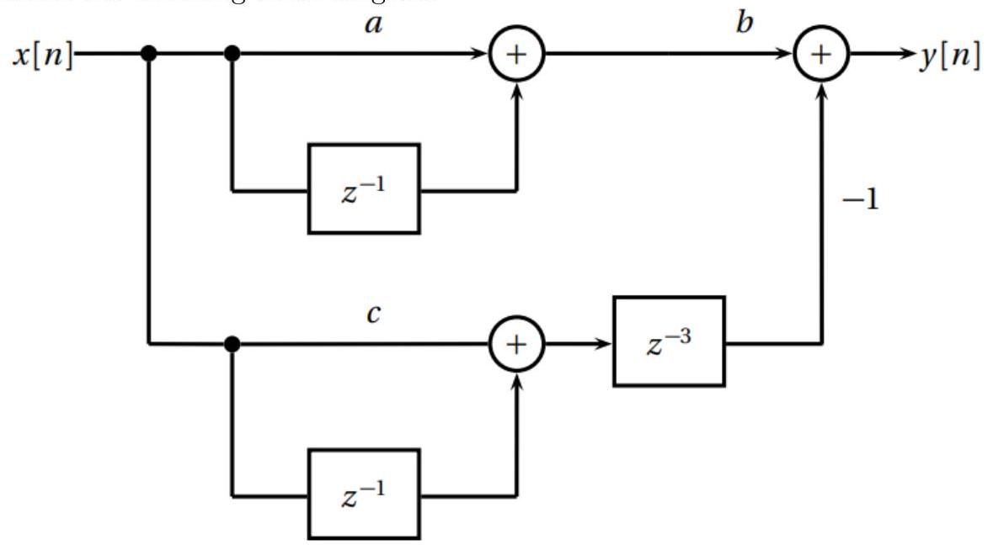

What is the equation representing the output response $y[n]$?

$$⟶a=x[n]+x[n-1]; c=\left[x[n-1]+x[n-3]\right](-1)$$

$⟶\left[x[n]+x[n-1]\right]-\left[x[n-1]+x[n-3]\right] ⟶y[n]=x[n]-x[n-3]$

**2.6 Signal Operations 3**

If we represent finite-length signals as vectors in Euclidean space, many operations on signals can be encoded as a matrix-vector multiplication. Consider for example a circular shift in $C^{3}$: a delay by one (i.e. a right shift) transforms the signal $x={\left[\begin{matrix}x_{0} & x_{1} & x_{2}\end{matrix}\right]}^{T}$ into $x^{'}={\left[\begin{matrix}x_{2} & x_{0} & x_{1}\end{matrix}\right]}^{T}$ and it can be described by the matrix

$$D=\left[\begin{matrix}0 & 0 & 1 \\ 1 & 0 & 0 \\ 0 & 1 & 0\end{matrix}\right]$$

so that $x^{'}=Dx$

Determine the matrix $F$ that implements the one-step-different operator in $C^{3}$ i.e. the operator that transforms a signal $x$ into

$$\frac{1}{\sqrt{2}}{\left[\begin{matrix}\left(x_{0}+0.5x_{1}-x_{2}\right) & \left(x_{1}-2x_{0}+x_{2}\right) & \left(x_{2}-x_{1}\right)\end{matrix}\right]}^{T}$$

$$⟶\frac{1}{\sqrt{2}}\left[\begin{matrix}(x_{0}+0.5x_{1}-x_{2}) \\ (x_{1}-2x_{0}+x_{2}) \\ (x_{2}-x_{1})\end{matrix}\right]=F\left[\begin{matrix}x_{0} \\ x_{1} \\ x_{3}\end{matrix}\right] ⟶\frac{1}{\sqrt{2}}\left[\begin{matrix}(x_{0}+0.5x_{1}-x_{2}) \\ (x_{1}-2x_{0}+x_{2}) \\ (x_{2}-x_{1})\end{matrix}\right]=\left[\begin{matrix}f_{11} & f_{12} & f_{13} \\ f_{21} & f_{22} & f_{23} \\ f_{31} & f_{32} & f_{33}\end{matrix}\right]\left[\begin{matrix}x_{0} \\ x_{1} \\ x_{2}\end{matrix}\right]$$

$$⟶ROW 1: \frac{1}{\sqrt{2}}\left(x_{0}+0.5x_{1}-x_{2}\right) = f_{11}x_{0}+f_{12}x_{1}+f_{13}x_{2}$$

$$⟶ROW 2: \frac{1}{\sqrt{2}}(x_{1}-2x_{0}+x_{2}) = f_{21}x_{0}+f_{22}x_{1}+f_{23}x_{2}$$

$$⟶ROW 3: \frac{1}{\sqrt{2}}(x_{2}-x_{1}) = f_{31}x_{0}+f_{32}x_{1}+f_{33}x_{2}$$

$$⟶ F = \frac{1}{\sqrt{2}}\left[\begin{matrix}1 & 0.5 & -1 \\ -2 & 1 & 1 \\ -1 & -1 & 0\end{matrix}\right]= \left[\begin{matrix}0.70711 & 0.35355 & -1.41421 \\ -1.41421 & 0.70711 & 0.70711 \\ -0.70711 & -0.70711 & 0\end{matrix}\right]$$

**2.7 Frequency Analysis**

Given the three signals:

(a) $x_{1}[n]=e^{j\frac{π}{2}n}$

(b) $x_{2}[n]=e^{-j\frac{π}{2}n}$

(c) $x_{3}[n]=\frac{2}{\sqrt{π}}e^{j2πn}$

Prove that $-\frac{x_{1}[n]}{x_{2}[n]}+x_{3}[n]=\frac{2\sqrt{π}+π}{π}$. Identify the fundamental frequencies of signals 2.7.a, 2.7.b, and 2.7.c. Relate the frequencies you have determined to the equality you have just solved. You may use verbal or computational reasoning.

$$⟶-\frac{e^{j\frac{π}{2}n}}{e^{-j\frac{π}{2}n}}+\frac{2}{\sqrt{π}}e^{j2πn} ⟶-\left(e^{j\frac{π}{2}n}×e^{j\frac{π}{2}n}\right)+\frac{2}{\sqrt{π}}e^{j2πn} ⟶-e^{2j\frac{π}{2}n}+\frac{2}{\sqrt{π}}e^{j2πn}$$

$$⟶-e^{jπn}+\frac{2}{\sqrt{π}}e^{j2πn} ; using e^{jπ}+1=0 ⟶-\left(-1\right)+\frac{2}{\sqrt{π}}e^{j2πn};$$

$$obtaining minimum period of e^{j2πn} ⟶1+\frac{2}{\sqrt{π}}\left(1\right) ⟶\left[\frac{2+\sqrt{π}}{\sqrt{π}}\right]\frac{\sqrt{π}}{\sqrt{π}} ⟶\frac{2\sqrt{π}+π}{π}$$