**School Management Project Requirements**

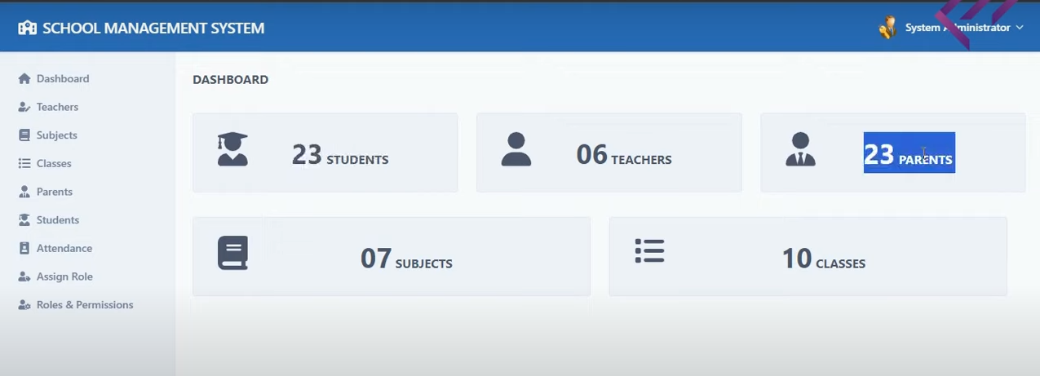

1. **Dashboard Screen Features**

Display Total of Objects

1. **Students**
2. **Teachers**
3. **Parents**
4. **Subjects**
5. **Classes**

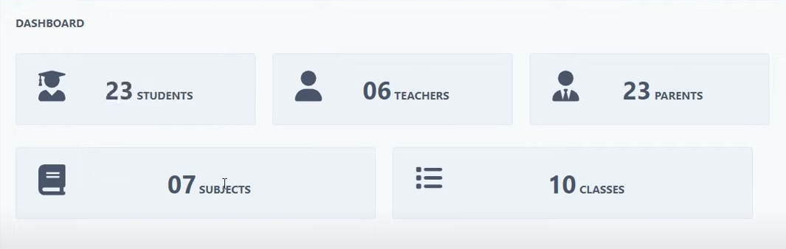

1. **Sidebar/Menu**

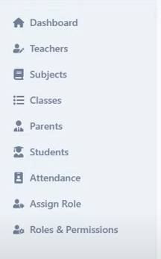

1. **Header Section**



1. **Teachers Module Screen**

* 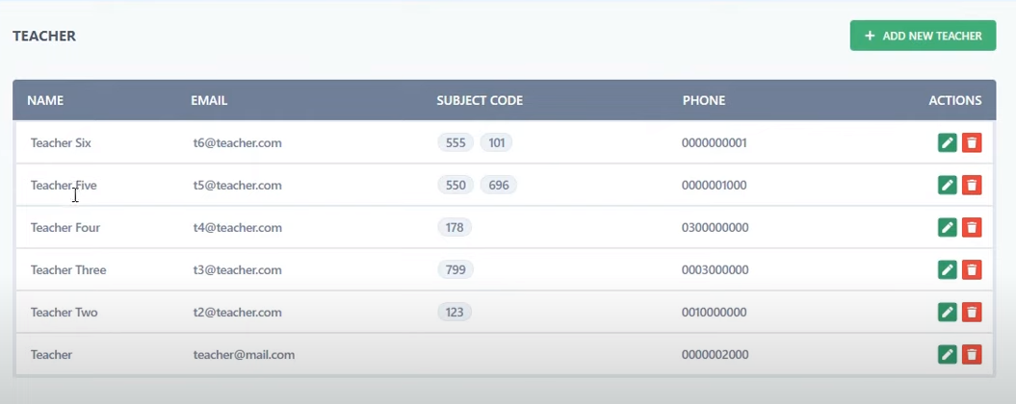**Teacher Module Listing**
* **Teacher Module Create Section**

1. Name
2. Email
3. Password
4. Phone
5. Gender -> options (Male, Female, Other)
6. Date of Birth
7. Current Address
8. Permanent Address
9. 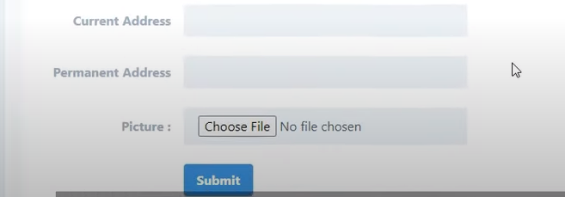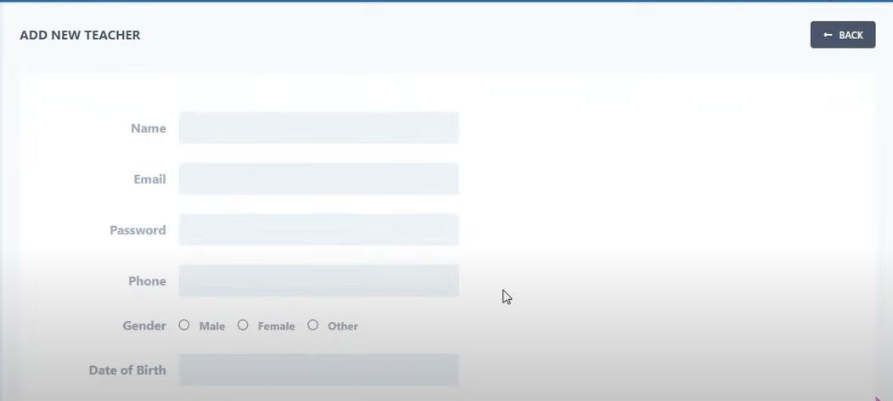Picture->format (File)

* **Teacher Module Edit Section**

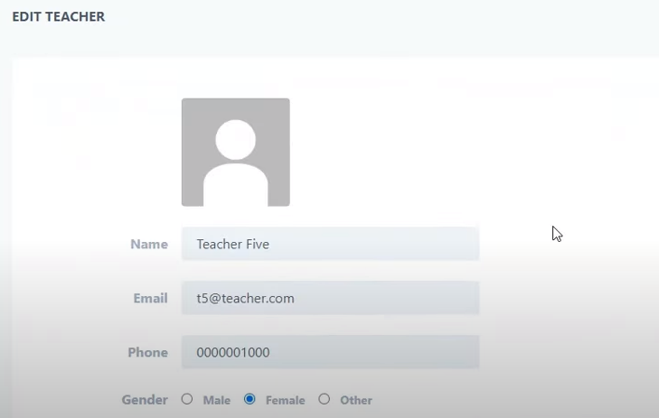

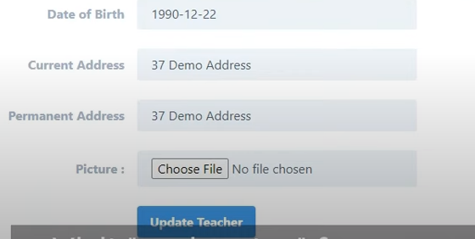

* **Teacher Module Delete Functionality (Simply Delete the Record).**

1. **Subjects Module Screen**

* **Subject Module Listing**

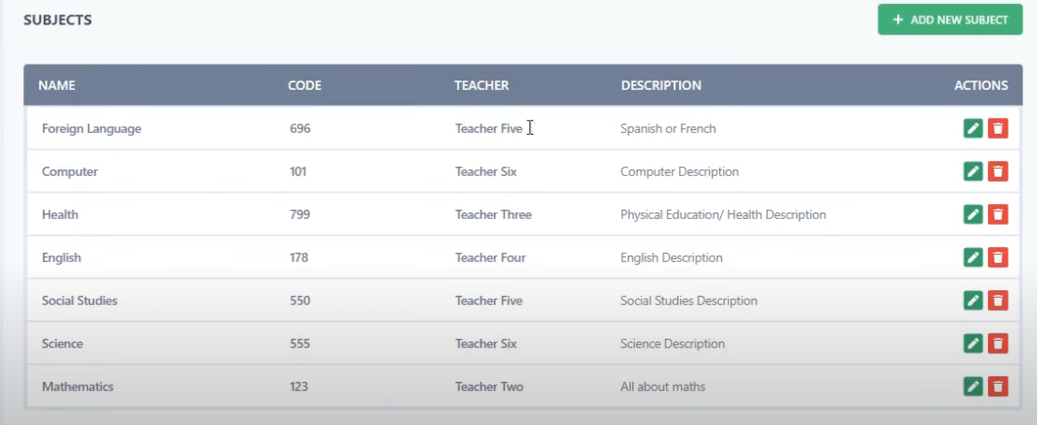

* **Subject Module Create Section**

1. Subject Name
2. Subject Code
3. Subject Description
4. 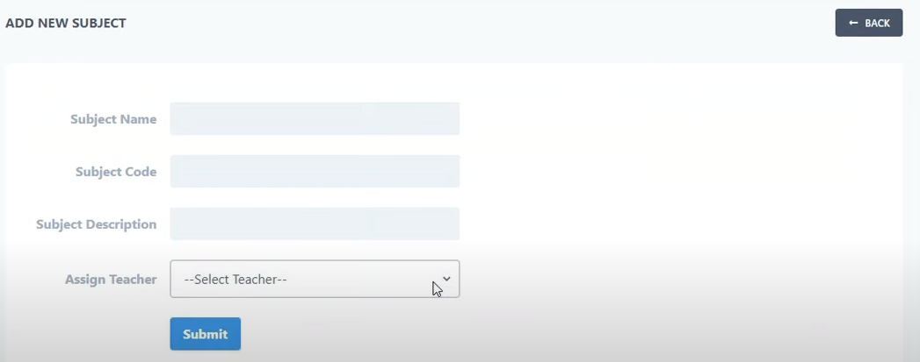Assign Teacher->dropdown (Teacher Name)

* **Subject Module Edit Section**

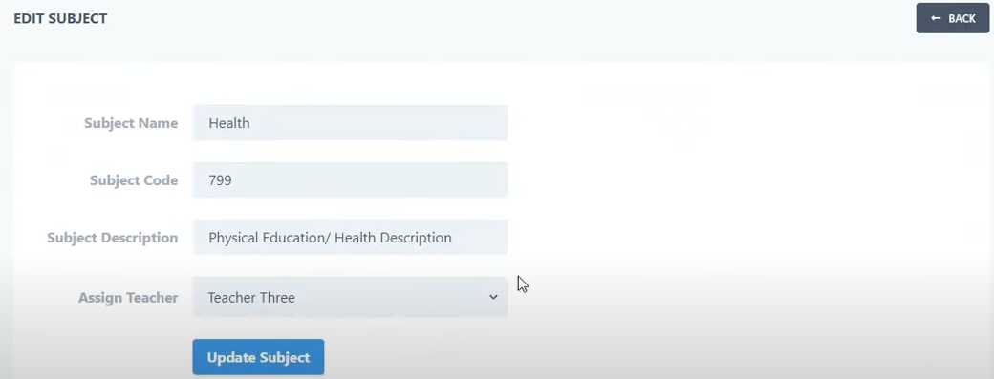

* **Subject Module Delete Functionality (Simply Delete the Record).**

1. **Classes Module Screen**

* 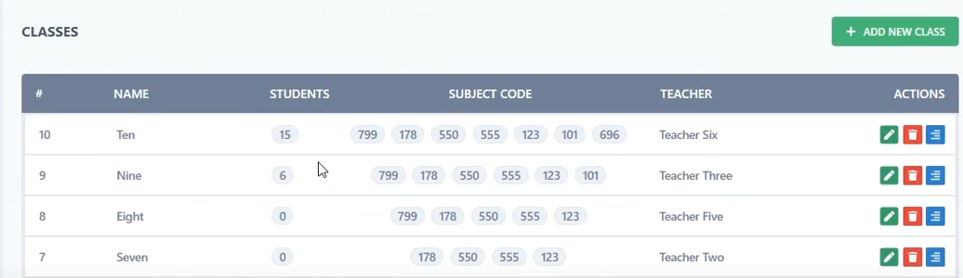**Classes Module Listing**
* **Classes Module Create Section**

1. Class Name
2. Class Numeric
3. Assign Teacher->dropdown (Teachers Name)
4. Class Description

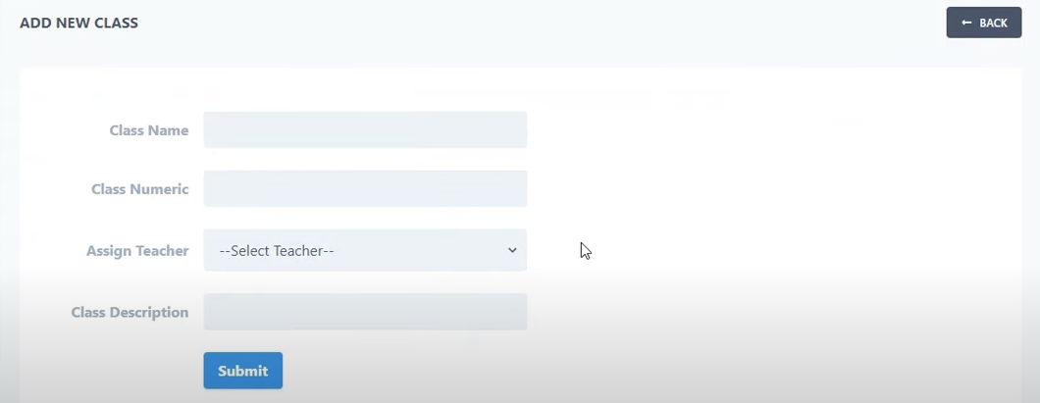

* 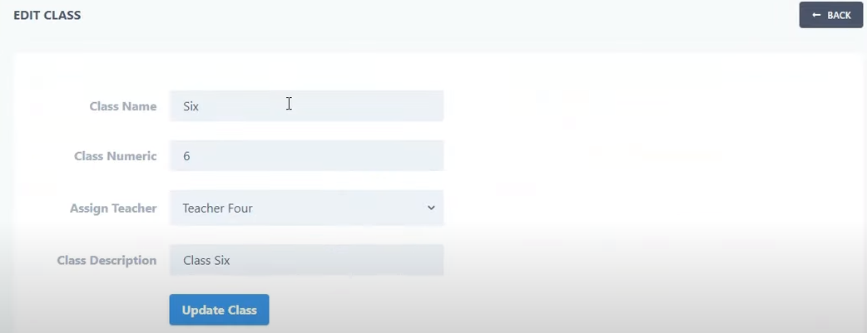**Classes Module Edit Section**
* **Classes Module Delete Function**

1. **Parent Module Screen**

* **Parent Listing Functionality ->Display Listing Fields**

1. Name
2. Email
3. Children
4. Phone
5. Action (Edit, Delete)

* **Parent Create Functionality -> Creating Fields**

1. Name
2. Email
3. Password
4. Phone
5. Gender (Male, Female, Other)
6. Current Address
7. Permanent Address
8. Upload Picture (File).

* **Parent Edit Functionality -> Updating Fields**

1. Display Picture Top of page
2. Same Fields at the time of creation

* **Delete Functionality**

1. **Student Module**

* **Student Module Listing**

1. Name
2. Email
3. Password
4. Roll Number
5. Phone
6. Gender (Male, Female, Other)
7. Date of Birth
8. Current Address
9. Permanent Address
10. Assign Class ->dropdown (List of Class Name, One, Two)
11. Student’s Parent ->dropdown (Parents Name)
12. Upload Picture (File)

* **Update Student Record**

Picture Upload at top of Page, Same Fields Update (Create)

* **View Function Same Fields Display in readonly format**
* **Delete Functionality**

1. **Attendance Module**

* 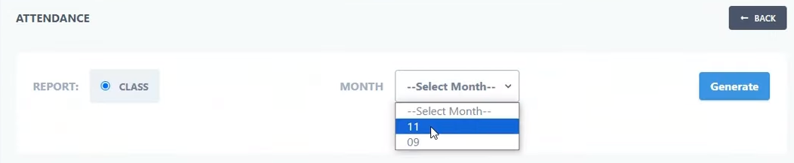**Screen : 1**

1. Radio button Report
2. Dropdown Month (List of Months)
3. Generate Button

* **Generate Report**

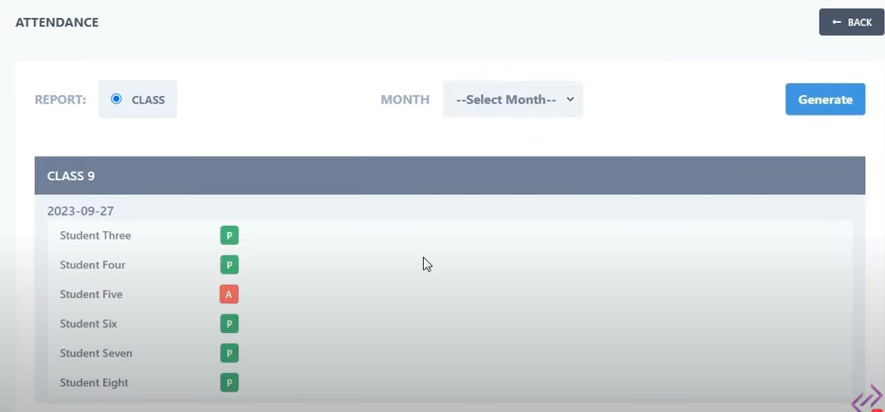

1. **Assign Role Module**

Assigning The Users as Parent or Student

* 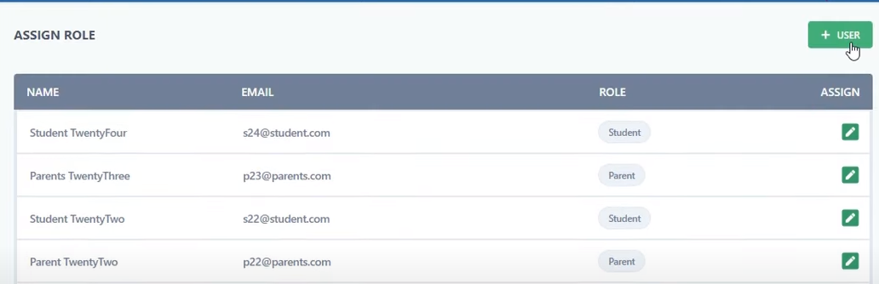**Listing**
* **Create User & Assign Role**

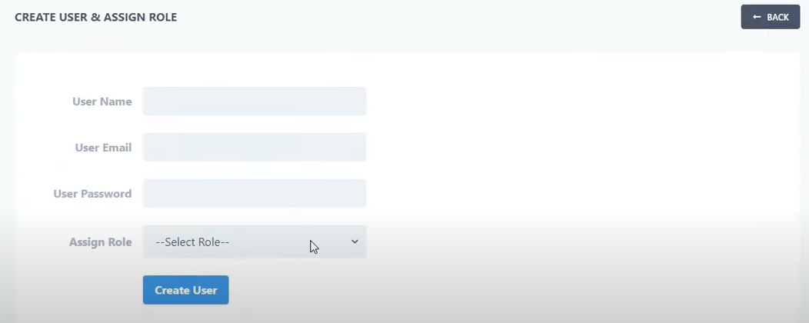

* **Edit Screen For Updating User and its Role**

1. **Roles and Permissions Screen**

* 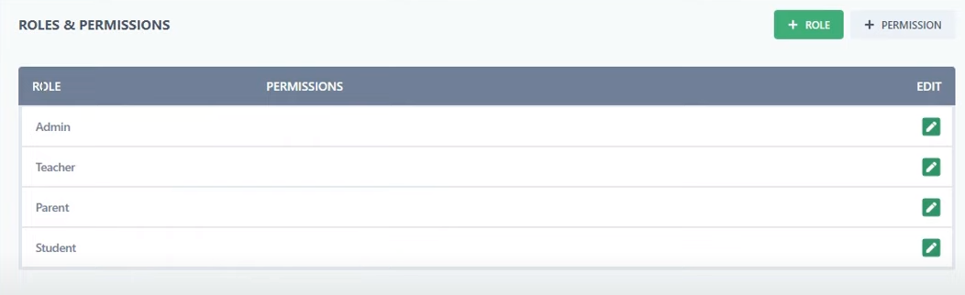**Listing**
* Different Dashboard Screen according to there roles

**Teacher Dashboard**

