Laravel 10/11 Notes

* Laravel follow MVC – model view controller
* Folders –

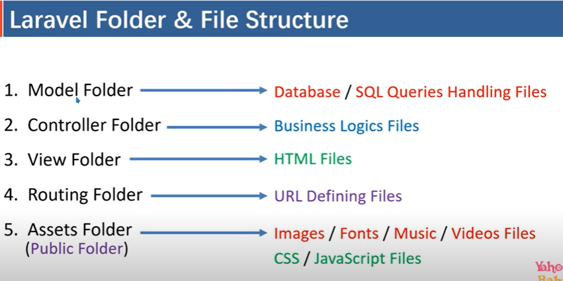

* Public (folder) -> index.php file j pahli run hnta hai jab laravel project run hnta hai
* Resources folder ma bhe css js ki files rakh sakte hai par sirf wo jo admin ko dekhane hai
* Storage folder->logs folder …. Logs bante rahte hai jo cache ka kam karte hai
* Test folder used for unit test
* Vendor->save packages, used composer for installing packages

ROUTES – Security level of laravel using routes

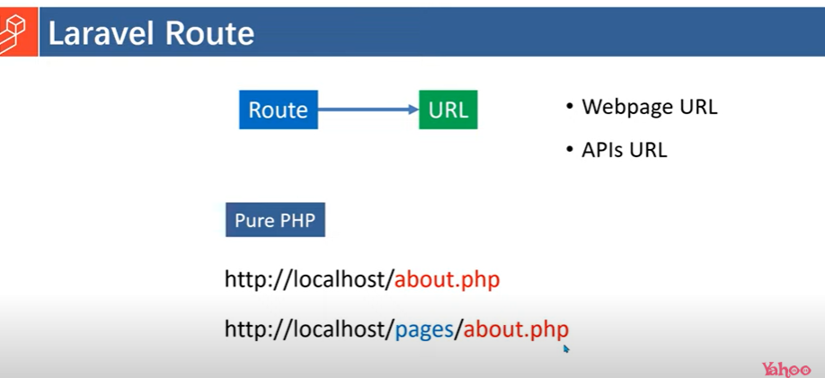

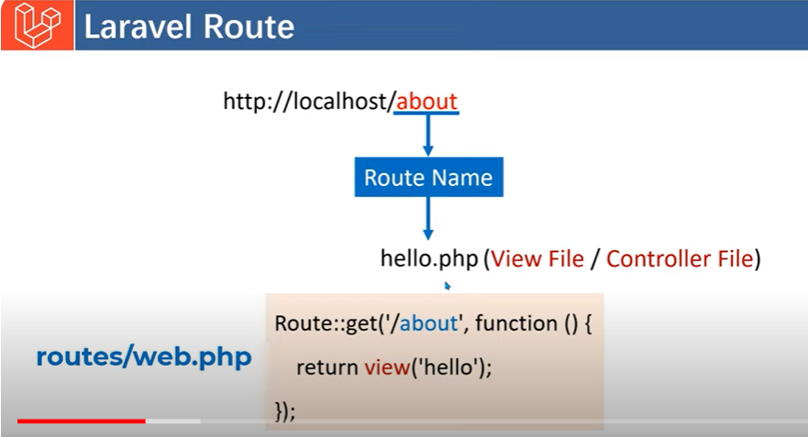

To see all php artisan commands write

----- php artisan

To see specific command related route with details

----- php artisan route –h

Available commands for the "route" namespace:

route:cache Create a route cache file for faster route registration

route:clear Remove the route cache file

route:list List all registered routes

php artisan route:list –except-vendor

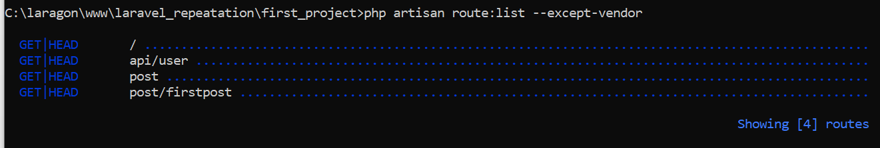

For finding specific routes

Php artisan route:list –path=post

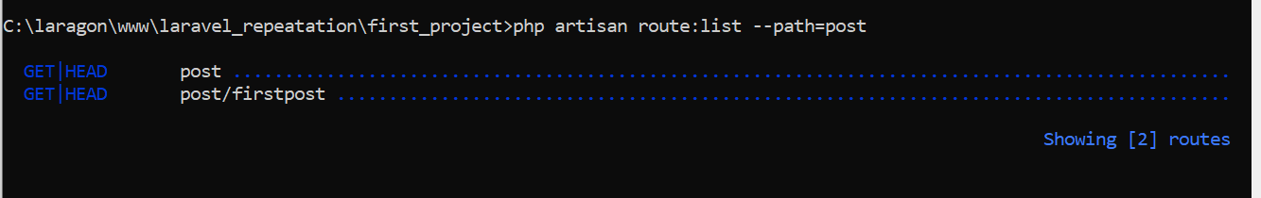

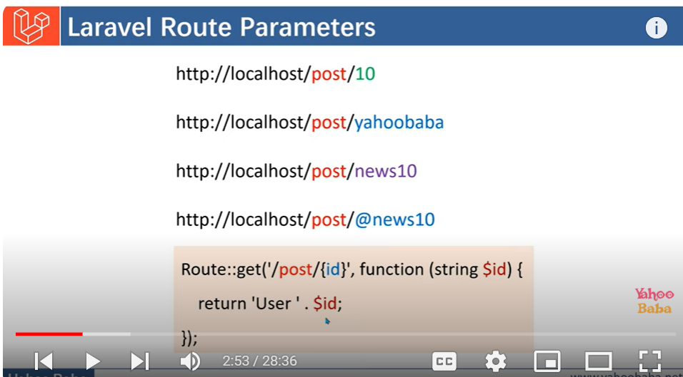

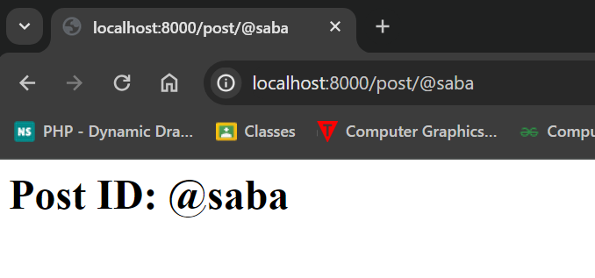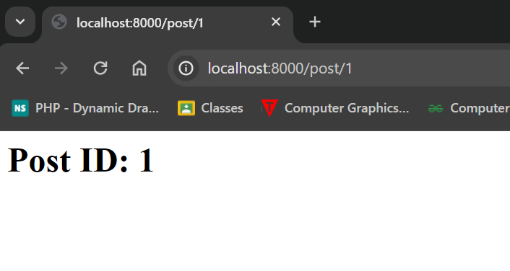

Agr parameter ki value pass nhi hnge to 404 page not found show hnga as liya hum parameter ko optional parameter banai ge..

Use of multiple parameter optional or passing multiple parameter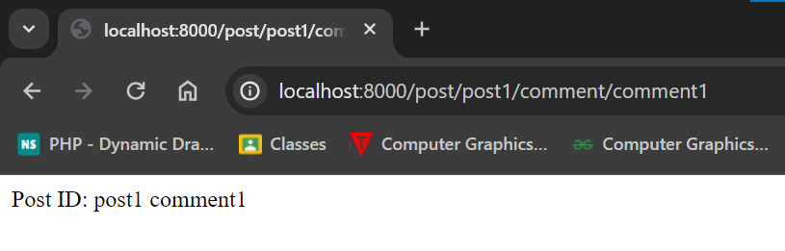

Parameter jo pass hnga uspe contraints ki kia pass kar sakte hai kia nhi

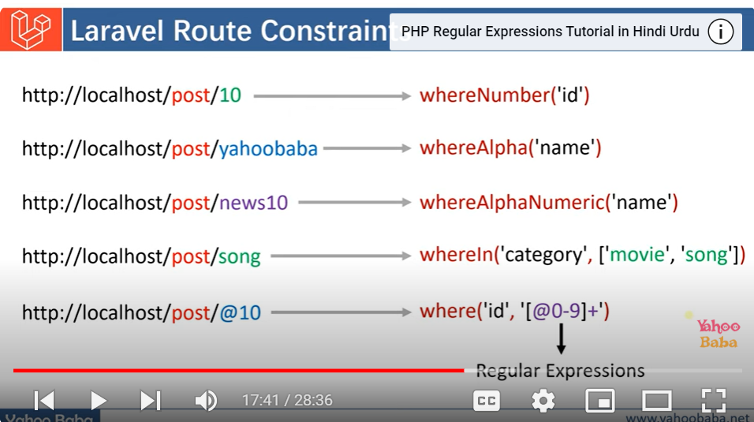

Usage

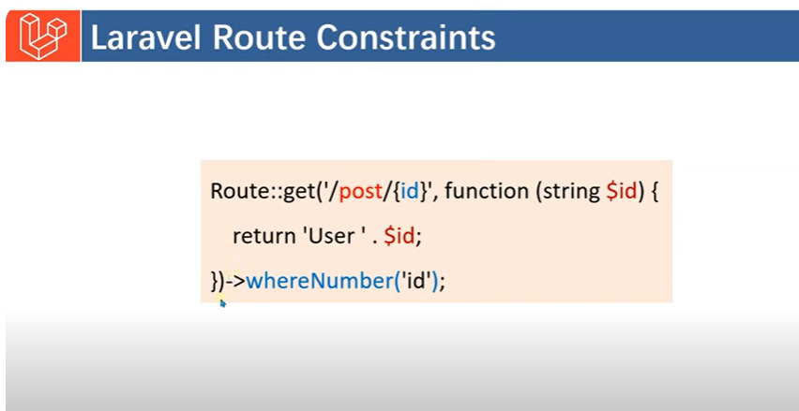

Multiple parameter with multiple constraints

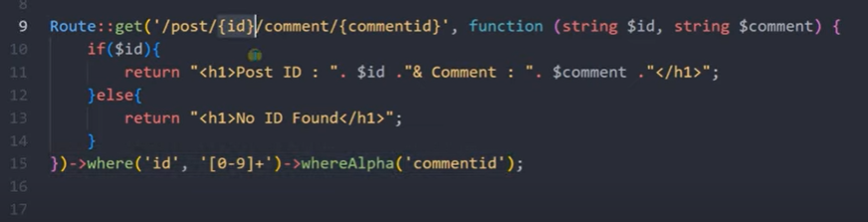

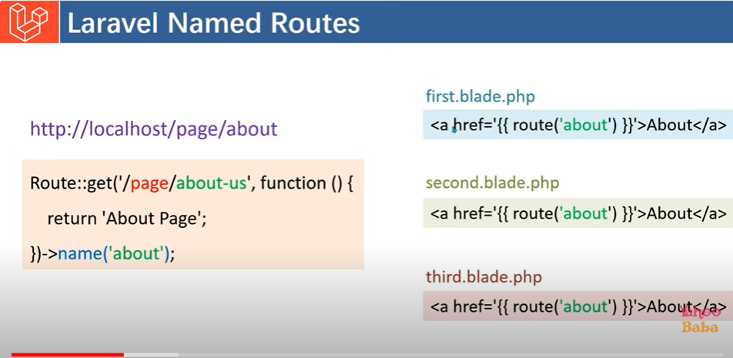

Laravel routes named problem ka solution hai, agr hum route change karte hai to wo jis file ma bhe use hn rahi hai usma jake change karta pare ga jo ki complex and bara process hai as liya route name uska solution hai routes ka name he code ma use hnga in future jab bhe routes ma koi changing hnge wo affect nhi karege

Redirection -> agr use koi url->route dale to automatically wo redirect hnjai dosre route ya tab use ma ata hai jab user bookmark karki rakhta hai website aur website url change ki hnte hai

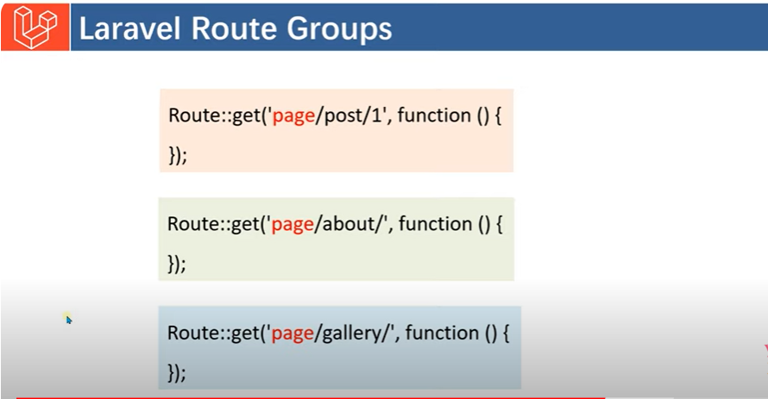

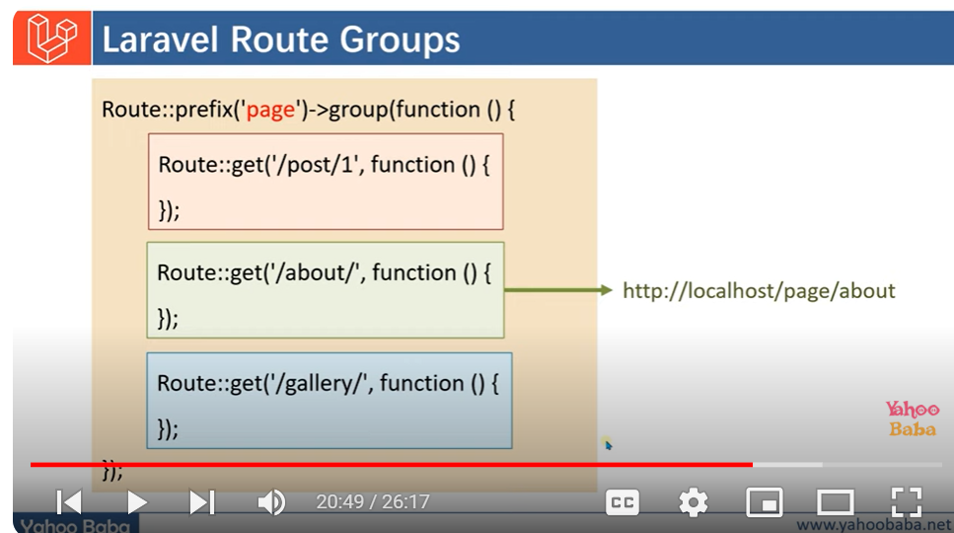

404 page not found na show hn asliya fallback function chalai ge hum