WEEK 3 PROJECT REPORT
Project Title: ServiceHub – Multi-Vendor Service Booking Platform
Internship Organization: UCT
Intern Name: Sanchita Sabale
Week: 3
Domain: Full Stack Web Development

1. Introduction
During Week 3 of my Full Stack Development Internship at UCT, I focused on developing the core backend and frontend modules of the ServiceHub platform. The goal was to design and implement a functional multi-vendor service booking system with secure authentication, role-based access control, and dynamic dashboard functionality.

2. Objectives of Week 3
• Design relational database schema
• Implement role-based authentication system
• Develop Customer, Merchant, and Admin modules
• Implement service management system
• Create booking and appointment workflow
• Integrate Razorpay payment gateway

3. Work Completed

3.1 Database Design & Implementation
Designed and implemented relational tables including users, merchants, services, orders, appointments, and reviews. Established proper foreign key relationships to maintain data integrity and consistency.
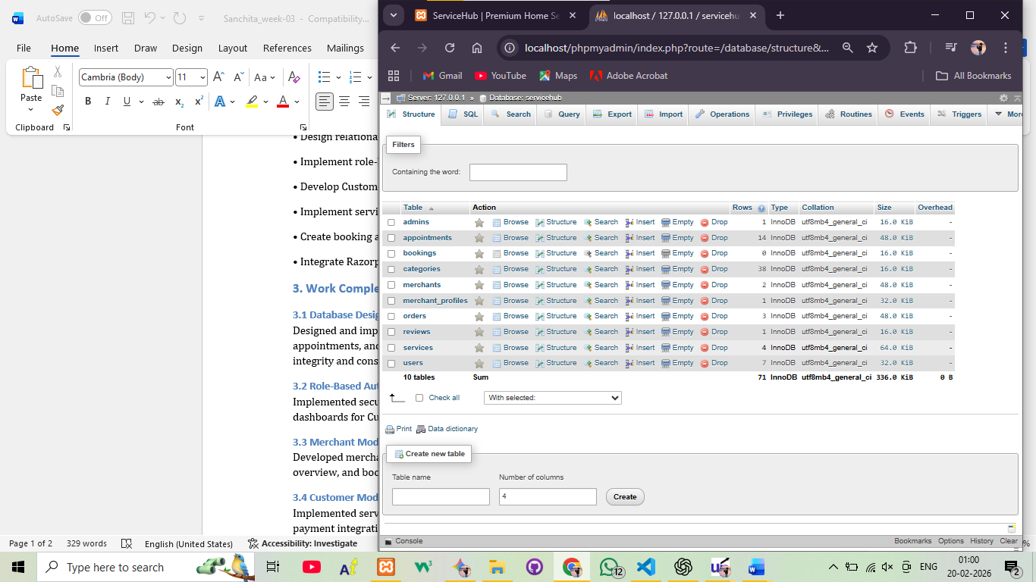

3.2 Role-Based Authentication System
Implemented secure login and session management using PHP sessions. Created separate dashboards for Customer, Merchant, and Admin roles.
Merchant dashboard----
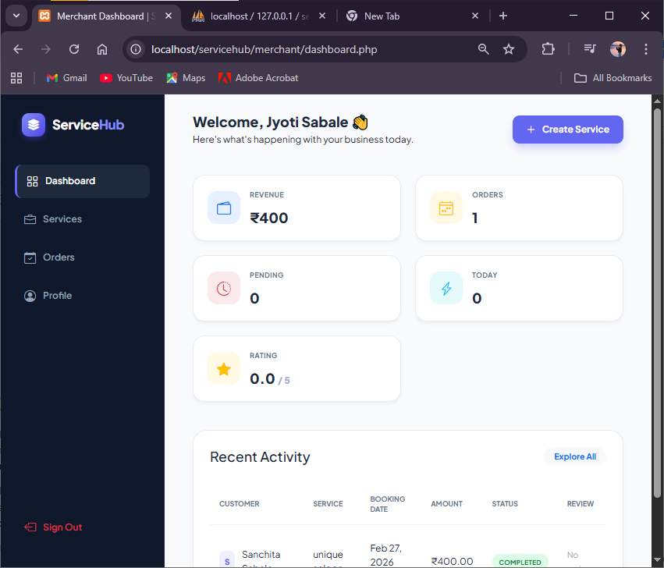

Customer dashboard---
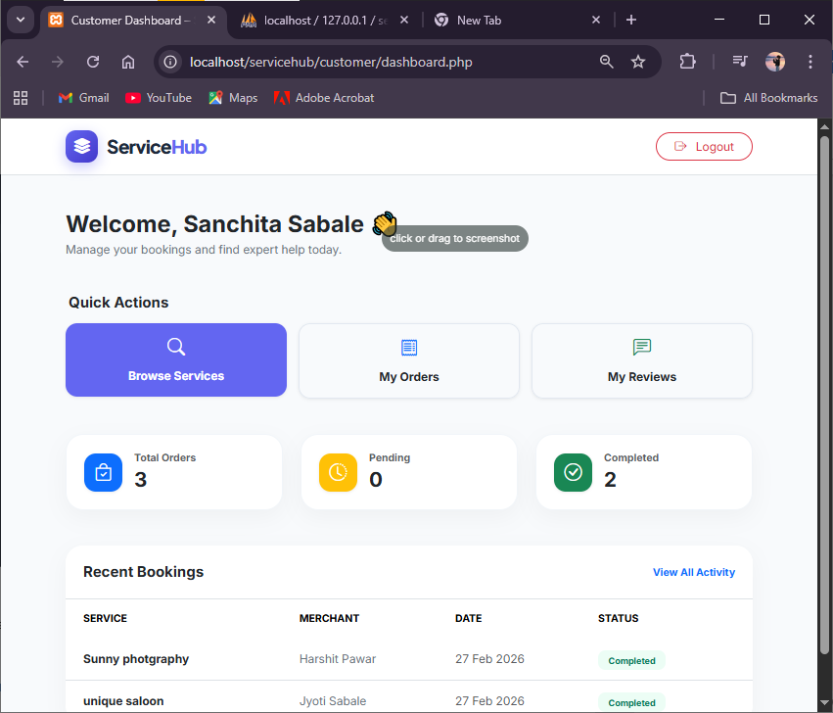

Admin login-
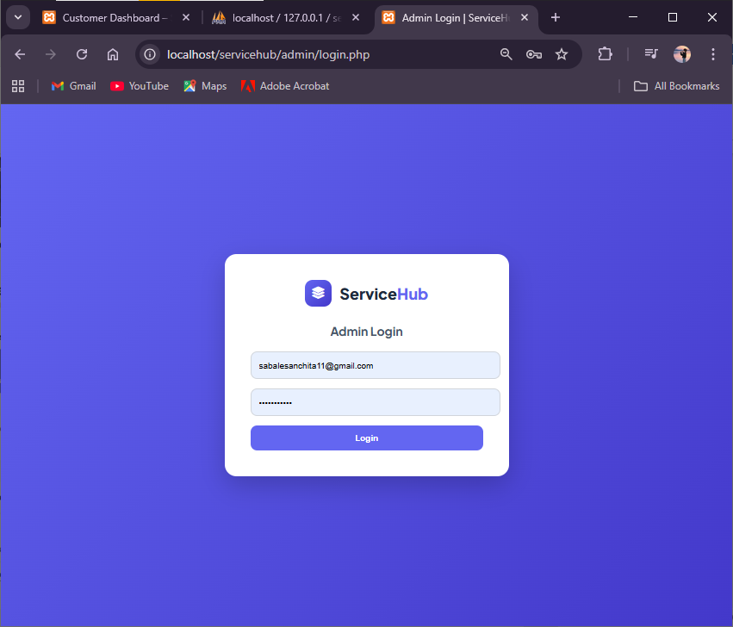

Admin dashboard
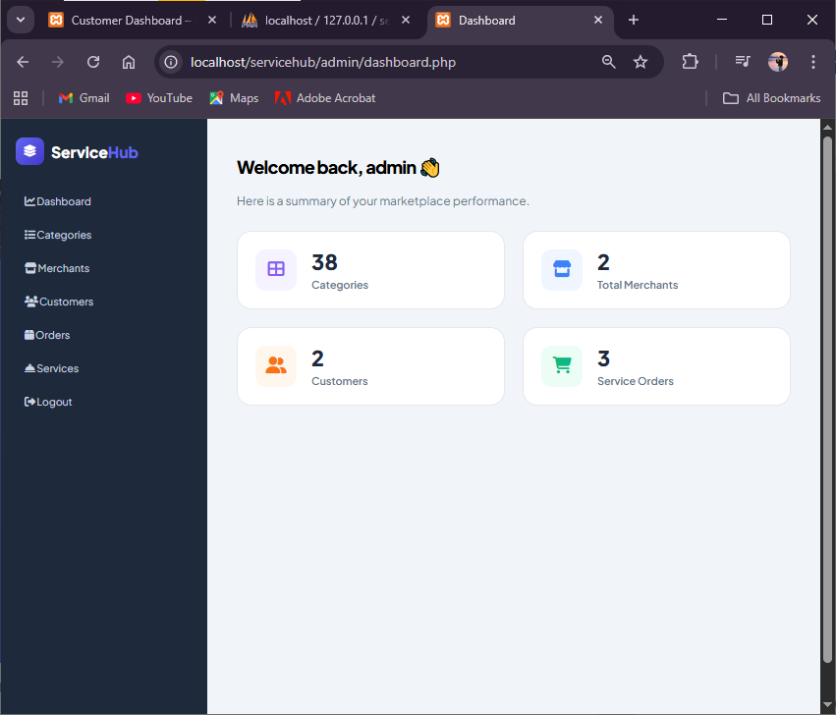

3.3 Merchant Module Development
Developed merchant dashboard including service management, order tracking, earnings overview, and booking status updates.

3.4 Customer Module Development
Implemented service browsing, booking system, appointment scheduling, and online payment integration for customers.

service browsing-
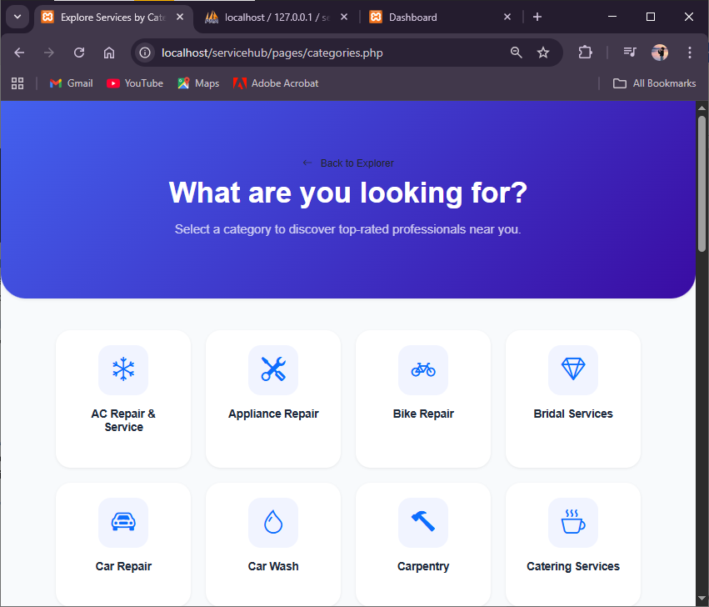
booking system and appointment scheduling--
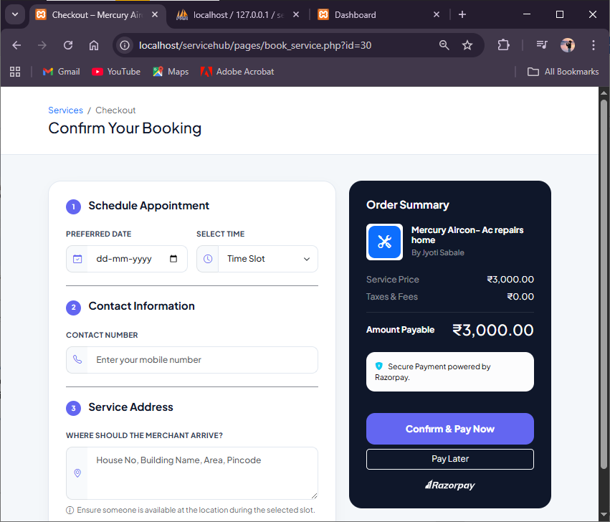

online payment integration-
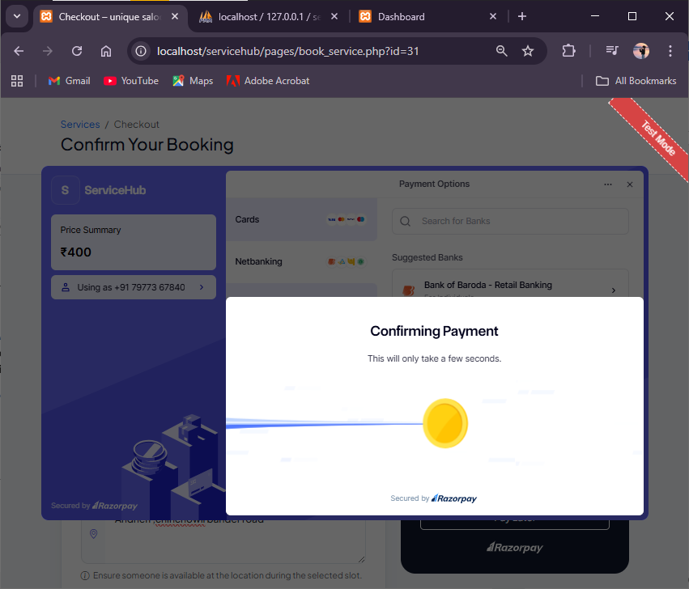

3.5 Payment Gateway Integration
Integrated Razorpay payment gateway to enable secure online transactions, including payment verification and transaction tracking.
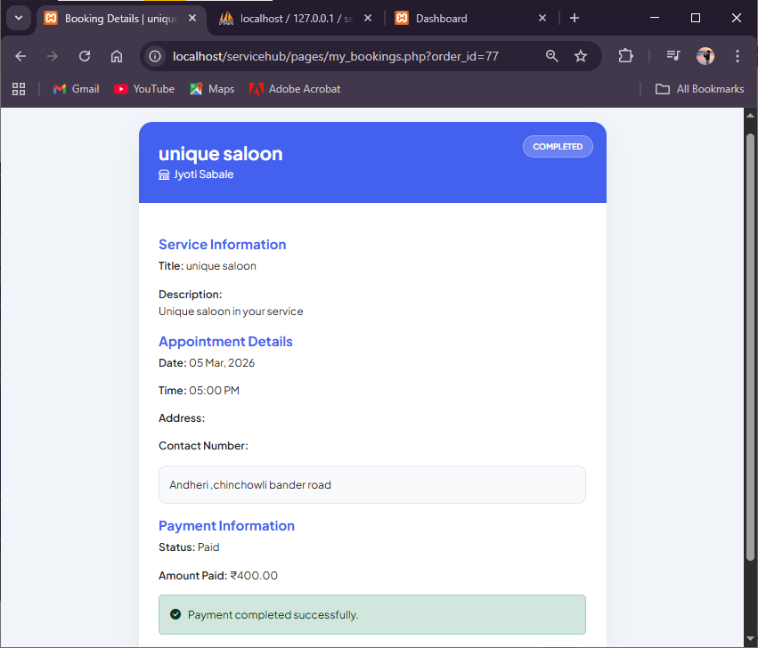

3.6 Admin Panel Development
Developed admin panel to manage users, merchants, and platform orders with centralized control.
Manage users ----------
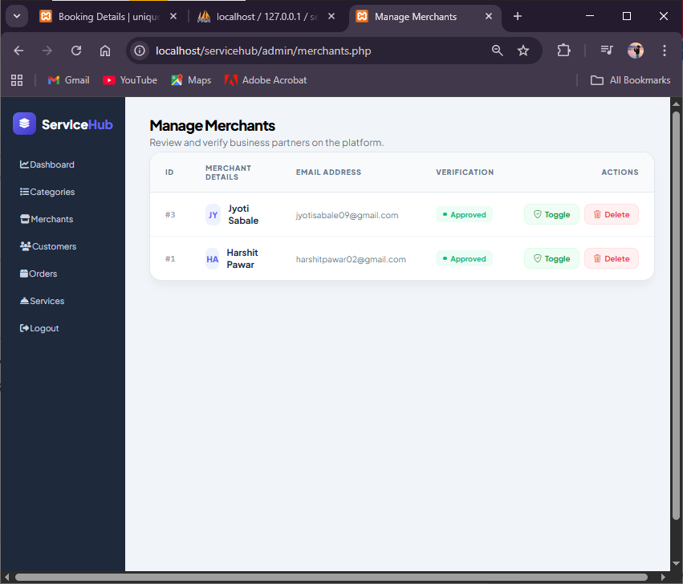

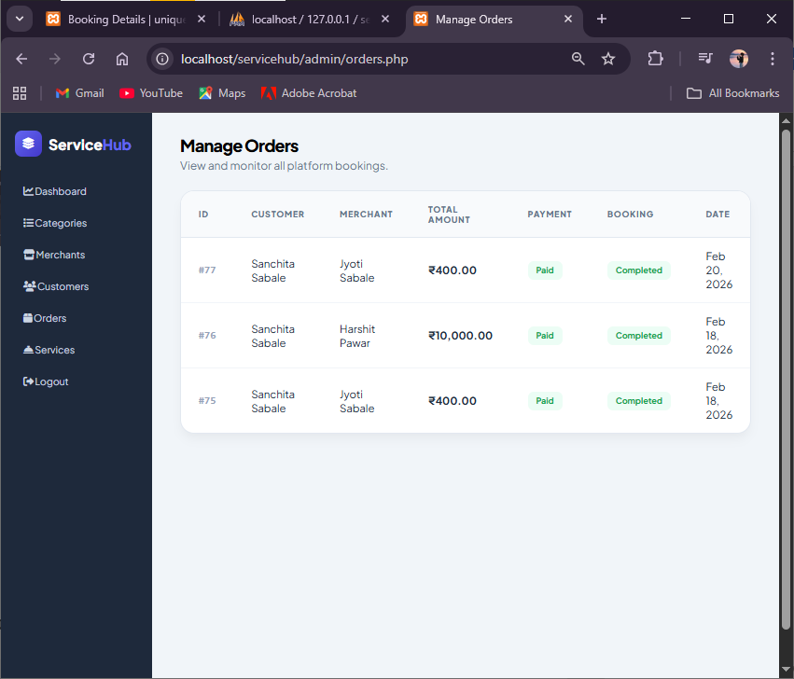 4. Technologies Used
Frontend: HTML5, CSS3, Bootstrap 5, JavaScript
Backend: PHP (Core PHP)
Database: MySQL
Payment Integration: Razorpay
Environment: XAMPP
Version Control: Git & GitHub

5. Challenges Faced
• Handling relational data consistency
• Managing session-based role authentication
• Debugging payment verification logic
• Structuring optimized SQL JOIN queries

6. Key Learnings
• Practical understanding of relational database design
• Role-based access control implementation
• Secure payment gateway integration
• Backend debugging and optimization

8. Conclusion
By the end of Week 3, the core functionality of the ServiceHub platform was successfully implemented. The system supported multi-role login, service management, booking flow, and secure payment integration.

