**Save time and money with automatic billing**

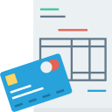

PDF Invoices

Send professional looking PDF invoices and receipts to customers



Recurring Billing

Invoice generation and payment capture for subscription-based services



Payment Reminders

Payment reminders and overdue notices for failed payments



Email Notifications

Automated email confirmations for all invoice and payment actions

# **Automate Services**

Automated Provisioning & Management  
Fully automated service account setup and management from setup to termination, automates the entire customer life cycle for services

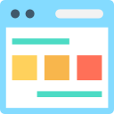

Service Portal

Allow admin to manage all aspects of their services of all the clients



##### Account Provisioning

Create, suspend, modify and terminate accounts across your services

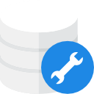

Upgrades/Downgrades

Uupgrade service accounts on-demand



Usage Statistics

Disk and Bandwidth Usage imported daily with support for usage-based billing



**Automate Email Marketing**

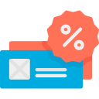

Coupons & Promotions

Create promo codes with criteria and fixed or percentage-based discounts



Email Notifications

Automated email marketing