Assignment 1 - Use Any Public Dataset and Perform Basic Operations on Pandas DataFrame

import pandas as pd

# Load public dataset
url = "https://raw.githubusercontent.com/mwaskom/seaborn-data/master/iris.csv"
df = pd.read_csv(url)

print("First 3 rows of dataset")
print(df.head(3))

print("\nDataset shape")
print(df.shape)

print("\nColumn names")
print(df.columns)

print("\nDataset information")
print(df.info())

print("\nChecking missing values")
print(df.isnull().sum())

print("\nStatistical summary")
print(df.describe())

print("\nFilter rows where species is setosa")
print(df[df['species'] == 'setosa'].head(3))

print("\nAverage sepal length")
print(df['sepal_length'].mean())

print("\nSorting by petal length")
print(df.sort_values(by='petal_length', ascending=False).head(3))

print("\nGrouping by species")
print(df.groupby('species').mean())

OUTPUT : -
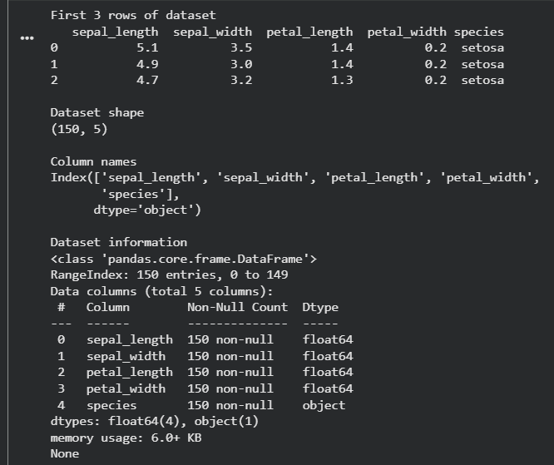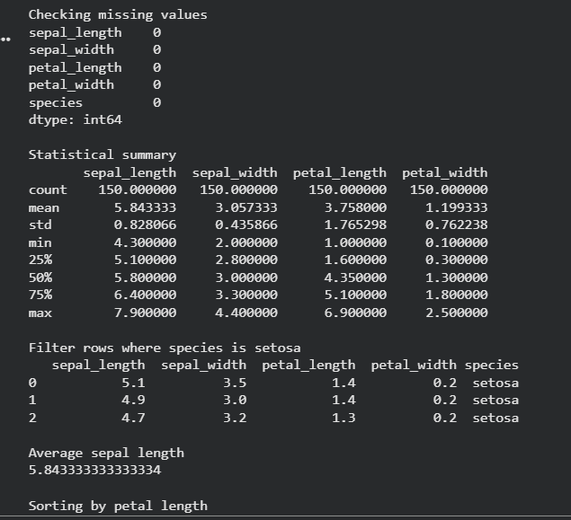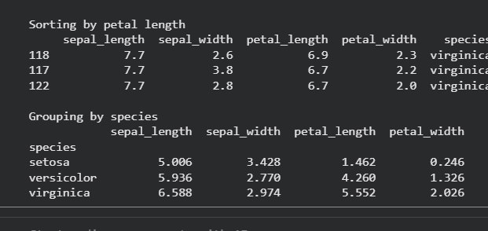
Assignment 2 - Data Visualization Using Python and Pandas

import pandas as pd
import matplotlib.pyplot as plt

# Load public dataset
url = "https://raw.githubusercontent.com/mwaskom/seaborn-data/master/iris.csv"
df = pd.read_csv(url)

print("First 3 rows of dataset")
print(df.head(3))

# Line plot
print("\nDisplaying Line Plot")
plt.figure(figsize=(6,4))
plt.plot(df['sepal_length'].head(20))
plt.title("Sepal Length Line Plot")
plt.xlabel("Index")
plt.ylabel("Sepal Length")
plt.show()

# Bar plot
print("\nDisplaying Bar Plot")
species_count = df['species'].value_counts()

plt.figure(figsize=(6,4))
plt.bar(species_count.index, species_count.values)
plt.title("Species Count")
plt.xlabel("Species")
plt.ylabel("Count")
plt.show()

# Scatter plot
print("\nDisplaying Scatter Plot")
plt.figure(figsize=(6,4))
plt.scatter(df['sepal_length'], df['petal_length'])
plt.title("Sepal Length vs Petal Length")
plt.xlabel("Sepal Length")
plt.ylabel("Petal Length")
plt.show()

# Histogram
print("\nDisplaying Histogram")
plt.figure(figsize=(6,4))
plt.hist(df['sepal_width'])
plt.title("Sepal Width Distribution")
plt.xlabel("Sepal Width")
plt.ylabel("Frequency")
plt.show()

OUTPUT :-
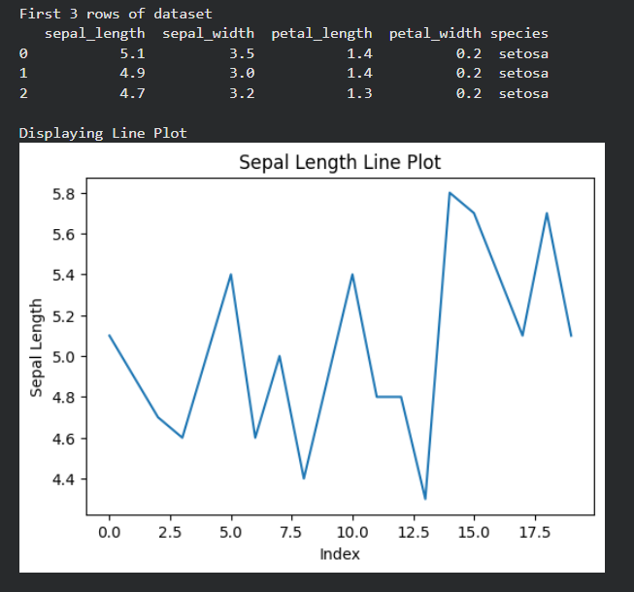
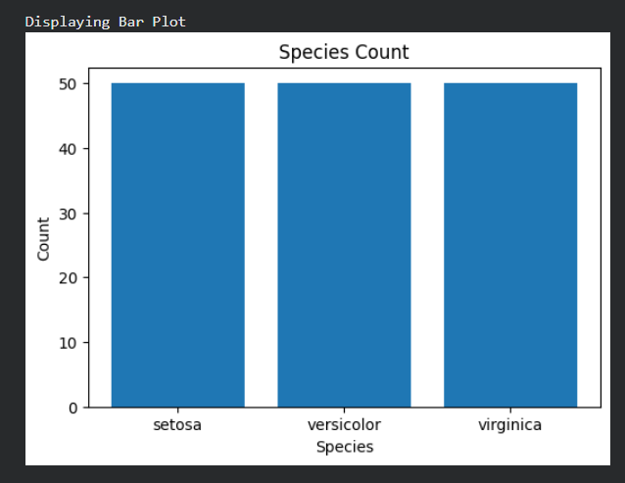
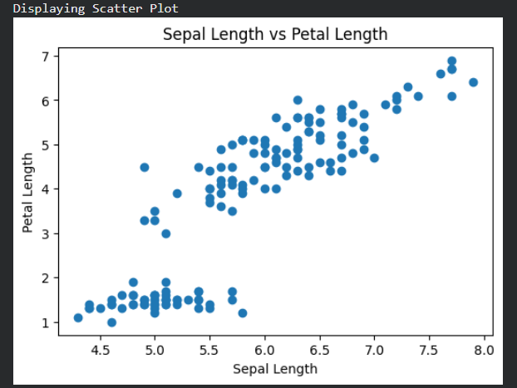
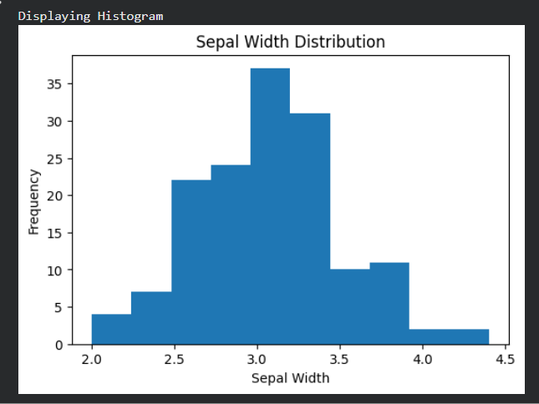

Assignment 3 - Generate Random Numbers and Perform Statistical Analysis with Data Visualization Using Python

import random
import numpy as np
import matplotlib.pyplot as plt
from statistics import mean, median, mode

# Generate 100 random numbers between 1 and 100
numbers = [random.randint(1, 100) for i in range(100)]

print("First 10 random numbers")
print(numbers[:10])

# Calculate mean
mean_value = mean(numbers)
print("\nMean of numbers")
print(mean_value)

# Calculate median
median_value = median(numbers)
print("\nMedian of numbers")
print(median_value)

# Calculate mode
mode_value = mode(numbers)
print("\nMode of numbers")
print(mode_value)

# Calculate IQR
q1 = np.percentile(numbers, 25)
q3 = np.percentile(numbers, 75)
iqr = q3 - q1

print("\nInter Quartile Range (IQR)")
print(iqr)

# Line Plot
print("\nDisplaying Line Plot")
plt.figure(figsize=(6,4))
plt.plot(numbers, color='blue')
plt.title("Line Plot of Random Numbers")
plt.xlabel("Index")
plt.ylabel("Value")
plt.show()

# Histogram
print("\nDisplaying Histogram")
plt.figure(figsize=(6,4))
plt.hist(numbers, color='green')
plt.title("Histogram of Random Numbers")
plt.xlabel("Value")
plt.ylabel("Frequency")
plt.show()

# Box Plot
print("\nDisplaying Box Plot")
plt.figure(figsize=(6,4))
plt.boxplot(numbers)
plt.title("Box Plot of Random Numbers")
plt.show()

# Scatter Plot
print("\nDisplaying Scatter Plot")
plt.figure(figsize=(6,4))
plt.scatter(range(100), numbers, color='red')
plt.title("Scatter Plot of Random Numbers")
plt.xlabel("Index")
plt.ylabel("Value")
plt.show()

OUTPUT:-
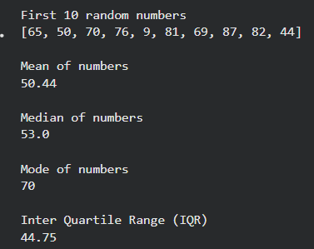
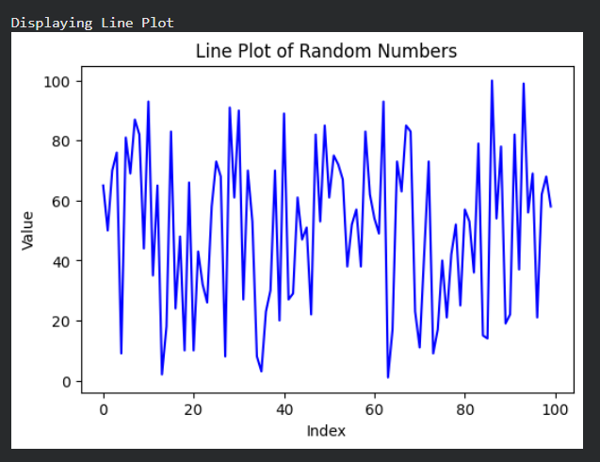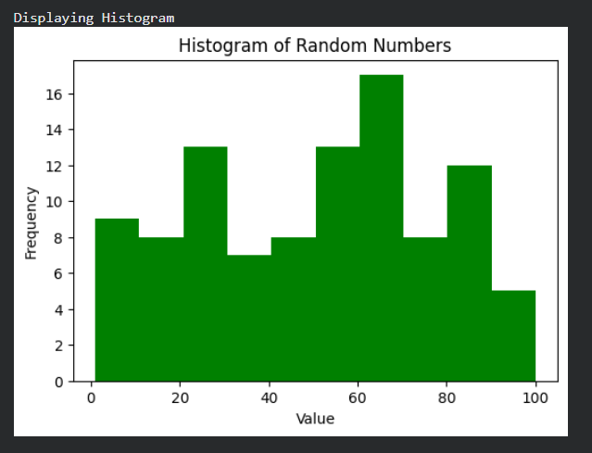
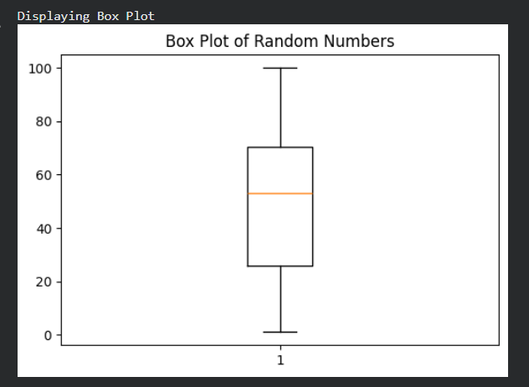
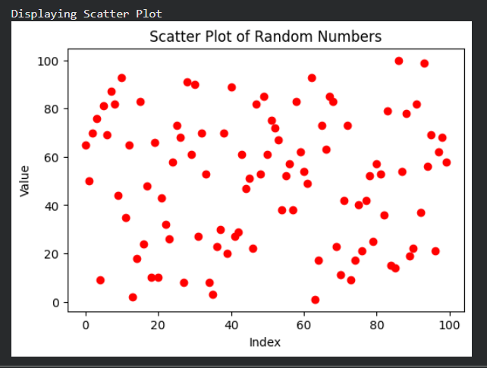

Assignment 4 - Pearson’s Correlation Coefficient and Scatter Matrix Plot Using Iris Dataset

import pandas as pd
import matplotlib.pyplot as plt
from pandas.plotting import scatter_matrix
from sklearn.datasets import load_iris

# Load Iris dataset
iris = load_iris()

# Create DataFrame
df = pd.DataFrame(iris.data, columns=iris.feature_names)

# Add class column
df['class'] = iris.target

print("First 3 rows of dataset")
print(df.head(3))

# Select three feature pairs
print("\nPearson Correlation Coefficient for Feature Pairs")

corr1 = df['sepal length (cm)'].corr(df['sepal width (cm)'])
print("\nSepal Length vs Sepal Width")
print(corr1)

corr2 = df['petal length (cm)'].corr(df['petal width (cm)'])
print("\nPetal Length vs Petal Width")
print(corr2)

corr3 = df['sepal length (cm)'].corr(df['petal length (cm)'])
print("\nSepal Length vs Petal Length")
print(corr3)

# Compute PCC between features and class
print("\nPearson Correlation Coefficient between Features and Class")

for column in df.columns[:-1]:
value = df[column].corr(df['class'])
print(column, ":", value)

# Scatter Matrix Plot for each class separately

# Setosa
print("\nDisplaying Scatter Matrix for Setosa")
setosa = df[df['class'] == 0]

scatter_matrix(setosa.iloc[:, :-1], figsize=(8,8), color='red')
plt.suptitle("Scatter Matrix - Setosa")
plt.show()

# Versicolor
print("\nDisplaying Scatter Matrix for Versicolor")
versicolor = df[df['class'] == 1]

scatter_matrix(versicolor.iloc[:, :-1], figsize=(8,8), color='green')
plt.suptitle("Scatter Matrix - Versicolor")
plt.show()

# Virginica
print("\nDisplaying Scatter Matrix for Virginica")
virginica = df[df['class'] == 2]

scatter_matrix(virginica.iloc[:, :-1], figsize=(8,8), color='blue')
plt.suptitle("Scatter Matrix - Virginica")
plt.show()

OUTPUT:-
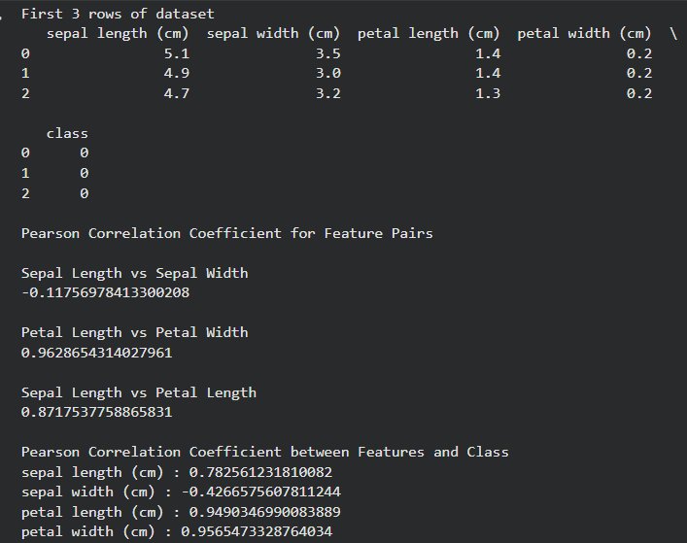
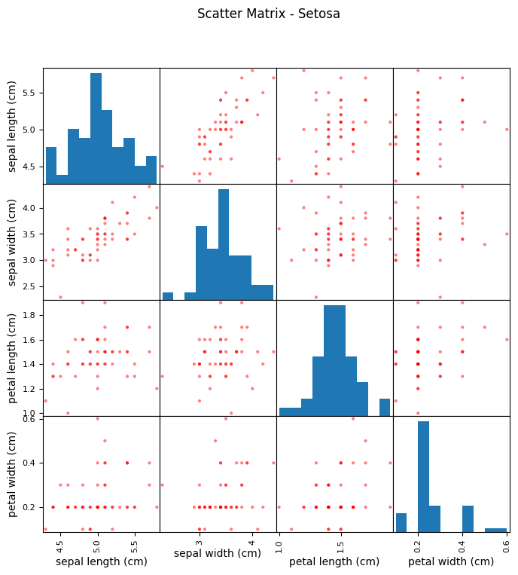
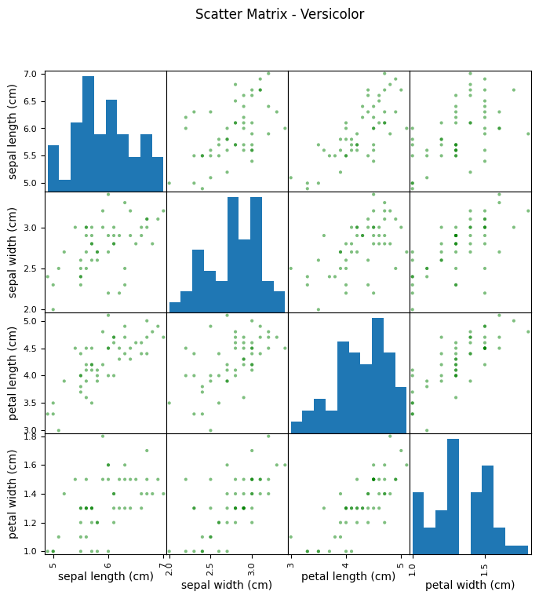
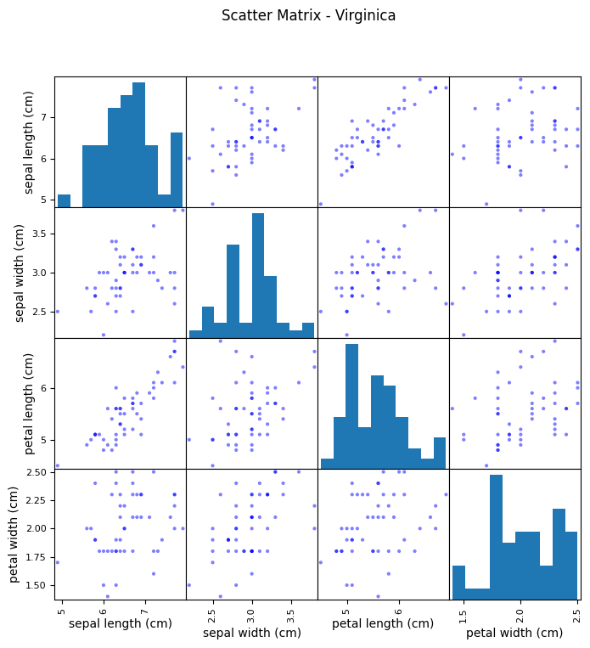
Assignment 5 - Spearman Correlation Coefficient Using Iris Dataset

import pandas as pd
from sklearn.datasets import load_iris

# Load Iris dataset
iris = load_iris()

# Create DataFrame
df = pd.DataFrame(iris.data, columns=iris.feature_names)

# Add class column
df['class'] = iris.target

print("First 3 rows of dataset")
print(df.head(3))

# Spearman Correlation between feature pairs
print("\nSpearman Correlation Coefficient for Feature Pairs")

corr1 = df['sepal length (cm)'].corr(df['sepal width (cm)'], method='spearman')
print("\nSepal Length vs Sepal Width")
print(corr1)

corr2 = df['petal length (cm)'].corr(df['petal width (cm)'], method='spearman')
print("\nPetal Length vs Petal Width")
print(corr2)

corr3 = df['sepal length (cm)'].corr(df['petal length (cm)'], method='spearman')
print("\nSepal Length vs Petal Length")
print(corr3)

# Spearman Correlation between features and class
print("\nSpearman Correlation between Features and Class")

for column in df.columns[:-1]:
value = df[column].corr(df['class'], method='spearman')
print(column, ":", value)

# Complete Spearman Correlation Matrix
print("\nComplete Spearman Correlation Matrix")
print(df.corr(method='spearman'))

OUTPUT:-
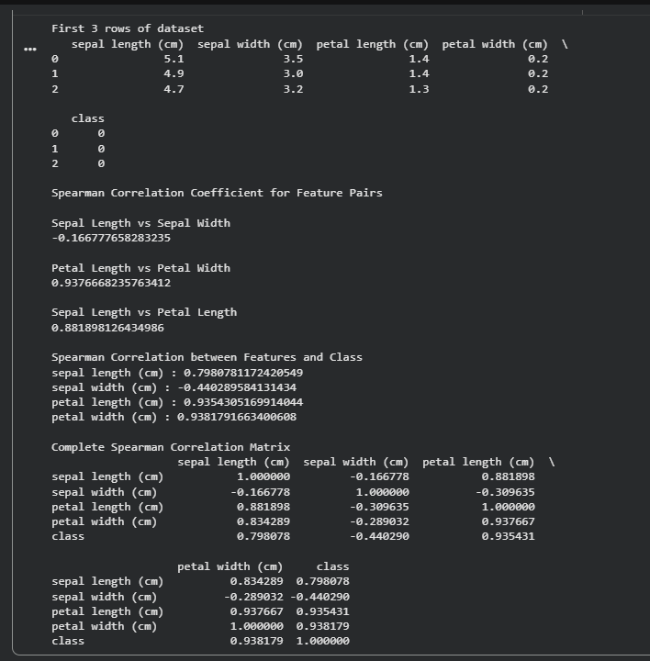

Assignment 6 - Simple Linear Regression on Real Estate Price Prediction

import pandas as pd
import matplotlib.pyplot as plt
from sklearn.linear_model import LinearRegression
from sklearn.model_selection import train_test_split
from sklearn.metrics import mean_squared_error, r2_score

# Load dataset
df = pd.read_csv("Real estate.csv")

print("First 3 rows of dataset")
print(df.head(3))

# Select single feature and target
X = df[['X4 number of convenience stores']]
y = df['Y house price of unit area']

# Split dataset
X_train, X_test, y_train, y_test = train_test_split(
X, y, test_size=0.2, random_state=42
)

# Create model
model = LinearRegression()

# Train model
model.fit(X_train, y_train)

# Predict values
y_pred = model.predict(X_test)

print("\nModel Coefficient")
print(model.coef_)

print("\nModel Intercept")
print(model.intercept_)

print("\nMean Squared Error")
print(mean_squared_error(y_test, y_pred))

print("\nR2 Score")
print(r2_score(y_test, y_pred))

# Plot regression line
print("\nDisplaying Simple Linear Regression Plot")
plt.figure(figsize=(6,4))
plt.scatter(X_test, y_test, color='blue')
plt.plot(X_test, y_pred, color='red')
plt.title("Simple Linear Regression")
plt.xlabel("Number of Convenience Stores")
plt.ylabel("House Price of Unit Area")
plt.show()
OUTPUT : -
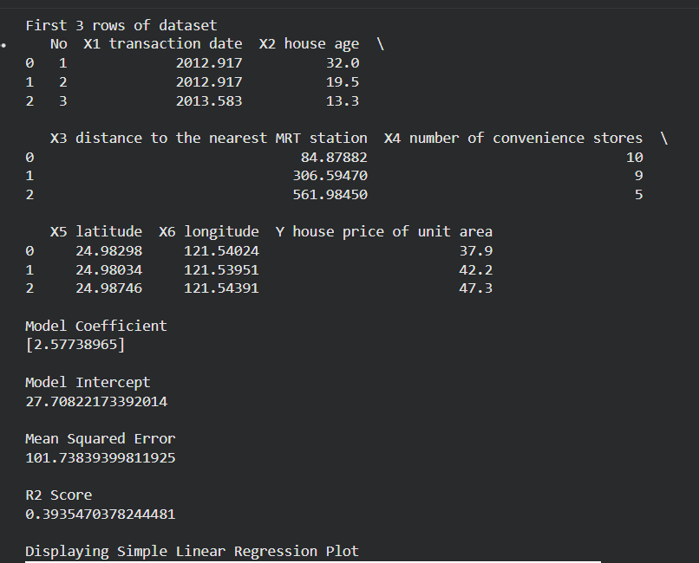
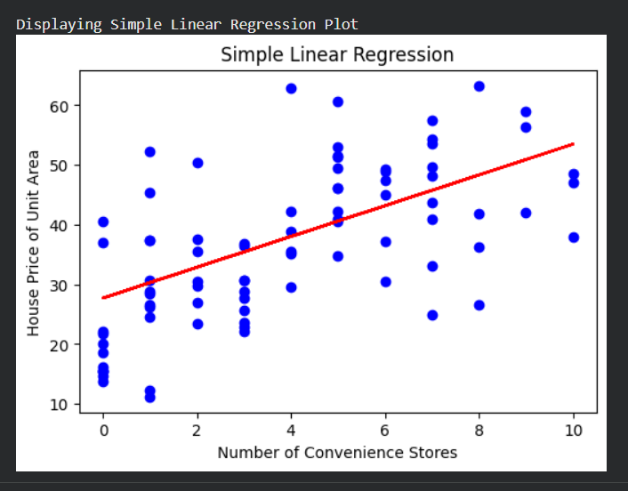
Assignment 7 - Multiple Linear Regression on Real Estate Price Prediction

import pandas as pd
import matplotlib.pyplot as plt
from sklearn.linear_model import LinearRegression
from sklearn.model_selection import train_test_split
from sklearn.metrics import mean_squared_error, r2_score

# Load dataset
df = pd.read_csv("Real estate.csv")
print("First 3 rows of dataset")
print(df.head(3))
# Select multiple features
X = df[
[
'X2 house age',
'X3 distance to the nearest MRT station',
'X4 number of convenience stores'
]
]
# Target variable
y = df['Y house price of unit area']

# Split dataset
X_train, X_test, y_train, y_test = train_test_split(
X, y, test_size=0.2, random_state=42
)
# Create model
model = LinearRegression()
# Train model
model.fit(X_train, y_train)
# Predict values
y_pred = model.predict(X_test)
print("\nModel Coefficients")
print(model.coef_)
print("\nModel Intercept")
print(model.intercept_)
print("\nMean Squared Error")
print(mean_squared_error(y_test, y_pred))
print("\nR2 Score")
print(r2_score(y_test, y_pred))
# Actual vs Predicted Plot
print("\nDisplaying Actual vs Predicted Plot")

plt.figure(figsize=(6,4))
plt.scatter(y_test, y_pred, color='green')

plt.title("Multiple Linear Regression")
plt.xlabel("Actual Price")
plt.ylabel("Predicted Price")
plt.show()

OUTPUT : -
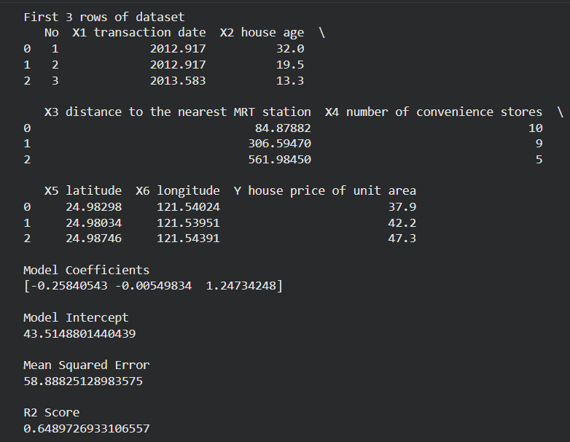
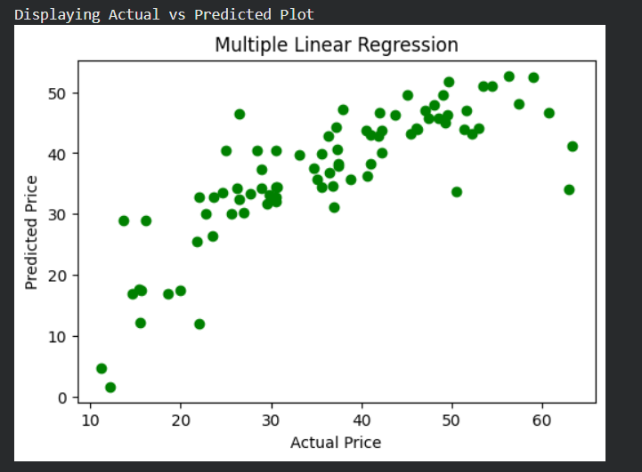
Assignment 8 - Non Linear Regression on Real Estate Price Prediction Dataset

import pandas as pd
import numpy as np
import matplotlib.pyplot as plt
from sklearn.preprocessing import PolynomialFeatures
from sklearn.linear_model import LinearRegression
from sklearn.model_selection import train_test_split
from sklearn.metrics import mean_squared_error, r2_score

# Load dataset
df = pd.read_csv("Real estate.csv")
print("First 3 rows of dataset")
print(df.head(3))
# Select feature and target
X = df[['X4 number of convenience stores']]
y = df['Y house price of unit area']
# Convert into polynomial features
poly = PolynomialFeatures(degree=2)
X_poly = poly.fit_transform(X)
# Split dataset
X_train, X_test, y_train, y_test = train_test_split(
X_poly, y, test_size=0.2, random_state=42
)

# Create model
model = LinearRegression()
# Train model
model.fit(X_train, y_train)

# Predict values
y_pred = model.predict(X_test)
print("\nModel Coefficients")
print(model.coef_)
print("\nModel Intercept")
print(model.intercept_)
print("\nMean Squared Error")
print(mean_squared_error(y_test, y_pred))
print("\nR2 Score")
print(r2_score(y_test, y_pred))
# Plot Non Linear Regression
print("\nDisplaying Non Linear Regression Plot")
plt.figure(figsize=(6,4))
plt.scatter(X.iloc[:,0], y, color='blue')
sorted_zip = sorted(zip(X.iloc[:,0], model.predict(X_poly)))
x_poly, y_poly = zip(*sorted_zip)
plt.plot(x_poly, y_poly, color='red')
plt.title("Non Linear Regression")
plt.xlabel("Number of Convenience Stores")
plt.ylabel("House Price of Unit Area")
plt.show()

OUTPUT : -
