**DIGITAL_NURTURE_4.0**

**Superset ID – 6402411**

**Exercise 1: Control Structures**

**Scenario 1 :**

BEGIN

FOR cust IN (

SELECT CustomerID

FROM Customers

WHERE TRUNC(MONTHS_BETWEEN(SYSDATE, DOB) / 12) > 60

) LOOP

UPDATE Loans

SET InterestRate = InterestRate - 1

WHERE CustomerID = cust.CustomerID;

END LOOP;

COMMIT;

DBMS_OUTPUT.PUT_LINE('Interest rate discount applied for customers above 60.');

END;

**SCENARIO 2:**

BEGIN

FOR cust IN (

SELECT CustomerID

FROM Customers

WHERE Balance > 10000

) LOOP

UPDATE Customers

SET IsVIP = 'Y'

WHERE CustomerID = cust.CustomerID;

END LOOP;

**SCENARIO 3:**

BEGIN

FOR loan IN (

SELECT l.LoanID, l.CustomerID, l.EndDate, c.Name

FROM Loans l

JOIN Customers c ON l.CustomerID = c.CustomerID

WHERE l.EndDate <= SYSDATE + 30

) LOOP

DBMS_OUTPUT.PUT_LINE('Reminder: Loan ID ' || loan.LoanID ||

' for customer ' || loan.Name ||

' is due on ' || TO_CHAR(loan.EndDate, 'YYYY-MM-DD'));

END LOOP;

END;

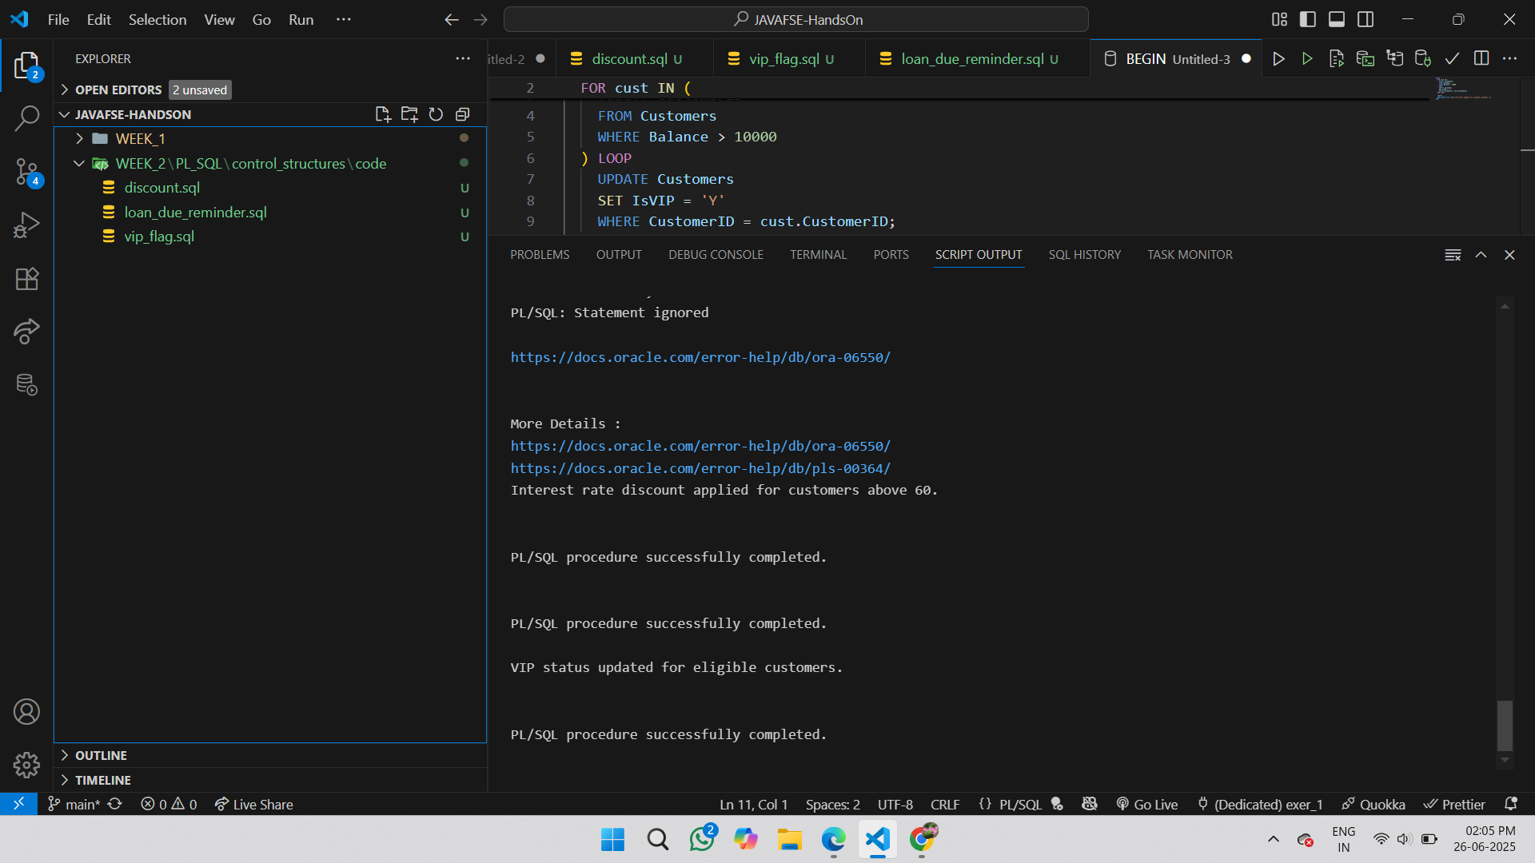**Output**

**Exercise 3 : Stored Procedures**

**Scenario 1:**

CREATE OR REPLACE PROCEDURE ProcessMonthlyInterest IS

BEGIN

UPDATE Accounts

SET Balance = Balance + (Balance * 0.01),

LastModified = SYSDATE

WHERE AccountType = 'Savings';

COMMIT;

DBMS_OUTPUT.PUT_LINE('Monthly interest applied to all savings accounts.');

END;

**Scenario 2:**

CREATE OR REPLACE PROCEDURE UpdateEmployeeBonus (

p_department IN VARCHAR2,

p_bonus_pct IN NUMBER

) AS

BEGIN

UPDATE Employees

SET Salary = Salary + (Salary * p_bonus_pct / 100)

WHERE Department = p_department;

IF SQL%ROWCOUNT = 0 THEN

DBMS_OUTPUT.PUT_LINE('No employees found in department: ' || p_department);

ELSE

DBMS_OUTPUT.PUT_LINE('Bonus applied to employees in department: ' || p_department);

END IF;

COMMIT;

END;

**Scenario 3:**

CREATE OR REPLACE PROCEDURE UpdateEmployeeBonus (

p_department IN VARCHAR2,

p_bonus_pct IN NUMBER

) AS

BEGIN

UPDATE Employees

SET Salary = Salary + (Salary * p_bonus_pct / 100)

WHERE Department = p_department;

IF SQL%ROWCOUNT = 0 THEN

DBMS_OUTPUT.PUT_LINE('No employees found in department: ' || p_department);

ELSE

DBMS_OUTPUT.PUT_LINE('Bonus applied to employees in department: ' || p_department);

END IF;

COMMIT;

END;

**OUTPUT**

