WEEK 7

9)App.js
import React from 'react';
import ListofPlayers from './ListofPlayers';
import IndianPlayers, { OddPlayers, EvenPlayers } from './IndianPlayers';

function App() {
const flag = false; // Change to false to test second output

return (
<div className="App">
{flag ? <ListofPlayers /> : (
<>
<OddPlayers players={["Sachin1", "Dhoni2", "Virat3", "Rohit4", "Yuvaraj5", "Raina6"]} />
<EvenPlayers players={["Sachin1", "Dhoni2", "Virat3", "Rohit4", "Yuvaraj5", "Raina6"]} />
<IndianPlayers />
</>
)}
</div>
);
}

export default App;
ListofPlayers.js
import React from 'react';
function ListofPlayers() {
const players = [
{ name: "Jack", score: 50 },
{ name: "Michael", score: 70 },
{ name: "John", score: 40 },
{ name: "Ann", score: 61 },
{ name: "Elisabeth", score: 61 },
{ name: "Sachin", score: 95 },
{ name: "Dhoni", score: 100 },
{ name: "Virat", score: 84 },
{ name: "Jadeja", score: 64 },
{ name: "Raina", score: 75 },
{ name: "Rohit", score: 80 }
];

const playersBelow70 = [];
players.map((item) => {
if (item.score <= 70) {
playersBelow70.push(item);
}
});

return (
<div>
<h2>List of Players</h2>
{players.map((item, index) => (
<div key={index}>
<li>Mr. {item.name} <span> {item.score} </span></li>
</div>
))}

<h2>List of Players having Scores Less than 70</h2>
{playersBelow70.map((item, index) => (
<div key={index}>
<li>Mr. {item.name} <span> {item.score} </span></li>
</div>
))}
</div>
);
}

IndianPlayers.js
export default ListofPlayers;
import React from 'react';

export function OddPlayers({ players }) {
const [first, , third, , fifth] = players;
return (
<div>
<h2>Odd Players</h2>
<li>First: {first}</li>
<li>Third: {third}</li>
<li>Fifth: {fifth}</li>
</div>
);
}

export function EvenPlayers({ players }) {
const [, second, , fourth, , sixth] = players;
return (
<div>
<h2>Even Players</h2>
<li>Second: {second}</li>
<li>Fourth: {fourth}</li>
<li>Sixth: {sixth}</li>
</div>
);
}

const T20Players = ['First Player', 'Second Player', 'Third Player'];
const RanjiTrophyPlayers = ['Fourth Player', 'Fifth Player', 'Sixth Player'];

const IndianPlayers = () => {
const allPlayers = [...T20Players, ...RanjiTrophyPlayers];
return (
<div>
<h2>List of Indian Players Merged</h2>
{allPlayers.map((player, index) => (
<li key={index}>Mr. {player}</li>
))}
</div>
);
};

export default IndianPlayers;

output:
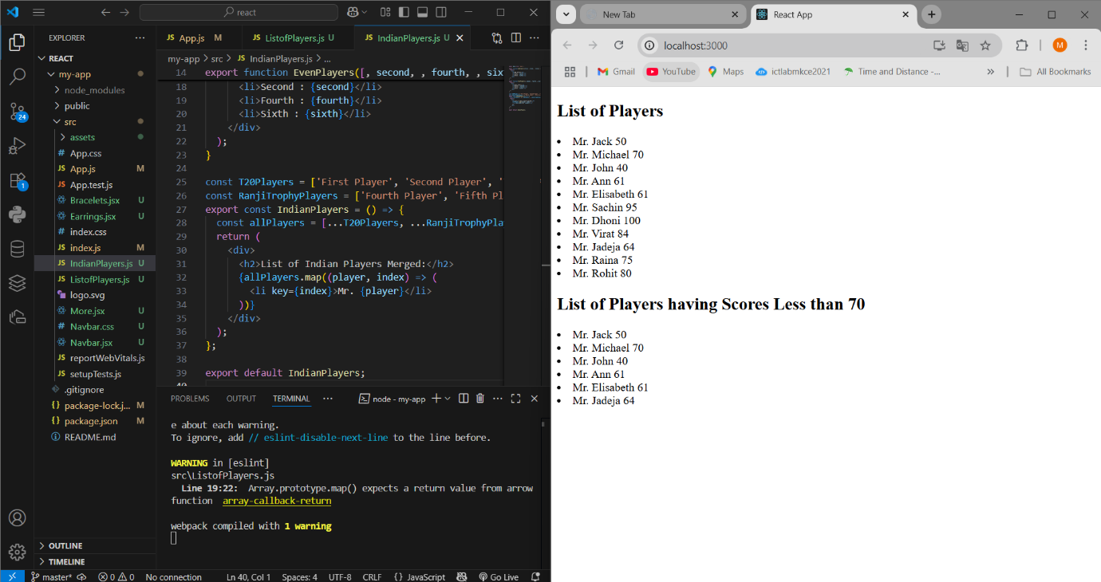

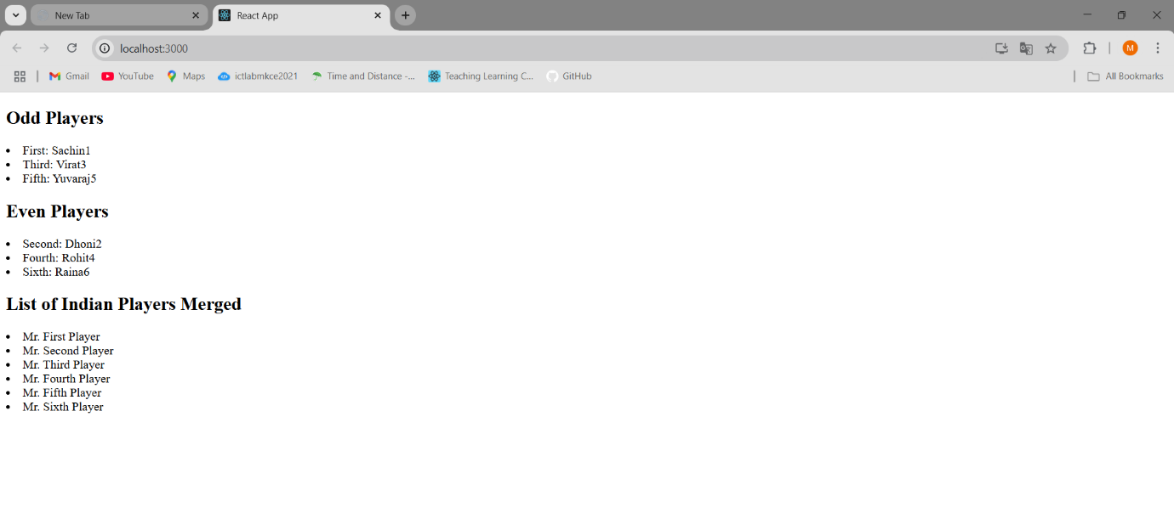

10)App.js
import React from "react";
import officeImage from "./office.jpg";
function App() {
const office = {
name: "DBS",
rent: 50000,
address: "Chennai",
image: officeImage,
};

const rentStyle = {
color: office.rent < 60000 ? "red" : "green",
fontWeight: "bold",
};

return (
<div style={{ textAlign: "center", fontFamily: "Arial" }}>
<h1>Office Space , at Affordable Range</h1>

<img
src={office.image}
alt="Office"
style={{ width: "300px", height: "200px", borderRadius: "8px" }}
/>

<h2 style={{ textAlign: "left", marginLeft: "35%" }}>
Name: {office.name}
</h2>

<p style={{ ...rentStyle, textAlign: "left", marginLeft: "35%" }}>
Rent: Rs. {office.rent}
</p>

<p style={{ textAlign: "left", marginLeft: "35%" }}>
Address: {office.address}
</p>
</div>
);
}

export default App;
App.css
.App {
text-align: center;
}

.App-logo {
height: 40vmin;
pointer-events: none;
}

@media (prefers-reduced-motion: no-preference) {
.App-logo {
animation: App-logo-spin infinite 20s linear;
}
}

.App-header {
background-color: #282c34;
min-height: 100vh;
display: flex;
flex-direction: column;
align-items: center;
justify-content: center;
font-size: calc(10px + 2vmin);
color: white;
}

.App-link {
color: #61dafb;
}

@keyframes App-logo-spin {
from {
transform: rotate(0deg);
}
to {
transform: rotate(360deg);
}
}
OUTPUT
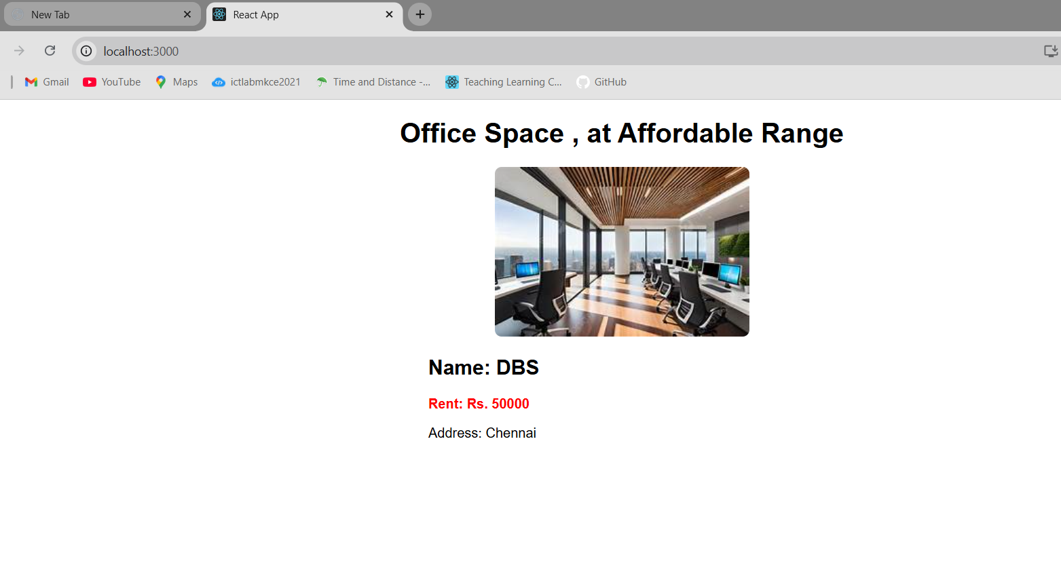
11)App.js
import React, { useState } from "react";
import CurrencyConvertor from "./CurrencyConvertor";

function App() {
const [count, setCount] = useState(1);

// Handle Increment - Calls two functions
const handleIncrement = () => {
increment();
sayHello();
};

const increment = () => {
setCount(count + 1);
};

const sayHello = () => {
console.log("Hello from Increment function!");
};

const handleDecrement = () => {
setCount(count - 1);
};

// Welcome Message
const sayWelcome = (msg) => {
alert(msg);
};

// Synthetic Event
const handleSyntheticClick = () => {
alert("I was clicked");
};

return (
<div style={{ fontFamily: "Arial" }}>
<h1>{count}</h1>

<button onClick={handleIncrement}>Increment</button>
<br></br>
<br />
<button onClick={handleDecrement}>Decrement</button>
<br></br>
<br />
<button onClick={() => sayWelcome("Welcome")}>Say welcome</button>
<br></br>
<br />
<button onClick={handleSyntheticClick}>click me</button>

<hr />

<CurrencyConvertor />
</div>
);
}

export default App;
App.css
.App {
text-align: center;
}

.App-logo {
height: 40vmin;
pointer-events: none;
}

@media (prefers-reduced-motion: no-preference) {
.App-logo {
animation: App-logo-spin infinite 20s linear;
}
}

.App-header {
background-color: #282c34;
min-height: 100vh;
display: flex;
flex-direction: column;
align-items: center;
justify-content: center;
font-size: calc(10px + 2vmin);
color: white;
}

.App-link {
color: #61dafb;
}

@keyframes App-logo-spin {
from {
transform: rotate(0deg);
}
to {
transform: rotate(360deg);
}
}
CurrencyConvertor.js
import React, { useState } from "react";

function CurrencyConvertor() {
const [amount, setAmount] = useState("");
const [currency, setCurrency] = useState("Euro");

const handleSubmit = () => {
if (currency === "Euro") {
// Your example assumes 1 Euro = 80 INR, so conversion is: INR * 80
const converted = amount * 80;
alert(`Converting to ${currency} Amount is ${converted}`);
}
};

return (
<div style={{ textAlign: "left", marginLeft: "40px", fontFamily: "Arial" }}>
<h2 style={{ color: "green", fontWeight: "bold" }}>
Currency Convertor!!!
</h2>

<p>
<label>Amount: </label>
<input
type="number"
value={amount}
onChange={(e) => setAmount(e.target.value)}
/>
</p>

<p>
<label>Currency: </label>
<select value={currency} onChange={(e) => setCurrency(e.target.value)}>
<option value="Euro">Euro</option>
</select>
</p>

<button onClick={handleSubmit}>Submit</button>
</div>
);
}

export default CurrencyConvertor;
OUTPUT:
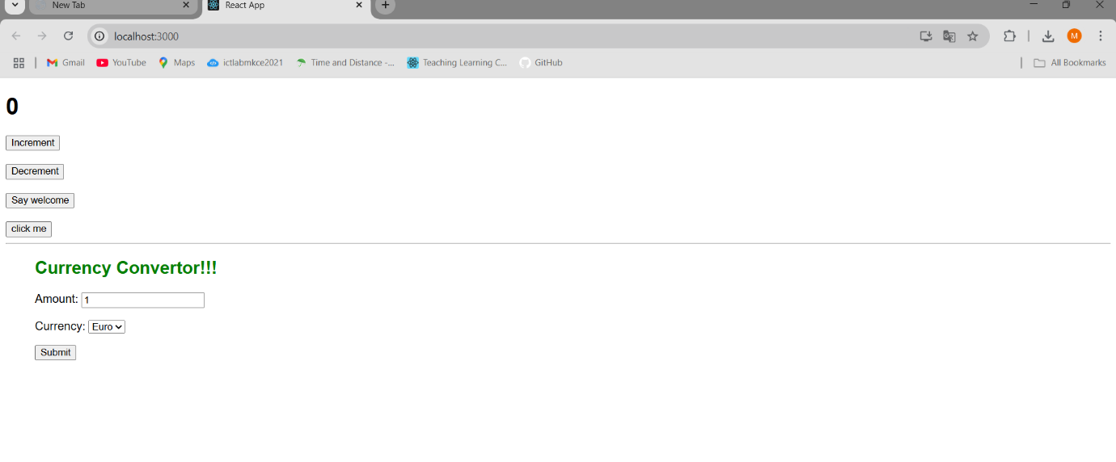
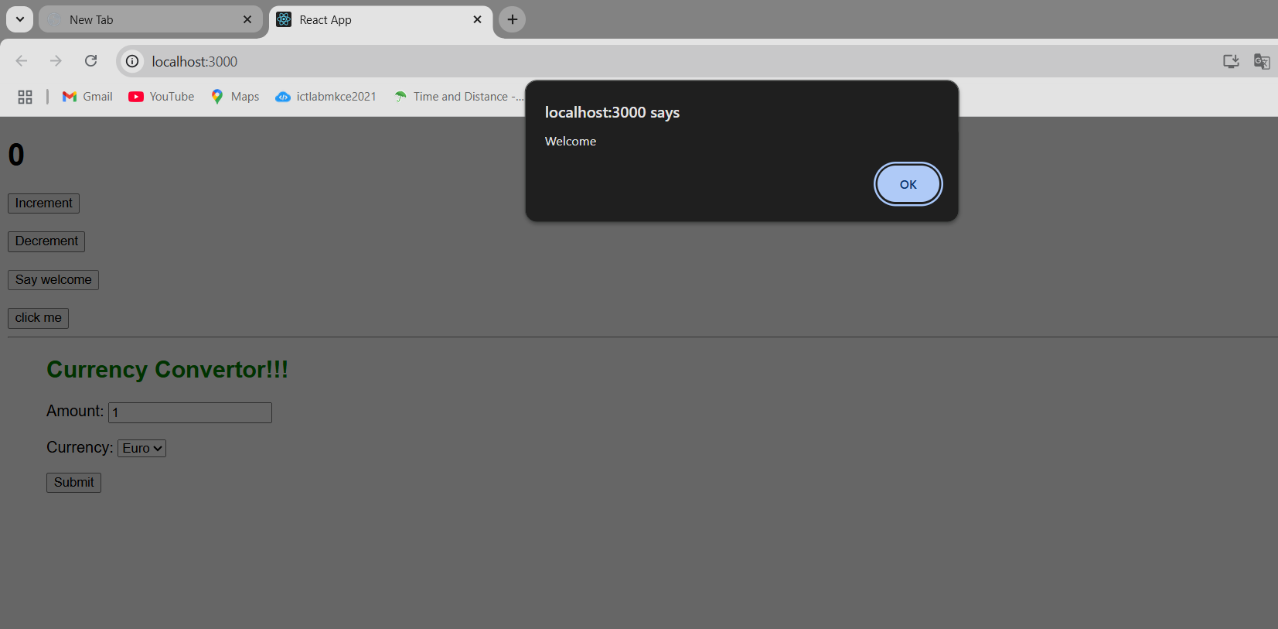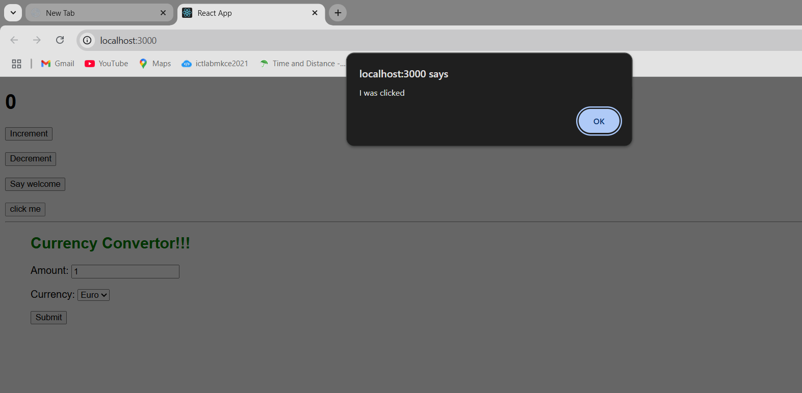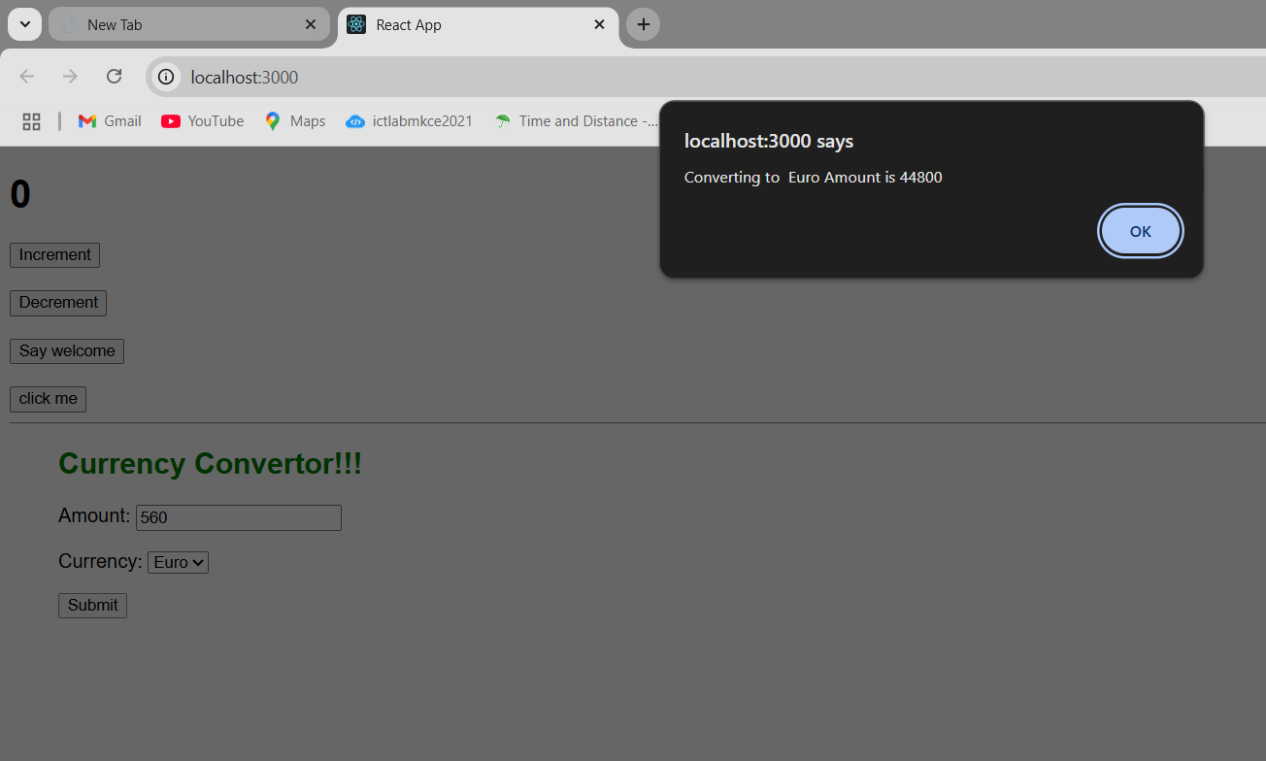
12)App.js
import React, { useState } from "react";
import GuestPage from "./components/GuestPage";
import UserPage from "./components/UserPage";

function App() {
const [isLoggedIn, setIsLoggedIn] = useState(false);

const handleLogin = () => setIsLoggedIn(true);
const handleLogout = () => setIsLoggedIn(false);

return (
<div style={{ padding: "20px" }}>
<h1>Ticket Booking App</h1>
{isLoggedIn ? (
<>
<button onClick={handleLogout}>Logout</button>
<UserPage />
</>
) : (
<>
<button onClick={handleLogin}>Login</button>
<GuestPage />
</>
)}
</div>
);
}

export default App;
App.css
.App {
text-align: center;
}

.App-logo {
height: 40vmin;
pointer-events: none;
}

@media (prefers-reduced-motion: no-preference) {
.App-logo {
animation: App-logo-spin infinite 20s linear;
}
}

.App-header {
background-color: #282c34;
min-height: 100vh;
display: flex;
flex-direction: column;
align-items: center;
justify-content: center;
font-size: calc(10px + 2vmin);
color: white;
}

.App-link {
color: #61dafb;
}

@keyframes App-logo-spin {
from {
transform: rotate(0deg);
}
to {
transform: rotate(360deg);
}
}
components
FlightCard.js
import React from "react";

const FlightCard = ({ flight }) => (
<div style={{ border: "1px solid #ccc", padding: "10px", margin: "10px" }}>
<h3>{flight.name}</h3>
<p>
From: {flight.from} → To: {flight.to}
</p>
<p>Price: ₹{flight.price}</p>
</div>
);

export default FlightCard;
GuestPage.js
import React from "react";
import FlightCard from "./FlightCard";

const flights = [
{ name: "IndiGo 202", from: "Chennai", to: "Bangalore", price: 3200 },
{ name: "Air India 101", from: "Delhi", to: "Mumbai", price: 4500 },
];

const GuestPage = () => (
<div>
<h2>Welcome Guest!</h2>
<p>Browse flights below. Please login to book tickets.</p>
{flights.map((flight, index) => (
<FlightCard key={index} flight={flight} />
))}
</div>
);

export default GuestPage;
UserPage.js
import React from "react";
import FlightCard from "./FlightCard";

const flights = [
{ name: "IndiGo 202", from: "Chennai", to: "Bangalore", price: 3200 },
{ name: "Air India 101", from: "Delhi", to: "Mumbai", price: 4500 },
];

const UserPage = () => (
<div>
<h2>Welcome Back, User!</h2>
{flights.map((flight, index) => (
<div key={index}>
<FlightCard flight={flight} />
<button>Book Ticket</button>
</div>
))}
</div>
);

export default UserPage;
OUTPUT:
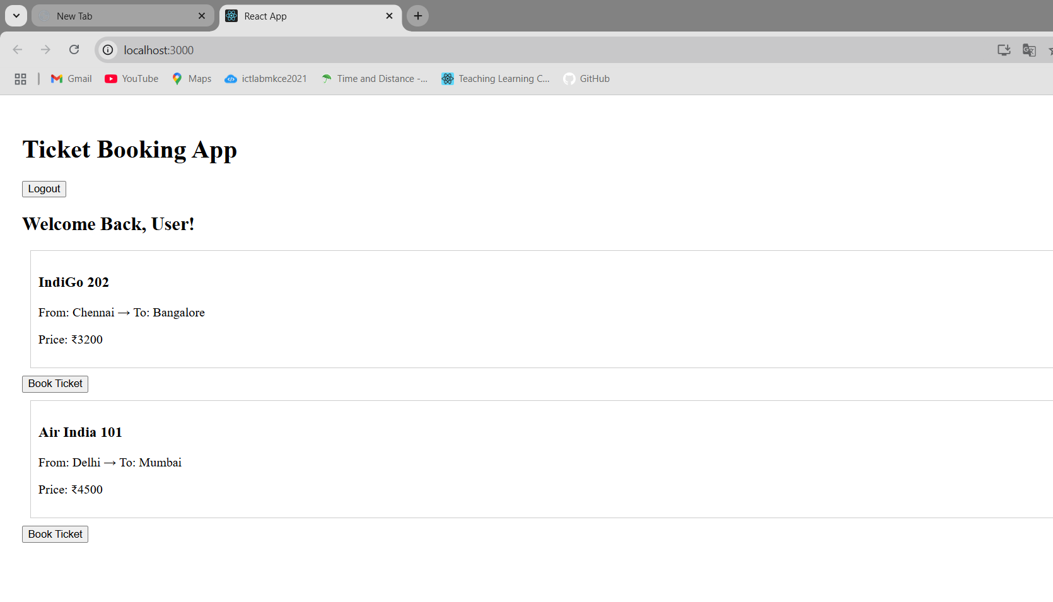
13)
App.js
import React from "react";
import { books } from "./data/books";
import { blogs } from "./data/blogs";
import { courses } from "./data/courses";
import "./App.css";
function App() {
const bookdet = books.map((book) => (
<div key={book.id}>
<strong>{book.bname}</strong>
<p>{book.price}</p>
</div>
));

const content = blogs.map((blog) => (
<div key={blog.id}>
<strong>{blog.title}</strong>
<p>
<em>{blog.author}</em>
</p>
<p>{blog.body}</p>
</div>
));

const coursedet = courses.map((course) => (
<div key={course.id}>
<strong>{course.cname}</strong>
<p>{course.date}</p>
</div>
));

return (
<div>
<div style={{ display: "flex", justifyContent: "space-around" }}>
<div className="st2">
<h1>Book Details</h1>
{bookdet}
</div>

<div className="v1">
<h1>Blog Details</h1>
{content}
</div>

<div className="mystyle1">
<h1>Course Details</h1>
{coursedet}
</div>
</div>
</div>
);
}

export default App;
App.css
.st2,
.v1,
.mystyle1 {
border-left: 5px solid green;
padding: 10px;
min-width: 200px;
}
data
blogs.js
export const blogs = [
{
id: 1,
title: "React Learning",
author: "Stephen Biz",
body: "Welcome to learning React!",
},
{
id: 2,
title: "Installation",
author: "Schwezdneier",
body: "You can install React from npm.",
},
];
books.js
export const books = [
{ id: 101, bname: "Master React", price: 670 },
{ id: 102, bname: "Deep Dive into Angular 11", price: 800 },
{ id: 103, bname: "Mongo Essentials", price: 450 },
];
courses.js
export const courses = [
{ id: 1, cname: "Angular", date: "4/5/2021" },
{ id: 2, cname: "React", date: "6/3/20201" },
];
Output:
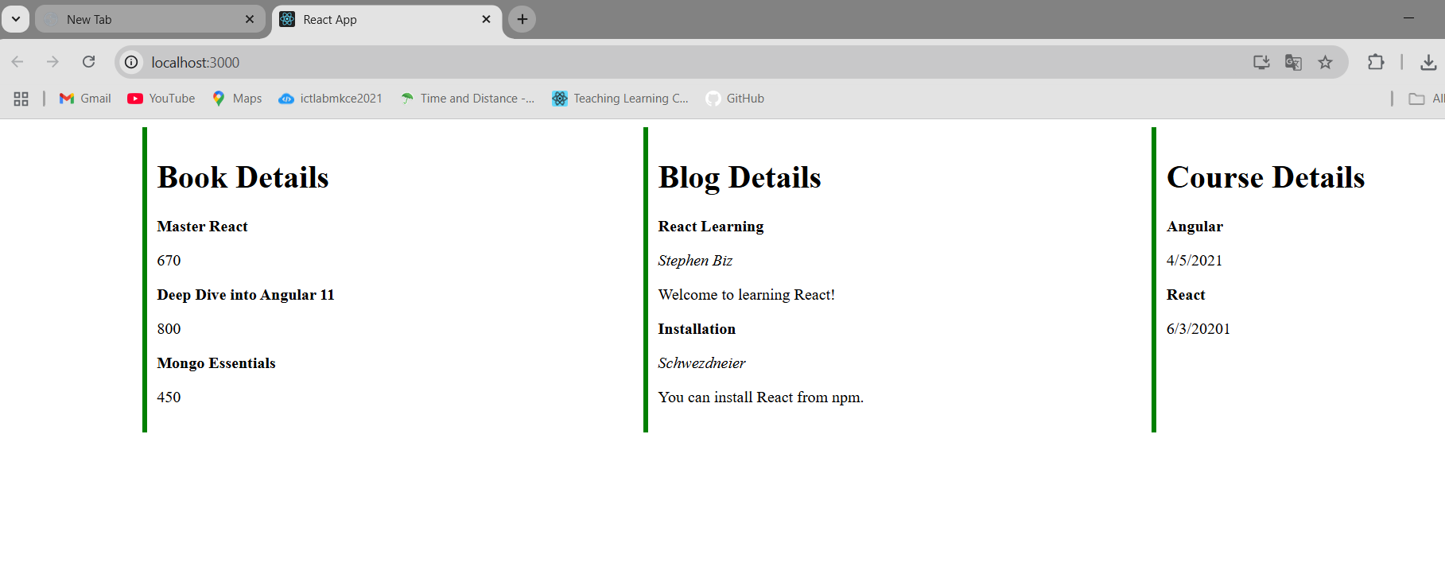
14)App.js
import "./App.css";
import { EmployeesData } from "./Employee";
import EmployeesList from "./EmployeesList";
import { useState } from "react";
import ThemeContext from "./ThemeContext";

function App() {
const [theme, setTheme] = useState("light");
const Employees = EmployeesData;

return (
<ThemeContext.Provider value={theme}>
{" "}
{/* wrap in context */}
<div>
<label>SELECT A THEME </label>
<select onChange={(e) => setTheme(e.target.value)}>
<option value="light">Light</option>
<option value="dark">Dark</option>
</select>
</div>
<EmployeesList employees={Employees} /> {/* no more theme prop */}
</ThemeContext.Provider>
);
}

export default App;
App.css
a {
display: inline-block;
margin: 3px 5px;
padding: 5px 5px;
border-radius: 3px;
text-decoration: none;
}
a.dark {
background-color: #333;
color: #eee;
}
a.light {
background-color: #eee;
color: #333;
}
.light {
background-color: white;
color: black;
padding: 5px;
text-decoration: none;
margin-right: 10px;
}

.dark {
background-color: black;
color: white;
padding: 5px;
text-decoration: none;
margin-right: 10px;
}
Employee.js
class Employee {
constructor(id, name, email, phone){
this.id=id;
this.name=name;
this.email=email;
this.phone=phone;
}
}

const EmployeesData=[
new Employee(101,'Jojo','jojo@congizant.com','98238971234'),
new Employee(102,'Sam','sam@congizant.com', '9981184126'),
new Employee(103,'Elisa','elisa@cognizant.com','9989389735')
];

export default Employee;
export {EmployeesData};
EmployeeCard.js
import { useContext } from "react";
import ThemeContext from "./ThemeContext"; // ✅ import
import Styles from "./EmployeeCard.module.css";

function EmployeeCard(props) {
const theme = useContext(ThemeContext); // ✅ get current theme

return (
<div className={Styles.Card}>
<h3>{props.employee.name}</h3>
<p>{props.employee.email}</p>
<p>{props.employee.phone}</p>
<p>
<button className={theme}>Edit</button>
<button className={theme}>Delete</button>
</p>
</div>
);
}

export default EmployeeCard;
EmployeeCard.module.cs
.Card{
display: inline-block;
width: 25%;
border:1px solid #999;
border-radius: 5px;
margin:10px;
padding:10px;
}
EmployeesList.js
import EmployeeCard from "./EmployeeCard";

function EmployeesList(props) {
return (
<div>
<h1>Employees List</h1>
{props.employees.map((employee) => (
<EmployeeCard employee={employee} key={employee.id} />
))}
</div>
);
}
export default EmployeesList;
ThemeContext.js
import React from "react";
const ThemeContext = React.createContext("light");
export default ThemeContext;
OUTPUT:
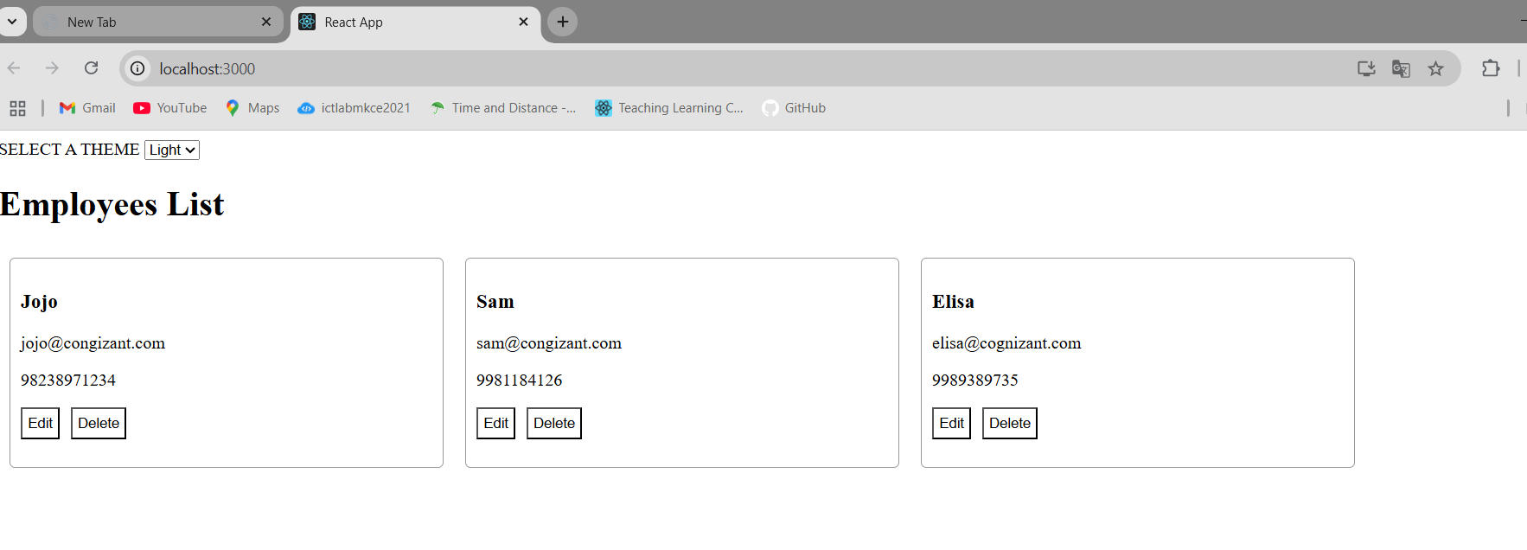
15)App.js
import React from "react";
import ComplaintRegister from "./ComplaintRegister";

function App() {
return (
<div className="App">
<ComplaintRegister />
</div>
);
}

export default App;
App.css
.App {
text-align: center;
}

.App-logo {
height: 40vmin;
pointer-events: none;
}

@media (prefers-reduced-motion: no-preference) {
.App-logo {
animation: App-logo-spin infinite 20s linear;
}
}

.App-header {
background-color: #282c34;
min-height: 100vh;
display: flex;
flex-direction: column;
align-items: center;
justify-content: center;
font-size: calc(10px + 2vmin);
color: white;
}

.App-link {
color: #61dafb;
}

@keyframes App-logo-spin {
from {
transform: rotate(0deg);
}
to {
transform: rotate(360deg);
}
}
ComplaintRegister.js
import React, { useState } from "react";

const ComplaintRegister = () => {
const [name, setName] = useState("");
const [complaint, setComplaint] = useState("");

const handleSubmit = (e) => {
e.preventDefault();

if (!name || !complaint) {
alert("Please fill out both fields.");
return;
}

const referenceNumber = "REF" + Math.floor(Math.random() * 1000000);

alert(
`Complaint registered successfully!\nEmployee: ${name}\nReference No: ${referenceNumber}`
);

// Reset form
setName("");
setComplaint("");
};

return (
<div style={styles.container}>
<h2 style={{ color: "red" }}>Register your Complaints here!!!</h2>
<form onSubmit={handleSubmit} style={styles.form}>
<label>Name:</label>
<input
type="text"
value={name}
onChange={(e) => setName(e.target.value)}
placeholder="Enter your name"
required
/>

<label>Complaint:</label>
<textarea
value={complaint}
onChange={(e) => setComplaint(e.target.value)}
placeholder="Describe your complaint"
required
></textarea>

<button type="submit">Submit</button>
</form>
</div>
);
};

const styles = {
container: {
width: "400px",
margin: "50px auto",
padding: "20px",
},
form: {
display: "flex",
flexDirection: "column",
gap: "10px",
},
};

export default ComplaintRegister;

OUTPUT:
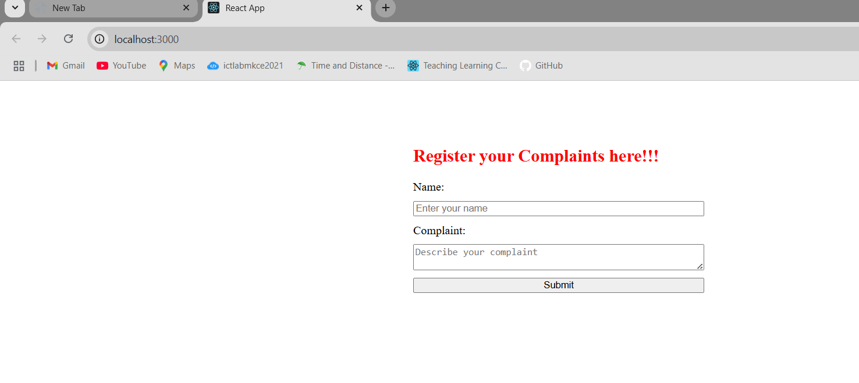
16)App.js
import React from "react";
import Register from "./Register";

function App() {
return (
<div className="App">
<Register />
</div>
);
}

export default App;
App.css
.App {
text-align: center;
}

.App-logo {
height: 40vmin;
pointer-events: none;
}

@media (prefers-reduced-motion: no-preference) {
.App-logo {
animation: App-logo-spin infinite 20s linear;
}
}

.App-header {
background-color: #282c34;
min-height: 100vh;
display: flex;
flex-direction: column;
align-items: center;
justify-content: center;
font-size: calc(10px + 2vmin);
color: white;
}

.App-link {
color: #61dafb;
}

@keyframes App-logo-spin {
from {
transform: rotate(0deg);
}
to {
transform: rotate(360deg);
}
}
Register.js
import React, { useState } from "react";

const Register = () => {
const [formData, setFormData] = useState({
name: "",
email: "",
password: "",
});

const [errors, setErrors] = useState({});

const validate = () => {
const newErrors = {};

if (formData.name.length < 5) {
newErrors.name = "Name must be at least 5 characters";
}

if (!formData.email.includes("@") || !formData.email.includes(".")) {
newErrors.email = "Email must contain @ and .";
}

if (formData.password.length < 8) {
newErrors.password = "Password must be at least 8 characters";
}

setErrors(newErrors);

// If no errors, return true
return Object.keys(newErrors).length === 0;
};

const handleChange = (e) => {
setFormData({
...formData,
[e.target.name]: e.target.value,
});
};

const handleSubmit = (e) => {
e.preventDefault();
if (validate()) {
alert("Registration successful!");
setFormData({ name: "", email: "", password: "" });
setErrors({});
}
};

return (
<div style={styles.container}>
<h2 style={{ color: "red" }}>Register Form!!!</h2>
<form onSubmit={handleSubmit} style={styles.form}>
<label>Name:</label>
<input
type="text"
name="name"
value={formData.name}
onChange={handleChange}
placeholder="Enter your name"
/>
{errors.name && <span style={styles.error}>{errors.name}</span>}

<label>Email:</label>
<input
type="email"
name="email"
value={formData.email}
onChange={handleChange}
placeholder="Enter your email"
/>
{errors.email && <span style={styles.error}>{errors.email}</span>}

<label>Password:</label>
<input
type="password"
name="password"
value={formData.password}
onChange={handleChange}
placeholder="Enter your password"
/>
{errors.password && <span style={styles.error}>{errors.password}</span>}

<button type="submit">Submit</button>
</form>
</div>
);
};

const styles = {
container: {
width: "400px",
margin: "50px auto",
padding: "20px",
},
form: {
display: "flex",
flexDirection: "column",
gap: "10px",
},
error: {
color: "red",
fontSize: "14px",
},
};

export default Register;
OUTPUT:
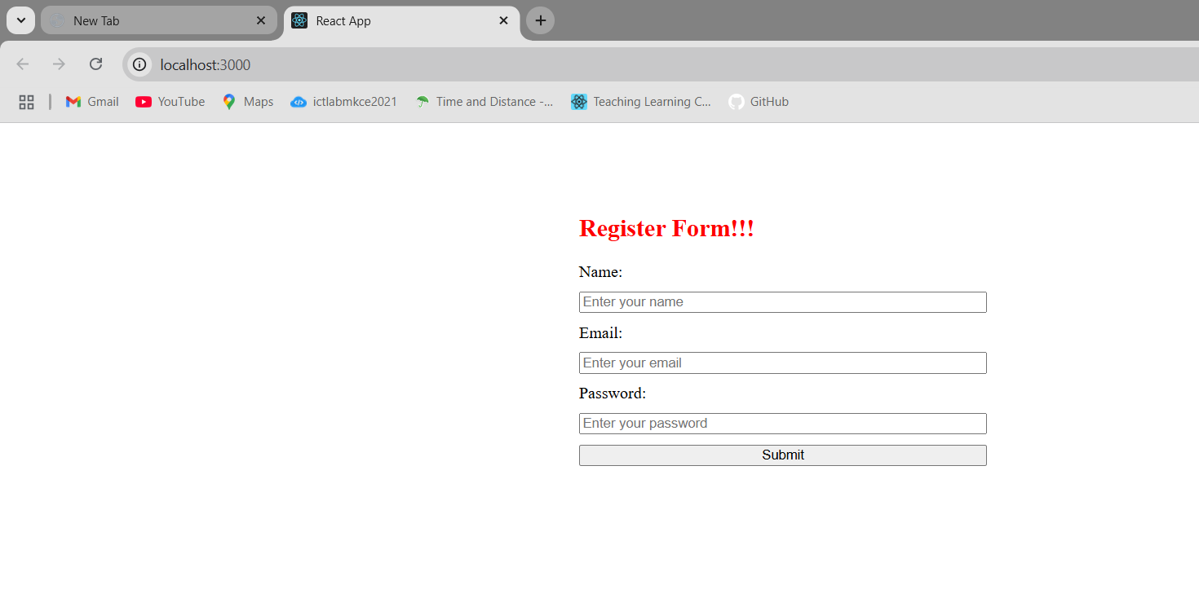
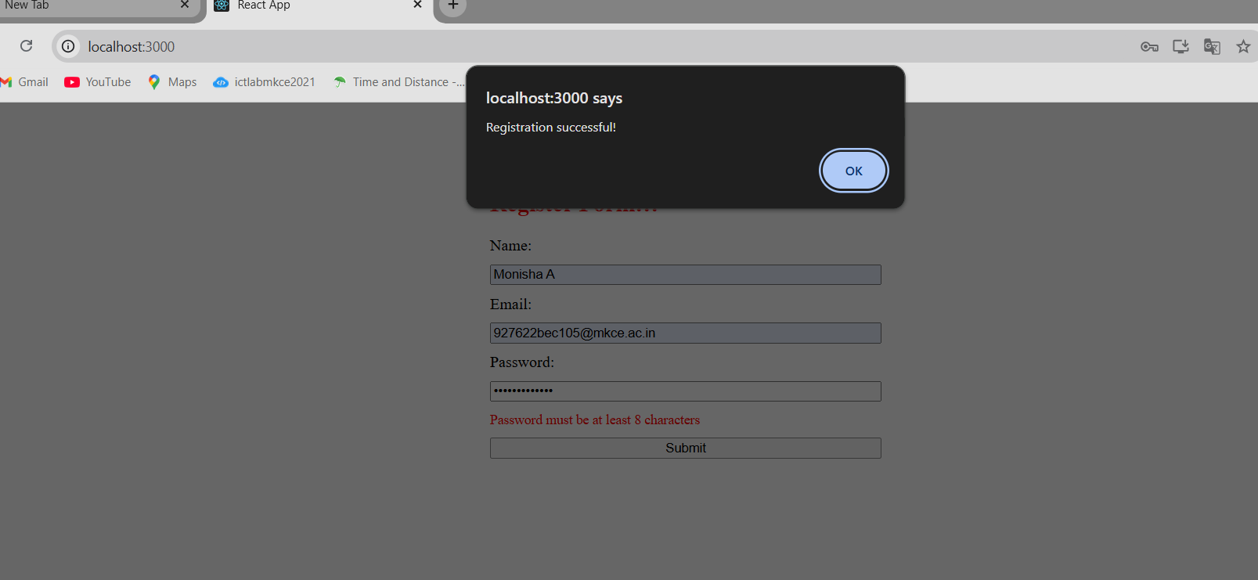
17)App.js
import React from "react";
import Getuser from "./Getuser";

function App() {
return (
<div className="App">
<Getuser />
</div>
);
}

export default App;
App.css
.App {
text-align: center;
}

.App-logo {
height: 40vmin;
pointer-events: none;
}

@media (prefers-reduced-motion: no-preference) {
.App-logo {
animation: App-logo-spin infinite 20s linear;
}
}

.App-header {
background-color: #282c34;
min-height: 100vh;
display: flex;
flex-direction: column;
align-items: center;
justify-content: center;
font-size: calc(10px + 2vmin);
color: white;
}

.App-link {
color: #61dafb;
}

@keyframes App-logo-spin {
from {
transform: rotate(0deg);
}
to {
transform: rotate(360deg);
}
}
Getuser.js
import React, { Component } from "react";

class Getuser extends Component {
constructor(props) {
super(props);
this.state = {
person: {},
loading: true,
};
}

async componentDidMount() {
const url = "https://api.randomuser.me/";
const response = await fetch(url);
const data = await response.json();
this.setState({ person: data.results[0], loading: false });
console.log(data.results[0]);
}

render() {
const { person, loading } = this.state;

if (loading) {
return <h2>Loading...</h2>;
}

return (
<div style={{ padding: "20px" }}>
<h1>
Mr {person.name.first} {person.name.last}
</h1>
<img src={person.picture.medium} alt="User" />
</div>
);
}
}

export default Getuser;
OUTPUT:
