EDA Notes: 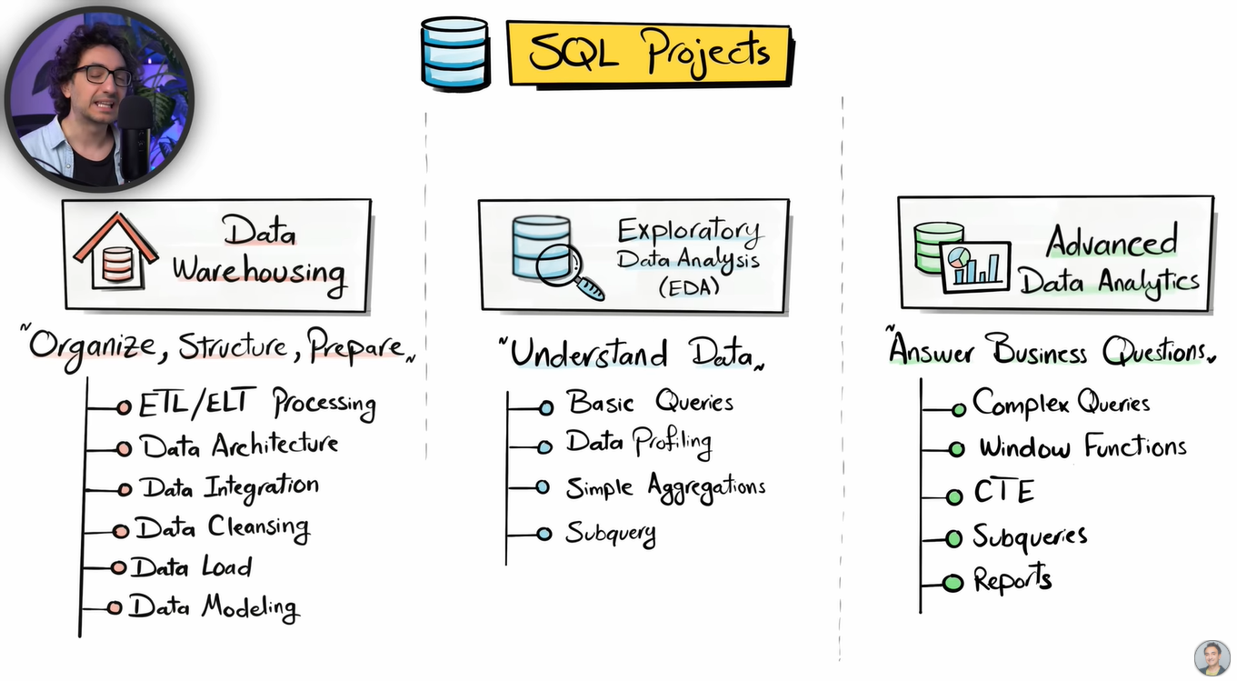

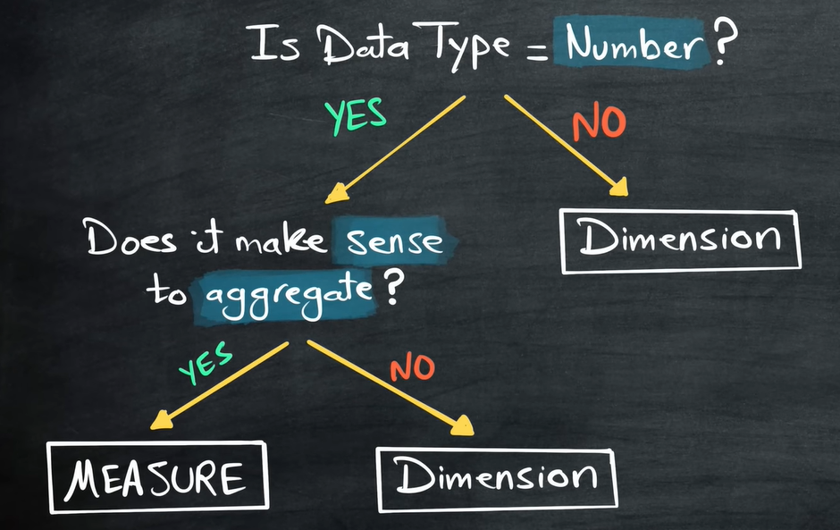
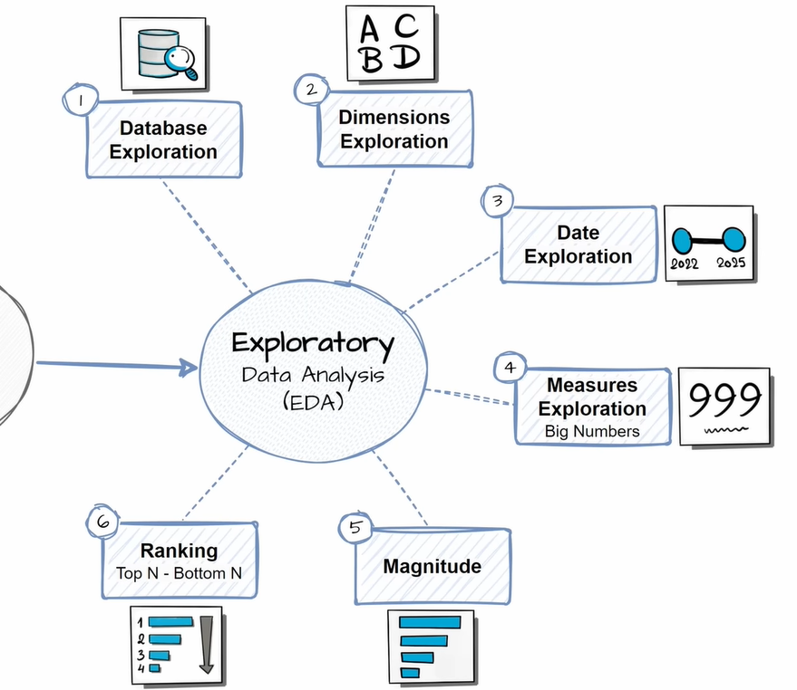

Low Cardinality Dimensions | High Cardinality Dimensions
Dimension with few unique values.  E.g. Category, Gender, Country | Dimension with large number of unique values.  E.g. Customers, Products, Address

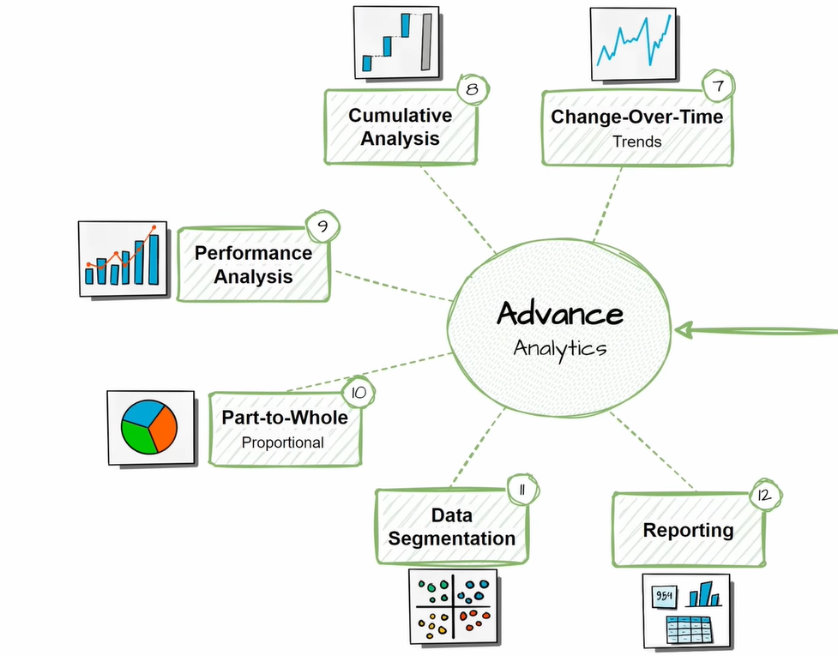
1. Changes over time:
Helps to analyze the measure data over time
Tracks trends and seasonality in data
Formula: SUM (Measure) by [Date Dimension]
E.g. Total sales by year, Average sales by month
2. Cumulative Analysis:
Aggregates the data progressively over time
Helps to understand whether the business is growing or declining
Formula: SUM (Cumulative Measure) by [Date Dimension]
E.g. Running total sales by year, Moving average of sales by month
3. Performance Analysis
Comparing the Current value to Target value
Helps measure success and compare perform
Formula: Current [Measure] – Target [Measure]
E.g. Current Sales – Average Sales, Current Year Sales – Previous Year Sales
4. Part to whole (Proportional Analysis)
Analyze how individual part is performed comparing to overall
Helps to measure which category has great impact on the business
Formula: ([Measure] / [Total Measure]) * 100 by [Category]
E.g. Sales / Total Sales * 100 by Product_Category, Quantity by Total quantity * 100 by Country
5. Data Segmentation
Group the Data based on specific range
Helps to understand correlation between two measures
Formula: [Measure] by [Measure Range]
E.g. Total Products by Sales Range, Total Customers by Age
6. Reporting – Building Final Data with required information which makes it ready for building dashboard.

