Hangman Screens
Screen 1 : Home Screen
Purpose : Get the player into a multiplayer game as quickly as possible.
The user should be able to:
- Enter their name.
- Create a room.
- OR join a room.
That's it.
Layout :
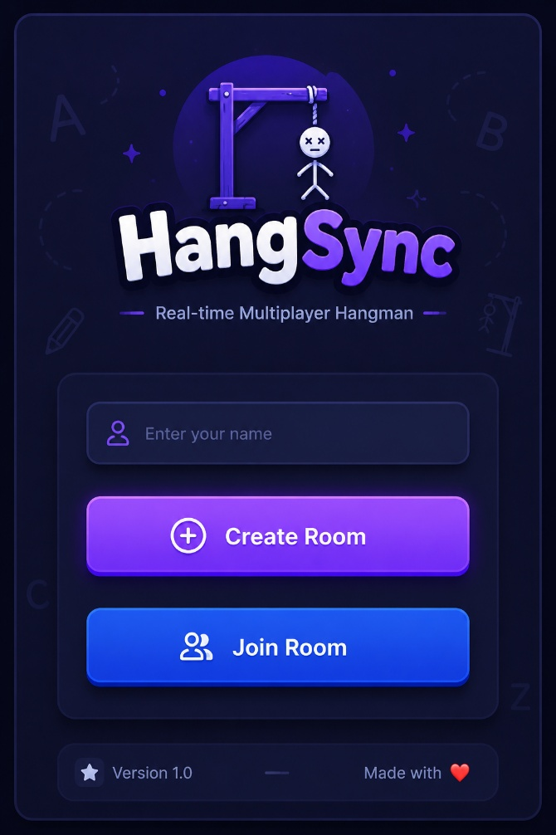

Components Used :
Home Screen
├── Logo
├── Input
├── Primary Button (Create Room)
├── Secondary Button (Join Room)
├── Toast

User Interactions :
┌──────────────────────┐
│ Enter Player Name │
│ (e.g., Sabareesh) │
└──────────┬───────────┘
│
▼
Choose an Action
┌────────┴────────┐
▼ ▼
Create Room Join Room
│ │
▼ ▼
Backend Creates Navigate to
Room Join Room Screen
│ │
▼ ▼
Navigate to Waiting Enter Room Code
Room Screen & Join Game

Validations :
Before continuing:
Name should
✅ Not be empty
✅ Minimum 3 characters
✅ Maximum 20 characters
Allowed
Sabareesh
John
Alex123

Not Allowed
""
" "
A
If invalid
Show toast
Please enter your name.
Backend Interaction :
Only two actions.
Create Room
POST /rooms/create

Join Room
Navigate
/join
No API yet.

Screen – 2 : Join Screen
Purpose : Allow a player to join an existing room using a room code. Allow a player to join an existing room using a room code.
User Flow :
Home
↓
Join Room
↓
Enter Room Code
↓
Click Join
↓
Waiting Room
If something goes wrong
Join Room
↓
Invalid Room Code
↓
Stay on Join Room Screen

Layout :
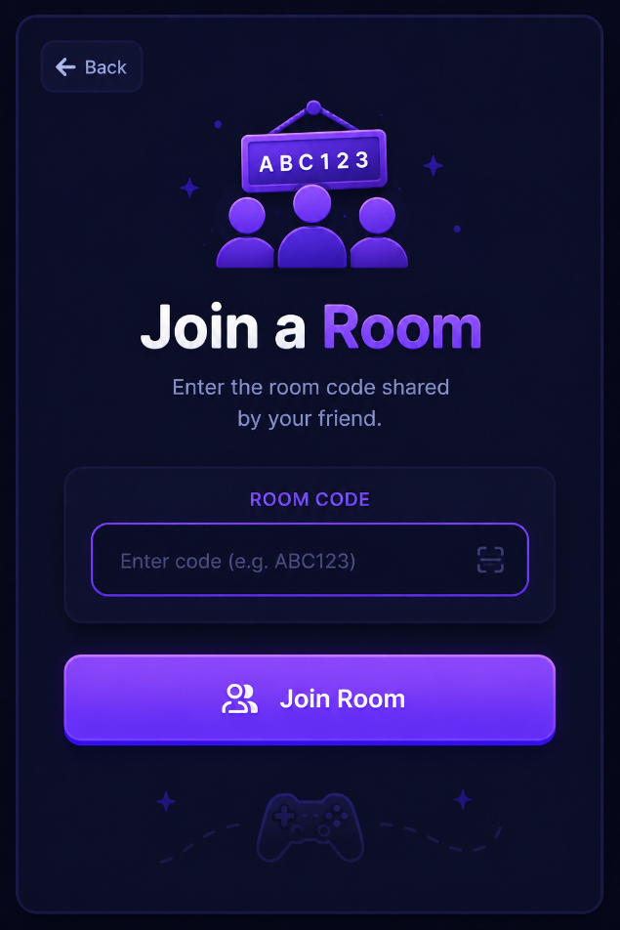

Components Used :
Join Room Screen
├── Back Button
├── Card
├── Title
├── Subtitle
├── Room Code Input
├── Primary Button
└── Toast

5. Room Code Input
This input is different from a normal text field.
Rules:
- Automatically convert to uppercase
- Remove spaces
- Maximum 6 characters
- Monospace font
- Center aligned
- Letter spacing
Example
AB12CD
This makes room codes much easier to read.

6. Join Button
Initially enabled only when the room code is valid in format.
Examples:
ABC123
✅ Enable button
AB
❌ Disable button
This avoids unnecessary API calls.

7. Validation Rules
Empty
Please enter a room code.

Less than 6 characters
Room code must be 6 characters.

Room doesn't exist
Room not found.

Room already full
This room is already full.

Game already in progress
This game has already started.
(We may choose to allow joining mid-game in a future version, but not in the MVP.)

Network Error
Unable to connect.
Please try again.

8. Button States
Default
Join Room

Loading
Joining...
⏳
Button disabled.

Success
Automatically navigate.

9. User Actions
Player types
↓
Room code becomes uppercase automatically.
↓
Player presses Join.
↓
Loading starts.
↓
Backend validates.
↓
Success
↓
Navigate to Waiting Room.

Backend Interaction
One API call.
POST /rooms/join
Request
{
"player_name": "Sabareesh",
"room_code": "AB12CD"
}
Possible responses:
Success
↓
Navigate.
or
Room Full
↓
Show toast.

Screen 3 — Waiting Room :
Purpose : Allow players to meet, verify they're in the correct room, and wait until both are ready to begin.
User Flow :
Create Room
│
▼
Waiting Room
│
├── Waiting for Player
│
▼
Second Player Joins
│
▼
Both Players Connected
│
▼
Host Starts Game
│
▼
Game Screen

Layout : waiting for Second Player
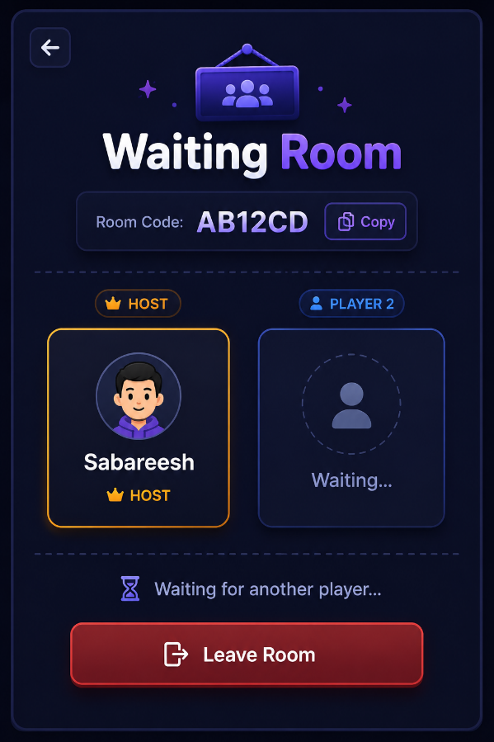
Once Second player joins

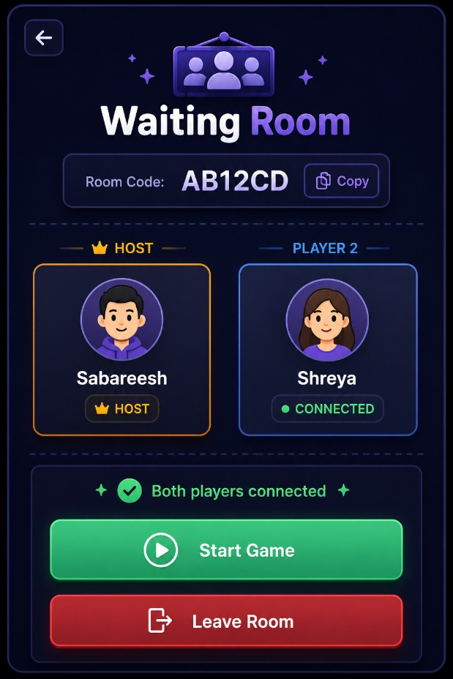

Components Used :
Waiting Room
├── Room Code Card
├── Copy Button
├── Player Card (Host)
├── Player Card (Guest)
├── Status Message
├── Primary Button (Start Game)
├── Secondary Button (Leave Room)
└── Toast

5. Player Cards
Each card shows:
👤 Sabareesh
HOST
Connected
Guest card before joining:
Waiting for player...
After joining:
👤 Shreya
Connected

6. Room Code Card
Example:
Room Code
AB12CD
📋 Copy
Clicking Copy copies the room code and shows:
Copied!

7. Status Messages
Examples:
Waiting
Waiting for another player...

Player Joined
Shreya joined the room.

Ready
Both players are connected.
Ready to start!

Player Left
Shreya left the room.

8. Buttons
Before second player joins
Only:
Leave Room

After second player joins
Host sees:
Start Game
Leave Room
Guest sees:
Waiting for host to start...
Leave Room
This keeps control with the host while making it clear what's happening.

9. WebSocket Events
This is our first real-time screen.
Events might look like:
room_created
player_joined
player_left
game_started
The frontend listens for these and updates instantly without refreshing.
📖 Game Screen Design Plan
Part 1 – Overall Layout
We'll decide:
- Header
- Left Panel
- Center Panel
- Right Panel
- Footer
- Responsive layout
No functionality yet—just placement.

Part 2 – Game Components
We'll design:
- Hangman
- Word Display
- Keyboard
- Wrong Letters
- Lives Display

Part 3 – Player Information
We'll design:
- Scoreboard
- Player Cards
- Current Turn
- Current Role
- Round Number

Part 4 – Gameplay Actions
We'll design:
- Ask for Clue
- Guess Full Word
- Waiting for Clue
- Receiving Clue
- Role-based UI (Guesser vs Word Setter)

Part 5 – Game States
We'll design how the screen changes during:
- Round Start
- Guess Correct
- Guess Wrong
- Win
- Lose
- Role Switch
- Next Round

Part 6 – Animations
We'll define animations for:
- Hangman drawing
- Letter reveal
- Keyboard key press
- Wrong guess shake
- Clue arrival
- Round transition
- Victory/Defeat

Game Screen Part 1 :
Screen Goals
This screen should let a player answer these questions within 2–3 seconds:
- Whose turn is it?
- What is the category?
- How many lives are left?
- What word am I solving?
- Which letters have I already guessed?
- What's the current score?
- What can I do next?
Layout :
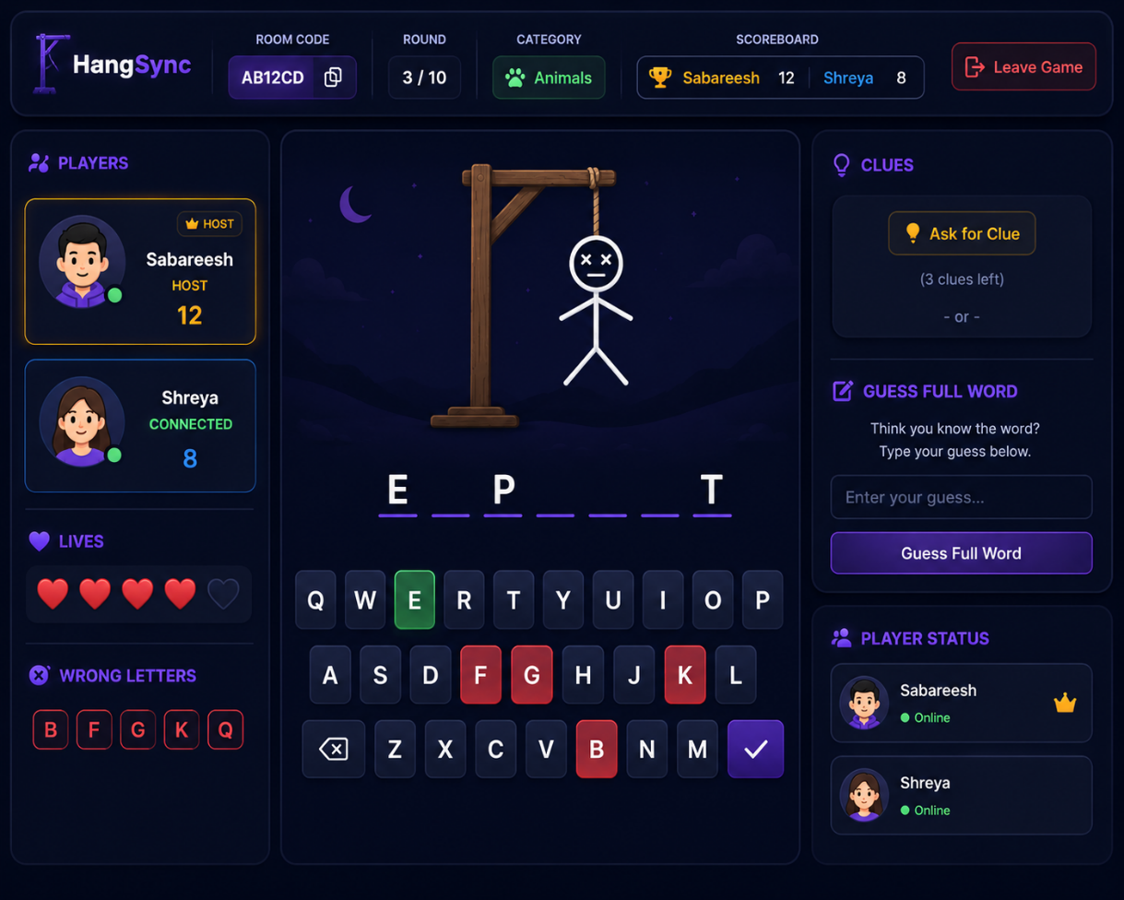

Components Used :
Header
├── Room Code Card
├── Round Indicator
├── Category Badge
├── Scoreboard
└── Leave Button
Left Panel
├── Player Cards
├── Lives Display
└── Wrong Letters
Center Panel
├── Hangman
├── Word Display
└── Keyboard
Right Panel
├── Clue Panel
├── Game Action Buttons
└── Player Status

