Manipulate HTML Attributes using jQuery

jQuery methods to get or set value of attribute, property, text or html.

| jQuery Method | Description |
| --- | --- |
| attr() | Get or set the value of specified attribute of the target element(s). |
| prop() | Get or set the value of specified property of the target element(s). |
| html() | Get or set html content to the specified target element(s). |
| text() | Get or set text for the specified target element(s). |
| val() | Get or set value property of the specified target element. |

**DOM element's attributes, properties and values.**

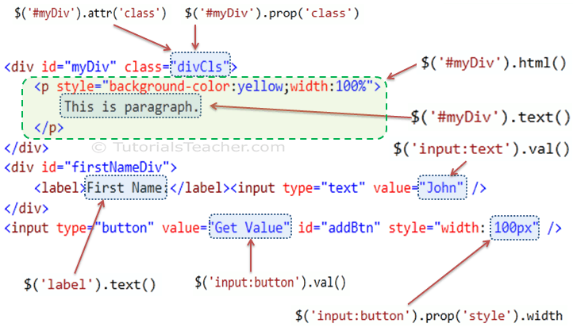

**jQuery attr() Method**

jQuery attr() method is used to get or set the value of specified attribute of DOM element.

Syntax:

$('selector expression').attr('name','value');

Example: jQuery attr() Method

$('p').attr('style'); // returns "font-size:16px;font-weight:bold"

$('div').attr('class','yellowDiv'); // adds class='divCls' to each div element

<div>

This is div.

</div>

<p style="font-size:16px;font-weight:bold">

This is paragraph.

</p>

<div>

This is div.

</div>

<p>This is paragraph.</p>

**jQuery prop() Method**

The jQuery prop() method gets or sets the value of specified property to the DOM element(s).

**Syntax:**

$('selector expression').prop('name','value');

**Example: jQuery prop() Method**

var style = $('p').prop('style');

style.fontWeight; // returns "bold"

$('div').prop('class','yellowDiv'); // add class="yellowDiv" to all div elements

<div>

This is div.

</div>

<p style="font-size:16px;font-weight:bold">

This is paragraph.

</p>

<div>

This is div.

</div>

<p>

This is paragraph.

</p>

**jQuery html() Method**

The jQuery html() method gets or sets html content to the specified DOM element(s).

Syntax:

$('selector expression').html('content');

Example: jQuery html() Method

$('#myDiv').html(); //returns innerHtml of #myDiv

//add <p>This is paragraph.</p> to #emptyDiv

$('#emptyDiv').html('<p>This is paragraph.</p>');

<div id="myDiv" class="yellowDiv">

<p style="font-size:16px;font-weight:bold">

This is paragraph.

</p>

</div>

<div id="emptyDiv">

</div>

**jQuery text() Method**

The jQuery text() method gets or sets the text content to the specified DOM element(s).

Syntax:

$('selector expression').text('content');

Example: jQuery text() Method

$('#myDiv').text(); //returns "This is paragraph."

$('p').text(); //returns "This is paragraph."

//removes all the content from #emptyDiv and inserts "This is some text." to it

$('#emptyDiv').text('This is some text.');

<div id="myDiv" class="divCls">

<p style="font-size:16px;font-weight:bold">

This is paragraph.

</p>

</div>

<div id="emptyDiv">

</div>

**jQuery val() Method**

The jQuery val() method gets or sets value property to the specified DOM element(s).

**Syntax:**

$('selector expression').val('value');

Example: jQuery val() Method

$('input:Submit').val(); //returns "Save"

//set value of input text to "Steve"

$('input:text').val('Steve');

$('input:text').val(); //returns "Steve"

<div>

<label>Name:</label><input type="text" />

</div>

<div>

<input type="Submit" value="Save" />

</div>