# Manipulate DOM Element's Dimensions using jQuery

The jQuery library includes various methods to manipulate DOM element's dimensions like height, width, offset, position etc.

| jQuery Method | Description |
| --- | --- |
| [height()](https://www.tutorialsteacher.com/jquery/jquery-get-dimensions-of-dom-elements#height) | Get or set height of the specified element(s). |
| innerHeight() | Get or set inner height (padding + element's height) of the specified element(s). |
| outerHeight() | Get or set outer height (border + padding + element's height) of the specified element(s). |
| [offset()](https://www.tutorialsteacher.com/jquery/jquery-get-dimensions-of-dom-elements#offset) | Get or set left and top coordinates of the specified element(s). |
| position() | Get the current coordinates of the specified element(s). |
| [width()](https://www.tutorialsteacher.com/jquery/jquery-get-dimensions-of-dom-elements#width) | Get or set the width of the specified element(s). |
| innerWidth() | Get or set the inner width (padding + element's width) of the specified element(s). |
| outerWidth() | Get or set outer width (border + padding + element's width) of the specified element(s). |

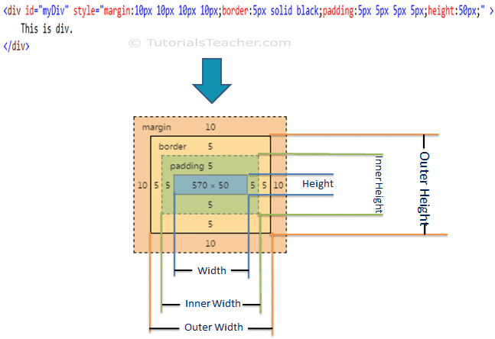

**jQuery height() Method**

**The jQuery height()method gets or sets height of the specified DOM element(s).**

**Syntax:**

**$('selector expression').height(value);**

Example: jQuery height() Method

$('#myDiv').height(); //returns height of #myDiv in pixels

$('p').height(); //returns height in pixel

//set height of all div elements

$('div').height(100);

<div id="myDiv" >

This is div.

</div>

<p>

This is paragraph.

</p>

**jQuery width() Method**

The jQuery width() method gets or sets width of the specified DOM element(s).

**Syntax:**

**$('selector expression').width(value);**

Example: jQuery width() Method

$('#myDiv').width(); //returns width of #myDiv in pixels

$('p').width(); //returns width of p in pixel

//set width of all div elements

$('div').width(100);

<div id="myDiv" >

This is div.

</div>

<p>

This is paragraph.

</p>

## **jQuery offset() Method**

The jQuery offset() method gets or sets coordinates of the specified element(s)

Syntax:

$('selector expression').offset(options);

Example: jQuery offset() Method

var ofs = $('#myDiv').offset();

alert('left:' + ofs.left + ', top: ' + ofs.top);

$('p').offset({ left:100, top:200});

<div id="myDiv" >

This is div.

</div>

<p>

This is paragraph.

</p>