PROJECT #11- SABARI SUNDAR A R
Table:1- Employee
Structure:
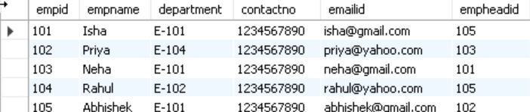
Table:2- EmpDept
Structure:
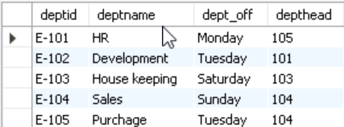
Table:3- EmpSalary
Structure:
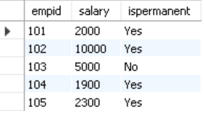
Table:4-Project
Structure:
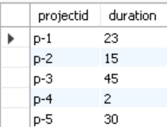
Table:5-Country
Structure:
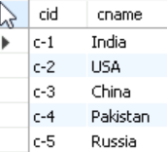

Table:6-ClientTable
Structure:
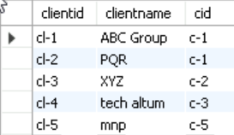

Table:7-EmpProject
Structure:
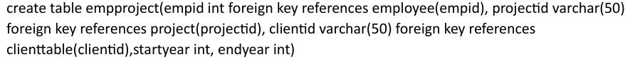
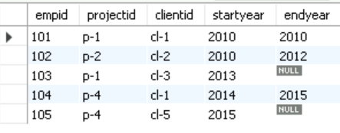

Question 1:
Query:
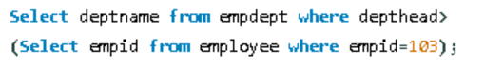
Output:
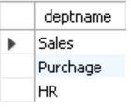

Question 2:
Query:
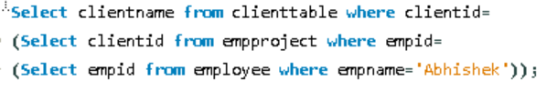

Output:
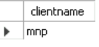
Question 3:
Query:
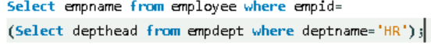
Output:
