Now at the output, the model will remember only (cuisine,is) and forgets Samosa which is the main key-word in this sentence

Building Long term memory along with short term memory  
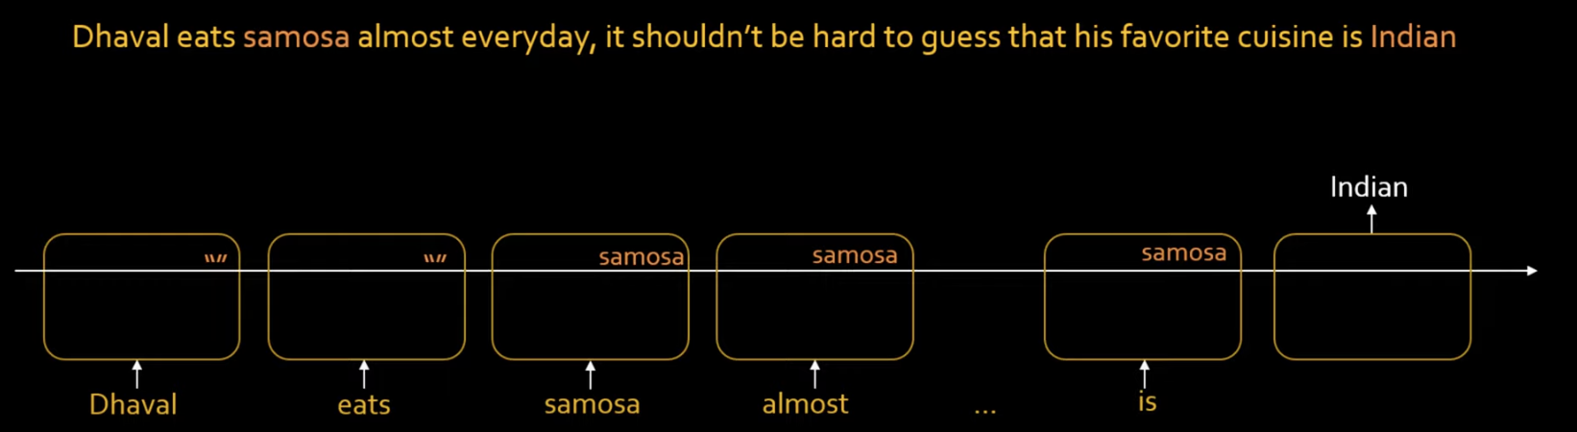

The moment I encounter Pasta, will forget Samosa 🡪 Concept of Forget get

If we want to Discard the previous memory, the sigmoid will return the output close to 0.   
So 0\*Memory of Samosa will return 0.  
