[Food Ingredients Identification from Dish Images by Deep Learning (scirp.org)](https://www.scirp.org/journal/paperinformation.aspx?paperid=108663)

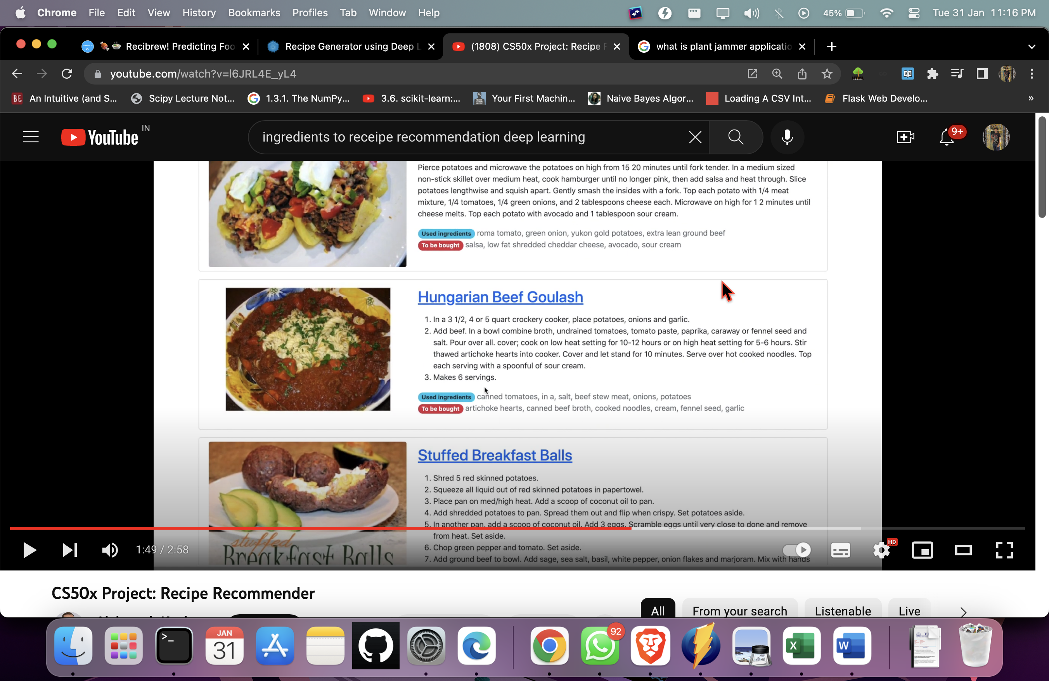

Captured Ingredients 🡪   
To be bought 🡪

Models to be used

<https://jackmleitch.medium.com/using-beautifulsoup-to-help-make-beautiful-soups-d2670a1d1d52>

<https://towardsdatascience.com/building-a-recipe-recommendation-api-using-scikit-learn-nltk-docker-flask-and-heroku-bfc6c4bdd2d4>

<https://towardsdatascience.com/building-a-recipe-recommendation-system-297c229dda7b>

Data-Sets

<https://github.com/kanishk307/IndianFoodDatasetGeneration>

EDA  
<https://github.com/sanju6890/Indian-food-Data-Analysis/blob/main/Indian_food_data_analysis_report.ipynb>

Classification Metrics  
<https://towardsdatascience.com/comprehensive-guide-on-multiclass-classification-metrics-af94cfb83fbd>

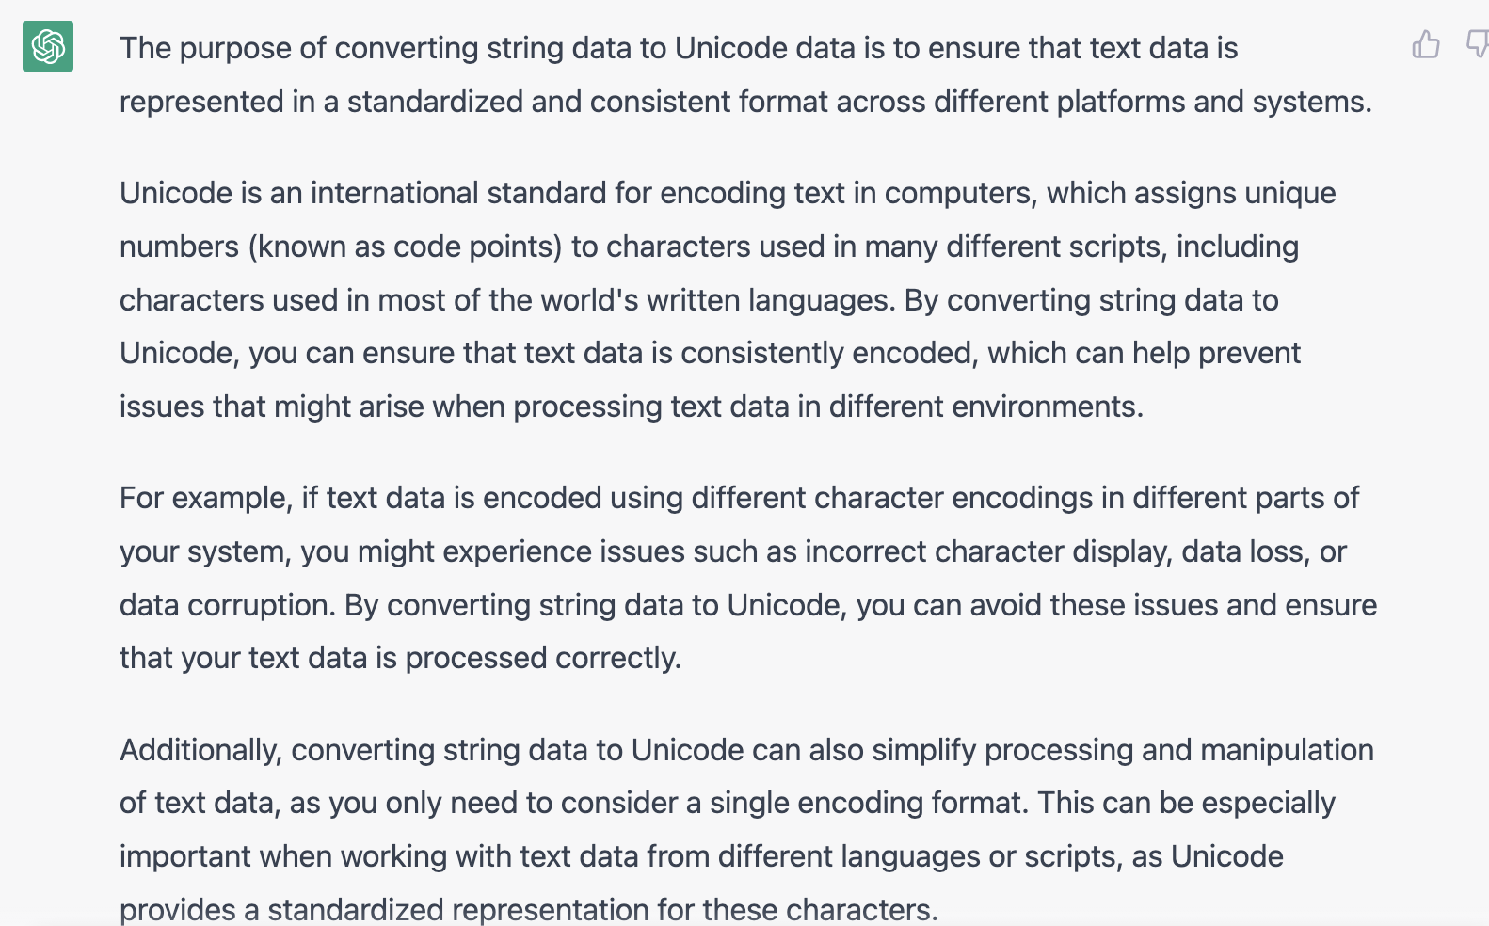

Similarity 🡪 Cosine Similarity, Spacy, KNN

<https://medium.com/smileinnovation/capturing-your-dinner-a-deep-learning-story-bf8f8b65f26f>

Given a recipe, generate a set of similar recipes 🡪 <https://towardsdatascience.com/this-ai-is-hungry-b2a8655528be>

pip install opencv-contrib-python

pip install cvlib

pip install gtts playsound

pip3 install PyobjC

<https://bytes.swiggy.com/image-based-ingredient-prediction-for-an-indian-food-dataset-56b566d98ac0>

Object Detection using YOLO

<https://towardsdatascience.com/how-to-train-a-custom-object-detection-model-with-yolo-v5-917e9ce13208>

**vegetables**

tomato

potato

onion

**fruits**

apple

banana

coffee maker