**Home Url:** [**http://localhost:8080/product**](http://localhost:8080/product)

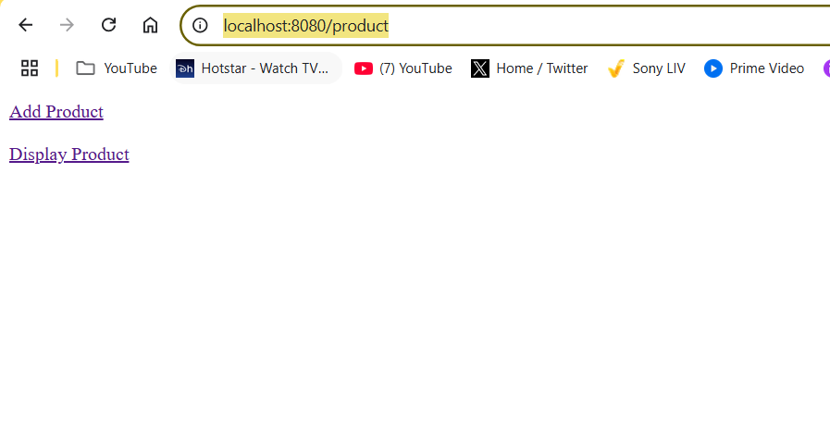

**Post click on Add Product link:**

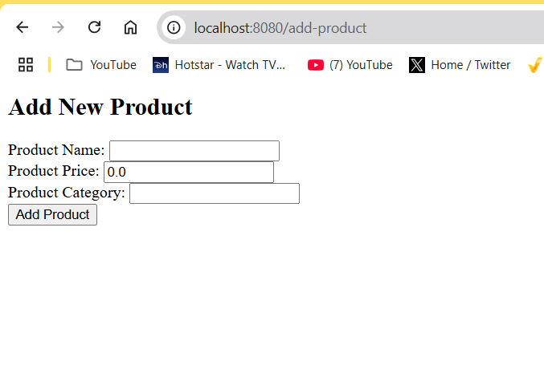

**Once click on Add product button: if will read the details from textbox and insert into table**

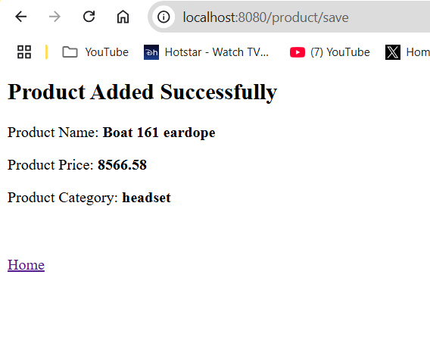

**Goto Home link, and click on Display Product below page will appear will all the details from Database:**

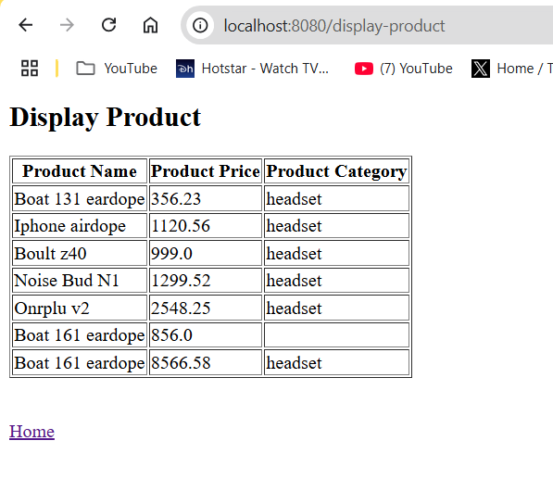

**Mysql Table details:**

