SRS – DIGITAL LOCKER SYSTEM
-C. SABARISH NATHAN
727723EUCS197

- SCOPE:
New users should sign up first using phone number (OTP) and by creating new password.

Registered users can upload and view their personal documents.

Colleges can directly upload authenticated mark sheets into individual student lockers.

The system ensures user privacy, access control, and document integrity.

- STAKEHOLDERS:
Student.

College Admin.

System Admin.

Developers.

- PROBLEM STATEMENT
Students rely on certificates, marksheet, and many more stuffs like that which are vulnerable to lose it, can get any physical damage, and other people for those who can’t carry the license, Adhaar card and other stuffs like that they can upload their some sort of identity card in this website, so they can access those files whenever they need. College marksheets can be lost so college management can upload their college marksheet to every student using the ABC id of every student.
- DATA MODEL:
*User.

*College Admin.

*System Admin.

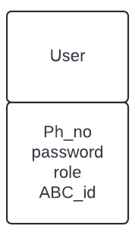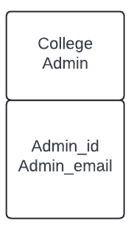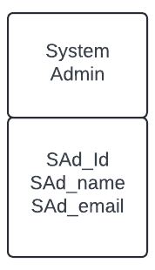

- FUNCTIONAL AND NON-FUNCTIONAL REQUIREMENTS:

*FUNCTIONAL REQUIREMENTS:
- Users are able to upload their certificates.
-College admin uploads marksheet using ABC id of every student.
-System admin can view all the user uploads.

*NON – FUNCTIONAL REQUIREMENTS:
-UI must be responsive across the devices.
-Files must be encryted before upload.
-Upload time must be under 2 seconds for files <10MB.
- UML DIAGRAM:

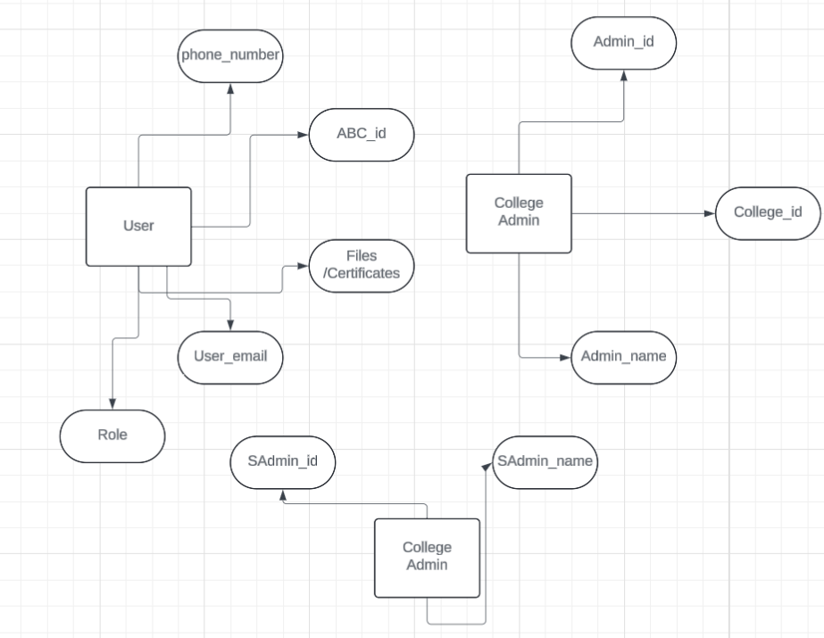

- USE CASE DIAGRAM:

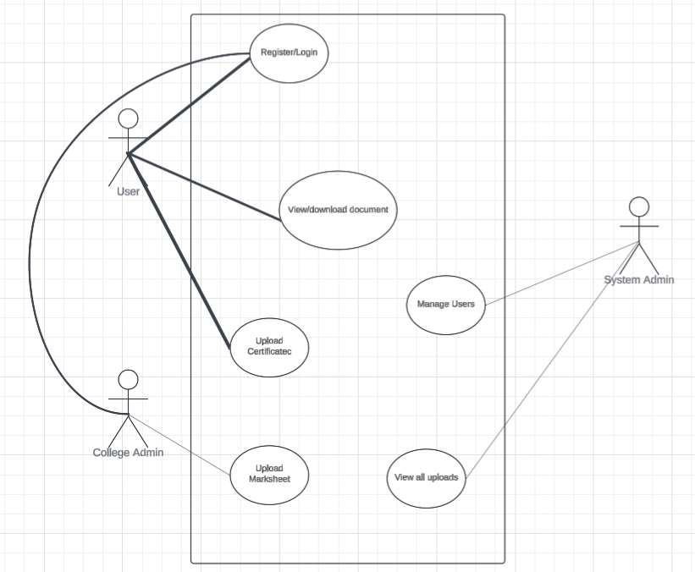

- E-R DIAGRAM:
