**Module 3 - PL/SQL Programming**

**Hands-on exercise**

Exercise 5: Triggers

**Scenario 1:**

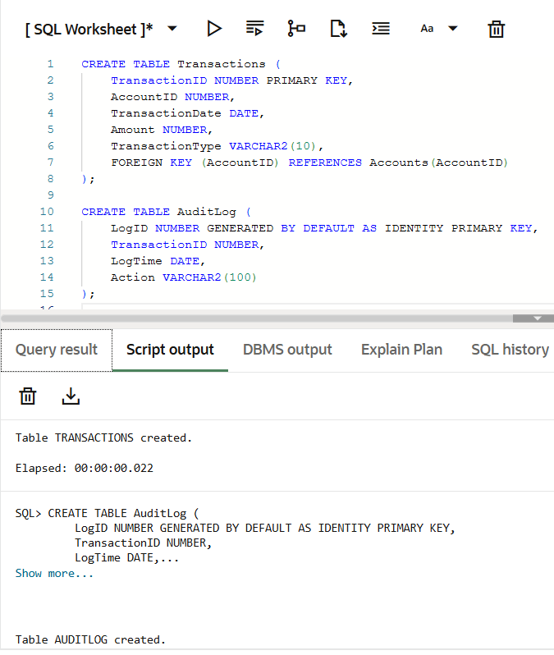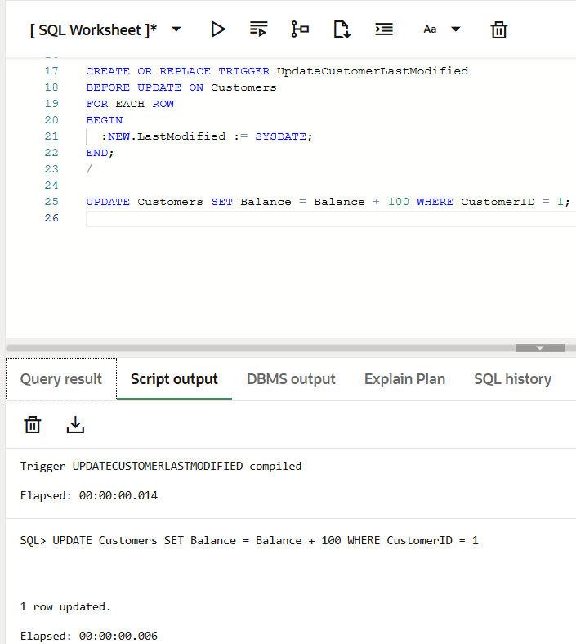

**Scenario 2:**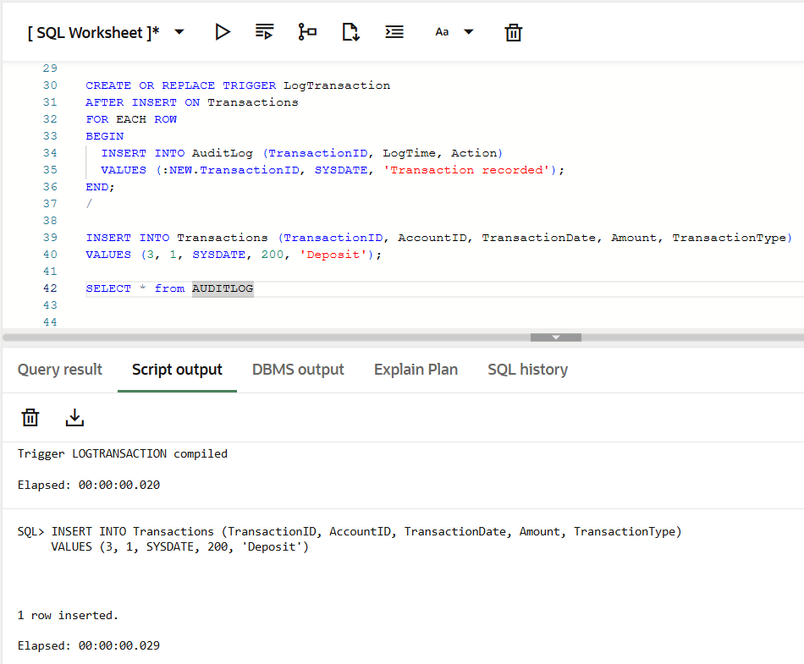

**Scenario 3:**