**Module 3 - PL/SQL Programming**

**Hands-on exercise**

Exercise 6: Cursors

**Scenario 1:**

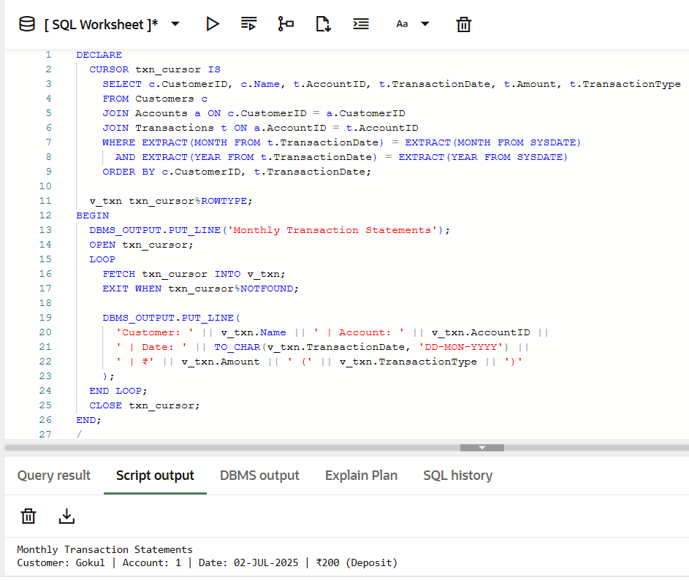

**Scenario 2:**

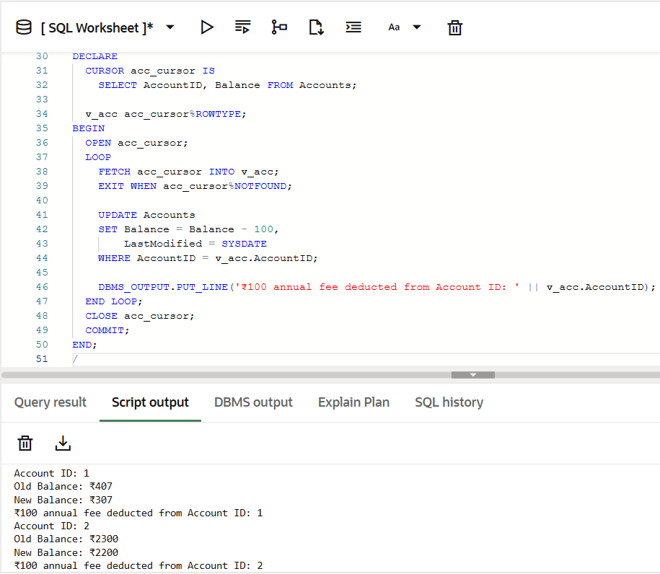

**Scenario 3:**

