STEP 1: PYTHON INSTALLATION

ONLINE :
* Python 3.8 should be installed initially. Download python3.8 (preferred 3..8.10) exe file from the official website. Added link in below and this may change based on their site maintanence

link : https://www.python.org/downloads/release/python-3810/

OFFLINE :
* you can get the python installation exe file from Dependencies folder and follow the below

* double tap to click install and check add python 3.8 add to path and click Install Now. Now click install for all users and continue steps further.

* Note down the path of installing while installing. This path should be used during the environment variable setup
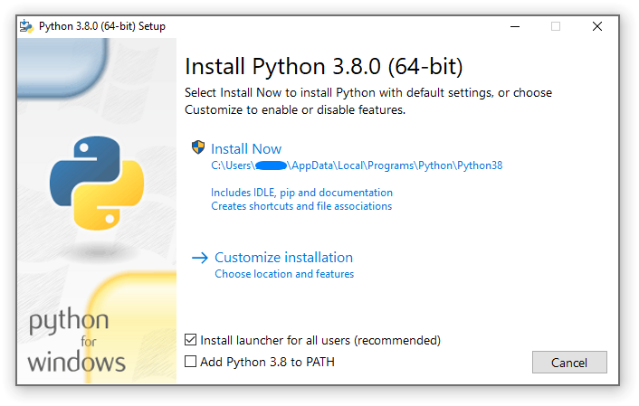

* To check whether it is installed or not, open command prompt and type below to validate

~$ python –version
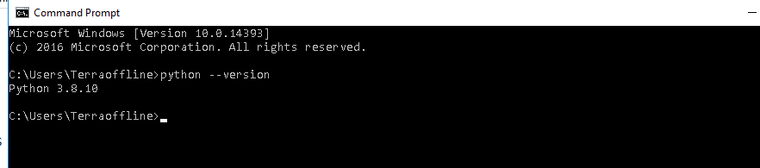

* If you get errors, try adding path’s manually to windows environment variables. For this you’ve to find the python installation path in C drive.

Go to --> mycomputer -right click --> properties --> advanced system settings --> environment variables --> system variables

1) In system variables click on path and add the path you’ve installed python & Scripts folder

ex : C:\Users\Terraoffline\AppData\Local\Programs\Python\Python38
C:\Users\Terraoffline\AppData\Local\Programs\Python\Python38\Scripts

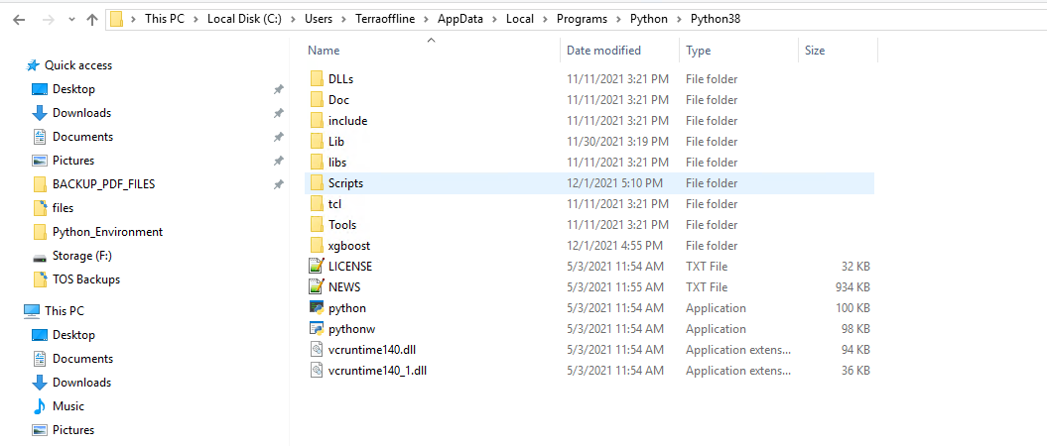
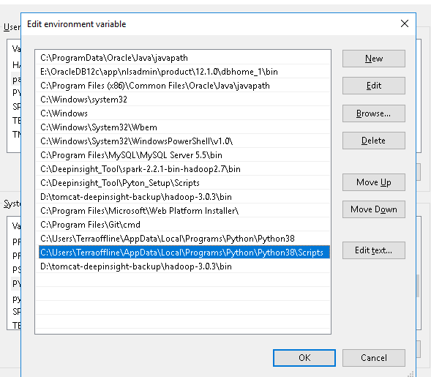

In environment variable click new and add python installed source path as python path
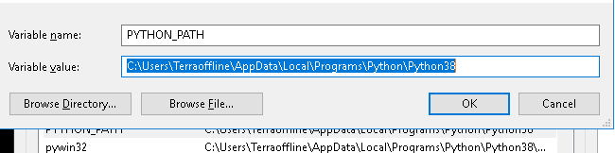
add one more variable, In python source path you may find Scripts folder add that folder as PIP_PATH
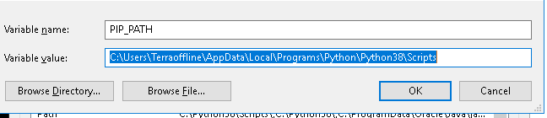

Save and do check now. You may able to get the python version in cmd.

STEP 2: FOLDER STRUCTURE

* To create the folder structure go to the respective path you’ve allocated for installation and create a following directory

* API *Python_Environments

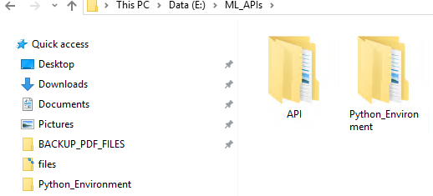

In API folder paste the source file and extract the file

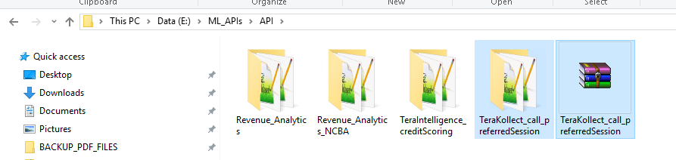

STEP 3: GIT TERMINAL SETUP
ONLINE :
* Download the git terminal using below link and do install it. Do search for Git Bash and open the terminal

Link : https://git-scm.com/downloads

OFFLINE :
* you can get the git installation exe file from Dependencies folder and install, do search for Git Bash and open the terminal
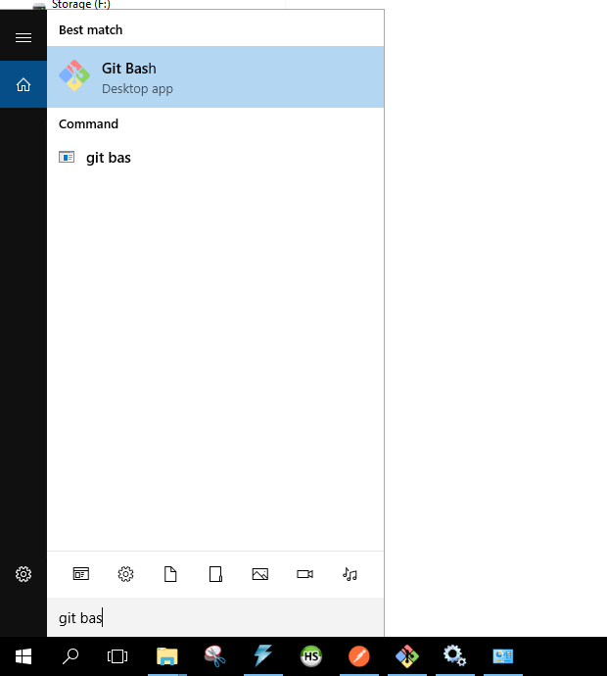
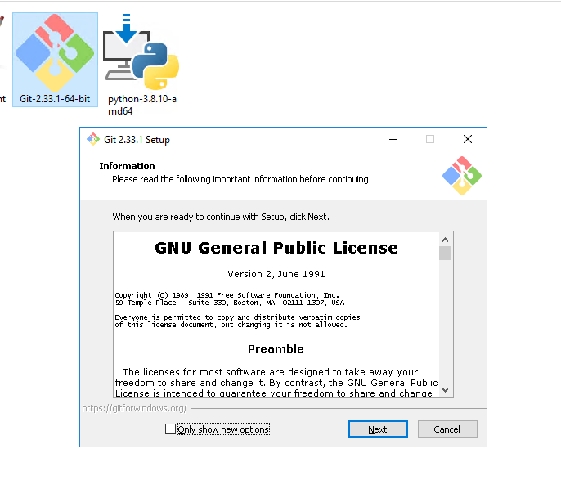

STEP 4: ENVIRONMENT SETUP

* Create the virtual environment and install necessory libraries to the respective enviroment. To create the virtual environmet,first to install virtual environment setup
* Go to project directory

~$ cd E:/ML_APIs/API/Recon_VirtualMatch_SBM

* Move to Dependency directory

~$ cd Dependencies/dependencies

* To install the dependencies

~$ pip install * -f ./ --no-index

* To install virtual environment from local

~$ pip install virtualenv-20.19.0-py3-none-any.whl -f ./ --no-index

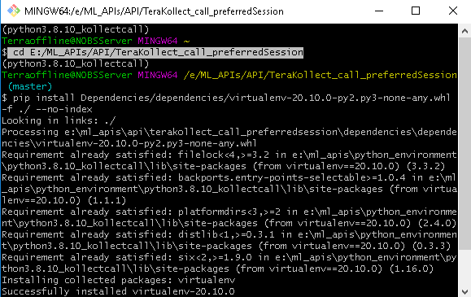

and followed by to create the virtual environment in Python_Environment folder we’ve created. Navigate to python environment folder using below command

~$ cd E:/ML_APIs/Python_Environment

and to install python environment

~$ python -m virtualenv python3.8.10_recon_virtualmatch_sbm

here navigated to Python_Environments path for installing python environment and python3.8_kollectcall_preferred_session is the environment name

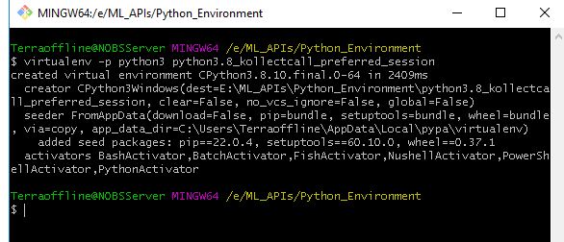

once the environment installed you may find the folder in the respective path you’ve mentioned

* To activate the created python environment

~$ source python3.8.10_recon_virtualmatch_sbm/Scripts/activate

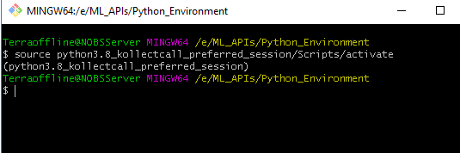

Here we navigated to python environment directory and then /Scripts/activate will activate your environment. you may find the environment name in terminal

* Now install the necessory libraries created environment. first navigate to project directory we’ve extracted and in that find requirement folder & in that requirement.txt have the all the necessory libraries

~$ cd E:/ML_APIs/API/Recon_VirtualMatch_SBM/Dependencies/dependencies
~$ pip install * -f ./ --no-index
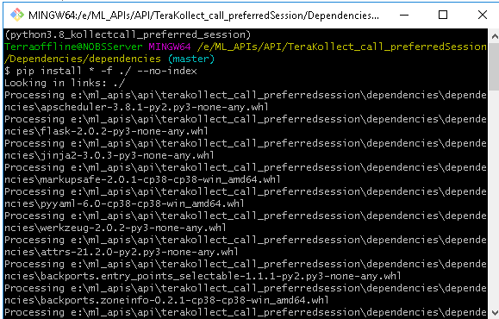

it will take some time based on the libraries we’ve used

STEP 5: DATABASE PREREQUISITES

* make sure the below tables exist in the database

nostro statement
statement$detail$history
tbl_recon_nostro$unmatched$entry
tbl_recon_nostro$matched$entry
recon$aml$api$status

* In further need two table’s to store the model information and input/output details
1) tbl_recon_nostro$execution$history
2) tbl_recon_nostro$virtual$possible$match
you may find the DDL script in project file under MYSQL folder and do execute the script.

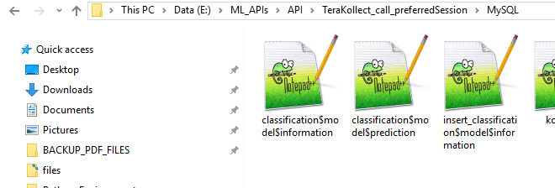

STEP 6: APPLICATION PREREQUISITES

* we are almost done, on last final step to setup is to set up database credentials in config file. To do that in source file go to the config folder and open config.sh using notepad. In that change the values as per the requirement

To encrypt the MYSQL password do the below
* Activate the environment as per above commands
* Nagavigate to project directory using above guidance
and do the follow

~$ source config/config.sh

~$ python -c 'from pyfiles.encryption import live_passkey_encryption; print(live_passkey_encryption("PASSWORD_STRING"))'

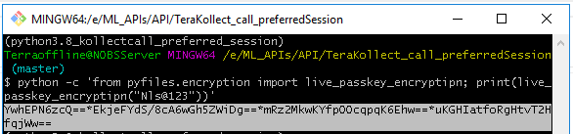

Replace password string with the respective password and enter you will get the encrypted string . Replace the encrypted string with LIVE_MYSQL_PASSWORD string

export LIVE_MYSQL_USER="root"
export LIVE_MYSQL_PASSWORD=”Rs6wIA==*uuYEPmy6/9eshVbHbQ/U4A" # Password encrypted
export LIVE_MYSQL_HOST="127.0.0.1"
export LIVE_MYSQL_PORT=3306
export LIVE_MYSQL_DB="recon_sbm"
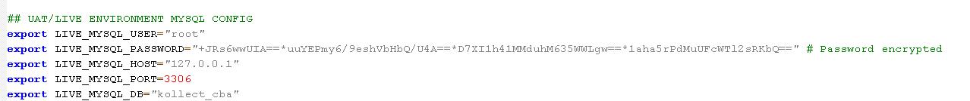

STEP 7 : RUN OUR APPLICATION

* To run our application first to active the python environment we’ve created initially. To active the environment navigate the respective directory and do activate

~$ cd E:/ML_APIs/Python_Environment
~$ source python3.8.10_recon_virtualmatch_sbm/Scripts/activate

* Next, to active the configuration files which has the DB related information. To active the config file navigate to project directory and execute below commands

~ $ cd E:/ML_APIs/API/ Recon_VirtualMatch_SBM
~$ source config/config.sh

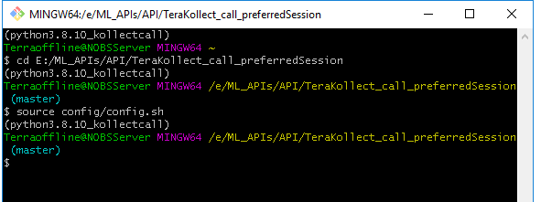

* To exceute the application as background process

~$ nohup python Recon_virtualMatch_app.py &

and type

~$ logout

and close terminal and execute the process in background

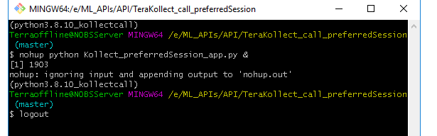
STEP 8: VALIDATE APPLICATION RUNNING OR NOT

* once application is up, the application creates the log files in source file directory under folder log named errorlog.log. You may open using notepad and see the latest time you’ve started the application.

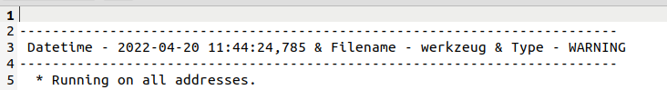

* In another way we may pass the respective url and input details in postman to get our respective output

METHOD TYPE : post
URL: http://127.0.0.1:2018/recon_virtualMatch_customModel
INPUT: {
"ID":1
}

make sure the ID exist in the recon$aml$api$status table

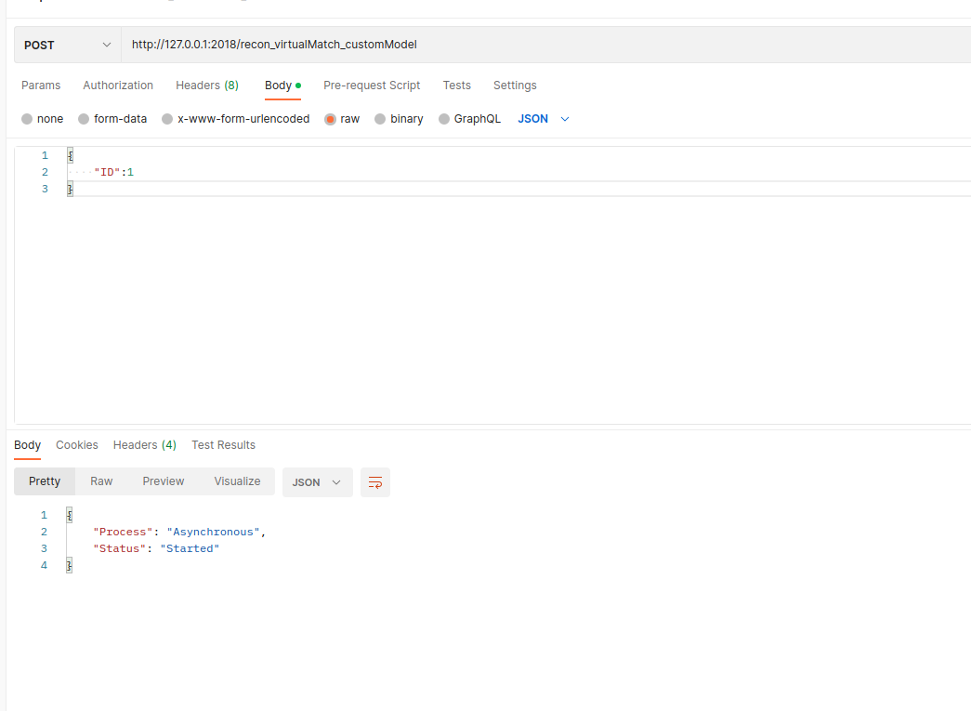

* FURTHER VERSION’S DEPLOYMENT

In the above we’ve seen how to deploy the fresh version.here quickly brief how to deploy the next and further releases

* Extract the latest file to the destination folder
* Activate the respective python environment using above commands
* navigate to the repective project directory in terminal

* First step to terminate the process we’ve executed already in past. We’re running our application in port no 2018 and going to kill our process using port number. To do that in cmd

~$ netstat -ano | findstr :2018
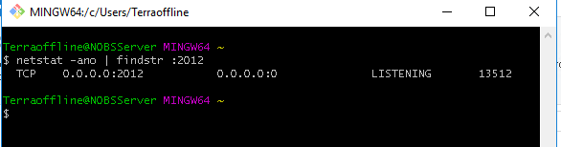

and using the above PID (13512) we have to kill the process. (Some times it may show multiple PID we have to kill all). To double check execute the cmd again and again till it is empty

To kill the PID

~$ taskkill //PID 13512 //F

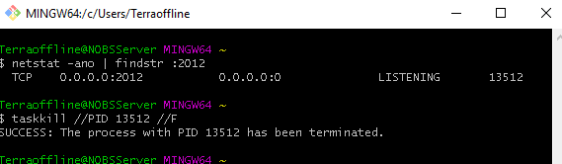

To Run our application again
Do navigate to environment and activate it & navigate to project directory

~$ nohup python Recon_virtualMatch_app.py &

and type

~$ logout

and close terminal and execute the process in background

and this need’s to be validated further, whether the application running or not using the above methods mentioned

