**FINAL REPORT**

**10 YEARS:**

On trying 1000 Monte Carlo runs for 120 wells with 80% chance of dry well the following graphs were obtained.

X-AXIS (No of Monte Carlo runs)

Y-AXIS (Cummulative gas production in mmscf)

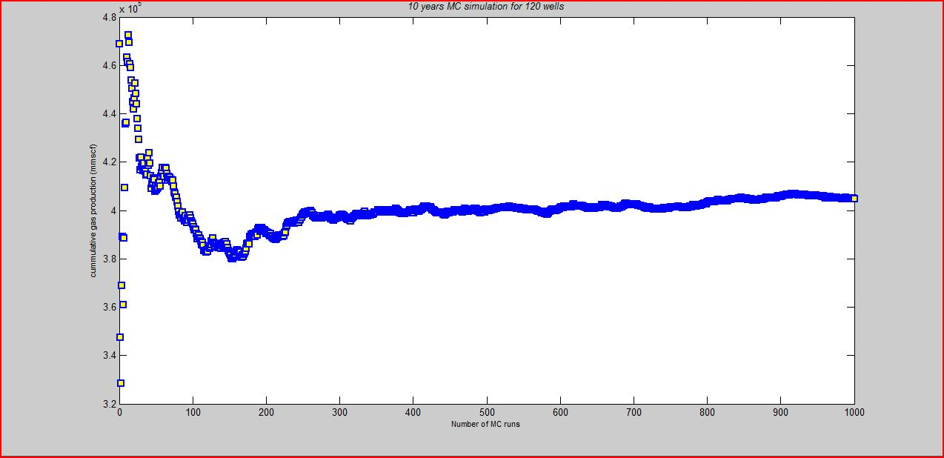

X-AXIS (No of Monte Carlo runs)

Y-AXIS (Cummulative oil production in bbl)

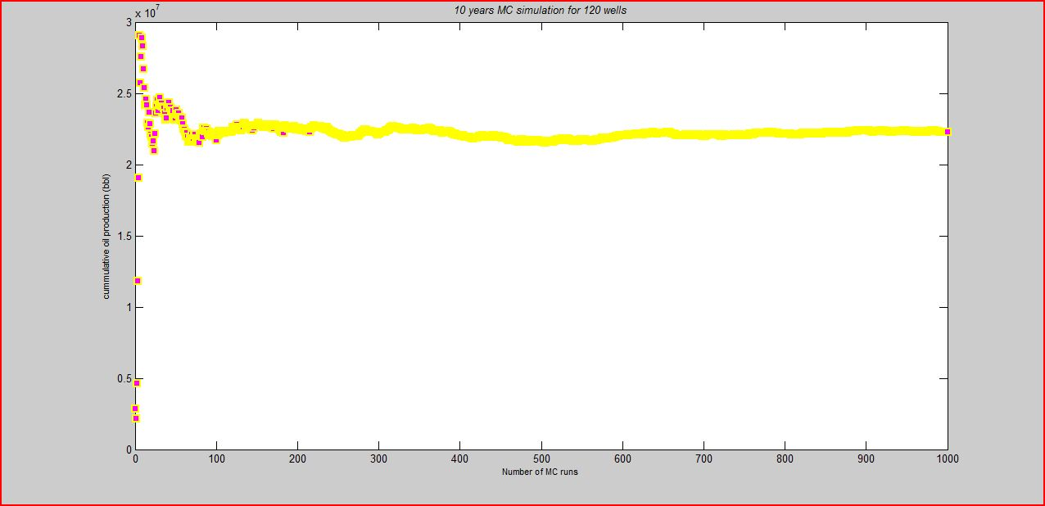

X-AXIS (No of Monte Carlo runs)

Y-AXIS (Return on Investment)

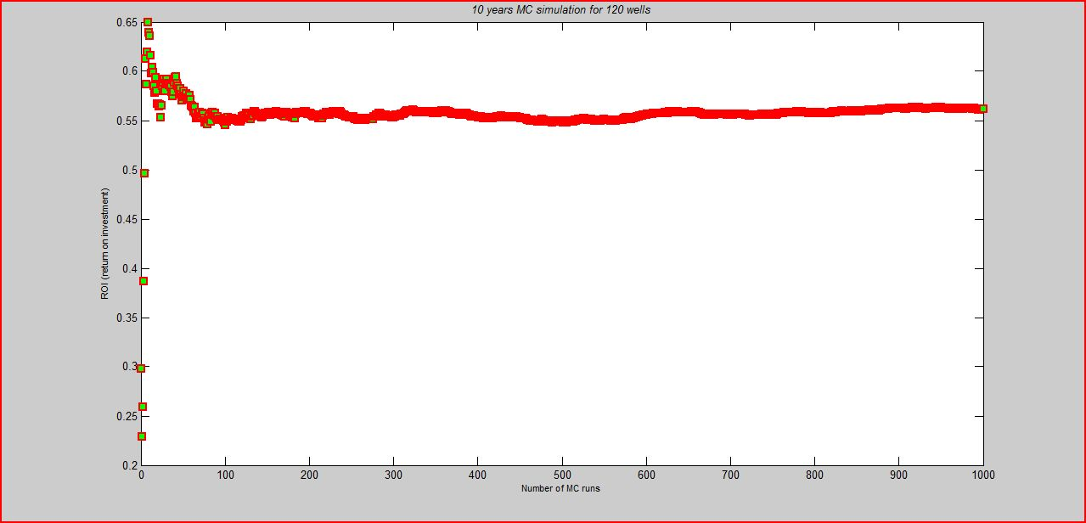

The ROI was approximately found to be 0.57

**20 YEARS:**

On trying 1000 Monte Carlo runs for 120 wells with 20% chance of dry well the following graphs were obtained.

X-AXIS (No of Monte Carlo runs)

Y-AXIS (Cummulative gas production in mmscf)

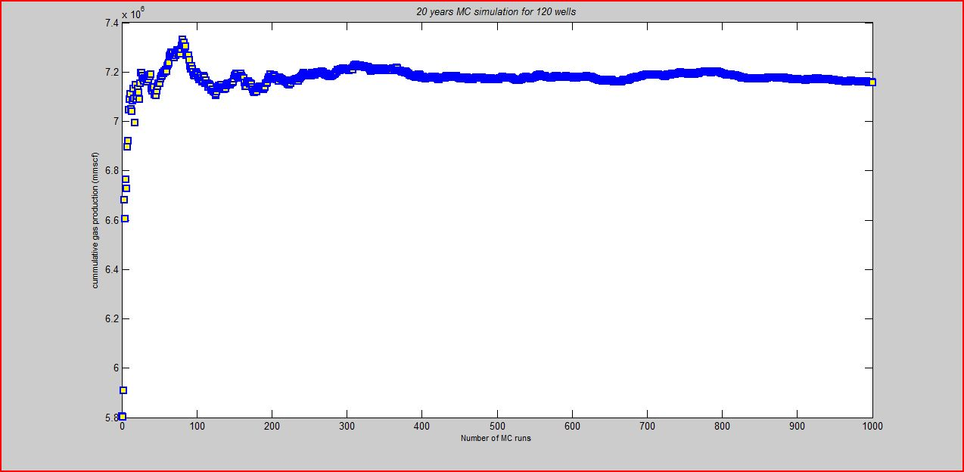

X-AXIS (No of Monte Carlo runs)

Y-AXIS (Cummulative oil production in bbl)

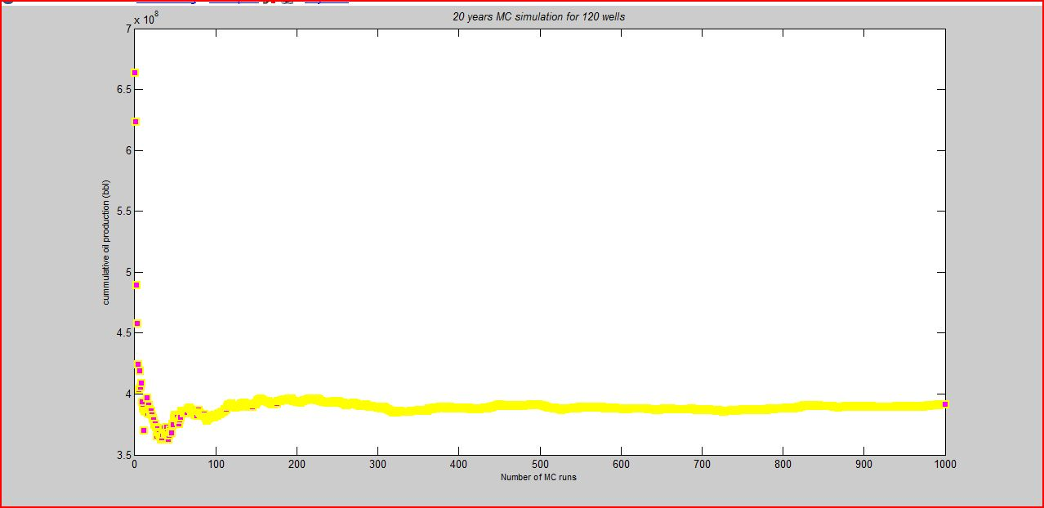

X-AXIS (No of Monte Carlo runs)

Y-AXIS (Return on Investment)

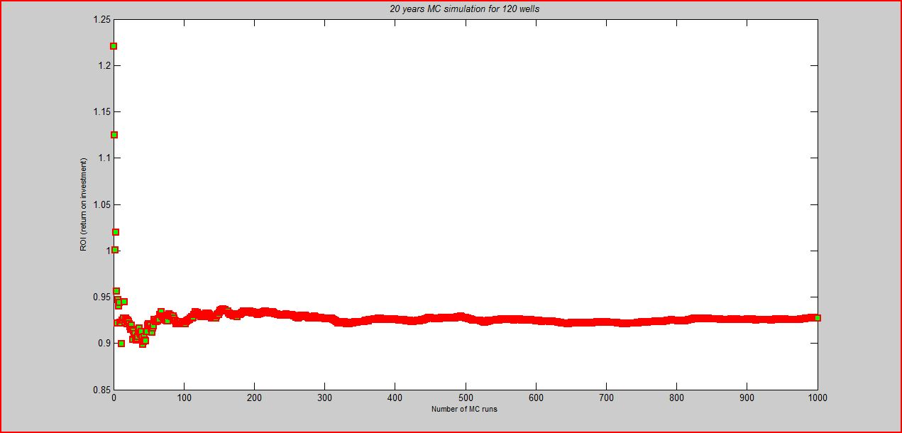

The ROI was approximately found to be 0.958

Since ROI of 20 year economical analysis with 20% chance of dry well in drilling 120 wells is greater than ROI of 10 year economical analysis with 80% chance of dry well in drilling 120 wells, the latter is better option and is very profitable.