Module 5: Critical Thinking Assignment

I learned a lot about branching during this module (Lysecky & Vahid, 2019, section 5). This module really made me think hard about architecting the assignment correctly to ensure the proper calculations and output. I know that it wasn’t part of the assignment but I also learned a lot about making sure we’re testing and looking out for wrong user input, using try/catch blocks.

Output:

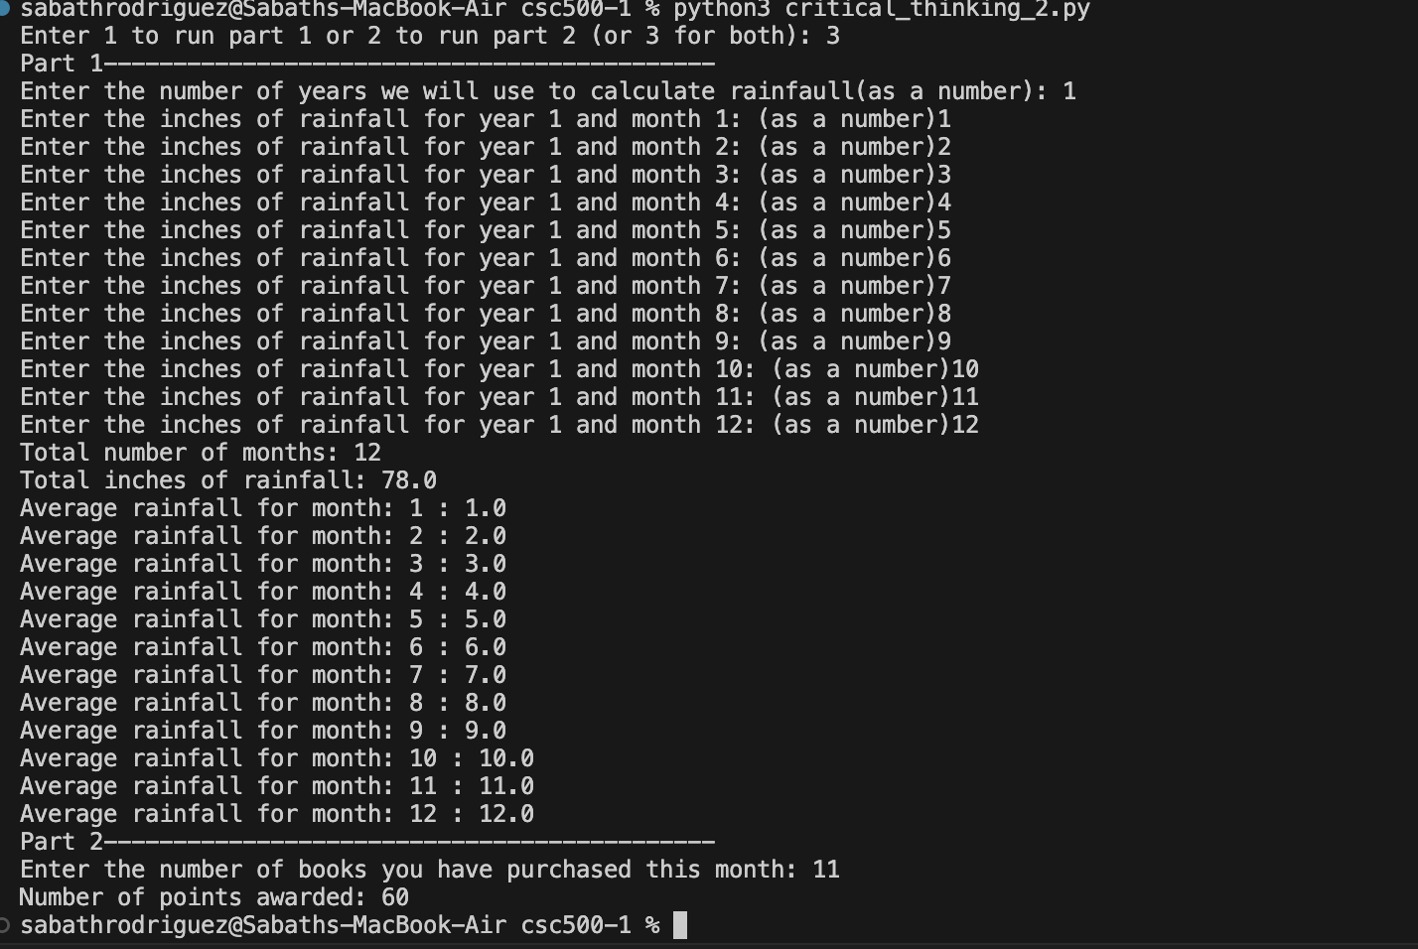

Git:

<https://github.com/Sabathrodriguez/grad_school/blob/main/csc500-1/critical_thinking_2.py>

References

Lysecky, R., & Vahid, F. (n.d.). 5 Branching. In CSC500: Principles of Programming. essay, ZyBooks.