I learned how to properly format strings and relearned the order of operations in programming. String formatting is such an interesting topic and one that varies widely among different programming languages. The creators of python made it simple and straightforward. I learned how easy it is to format an output string as a float with precision (Lysecky & Vahid, 2019, section 3.9). Another thing I relearned was the order of operations when computing data. I realized how important it is to make your expressions legible and clear for a computer to read, and an easy way of doing that is by using parenthesis. (Lysecky & Vahid, 2019, section 2.5)

Output:

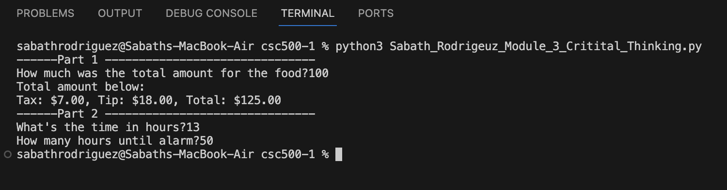

Git:

<https://github.com/Sabathrodriguez/grad_school/blob/main/csc500-1/Sabath_Rodrigeuz_Module_3_Critital_Thinking.py>

References

Lysecky, R., & Vahid, F. (n.d.). 3.9 String Formatting. In CSC500: Principles of Programming. essay, ZyBooks.

Lysecky, R., & Vahid, F. (n.d.). 2.5 Arithmetic Expressions. In CSC500: Principles of Programming. essay, ZyBooks.