On this assignment I learned several things, some technical and some not. I learned how to properly use equality and relational operators (Lysecky & Vahid, 2019, section 5.4). I also learned that I need to slow down and pay attention to details. I would argue that is something much more valuable than learning how to write a for loop, especially in the real world. Going forward I will double check my work prior to submitting any assignments.

Output:

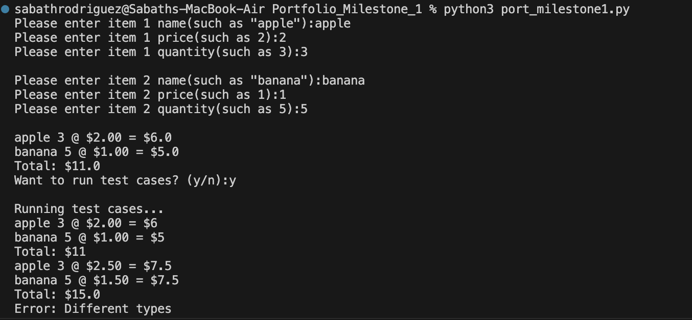

References

Lysecky, R., & Vahid, F. (n.d.). 5.4 Equality and relational operators In CSC500: Principles of Programming. essay, ZyBooks.