**Assignment – 1**

1.

Draw a network for the simple project of erection of steel works for a shed. The various activities of the project are as under:

2.

Draw a network for the project X. The various activities of the project are as under:

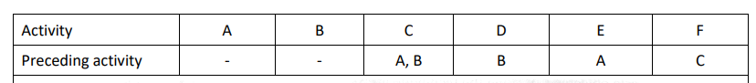

3.

Draw the network diagram for the following list of activities :

4.

Draw the network for the following activities and find critical path and total duration of project:

Use both Activity on Node and Activity on Arow.

5.

The utility data for a network are given below. Determine the total, free, independent and interfering floats and identify the critical path.

