**Assignment**

1. Write a Reusable PHP Function that can check Even & Odd Number and Return Decision.
2. 1+2+3...…….100 Write a loop to calculate the summation of the series.

**Solution:**

**Ans.to the question no 1**

**For Even Number:**

<?php

function checkEvenOrOdd($x){

    if($x % 2 ==0){

        return 1;

    }

    else{

        return 0;

    }

}

$x = 18;

$y = checkEvenOrOdd($x);

if($x == 0){

    echo "Invalid Number";

}

elseif($y==1){

    echo "The number is Even";

}

else{

    echo "The number is Odd.";

}

**Output:**

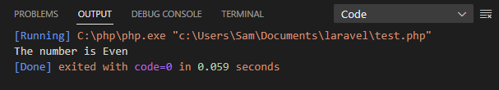

**For Odd Number:**

<?php

function checkEvenOrOdd($x){

    if($x % 2 ==0){

        return 1;

    }

    else{

        return 0;

    }

}

$x = 17;

$y = checkEvenOrOdd($x);

if($x == 0){

    echo "Invalid Number";

}

elseif($y==1){

    echo "The number is Even";

}

else{

    echo "The number is Odd.";

}

**Output:**

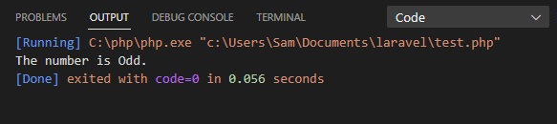

**For 0:**

<?php

function checkEvenOrOdd($x){

    if($x % 2 ==0){

        return 1;

    }

    else{

        return 0;

    }

}

$x = 0;

$y = checkEvenOrOdd($x);

if($x == 0){

    echo "Invalid Number";

}

elseif($y==1){

    echo "The number is Even";

}

else{

    echo "The number is Odd.";

}

**Output:**

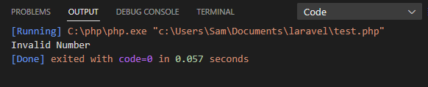

**Ans. to the question no 2**

<?php

$n = 100;

$sum = 0;

for ($i = 0; $i <= $n; $i++){

    $sum = $sum + $i;

}

echo "The Total Sum is : ".$sum;

**Output:**

