
American International University-Bangladesh (AIUB)
Faculty of Science and Technology (FST)
Department of Computer Science (CS)
SDPM Group Project, Summer 2026
Project Title: ShobKaaj - One App for Every Task Near You
Section: B
Submitted by
Name | ID
Sabbir Ahmed | 22-49109-3
Gazi Md Rafayet Hossen | 22-47836-2

1.0 Introduction
This report is our full project plan for ShobKaaj. ShobKaaj is a mobile app that will help people across Bangladesh find everyday help, things like tutoring, delivery, repair work and event setup, from nearby workers they can trust. This report builds on our earlier project proposal and goes into more detail about the reasoning, design and planning behind the app. We are writing this for our SDPM course teacher and evaluators, our client Dr. Anwarul Kabir and our own team since we will keep using this plan while we build the app this semester. This document explains what we are building, why we are building it, who it is for and how we plan to design, schedule, staff and deliver it this semester.
2.0 Project Title
ShobKaaj - One App for Every Task Near You
3.0 Objectives
Primary Objective: To build a safe and easy to use mobile app that connects clients and workers for local jobs and services across Bangladesh, in a way that is verified, quick and reliable.
Sub-Objectives:
Objective 1: Let users verify themselves with their phone number or NID card, so everyone on the app is who they say they are.
Objective 2: Use GPS to match clients and workers who are close to each other in real time.
Objective 3: Add real time chat, ratings and trust badges so people can build a good name on the app.
Objective 4: Add mobile payments (bKash, Nagad) and a Bangla first design that works well on cheaper Android phones.
4.0 Justification
Many people in Bangladesh do not have steady work, while many clients cannot find someone reliable to do a simple job. This gap exists because no single app offers verified, GPS matched, Bangla friendly job listings with built in chat and payments.
Here is what ShobKaaj offers:
I.Makes it faster and easier to find and hire verified local workers
II.Cuts down the manual work of hiring people locally
III.Helps small businesses and households get more work done
IV.Keeps job information correct and organized with proper postings and verified profiles
V.Improves safety with NID and phone verification plus encrypted data
VI.Builds better service quality through chat and honest ratings
VII.Saves money by cutting down scams and bad hires
VIII.Gives admins the tools to spot problems and act faster
5.0 Systems Overview
ShobKaaj is a mobile app that connects people who need everyday help like tutoring, delivery, repair work, event setup and similar tasks with nearby workers they can trust. Finding reliable local help in Bangladesh is harder than it should be. Job and service listings are spread across small apps and informal networks, most apps only cover one type of work, and none of them properly check who you are dealing with. This leaves workers in rural and semi urban areas left out. ShobKaaj brings job discovery, verification, chat and payment together in one simple, Bangla first app that works well even on low end phones.
The diagram below shows how our three main users, Client, Worker and Admin, use the system. It covers everything from signing up and getting verified to posting jobs, matching by GPS, chatting, getting hired, making payments and leaving ratings. It also shows admin actions like managing users, handling disputes and viewing reports.
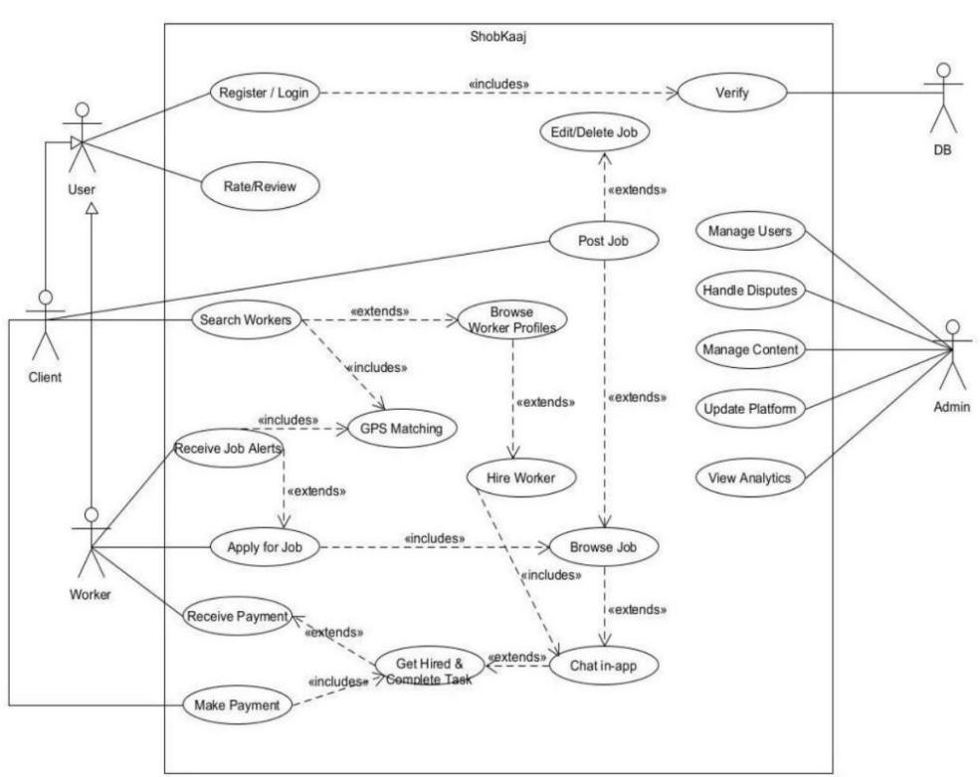
Figure 1: ShobKaaj System Use Case Diagram
6.0 Stakeholders Analysis
Here is a simple list of everyone with a stake in this project:
Stakeholder | Role in the System | Responsibilities | Benefits from the System
Clients | Main requesters of local services | Post jobs, hire workers, make payments, and rate service | Faster, safer access to trustworthy local help
Workers | Service providers looking for paid work | Build profiles, receive alerts, apply for jobs, and get paid | Flexible, verified work opportunities with fair pay
Admin / Platform Team | Oversees platform safety and trust | Verify users, moderate content, resolve disputes | Ensures a safe, trustworthy platform for everyone
Scrum Master | Facilitates the Scrum process | Runs Scrum meetings, clears blockers for the team | Keeps the project running smoothly and on schedule
Product Owner | Defines product direction | Decides what gets built first, defines requirements | Ensures the product matches real user needs
Development Team | Builds and maintains the system | Designs, builds, and tests the app | Gains hands on experience delivering a real product
Payment Partners (bKash, Nagad) | External payment gateway providers | Provide and maintain the payment gateway | Reach more users through transaction volume
Regulatory Bodies (ICT Ministry) | Oversee digital services and compliance | Set and enforce data and service regulations | Ensures the platform operates within legal bounds
7.0 Feasibility Study
Technical Feasibility: The technology we are using, Kotlin/Java with Android SDK on the front end, Node.js and Express on the backend and PostgreSQL/MongoDB for the database is well known and something our team has already used in coursework. So we are confident we can build this in one semester. Real time features like chat and GPS matching can be built with Firebase or Socket.IO and bKash and Nagad both give sandbox accounts we can test with before going live. Hosting on AWS or GCP lets us start small and grow later without rebuilding the system. None of these parts are new or untested, so the main risk is time spent on integration and testing, not whether the technology works.
Financial Feasibility: Based on our COCOMO estimate, the total cost of building ShobKaaj comes to around BDT 17,50,000 (about USD 14,700), spread across an 8 sprint, 17 week schedule. This cost covers design, development, testing, deployment and two months of support after launch. It is broken down sprint by sprint in the budget section of this report, so spending stays predictable and tied to real work instead of one big lump sum. Given the size of the problem ShobKaaj solves and the market it could reach, we think this is a realistic and fair budget for the value the finished app would give.
8.0 Systems Component
Before breaking the system into modules, it is worth being clear about scope. What is included user registration and verification (client/worker/admin), job posting and browsing, GPS based matching, in app chat, payments (bKash/Nagad integration), ratings/reviews and trust badges and admin moderation and dispute resolution. What not included for now are the first version is Android only, built on a REST API backend, iOS and Web versions are not part of this phase, though the system is designed so we can add them later without starting over. What we will deliver: a working Android app, the backend API and database, the source code, UML diagrams, UI/UX designs (Figma) and documentation explaining how everything works.
Based on this scope, we have broken ShobKaaj down into six core modules:
1. Authentication & Verification Module: Handles phone number and NID-based registration, login and identity verification for clients, workers and admins.
2. Job Posting & GPS Matching Module: Lets clients post jobs and matches them with nearby, available workers using GPS.
3. In-App Chat Module: Real-time messaging between clients and workers once a job is posted or accepted.
4. Ratings & Trust Badge Module: Collects reviews after each job and awards trust badges to build reputation over time.
5. Payment & Billing Module: Handles bKash and Nagad transactions, payment status, and payment history.
6. Admin & Moderation Dashboard Module: Gives the admin team tools to verify users, resolve disputes, and view platform analytics.
On top of these six modules, a few features connect everything together: location and skill based search so people can find the right job or worker quickly, role based access so clients, workers and admins only see what applies to them, admin side reports with analytics and dispute logs, and regular backup and recovery for user, job and payment data.
9.0 Process Model to be Followed
We will follow the Agile (Scrum) model for this project.
ShobKaaj has a lot of moving parts: GPS matching, real time chat, payment integration and a verification system, and we do not expect to get everything right on the first try. Agile lets us break the work into short sprints, build and test one part of the system at a time, and adjust based on what we learn instead of fixing every requirement at the start. It also fits how our team is set up, with a Product Owner deciding what to build first and a Scrum Master keeping sprints on track. We are planning the work across a pre game planning phase and 8 sprints, covering everything from requirements and design to final deployment, laid out in detail in the effort estimation and activity diagram sections below.
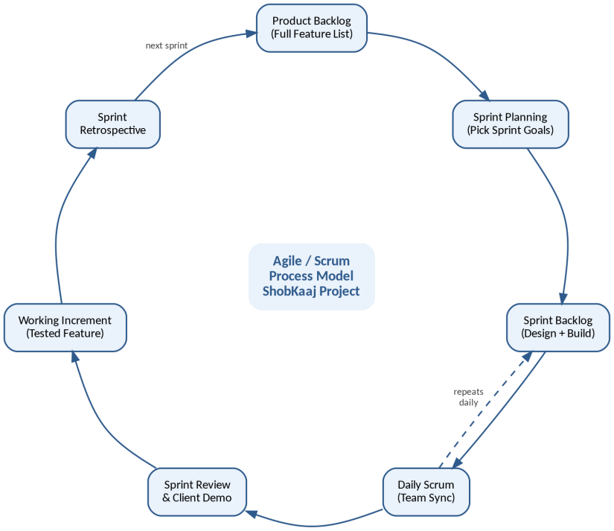
Figure 2: Agile / Scrum Process Model - ShobKaaj Project
10.0 Efforts Estimation
Using COCOMO (Semi detached model, around 10,000 lines of code), we estimate about 39.55 person months of effort for this project. To finish in about 17 weeks, we would need a team of about 9 to 10 people working together across design, development and testing. Here is how we plan to break down the roles and effort by sprint:
Role | Responsibility
Scrum Master | Runs Scrum meetings, clears blockers, supports the team and Product Owner
Product Owner | Decides what to build first, defines requirements
Development Team (4 to 6 members) | UI/UX design, Android development, backend/API work, GPS & payment integration
QA / Test Engineer | Tests functionality, security, and performance across sprints
Admin / Support Staff | Verifies users, moderates content, and handles disputes after launch

Phase | Focus | Approx. Effort (PM)
Pre-Game | Project planning, backlog & environment setup | 1.5
Sprint 1 | Requirements & Design | 5.0
Sprint 2 | Authentication & Profiles | 4.5
Sprint 3 | Job Posting & Matching | 4.5
Sprint 4 | Core Interactions (Chat, Ratings, Payments) | 5.5
Sprint 5 | Engagement & Notifications | 4.0
Sprint 6 | Optimization & Testing | 4.5
Sprint 7 | Beta Release | 4.5
Sprint 8 | Final Deployment | 6.0
Bottom Up Method: Second Estimate
To check our COCOMO number, we also estimated the project a second way. This time we split the whole project into its smaller tasks, based on the modules in section 8.0 and the general planning work, and gave each task its own effort in person days. Adding all of these up gives us the total effort for the project. This is called the bottom up method, since it builds the big number from many small ones instead of using one formula for the whole system.
Here is how we split the work. Requirements analysis and planning took about 60 person days. UI and UX design in Figma took about 70 person days. The authentication and verification module took about 90 person days. The job posting and GPS matching module took about 110 person days. The in app chat module took about 90 person days. The ratings and trust badge module took about 60 person days. The payment and billing module took about 100 person days. The admin and moderation dashboard took about 80 person days. Integration and system testing took about 120 person days. Deployment, documentation and support setup took about 90 person days.
Added together, this comes to about 870 person days. If we count 22 working days in a month, that works out to close to 39.5 person months. Our COCOMO estimate was 39.55 person months, so the two methods land on almost the same number. Since two different ways of estimating give us nearly the same result, we feel confident that our effort estimate for ShobKaaj is realistic.
11.0 Activity Diagram
The diagram below shows the order of activities in our project schedule, and how each phase depends on the one before it across our 17 week timeline. Because we are following this sprint order one after another, a delay in one sprint can push back the final delivery date, so we plan to track progress closely at each sprint review.
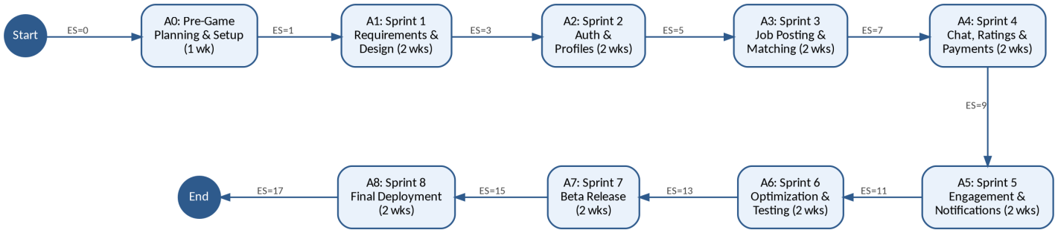
Figure 3: ShobKaaj Activity Precedence Network Diagram
12.0 Risk Analysis
Here are the main risks we've identified for this project, along with how we plan to manage each one:
GPS Accuracy in Rural Areas: GPS matching may be less accurate in low connectivity rural and semi urban areas. To fix this, we have added a manual location entry option as a backup, so matching still works when GPS signal is weak.
Third-Party Dependency: bKash, Nagad and mapping services are outside our control, and any downtime, fee changes or policy updates on their end could affect our app. To fix this, we will use their sandbox accounts early in development and build the integrations in a way that lets us adapt quickly if something changes.
Data Security & Privacy: Storing phone numbers and NID details makes user data sensitive and worth protecting. To fix this, we will encrypt sensitive data both while it moves and while it is stored, and limit access to verification data to the admin module only.
Scope Creep: Requirements could keep growing once the client sees the product taking shape. To fix this, we are running Agile sprints with a fixed scope per sprint, and sending any new requests through the Product Owner before they are added to the backlog.
User Trust & Adoption: People are used to finding work and workers informally, so getting them to trust and use a new app is not guaranteed. To fix this, ratings, trust badges and admin verification are built in from day one to build trust early.
Team & Resource Risk: As a student team, our time is limited by classes and exams alongside the project timeline. To fix this, we use clear task assignment, extra time built into sprints, and regular Scrum check ins to catch delays early and share out work again if needed.
Alongside these risks, a few assumptions and limits shape this plan. We are assuming we will get the information, approvals and any branding assets we need on time, that cloud hosting and payment gateway sandbox access will be ready before we deploy, and that the core requirements will not change a lot once development starts unless we all agree to it. In terms of limits, anything outside this scope, like building iOS or Web versions, would need extra time and cost; outside services (bKash, Nagad, GPS/mapping) come with their own terms, fees and uptime that we do not control; and GPS matching may be less accurate in low connectivity rural areas, which is why we have added the manual location option mentioned above.
13.0 Budget for the Project
Based on our COCOMO estimate (about 39.55 person months) and a tight 17 week schedule. Here is what the project would cost from start to finish.
Total Project Cost: BDT 17,50,000 (approx.) / USD 14,700 (approx.)
Category | Estimated Cost (BDT)
Requirements & UI/UX Design (Sprint 1) | 2,00,000
Backend & Authentication Development (Sprint 2) | 2,50,000
Job Posting, Matching & GPS Integration (Sprint 3) | 2,50,000
Chat, Ratings & Payment Integration (Sprint 4) | 3,00,000
Notifications & Localization (Sprint 5) | 1,50,000
QA, Security & Performance Testing (Sprint 6) | 2,00,000
Beta Release & Feedback Iteration (Sprint 7) | 1,50,000
Final Deployment, Admin Tools & Documentation (Sprint 8) | 2,50,000
Total | 17,50,000
(These numbers are an estimate for this proposal. We will check them against real hosting, vendor and API costs before anything is final.)
By the end of the project, the client will receive:
A fully working ShobKaaj Android app
Source code (both app and server side)
The database schema and a test database
A user manual
Technical documentation (including the use case, class, state, activity and sequence diagrams)
An installation guide
A short training session for admin/support staff, if needed
60 days of warranty support after delivery
Once the project is finished and accepted, we will give 60 days of warranty. If anything breaks because of how we built it, we will fix it at no extra cost during that time. After the 60 days, we are happy to keep supporting the app with updates, new features and support for more users under a separate agreement.
14.0 Conclusion
Through this project, we wanted to design something that could make finding trustworthy local help, and finding real work, easier for people across Bangladesh. ShobKaaj brings verification, GPS based matching, in app chat, ratings and mobile payments together into one simple, Bangla first app that we believe fills a real gap in a market that is currently held together by scattered listings and informal networks. In this report, we have gone through our objectives and reasons, our stakeholders and system design and our technical plan, schedule, risks and budget built around an Agile process. We believe this plan will help us deliver a working, safe and useful product by the end of the semester and we are looking forward to building it.

