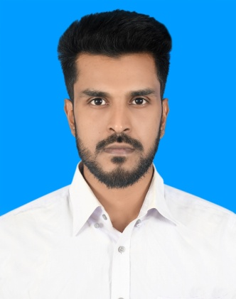

**CurriculumVitae** *of*

Md.Sabbir Hasan

**Mailing Address:** House: 325/1, Village: Atua Kha Para, Post: Pabna, District: Pabna Sadar – 6600.

**Mobile:** 01797152105

**E-mail:** [sabbirhossainn366@gmail.com](mailto:sabbirhossainn366@gmail.com)

**Protfolio:**

# CAREER OBJECTIVE

Seeking of an opportunity to my knowledge and capabilities to work in an organization proper utilizing my strong imagination and communication challenge, this will help to your organization and build up my career.

# EDUCATIONAL BACKGROUND

### Diploma in Engineering

Technology : Computer (66).

Institution : Pabna Technical School And College.

Location : Technical Road, Pabna 6600.

Result : 3.33 (Scale of 4).

Passing Year : 2020.

Board : Bangladesh Technical Education Board, Dhaka.

### Secondary School Certificate (SSC)

Subject : Computer (66).

Institution : Pabna Technical School And College.

Location : Technical Road, Pabna 6600.

Result : 4.07 (Scale of 5).

Passing Year : 2016.

Board : Bangladesh Technical Education Board, Dhaka.

# TRAINING BACKGROUND

### Professional Responsive Web Design

Institution : Creative IT Institute.

Location : Momotaz Plaza (4th Floor), Dhanmondi , Dhaka-1205.

Duration : 3 Month.

Passing Year : 2020.

# COMPUTER SKILLS

Application Package : MS Word, Excel & PowerPoint.

Responsive Web Design : HTML, CSS, BOOTSTRAP, JAVA SCRIPT, JQUERY.

# LANGUAGE PROFICIENCY

Bangla : Fluent.

English : Full working knowledge in English.

# PERSONAL INFORMATION

Full Name : Sabbir Hasan.

Nick Name : Sabbir.

Father’s Name : Robiul Hasan.

Mother’s Name : Johura Begum. Permanent Address : Atua Kha Para, Pabna.

Date of Birth : 01-01-2000.

National ID : 6911224019.

Birth Certificate : 2000762553000865.

Blood Group : B+

Marital Status : Unmarried.

Religion : Islam.

Nationality : Bangladeshi.

Interests : Traveling, Playing, Listing Song & Reading.

# REFERENCES

## 01.

**MD Hasanuzzaman CI**

Department Head, CSE

Pabna Technical School & College Cell: 01716-884437

E-mail:

**02.**

**M.h. Sajjad Hossain Ripon** Web Developer At Jayed Corp. Creative IT Institute

Cell: 01913-055200

[E-mail: mail.mhsajjad@gmail.com](mailto:mail.mhsajjad@gmail.com)

***sabbir***

.......................................

## Signature and Date