Understanding Extreme Floods And Their Impact On Crops In The Sylhet Region: A Probabilistic Deep Learning Approach

Abstract

Introduction
Flash floods represent among the most devastating natural disasters due to their sudden occurrence, often triggered by intense, short-term rainfall [1]. Their rapid onset, within minutes to just a few hours following heavy rains, leaves little time for effective response, resulting in profound consequences such as loss of life, property damage, disruption of infrastructure, and environmental degradation [2]. While it's impossible to entirely prevent the irreversible impacts of floods, their severity can be significantly reduced through appropriate disaster management strategies [3]. In recent years, flood management approaches have evolved, emphasizing both non-structural measures and structural planning within disaster management frameworks [4]. Among these strategies, flood susceptibility mapping plays a crucial role, enabling early warning systems, facilitating emergency responses, mitigating future flood risks, and guiding flood management initiatives [5–7]. Thus, accurate flood susceptibility mapping is essential for precisely identifying areas vulnerable to flash floods and ensuring effective disaster preparedness and response.
Bangladesh, situated at the confluence of the Ganges, Brahmaputra, and Meghna river systems in Southeast Asia, is among the most flood-prone countries in the world. This vulnerability is particularly pronounced in the northeastern region, including Companiganj Upazila in Sylhet, due to its unique geographical and hydrological characteristics. With approximately 92.5% of the river basin area located beyond the country's borders, Bangladesh is significantly impacted by transboundary water flows, especially during the monsoon season [8]. The region receives heavy monsoon rains, with over 80% of its annual precipitation occurring between June and September, frequently resulting in flash floods that inundate extensive areas [9]. Contributing factors include rising sea levels, insufficient sediment deposition, and widespread deforestation, which further exacerbate the flooding situation [9, 10].
Companiganj Upazila, situated near the Doloi and Piyain rivers, is especially prone to extreme weather events, significantly affected by upstream water flow from the Indian state of Meghalaya. The flash floods of 2022, which submerged over 90% of Companiganj Upazila, starkly illustrate the severe impacts of climate change and shifting hydrological dynamics in the region [11]. The northeastern haor (wetland) area is particularly vulnerable to flash floods due to its low-lying topography and land use patterns, categorizing it as a high flood-prone zone [11]. Additionally, long-term weather data from Meghalaya indicate a rising trend in maximum temperatures, and while increases in rainfall are statistically non-significant, the interplay of these factors contributes to the intensification of extreme weather events in the region [12]. Moreover, the geological composition of the Surma Basin, known for its significant hydrocarbon potential, may also impact local water management and environmental policies.
In the past two decades, the utilization of machine learning (ML) based data-driven models in flood susceptibility studies has significantly escalated. This surge is attributed to their robust capacity to develop effective and dependable solutions [13, 14]. In Bangladesh, flood susceptibility studies employing ML techniques have been conducted at various scales, including the national [10] [15], basin [16–18], and regional levels [19, 20]. Nevertheless, there remains a notable gap in research focusing specifically on flash flood susceptibility at the local scale.
Traditional flood prediction models often struggle to effectively capture the complexities of variable topography and rapidly changing rainfall patterns, especially in regions like northeastern Bangladesh. This limitation has prompted the adoption of ML approaches as more viable alternatives. Recent research suggests that ML models can utilize global precipitation data alongside local hydrological information to predict flood peaks in ungauged areas, achieving performance levels comparable to those of locally trained models [21]. ML techniques, such as Random Forest (RF) and Support Vector Machines (SVM), have shown significant effectiveness in flood prediction, particularly when integrated with Geographic Information Systems (GIS). These models have exhibited high accuracy in flood susceptibility mapping; for instance, studies have reported that algorithms like RF and Extreme Gradient Boosting achieved area under the curve (AUC) values exceeding 0.80 [22, 23].
While ML models have been extensively applied in flood susceptibility assessments globally [24–26], only one study has specifically examined their effectiveness in assessing flash flood susceptibility in Bangladesh using RF and SVM [27]. Notably, no research has explored the use of Deep Learning models in this context. Therefore, this study presents a novel approach by assessing the performance of two Deep Learning (DL) models, Convolutional Neural Networks (CNN) and Long Short-Term Memory (LSTM), in flash flood susceptibility assessment at the local scale using statistical and spatial metrics.
The present study aims to address the critical research gap in understanding extreme floods and their agricultural impacts in the Sylhet region by employing a probabilistic deep learning approach. This research seeks to develop a highly accurate flood forecasting model for the region by integrating the extensive coverage and all-weather capabilities of Sentinel-1 satellite data with rainfall and other meteorological information. Leveraging the advanced machine learning techniques applied to Sentinel-1 data, the study will enhance the accuracy of weather and flood prediction models. Additionally, it will analyze patterns of extreme flooding, evaluate their impact on crop availability, and identify the areas most vulnerable to such events. The findings are intended to support disaster management efforts and inform stakeholders and policymakers in crafting effective flood prevention strategies, thereby contributing to sustainable agricultural and regional development.

Methods

FCF Selection

To enhance the predictive accuracy of the model, a careful feature selection process was undertaken, addressing the inherent multicollinearity among meteorological variables due to their natural interdependence. Predictor variables with correlation coefficients exceeding 0.8 were excluded to minimize redundancy and ensure the inclusion of meaningful features [15]. Additionally, the Information Gain Ratio (IGR) was employed as a metric to evaluate the significance of features, utilizing a 10-fold cross-validation technique for robust assessment. Features with zero importance, as determined by IGR analysis, were excluded from the model training phase to avoid introducing irrelevant factors that could negatively impact model performance [26].

Data Pre-processing
Data preprocessing was a critical step in preparing the dataset for analysis after exporting the CSV file from GEE. Initially, the dataset was loaded into Python, which contained various features essential for flood susceptibility modeling, including elevation, NDVI, NDWI, slope, TWI, TPI, precipitation, soil type, distance to water, and distance to road. To ensure that the model could learn effectively, the feature data underwent standardization using a `StandardScaler`. This process adjusted the features to have a mean of zero and a standard deviation of one, which is crucial for improving the convergence of the learning algorithms, particularly in neural network training. Subsequently, the data was reshaped to conform to the input requirements of the CNN and LSTM. Specifically, the samples were restructured to include a single temporal step, ensuring that the model could process the spatial and temporal characteristics of the data effectively. Finally, to evaluate the model's performance rigorously, the dataset was split into training and testing sets. A total of 70% of the data was designated for training the model, allowing it to learn the underlying patterns and relationships between conditioning factors and flood occurrences. The remaining 30% was set aside for testing, enabling an assessment of how well the model generalized to unseen data.

Deep Learning Models Evaluation
In this study, two deep learning models, a CNN and a LSTM network, were developed, trained, and evaluated for the classification of flood and non-flood events based on cross sectional data.
Convolution Neural Network (CNN)
Convolutional Neural Networks (CNNs) have a deep structure that enhances their ability to extract features compared to traditional Artificial Neural Networks (ANNs). When data is input into a CNN, numerous features are extracted through repeated convolution and pooling operations, which also help reduce the weights. These features are then processed in a fully connected layer to generate the regression results. By utilizing a weight-sharing mechanism, CNNs assign identical weights to multiple neurons, reducing the overall number of parameters and improving computational efficiency [28]. The CNN model was constructed using a sequential architecture, starting with a one-dimensional convolutional layer that applied 32 filters with a kernel size of 3 and a ReLU activation function. This was followed by a max pooling layer to down-sample the feature maps, and a second convolutional layer with 64 filters, also followed by max pooling. The model was then flattened and passed through a dense layer with 128 units before the final output layer, which employed the softmax activation function for binary classification. The model was compiled using the Adam optimizer with categorical cross-entropy as the loss function and accuracy as the evaluation metric. During the training phase, the CNN model was fit to the training data over 50 epochs with a batch size of 28, and validation was performed on a separate test set.
Long Short Term Memory (LSTM)
Long Short-Term Memory (LSTM) networks are widely used in climate prediction due to their ability to address long-term dependency issues in Recurrent Neural Networks (RNNs). They are particularly effective at capturing nonlinear features in climate data through the coordinated operation of three key gates. The input gate determines the amount of new information stored in the memory unit, while the forget gate controls the extent to which previous data is discarded. The output gate manages the information passed from the memory unit to the next layer. These gates work together to process and regulate climate data, enabling LSTM to effectively capture and analyze long-term dependencies. By integrating both short-term and long-term memory, LSTM networks can recall and process information across various timescales, making them well-suited for forecasting climate changes [29]. The LSTM model was built to capture temporal dependencies within the sequential data, utilizing a two-layer architecture where the first LSTM layer included 64 units and returned sequences for the subsequent layer. A dropout layer followed each LSTM layer to prevent overfitting. The output layer was also designed for binary classification with softmax activation. Like the CNN model, the LSTM model was compiled using the Adam optimizer and trained for 50 epochs with the same batch size and validation data. Both models were visualized through training and validation accuracy and loss plots.

Model Evaluation Metrics
The models were evaluated using a combination of spatial and statistical metrics, including precision (P), recall (R), specificity (S), accuracy (ACC), kappa coefficient (κ), and F-score (F), which are widely recognized for their effectiveness in assessing model performance. A confusion matrix classified four outcomes: true positives (TP), false positives (FP), true negatives (TN), and false negatives (FN). High TP and low FP values indicate better model performance. The statistical measures were calculated as follows (1 – 5):
$$Accuracy=\frac{True Positive+True Negative}{True Positive+True Negetive+False Positive+False Negative} (1)$$
$$Precision= \frac{True Positive}{True Positive+False Positive} (2)$$
$$Recall= \frac{True Positive}{True Positive+False Negative } (3)$$
$$F1 Score= \frac{2*Precision*Recall}{Precision+Recall } (4)$$
$$Specificity= \frac{True Nagative}{True Negative+False Positive} (5)$$

RESULT AND DISCUSSION

FCF Analysis
Feature importance was assessed using a Random Forest model in Python with a 10-fold cross-validation technique, revealing that distance to road (distToRoad) held the highest importance at 0.14, followed by distance to water, NDVI, NDWI, and TPI, each at 0.12 [Figure 1]. The analysis found that all features demonstrated some degree of importance, so none were eliminated at this stage. Pearson correlation analysis revealed no strong linear relationships among the factors, except for a high negative correlation of -0.99 between NDVI and NDWI [Figure 2]. Due to this near-perfect multicollinearity, NDWI was excluded from further analysis. Consequently, the final set of flood conditioning factors included elevation, NDVI, slope, TWI, TPI, precipitation (precip), soil type, distance to water, and distance to road (distToRoad).

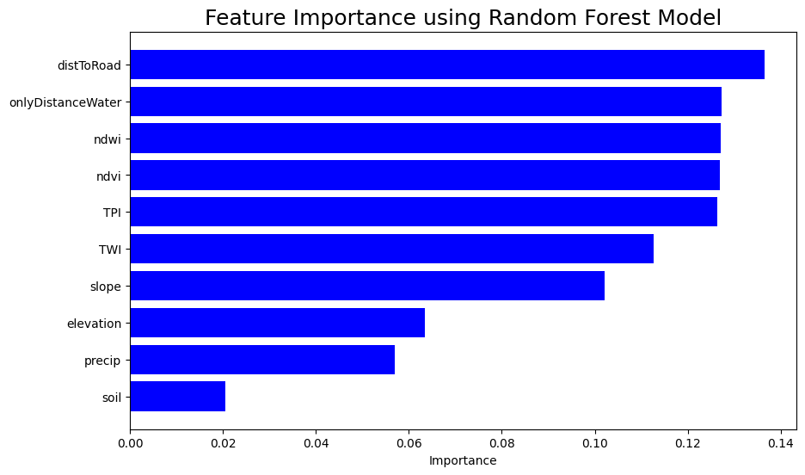

Figure 1: Feature importance using Random Forest model for deep learning approach
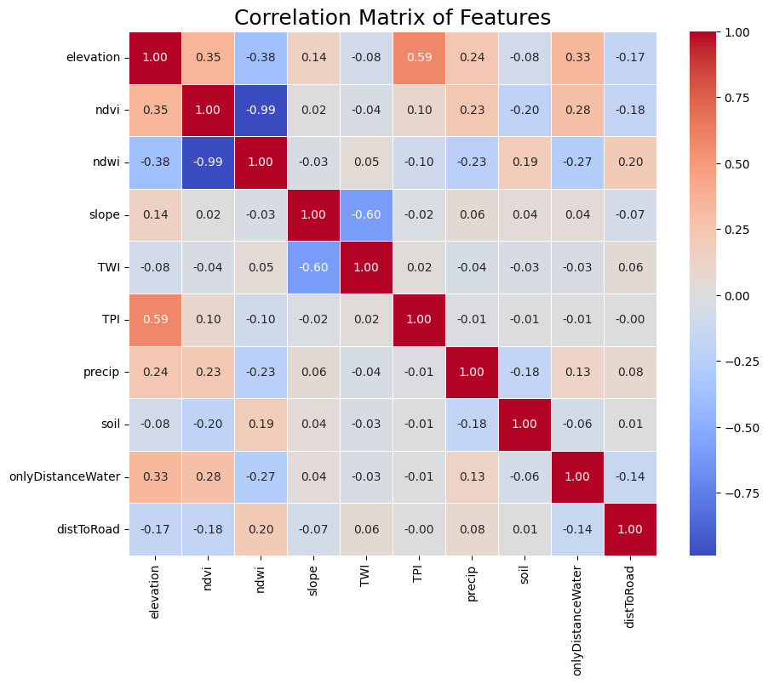

Figure 2: Pearson Correlation matrix plot for all flood conditioning factors

Model Performance Assessment

In this study, two deep learning models, Convolutional Neural Networks (CNN) and Long Short-Term Memory (LSTM) networks, were employed to predict flood events, and their performance was evaluated using multiple statistical metrics. The CNN model achieved an accuracy of 73.33%, with true positive and true negative counts of 929 and 1064, respectively. However, the model also recorded 296 false positives and 429 false negatives , indicating areas of misclassification.
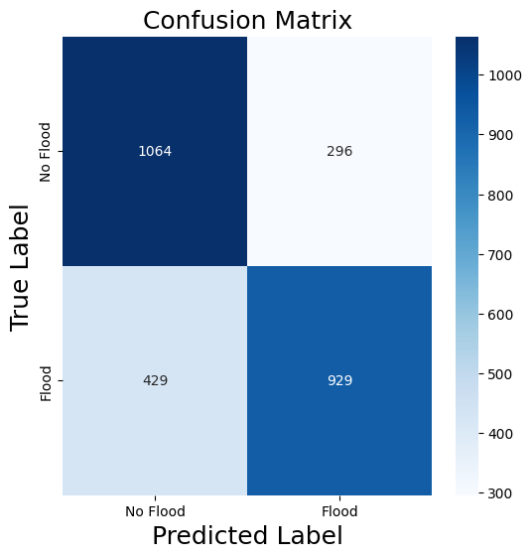

Figure 3: Confusion Matrix for CNN

While the CNN's precision of 0.76 demonstrates a reasonably strong ability to correctly identify flood events without overestimating, its recall (sensitivity) of 0.68 suggests a moderate ability to detect true flood events. This is complemented by its specificity of 0.78, reflecting the model's capacity to identify true non-flood conditions effectively. The model's F-score, calculated at 0.72, highlights a balanced trade-off between precision and recall, while the kappa statistic of 0.47 suggests moderate agreement beyond chance.

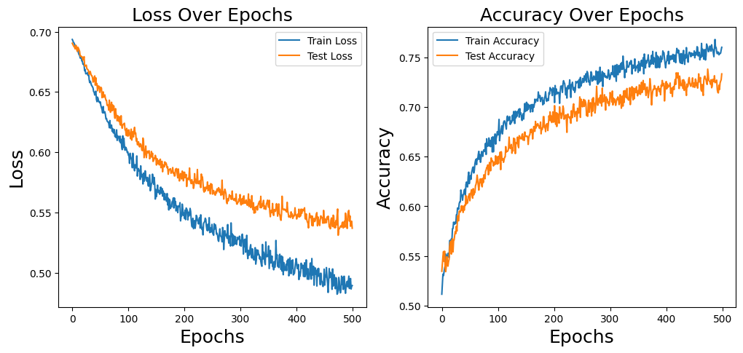

Figure 4: CNN model accuracy and Loss

The AUC (Area Under the Curve) score of 0.81 further underscores the CNN’s ability to differentiate between flood and non-flood events, making it a viable, albeit suboptimal, tool for flood prediction.

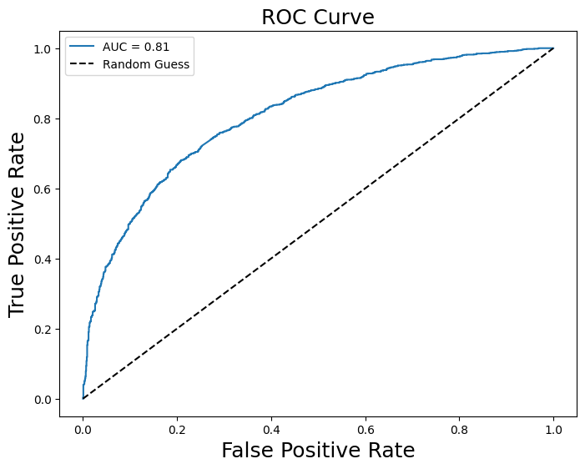

Figure 5: ROC curve for CNN model

The LSTM model, leveraging its strength in handling sequential and temporal data, exhibited markedly better performance across all evaluation metrics compared to the CNN model. With an accuracy of 82.49%, the LSTM demonstrated its superiority in overall prediction correctness. It recorded true positive and true negative counts of 1003 and 1239, significantly reducing both false positives (121) and false negatives (355) compared to the CNN model.
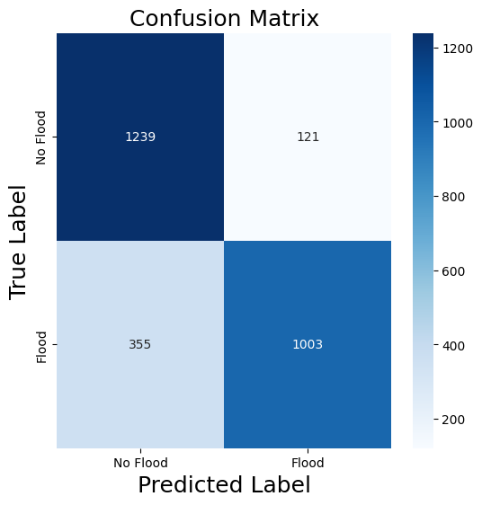

Figure 6: Confusion Matrix for LSTM Model

The model's precision of 0.89 highlights its exceptional ability to make accurate positive predictions, ensuring a low rate of false alarms. Moreover, the recall (sensitivity) of 0.74 indicates the model's enhanced ability to identify actual flood events, minimizing missed detections. With a specificity of 0.91, the LSTM demonstrated an outstanding ability to identify true non-flood conditions, showing its robustness in scenarios with imbalanced data. Notably, the model's F-score of 0.81 and kappa statistic of 0.65 signify a substantial improvement in predictive agreement over the CNN model.

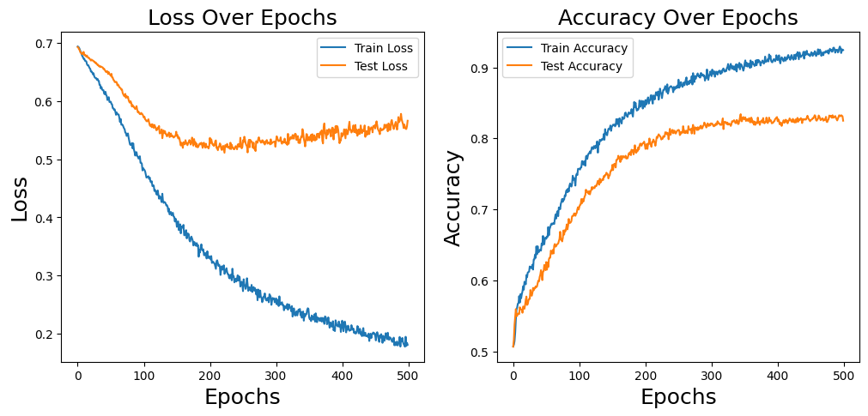

Figure 7: LSTM Model Accuracy and Loss

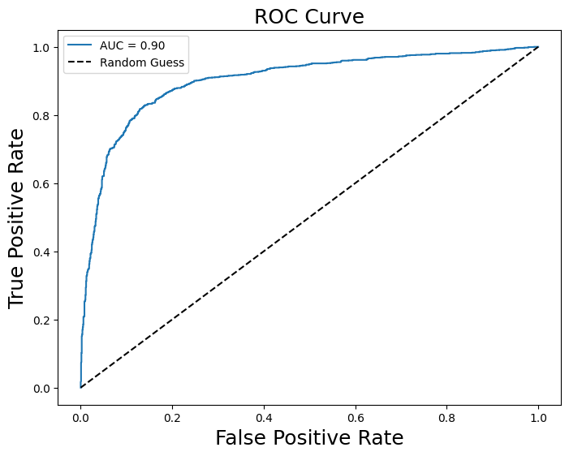

Figure 8: ROC curve for LSTM model

The AUC (Area Under the Curve) score of 0.90 further emphasizes the LSTM model’s outstanding capability to distinguish between flood and non-flood events, solidifying its role as a highly reliable tool for flood prediction.
Overall, the LSTM model clearly emerges as the better-performing model for flood prediction. Its robustness in handling sequential and temporal data makes it particularly well-suited for this application, and its superior metrics highlight its reliability as a predictive tool. While the CNN model provides a foundational approach, the LSTM model’s marked improvement in both sensitivity and specificity, coupled with its stronger overall agreement metrics, makes it the preferred choice for accurate and reliable flood prediction.

Crop Damages Due to Flooding
The flash flood had a significant impact on agricultural areas, leading to substantial crop losses. A crop damage map was generated using Google Earth Engine and the European Space Agency's (ESA) WorldCover 10m V200 product, which provides a global land cover map at a 10m resolution based on Sentinel-1 and Sentinel-2 data. Figure 3.7 shows the affected crop areas in brown, indicating the extent of flood-related damages in 2024. Calculations based on pixel size reveal that approximately 10,656 hectares of crop land were damaged. This extensive loss has contributed to shortages of rice and vegetables, directly affecting the local population.
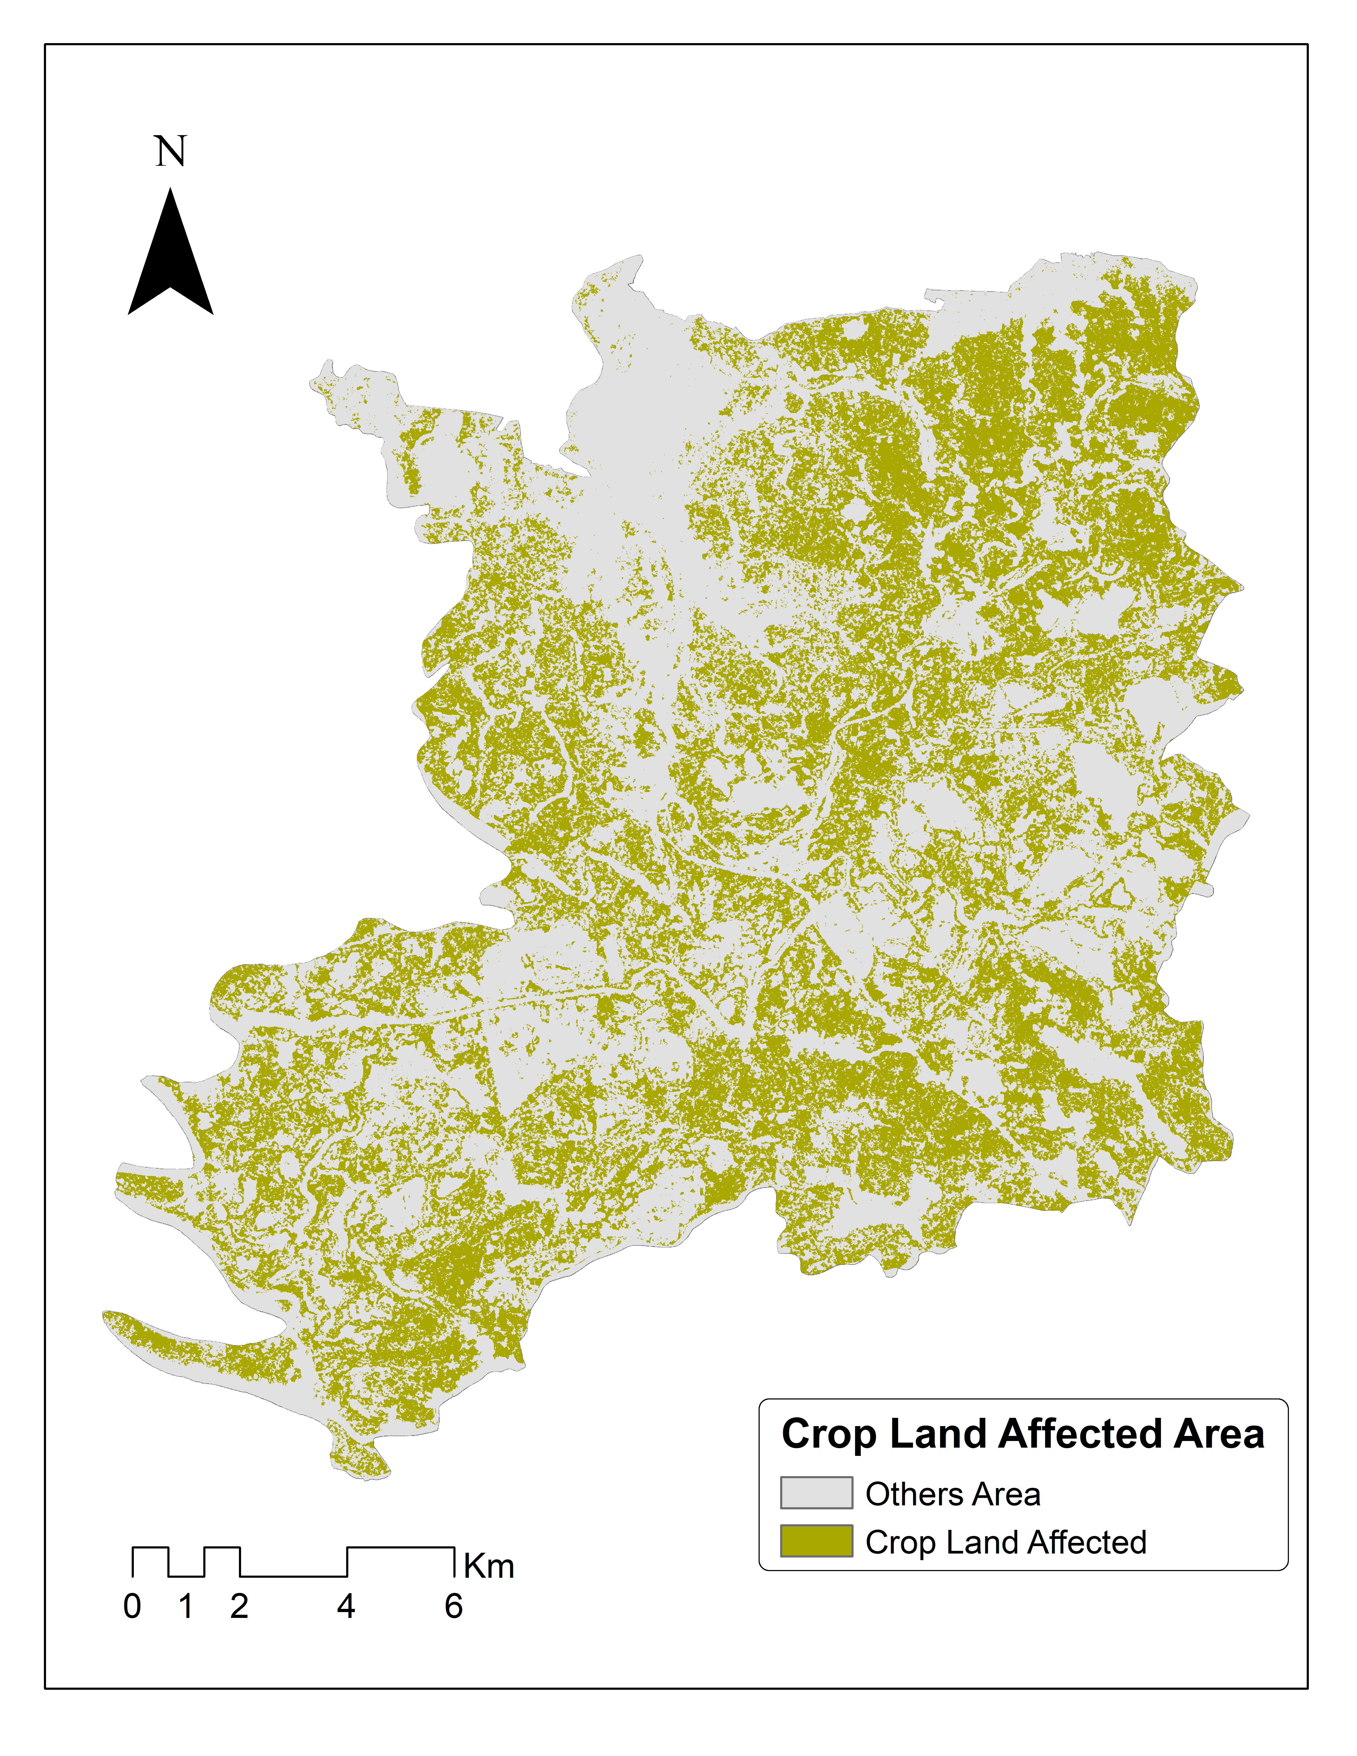

Figure 9: Crop Land affected Map due to flooding

Conclusion
This study assessed the performance of DL algorithms, specifically CNN and LSTM in flood susceptibility mapping at a sub-district level. The findings demonstrated that RF outperformed LSTM in both statistical and spatial dimensions, indicating its superior ability to generalize flood events and provide consistent classifications. The analysis revealed that major flood conditioning factors included NDVI, soil classification, elevation, and slope, significantly influencing flood susceptibility. The results highlighted that a considerable proportion of the study area falls within very high and high susceptibility zones, particularly emphasizing the vulnerability of croplands in northeastern Bangladesh. While this study contributed valuable insights into local flood dynamics, it also identified limitations related to the lack of historical flood data and spatial resolution constraints. Nevertheless, the outcomes offer a foundation for future research and practical applications, guiding policymakers in implementing informed land use strategies and enhancing community resilience to flood hazards. Ultimately, integrating DL models with comprehensive data sets and stakeholder engagement will advance the understanding and management of flood risks in vulnerable regions.

References
1. Biswas NK, Hossain F, Bonnema M, Aminul Haque AM, Biswas RK, Bhuyan A, et al. A computationally efficient flash flood early warning system for a mountainous and transboundary river basin in Bangladesh. Journal of Hydroinformatics. 2020;22:1672–92.
2. Brammer H. Floods in Bangladesh: geographical background to the 1987 and 1988 floods. Geographical journal. 1990;:12–22.
3. Alipour A, Ahmadalipour A, Moradkhani H. Assessing flash flood hazard and damages in the southeast United States. J Flood Risk Manag. 2020;13:e12605.
4. Kumari A, Frazier TG. Evaluating social capital in emergency and disaster management and hazards plans. Natural Hazards. 2021;109:949–73.
5. Bubeck P, Botzen WJW, Aerts JCJH. A review of risk perceptions and other factors that influence flood mitigation behavior. Risk Analysis: An International Journal. 2012;32:1481–95.
6. Mandal SP, Chakrabarty A. Flash flood risk assessment for upper Teesta river basin: using the hydrological modeling system (HEC-HMS) software. Model Earth Syst Environ. 2016;2:1–10.
7. Mukherjee F, Singh D. Detecting flood prone areas in Harris County: A GIS based analysis. GeoJournal. 2020;85:647–63.
8. Mirza MMQ. Three recent extreme floods in Bangladesh: a hydro-meteorological analysis. Flood problem and management in South Asia. 2003;:35–64.
9. Khalequzzaman MD. Recent floods in Bangladesh: Possible causes and solutions. Natural Hazards. 1994;9:65–80.
10. Paudyal GN. Prévision et annonce de catastrophes hydrologiques en contexte hydraulique complexe—le cas du Bangladesh. Hydrol Sci J. 2002;47:S5–18.
11. Haque MN, Siddika S, Sresto MA, Saroar MM, Shabab KR. Geo-spatial analysis for flash flood susceptibility mapping in the North-East Haor (Wetland) Region in Bangladesh. Earth Systems and Environment. 2021;5:365–84.
12. Choudhury BU, Das A, Ngachan S V, Slong A, Bordoloi LJ, Chowdhury P. Trend analysis of long term weather variables in mid altitude Meghalaya, North-East India. Journal of Agricultural Physics. 2012;12:12–22.
13. Adnan MSG, Siam ZS, Kabir I, Kabir Z, Ahmed MR, Hassan QK, et al. A novel framework for addressing uncertainties in machine learning-based geospatial approaches for flood prediction. J Environ Manage. 2023;326:116813.
14. Mudashiru RB, Sabtu N, Abustan I. Quantitative and semi-quantitative methods in flood hazard/susceptibility mapping: a review. Arabian Journal of Geosciences. 2021;14:941.
15. Rahman M, Ningsheng C, Islam MM, Dewan A, Iqbal J, Washakh RMA, et al. Flood susceptibility assessment in Bangladesh using machine learning and multi-criteria decision analysis. Earth Systems and Environment. 2019;3:585–601.
16. Islam ARMT, Talukdar S, Mahato S, Kundu S, Eibek KU, Pham QB, et al. Flood susceptibility modelling using advanced ensemble machine learning models. Geoscience Frontiers. 2021;12:101075.
17. Ahmed N, Hoque MA-A, Arabameri A, Pal SC, Chakrabortty R, Jui J. Flood susceptibility mapping in Brahmaputra floodplain of Bangladesh using deep boost, deep learning neural network, and artificial neural network. Geocarto Int. 2022;37:8770–91.
18. Talukdar S, Ghose B, Shahfahad, Salam R, Mahato S, Pham QB, et al. Flood susceptibility modeling in Teesta River basin, Bangladesh using novel ensembles of bagging algorithms. Stochastic Environmental Research and Risk Assessment. 2020;34:2277–300.
19. Hasan MH, Ahmed A, Nafee KM, Hossen MA. Use of machine learning algorithms to assess flood susceptibility in the coastal area of Bangladesh. Ocean Coast Manag. 2023;236:106503.
20. Adnan MSG, Talchabhadel R, Nakagawa H, Hall JW. The potential of tidal river management for flood alleviation in south western Bangladesh. Science of the Total Environment. 2020;731:138747.
21. Rasheed Z, Aravamudan A, Zhang X, Anagnostopoulos GC, Nikolopoulos EI. Combining global precipitation data and machine learning to predict flood peaks in ungauged areas with similar climate. Adv Water Resour. 2024;192:104781.
22. Demissie Z, Rimal P, Seyoum WM, Dutta A, Rimmington G. Flood susceptibility mapping: Integrating machine learning and GIS for enhanced risk assessment. Applied Computing and Geosciences. 2024;:100183.
23. Singha C, Rana VK, Pham QB, Nguyen DC, Łupikasza E. Integrating machine learning and geospatial data analysis for comprehensive flood hazard assessment. Environmental Science and Pollution Research. 2024;31:48497–522.
24. Wang Z, Lai C, Chen X, Yang B, Zhao S, Bai X. Flood hazard risk assessment model based on random forest. J Hydrol (Amst). 2015;527:1130–41.
25. Tehrany MS, Pradhan B, Mansor S, Ahmad N. Flood susceptibility assessment using GIS-based support vector machine model with different kernel types. Catena (Amst). 2015;125:91–101.
26. Al-Abadi AM. Mapping flood susceptibility in an arid region of southern Iraq using ensemble machine learning classifiers: a comparative study. Arabian Journal of Geosciences. 2018;11:1–19.
27. Islam R, Chowdhury P. Local-scale flash flood susceptibility assessment in northeastern Bangladesh using machine learning algorithms. Environmental Challenges. 2024;14:100833.
28. Pan S, Yang B, Wang S, Guo Z, Wang L, Liu J, et al. Oil well production prediction based on CNN-LSTM model with self-attention mechanism. Energy. 2023;284:128701.
29. Al Mehedi MA, Amur A, Metcalf J, McGauley M, Smith V, Wadzuk B. Predicting the performance of green stormwater infrastructure using multivariate long short-term memory (LSTM) neural network. J Hydrol (Amst). 2023;625:130076.

