Hydrochemical characteristics and quality assessment of Surface and Ground Water Quality in the First Part of the Eastern Surma-Kushiyara Floodplain Basin for Drinking and Irrigation Utilities
Saiful Alam¹, Md Sabbir Hossain², Md. Tanbir Ahmed¹ ,Khalidur Rahman², Dipta Maitra Tarun¹, Tajmunnaher¹
^{Saiful Alam}
^{saiful.ceesust@gmail.com}
^{Md Sabbir Hossain}
^{bmsabbirhossainsakib@gmail.com}
^{Md. Tanvir Ahmed}
^{tanbirahmed105103@gmail.com}
^{Khalidur Rahman}
^{khalid_sust@yahoo.com}
^{Dipta Maitra Tarun}
^{dipta.maitra@yahoo.com}
^{Dr. Tajmunnaher}
^{moon_cee@yahoo.com}
1. Department of Statistics, Shahjalal University of Science and Technology, Sylhet-3114, Bangladesh
2. Department of Civil And Environmental Engineering, Shahjalal University Of Science And Technology, Sylhet, Bangladesh
*Correspondence. khalid_sust@yahoo.com

Abstract
This study has been conducted in the first part of the Eastern Surma-Kushiyara Floodplain Basin located in Golapganj Upazila, Sylhet district, Bangladesh. A total of 60 water samples (30 for surface and 30 for ground) were gathere to examine the hydrochemical properties of surface and groundwater. To define the water quality for general, drinking, and irrigation uses, several different statistical and graphical techniques were used. In addition, water quality parameters were utilized to assess the quality of the water for agricultural usage. A comparison of standard values for different parameters indicates that the condition of the water at the study site is not completely normal for drinking. According to the results, electro-neutrality balances are not properly satisfied. The most common water type in the field of study is Ca-HCO₃ water (both surface and ground), but Mg-HCO₃ water (33 percent of surface water samples) is also present. The obtained results also indicate that both the quality of surface and groundwater in the study site is suitable for the use of irrigation purposes. The results of this study are expected to be useful for the management of groundwater and surface water and for future maintenance at the site of the study.
Keywords: Groundwater, Hydro-chemical Analysis, ICP-OES, Irrigation, Surfacewater
Highlights:
- The hydrochemical analysis has been used to determine the concentration of elements and compare them to drinking water and irrigation standards.
- The compatibility of surface and groundwater was also assessed using a variety of graphical representations and water quality parameters.
- According to the analysis, the samples (both surface and ground) are relatively good for irrigation but not perfectly suitable for drinking purposes.

1 Introduction
Water is one of the most valuable natural resources because it can be redirected, distributed, preserved, and reused, making it one of the most versatile (Dev Mudgal et al., 2009). People's lives and livelihoods are dependent on water, which is important both in terms of consumption and in terms of the economy (Tiri & Belkhiri, 2018). It is one of the most vital resources for humans and other living species (Rahman, 2018). It is a valuable component with diverse benefits in agriculture, industry, and everyday life (Zhang et al., 2018).
Groundwater is the principal source of freshwater needed for life on earth (Ayuba et al. 2013).According to estimates made by Nickson et al. (2005), around one-third of the world's population consumes groundwater for drinking. As a heterogeneous chemical mix, groundwater's composition is mostly influenced by how easily it dissolves in and interacts chemically with the rock or soil masses it travels through. The main cause of the change in groundwater chemical characteristics is hydro-geochemical reactions. But at the moment, groundwater provides 50% of urban water needs, 85% of rural drinking water needs, and 62.4 percent of net irrigation needs (Janardhana Raju & Reddy, 1998).
Surface water quality is a crucial aspect (Simeonov et al., 2003). Surface water is used for many human purposes because it is easier to get than groundwater. It is used to irrigate agriculture and is a significant supply of drinking water. According to the National Geographic Society, nearly 80% of the water consumed in the United States in 2015 originated from surface water. Aquatic plants and animals have an important home in wetlands with surface water. Surface waters are prone to contamination due to the significance of containing industrial, municipal, and farming runoff across the watersheds (K. P. Singh et al., 2004). On the other hand, groundwater quality is deteriorating as a result of human activities. That is a major environmental problem (Brehme et al., 2011). The quality of regional groundwater supplies is highly dependent upon anthropogenic sources (Kallioras et al., 2006). Scientific understanding of water's hydro-geochemistry is essential for assessing water for drinking, agriculture, and a variety of other purposes (Sakram & Adimalla, 2018). Physical, chemical, and biological procedures are necessary for long-term monitoring and reporting, which have a positive influence on the water evaluation process, and expose contaminants (Liao, Xu, & Wang, 2011).
This research is, therefore, being conducted in the Eastern Surma-Kushiyara Floodplain Basin, which is located in the Surma-Kushiyara (rivers) floodplain's considerably higher areas. River sediment from the northern and eastern hills emptied into the Meghna catchment region, forming the floodplain. The most prevalent source of drinking water in this area is groundwater. In addition, surface water is used in housework. Throughout the region, many agricultural activities are carried out all year round, and surface and groundwater are regularly used for these purposes. As a result, assessing the water quality in that location is essential for supplying the inhabitants with secure drinking water and proper farming.
The study's major goal is to look at the chemical properties of the surface and groundwater in the first part of the Eastern Surma-Kushiyara floodplain basin. The particular objectives of this study are: a) to determine the quality of surface and groundwater for household and agricultural usage in the anticipated region; b) to compare the existing status of water quality properties to WHO and BS drinking water recommendations.
2 Materials and Methods
2.1 Study Area:
This study has been performed on the first part of the Eastern Surma-Kushiyara Floodplain Basin. The research area covers around 250 square kilometers and is located between 24°41'N and 24°55'N and 91°55'E and 92°06'E. It is located around 10 kilometers east of Sylhet city. This area lies in the midst of the Golapganj Upazila, which is bounded on the north by the Surma River and the Kushiyara River on the south (see Figure 1, indicated in golden hue). This region was chosen because the water quality of the Surma and Kushiyara rivers has an impact on it.
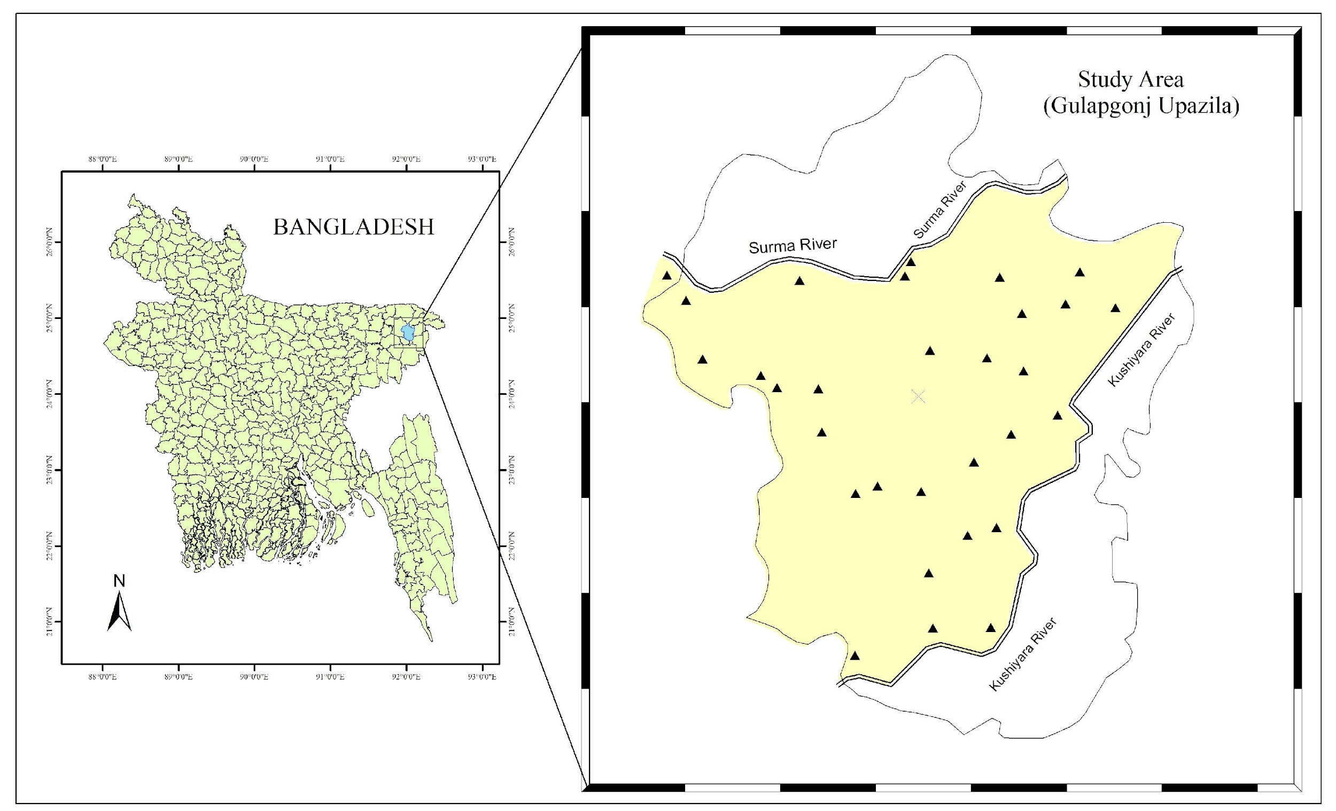
Figure 1: The colored area shows where the water was collected
2.2 Sample Collection:
Table 1: Geographic Location of the Sampling Sites
ID | Location | Longitude | Lattitude
1 | Hawortola | 24.7284 | 91.9945
2 | Guashpur | 24.7378 | 92.0401
3 | Shekhpur | 24.7376 | 92.0207
4 | Vadeyshor | 24.7561 | 92.0193
5 | Ujan Meherpur | 24.7714 | 92.0420
6 | Silimpur | 24.7688 | 92.0323
7 | Kanishail | 24.7935 | 92.0345
8 | Korgoan | 24.7835 | 92.0167
9 | Nowai | 24.7854 | 92.0020
10 | Fulshaind | 24.7829 | 91.9946
11 | Lokkhanaband | 24.8035 | 91.9833
12 | Jhangalhata | 24.8182 | 91.9821
13 | Laxmipasha | 24.8185 | 91.9682
14 | Nimadol | 24.8227 | 91.9628
15 | Dora | 24.8281 | 91.9431
16 | Rofipur | 24.8479 | 91.9376
17 | Barocut | 24.8310 | 92.0198
18 | Dharabor | 24.8285 | 92.0389
19 | Shilghat | 24.8241 | 92.0512
20 | Nagar | 24.8028 | 92.0470
21 | Sunampur | 24.8093 | 92.0626
22 | Amnia | 24.8435 | 92.0506
23 | Amora | 24.8467 | 92.0653
24 | Sundishail | 24.8576 | 92.0701
25 | Gagua | 24.8454 | 92.0821
26 | Ghugarkul | 24.8557 | 92.0431
27 | Saraswati | 24.8609 | 92.0133
28 | Kadamgach (Bazar) | 24.8561 | 92.0113
29 | Hazipur | 24.8547 | 91.9758
30 | Pachmail | 24.8563 | 91.9311

All the water samples were collected from different stations in Golapganj Upazila. A total of 30 samples of surface water were taken from ponds and canals. The groundwater samples (30 samples) were taken from tube wells that are adjacent to selected ponds or canals. These groundwater samples were carried out after pumping for 5 minutes. The samples were stored in good-quality screw-capped, High-Density Polyethylene (HDPE) bottles, which were cleaned by acid and had a capacity of 1 liter. The bottles were rinsed three times before use. Ponds, rivers, and canals were used to collect surface water samples at 30 stations numbered SW-1 to SW-30. Furthermore, the groundwater samples were numbered GW-1 to GW-30. Two sets of samples were collected at each location. One of these two sample sets was used for cation analysis, and the other one was for anion analysis. In particular, samples had to be acidified with nitric acid (HNO3) for cation analysis. After the collection of samples, the temperature, pH, electrical conductivity (EC), and total dissolved solids (TDS) of the samples were determined on-site by Hanna. Ice chests were used for the storage of all the samples as the permissible temperature was less than 4 °C. Subsequently, the samples were transferred into the laboratory for cation and anion analysis. All of the samples were kept in the refrigerator at temperatures below 4 °C. The analysis of anions (HCO₃⁻, CO₃²⁻, SO₄²⁻, PO₄³⁻, Cl⁻, NO₃⁻, F⁻) was done by some representative methods. The HCO₃⁻, CO₃²⁻, and Cl⁻anions were determined using the titration method. In addition, a UV spectrometer was used to determine the anions (SO₄²⁻, PO₄³⁻, NO₃⁻, F⁻). The Inductively Coupled Plasma-Optical Emission Spectrometry (ICP-OES) technique was used to identify major cations (Na⁺, Ca²⁺, Mg²⁺, K⁺, Fe²⁺, Si⁴⁺, Rb⁺, Al³⁺, Mn²⁺, P³⁺). An instrument named the Perkin Elmer Avio-200 was used for this technique. All these tasks took place at the laboratory.

2.3 Analysis:
The characteristics of a data collection are summarized or described using descriptive statistics. In this study, descriptive statistics such as average, standard deviation (SD), minimum and maximum values were calculated for each parameter to study variability. Each sample was evaluated for reliability following analysis using this procedure to get the proportion of charge balance errors (%CBE) for each sample.
$\%CBE=\frac{(∑ cations -∑anions )}{(∑ cations +∑ anions )}$$×100\%$
Meq/L is used to refer to both cations and anions in this context. A physicochemical analysis is frequently regarded as satisfactory if the CBE percentage is within ±5%. %CBE within ±10% indicates that all of the samples are in good condition.
This study includes several graphical methods which provide an impactful assessment of the water samples. They are described below.
Collin’s bar diagram: It is a type of bar chart with vertical bars. Two bars, one for cations and the other for anions, are used to represent each sample. Each bar's elevation is proportional to the total cations or anions’ concentration in meq/l. By reviewing this figure, it is easy to verify whether the electro-neutrality criteria are met by a sample of water.
Stiff diagram: A polygonal shape is formed by connecting four parallel horizontal axes on either side of a vertical zero axis in a Stiff diagram. Cations and anions are indicated (in meq/l) on the left hand and right hand side of the zero axis. The patterns of this diagram are effective for quick visual comparisons among water samples from different locations.
Piper diagrams (trilinear): The cation and anion compositions of each water sample are shown individually by two points in the cation and ternary plots. These points, which correspond to all samples, are projected into a diamond. A matrix transition converts a graph of anions (SO₄²⁻+ Cl⁻/total anions) and cations (Na+, K⁺/total cations) into a diamond shape.
Durov diagrams: In this diagram, cations and anions are represented by two separate triangles. The triangles in this diagram are identical to those in the Piper diagram. On a center square pattern, the sample points from the two triangles are projected onto a region that is adjacent to each triangle's third axis and depicts the sample's overall chemical composition. The principal advantage of the Durov diagram is that it gives a visual characterization of eight major ions and two characteristics for groundwater in a given area on a single frame.
Schoeller diagrams: The Schoeller diagram is a histogram-type diagram that depicts the log concentrations of solutes (minor substances in a solution, dissolved in the solvents) in meq/l from a number of samples and illustrates the effects of combining waters.
Wilcox diagram: Wilcox produced a graphic for estimating the adequacy of water quality for irrigation based on EC and salt percentage (percent Na).
US Salinity Laboratory (USSL) diagram: The USSL Diagram is used to assess if water is suitable for irrigation. The quantity of sodium absorbed by the soils and the sodium adsorption ratio (SAR) values have a strong relationship with irrigation water.
Rockware Aq.QA (Water Analysis Worksheet) version 1.1, EasyQuim, and MS Excel were used to develop the above mentioned diagrams. Some parameters are also used for this analysis. These are Magnesium Hazard (MH), Corrosivity Ratio (CR), Kelly’s Ratio (KR), Sodium Absorption Ratio (SAR), Residual Sodium Carbonate (RSC), Permeability Index (PI), Soluble Sodium Percentage (Na%), Chloro-Alkaline Indices, and Scatter plots.
3 Results
3.1 Descriptive Statistics:
Table 2: Descriptive Statistics and Comparison of Surface and Groundwater Parameters with Standards.
Parameters | Surface |  |  |  | Guide Line |  | Ground
 | Mini. | Maxi. | Mean | SD | BS (mg/L) | WHO(mg/L) | Mini. | Maxi. | Mean | SD
pH | 5.70 | 8.40 | 7.00 | 0.66 | - | 6.5-8.5 | 4.10 | 7.60 | 5.97 | 0.96
EC | 0.04 | 0.29 | 0.13 | 0.08 | - | - | 0.01 | 0.54 | 0.17 | 0.14
TDS | 33.00 | 209.00 | 103.47 | 55.60 | 1000 | - | 22.00 | 389.00 | 133.37 | 97.01
SO₄²⁻ | 0.00 | 79.00 | 7.50 | 19.49 | 400 | - | 0.00 | 101.00 | 17.00 | 30.67
Cl⁻ | 6.30 | 87.00 | 30.24 | 20.10 | 150-600 | - | 5.00 | 142.00 | 39.86 | 34.13
NO₃⁻ | 0.10 | 2.10 | 0.81 | 0.59 | 10 | 50.0 as N | 0.00 | 4.20 | 1.01 | 0.91
PO₄³⁻ | 0.00 | 0.73 | 0.09 | 0.15 | 6 | - | 0.02 | 3.57 | 1.13 | 1.35
F⁻ | 0.03 | 0.34 | 0.16 | 0.06 | 1 | 1.5 | 0.00 | 0.76 | .216 | 0.13
CO₃²⁻ | 0.00 | 0.00 | 0.00 | 0.00 | - | - | 0.00 | 0.00 | 0.00 | 0.00
HCO₃⁻ | 20.00 | 190.00 | 71.20 | 48.63 | - | - | 10.00 | 330.00 | 103.03 | 82.95
Al³⁺ | 0.00 | 0.65 | 0.07 | 0.14 | 0.2 | - | 0.00 | 2.20 | 0.34 | 0.57
Ca²⁺ | 0.00 | 34.24 | 4.00 | 6.41 | 75 | - | 0.26 | 36.40 | 9.84 | 10.79
Fe²⁺ | 0.00 | 14.05 | 1.88 | 3.39 | 0.3-1.0 | - | 0.00 | 4.79 | 0.57 | 0.94
Mg²⁺ | 0.18 | 4.64 | 1.73 | 1.34 | 30-35 | - | 0.07 | 16.29 | 2.45 | 3.06
Mn²⁺ | 0.00 | 0.54 | 0.14 | .155 | 0.1 | - | 0.00 | 0.29 | .075 | 0.08
P³⁺ | 0.00 | 3.68 | 0.38 | 0.74 | 0 | - | 0.03 | 0.24 | 0.10 | 0.04
K⁺ | 0.00 | 31.04 | 2.25 | 5.50 | 12 | - | 0.00 | 23.81 | 3.38 | 4.58
Na⁺ | 0.00 | 55.05 | 7.38 | 11.04 | 200 | - | 0.00 | 23.27 | 5.91 | 7.01
Rb⁺ | 0.04 | 1.42 | .673 | 0.53 | - | - | 0.04 | 1.44 | 0.74 | 0.59
Si⁴⁺ | 0.73 | 28.22 | 10.10 | 6.59 | - | - | 0.90 | 30.22 | 13.23 | 8.50
All values are in mg/L, except pH, EC (mS/cm), SD (Standard Deviation), BS (Bangladesh Standards)

Descriptive statistics are very useful for summarizing the basic information of a collected data set and for presenting various features of the entire scenario or a subset of it. Therefore, selected parameters of surface water and groundwater that were collected have been consistently summarized in Table 2 with their descriptive statistics. Na+, Ca2+, and Si4+ are the main dominating cations for both surface water and groundwater, while HCO3- and Cl- are the leading dominating anions. Total dissolved solids (TDS) and HCO3- have the highest standard deviations, whereas Fe2+, Al3+ , Mn2+, P3+, and Rb+ have the lowest standard deviations in both surface water and groundwater. HCO3-, SO42-, Ca2+ , and Si4+ concentrations in groundwater were significantly higher than those in surface water, whereas Fe2+ and Na+ concentrations were lower. Although groundwater's PH was lower than that of surface water, its total dissolved solids (TDS) concentration was much higher than that of the latter. This table also shows a For comparison with the standard level for each parameter proposed by the World Health Organization (WHO) and the Bangladeshi standard (BS) recommended by the Department of Public Health Engineering-DPHE (2021). The majority of the parameters are within the recommended limits. However, for both surface and groundwater, some water samples have pH values that are below the level recommended by the WHO. Besides, according to the BS, the Cl⁻ (chlorine) level should be between 150 and 600, and Mg²⁺ should be between 30 and 35. But, all of the water samples are below the requirements. Lastly, many water samples exceed the standard limits for Al³⁺, Fe²⁺, Mn²⁺, P³⁺, and K⁺. Thus, both the surface and groundwater of the study area are not perfectly suitable for drinking purposes.
3.2 Graphical Analysis
3.2.1 Collin’s bar diagram
It is a type of bar chart with vertical bars. On the left, major cations (Na⁺, Ca²⁺, Mg²⁺, K⁺, Fe²⁺, Si⁴⁺, Rb⁺, Al³⁺, Mn²⁺, P³⁺) in meq/L are plotted, while on the right, major anions (HCO₃⁻, CO₃²⁻, SO₄²⁻, PO₄³⁻, Cl⁻, NO₃⁻, F⁻) in meq/L are plotted. The sum of cations and anions is 100 %. The results from the bar charts in terms of balancing of charges have found that out of 30 surface water samples, four are the best (the cation/anion imbalance is less than 5%), fifteen are better (between 5% to 10%), and the rest eleven are good (around 10%, but more than that) in variations. With 30 groundwater samples, the similar results indicated that four of them are the best, sixteen are better, and the remaining ten are good in variations. The bar charts also indicated that the dominating ions among the anions and cations in both surface and groundwater are Si⁴⁺, Na⁺, Cl⁻, HCO₃⁻ and Ca²⁺, respectively. A variation between the height of the cations and anions bars might be due to an analytical error or the absence of some ions that appear in large quantities.
3.2.2 Stiff Diagrams:
The corresponding concentration of the cations is plotted to the left of the center axis, while the equivalent concentration of the anions is plotted to the right. Each diagram is formed by connecting the points. All units are in meq/L. It is essential to produce each diagram using the same ionic species, in the same sequence, and on the same scale when comparing Stiff diagrams across various water samples. The concentrations of the major ions that were applied to identify the various groundwater and surface water samples in this study are shown in Figure 2 and Figure 3, respectively.

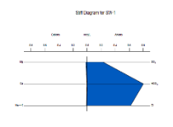  SW-1 | 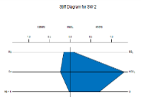  SW-2 | 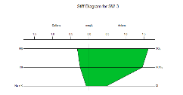  SW-3 | 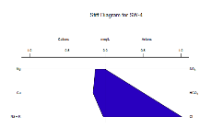  SW-4 | 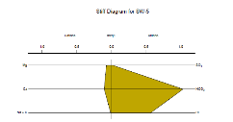  SW-5
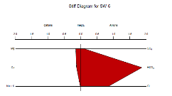  SW-6 | 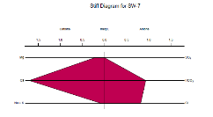  SW-7 | 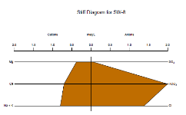  SW-8 | 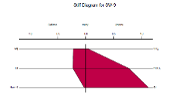  SW-9 | 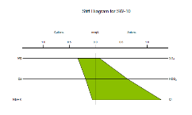  SW-10
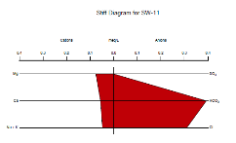  SW-11 | 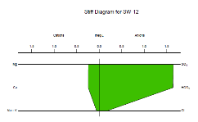  SW-12 | 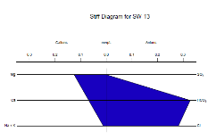  SW-13 | 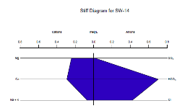  SW-14 | 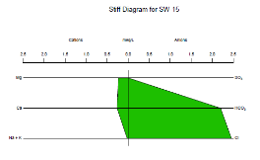  SW-15
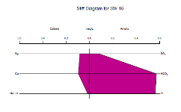  SW-16 | 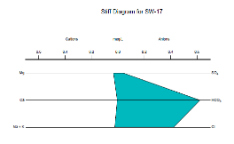  SW-17 | 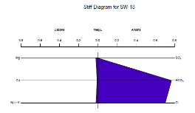  SW-18 | 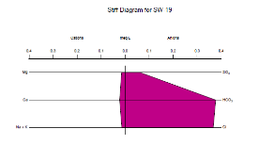  SW-19 | 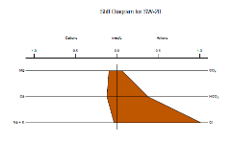  SW-20
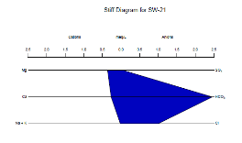  SW-21 | 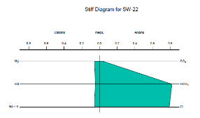  SW-22 | 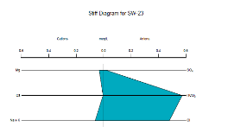  SW-23 | 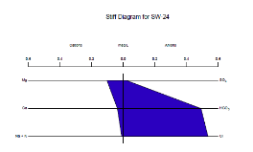  SW-24 | 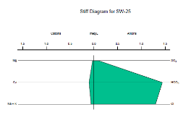  SW-25
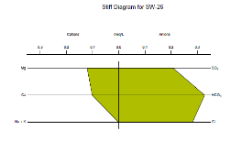 | 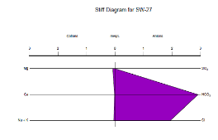 | 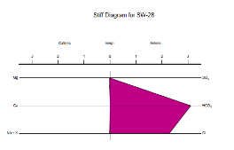 | 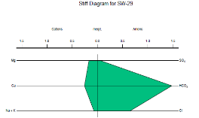 | 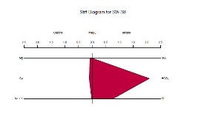
SW-26 SW-27 SW-28 SW-29 SW-30
Figure 2: Stiff Diagrams of Surface Water Samples

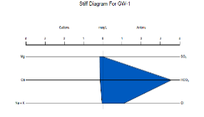  GW-1 | 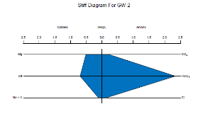  GW-2 | 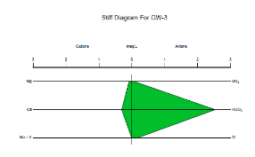  GW-3 | 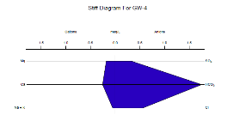  GW-4 | 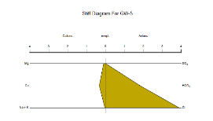  GW-5
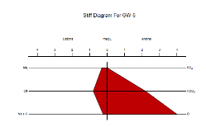  GW-6 | 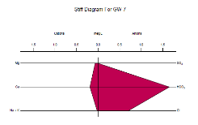  GW-7 | 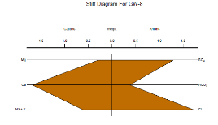  GW-8 | 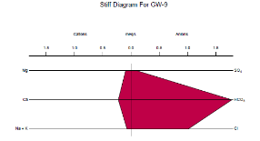  GW-9 | 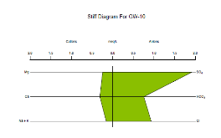  GW-10
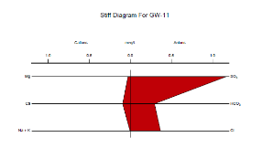  GW-11 | 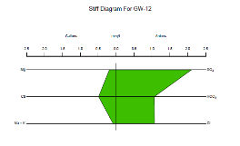  GW-12 | 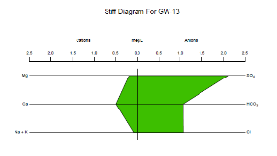  GW-13 | 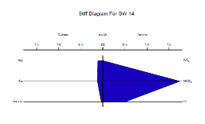  GW-14 | 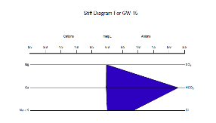  GW-15
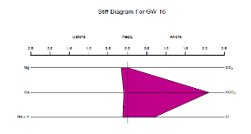  GW-16 | 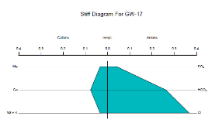  GW-17 | 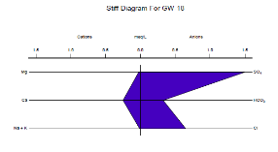  GW-18 | 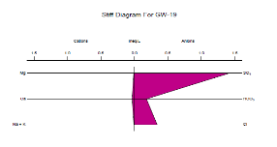  GW-19 | 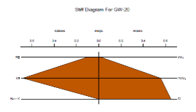  GW-20
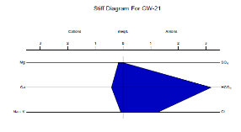  GW-21 | 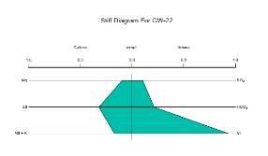  GW-22 | 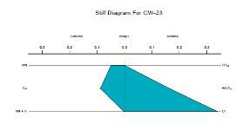  GW-23 | 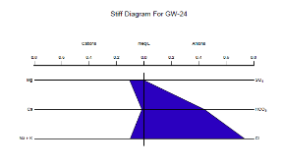  GW-24 | 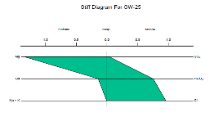  GW-25
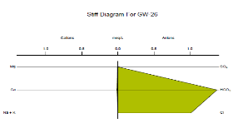  GW-26 | 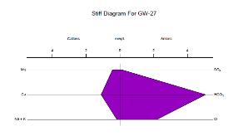  GW-27 | 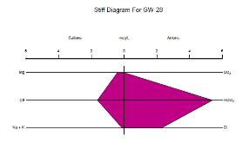  GW-28 | 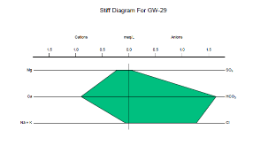  GW-29 | 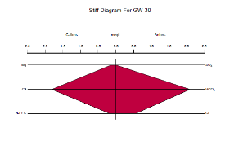  GW-30
Figure 3: Stiff Diagrams of Ground Water Samples
According to the stiff diagrams of surface water samples, the Ca cation is the most frequent among the cations, while the HCO₃ anion is the dominant anion in some locations. From Ground Water samples, 23% are Cl dominated and 20% of the samples are SO4 dominated. From surface water samples, 26% of the samples are Mg dominated. On the other hand, the Ca-HCO₃ water type is also the most commonly occurring water type for ground water samples.
3.2.3 Piper diagram:
The Piper diagram for surface, as presented in Figure 4, shows that 33% of surface water samples are plotted in the CaCl region and the majority of samples (37%) are plotted in the Ca-HCO₃ region. Furthermore, 23% of samples are plotted in the Ca-Na-HCO₃ region. The rest of the samples were from the NaCl and Ca-Mg-Cl region.
Similarly, the Piper diagram for ground, shows that the majority of groundwater samples (57%) are plotted in the Ca-Cl region and 40% of samples are plotted in the Ca-HCO₃ region. The rest of the samples were from the Ca-Na-HCO₃ region.

Figure 4: Piper Diagram for Surface Water and Groundwater Samples

3.2.4 Durov diagram:
A Durov diagram is a typical hydrogeology presentation tool that shows the major ions in two ternaries (trilinear) graphs with percentages of milli-equivalents. The data points are put into a grid pattern just at the base of every triangle. In addition, the cations and anions' values are plotted on two different triangular fixtures.

Figure 5: Durov Diagram for Surface Water and GroundWater Samples
According to Figure 5, Total Dissolved Solids (TDS) is below 100mg/L in nearly half of the surface water samples. All anions' concentrations are close to each other, showing a mixed sort of surface water. In the figure, the predominant ion concentrations of Ca and SO₄ with respect to a significant percentage of Na and Mg are well-represented. On the other hand, total dissolved solids (TDS) is below 150mg/L in nearly half of the groundwater samples. All anions' concentrations are close to each other, showing a mixed sort of groundwater. Like surface water, the predominant ion concentrations for the groundwater samples are Ca and SO₄ with respect to a significant percentage of Na and Mg.
3.2.5 Schoeller diagram:
Schoeller diagrams are used to illustrate relative anions and cations concentrations, which are commonly given in millie-equivalents per liter. The chemical features of water compositions were analyzed based on major ion concentrations. The Schoeller diagram is determined for each ground and surface water sample as explained below.
In Figure 6, all the samples are plotted on Schoeller semi-logarithmic diagrams for each ground water sample. The diagram shows that the concentration of HCO₃⁻, Cl⁻, SO₄²⁻, Mg²⁺, Ca²⁺, K⁺ are high and the concentration of CO₃²⁻, Na⁺ are low.

Figure 6: Schoeller Diagram for Surface Water and GroundWater Samples

3.2.5 Wilcox’s diagram:

Figure 7: Wilcox’s Classification of Surface and Ground Water Samples
The Wilcox plot relates the "sodium danger" (sodium adsorption ratio) along that Y-axis to the "salinity hazard" (electrical conductivity) just on that X-axis in a semi-log plot. The chemical data of both surface and groundwater samples are represented in Wilcox's diagram, in Figure 7, for the research region, and it is found that nearly all of the samples are in the "very good to good" class.

3.2.6 US Salinity Laboratory (USSL) diagram:
Such a diagram is mostly used to define irrigation water investigation. In the vertical axis, it needs to employ the sodium absorption ratio (SAR), and in the horizontal axis, it employs conductance. Water is divided into 16 categories in this diagram. From the USSL diagrams in Figure 8, it can be said that the majority of all water samples (surface and groundwater) have fallen into the C1-S1 class, which indicates that both salinity and sodium hazard are low.

Figure 8: USSL diagram of Surface and Ground Water Samples

3.3 Parameters: Suitability for Irrigation usage
Several water quality parameters that have been discussed are determined in Table 3 and Table 4 for the surface and groundwater samples, respectively.
Table 3: Water Quality Parameters for Surface Water Samples
Samples no | MH | PI | RSC | Kelly's Ratio | Corrosively Ratio (CR) | Chloro Alkaline Index-1 | Chloro Alkaline Index-2 | SAR | SSP
1 | 81.82 | 4073.19 | 0.78 | 0.00 | 2.80 | 0.98 | 0.59 | 0 | 31.67
2 | 39.49 | 291.62 | 0.92 | 0.01 | 1.67 | 0.97 | 0.48 | 0.012 | 4.8
3 | 56.70 | 205.66 | 0.88 | 0.04 | 3.26 | 0.83 | 0.13 | 0.063 | 12.3
4 | 44.83 | 243.79 | 0.22 | 0.01 | 5.71 | 0.98 | 1.89 | 0.016 | 8.16
5 | 41.44 | 556.22 | 0.85 | 0.01 | 1.60 | 0.98 | 0.51 | 0.011 | 6.98
6 | 54.30 | 464.66 | 1.58 | 0.01 | 1.41 | 0.98 | 0.42 | 0.014 | 6.23
7 | 11.82 | 49.87 | 0.00 | 0.00 | 2.50 | 0.89 | 0.77 | 0 | 4.26
8 | 35.14 | 129.96 | 0.91 | 0.00 | 2.04 | 0.42 | 0.28 | 0.007 | 42.38
9 | 49.13 | 188.97 | 0.31 | 0.01 | 4.30 | 0.97 | 1.33 | 0.015 | 6.28
10 | 64.24 | 150.82 | 0.10 | 0.00 | 6.10 | 0.96 | 1.64 | 0.003 | 9.85
11 | 57.58 | 474.32 | 0.26 | 0.00 | 2.26 | 0.85 | 0.64 | 0 | 26.97
12 | 49.80 | 260.37 | 1.15 | 0.01 | 2.40 | 0.67 | 0.04 | 0.016 | 10.73
13 | 64.62 | 291.73 | 0.13 | 0.01 | 2.46 | 0.96 | 0.80 | 0.008 | 5.63
14 | 45.32 | 155.98 | 0.17 | 0.02 | 1.78 | 0.83 | 0.48 | 0.033 | 11.74
15 | 46.80 | 293.29 | 1.70 | 0.02 | 3.19 | 0.99 | 1.10 | 0.022 | 5.13
16 | 46.37 | 417.93 | 0.40 | 0.02 | 3.11 | 0.97 | 0.82 | 0.012 | 7.98
17 | 87.18 | 2023.86 | 0.58 | 0.00 | 2.08 | 0.94 | 0.60 | 0.002 | 37.94
18 | 74.07 | 3249.99 | 0.74 | 0.00 | 2.62 | 0.97 | 0.89 | 0 | 40.33
19 | 39.47 | 1615.80 | 0.34 | 0.00 | 3.12 | 0.96 | 0.80 | 0 | 27.21
20 | 44.39 | 286.92 | 0.16 | 0.00 | 8.04 | 0.97 | 2.22 | 0.001 | 13.48
21 | 57.59 | 247.60 | 1.83 | 0.00 | 1.23 | 0.98 | 0.39 | 0.005 | 3.3
22 | 53.92 | 423.05 | 0.72 | 0.01 | 2.86 | 0.93 | 0.85 | 0.004 | 35.77
23 | 88.89 | 2104.52 | 0.54 | 0.00 | 2.47 | 0.87 | 0.69 | 0.004 | 62.52
24 | 73.57 | 498.18 | 0.35 | 0.01 | 3.20 | 0.98 | 1.01 | 0.004 | 6.43
25 | 21.54 | 905.14 | 1.31 | 0.02 | 2.72 | 0.95 | 0.79 | 0.016 | 31.56
26 | 54.26 | 255.43 | 0.11 | 0.01 | 3.78 | 0.99 | 0.49 | 0.009 | 0.97
27 | 83.16 | 1797.81 | 2.82 | 0.00 | 1.91 | 0.98 | 0.65 | 0 | 29.89
28 | 100.00 | 6535.75 | 3.09 | 0.00 | 2.10 | 0.99 | 0.72 | 0 | 39.35
29 | 39.53 | 283.18 | 1.05 | 0.01 | 1.34 | 0.89 | 0.37 | 0.018 | 13.99
30 | 42.19 | 744.33 | 1.91 | 0.02 | 1.04 | 0.97 | 0.35 | 0.014 | 10.15

Table 4: Water quality parameters for ground water samples
Samples no | MH | PI | RSC | Kelly's ratio | Corrosively ratio (CR) | Chloro Alkaline Index-1 | Chloro Alkaline Index-2 | SAR | SSP
1 | 53.31 | 624.17 | 3.27 | 0.00 | 0.88 | 1.06 | 0.30 | 0.004 | 11.74
2 | 42.32 | 126.94 | 1.14 | 0.00 | 0.38 | -0.64 | 0.01 | 0.008 | 8.39
3 | 22.03 | 403.48 | 2.14 | 0.00 | 0.28 | 0.14 | 0.07 | 0.001 | 2.07
4 | 41.46 | 301.22 | 1.31 | 0.00 | 1.32 | 0.47 | 0.24 | 0.003 | 10.88
5 | 23.17 | 320.24 | 1.41 | 0.00 | 6.08 | 3.88 | 2.08 | 0 | 7.3
6 | 27.85 | 132.94 | 1.08 | 0.01 | 5.23 | 3.95 | 1.69 | 0.014 | 17.5
7 | 26.82 | 492.90 | 1.39 | 0.00 | 1.22 | 0.67 | 0.41 | 0 | 8.22
8 | 15.08 | 31.10 | 0.00 | 0.00 | 20.18 | 1.36 | 0.64 | 0.01 | 23.68
9 | 29.91 | 414.37 | 1.46 | 0.01 | 1.75 | 0.94 | 0.50 | 0.008 | 18.43
10 | 43.99 | 155.10 | 0.20 | 0.01 | 8.82 | 0.76 | 0.29 | 0.021 | 22.1
11 | 23.58 | 441.58 | 0.17 | 0.00 | 11.79 | 0.36 | 0.25 | 0 | 3.17
12 | 28.05 | 151.46 | 0.38 | 0.00 | 6.99 | 0.99 | 0.31 | 0.003 | 11.29
13 | 48.15 | 545.02 | 1.51 | 0.00 | 0.83 | 0.43 | 0.26 | 0.001 | 13.85
14 | 46.97 | 2294.84 | 2.23 | 0.00 | 1.05 | 0.84 | 0.37 | 0 | 3.74
15 | 16.69 | 94.15 | 0.90 | 0.00 | 2.60 | 2.33 | 0.86 | 0.003 | 4.7
16 | 63.04 | 560.37 | 1.86 | 0.01 | 0.97 | 0.54 | 0.27 | 0.011 | 31.44
17 | 30.63 | 457.91 | 0.15 | 0.01 | 4.33 | 0.28 | 1.06 | 0.004 | 23.19
18 | 9.12 | 209.02 | 0.05 | 0.00 | 15.18 | 0.63 | 0.35 | 0 | 4.11
19 | 22.73 | 964.24 | 0.14 | 0.00 | 21.73 | 0.31 | 0.21 | 0 | 16.38
20 | 13.42 | 94.49 | 0.00 | 0.00 | 3.40 | 0.64 | 1.09 | 0.006 | 0.35
21 | 28.47 | 302.66 | 2.60 | 0.00 | 1.13 | 1.20 | 0.37 | 0.004 | 12.67
22 | 23.21 | 110.31 | 0.00 | 0.01 | 13.50 | 0.75 | 2.10 | 0.012 | 29.12
23 | 35.77 | 295.60 | 0.03 | 0.00 | 5.90 | 0.33 | 1.78 | 0 | 2.13
24 | 87.39 | 554.86 | 0.32 | 0.01 | 4.74 | 0.60 | 1.37 | 0.006 | 45.66
25 | 90.30 | 58.51 | 0.00 | 0.00 | 3.75 | 0.95 | 1.17 | 0 | 0.44
26 | 31.58 | 6176.09 | 1.36 | 0.00 | 2.11 | 1.02 | 0.73 | 0 | 1.18
27 | 28.31 | 144.78 | 3.53 | 0.01 | 1.29 | 2.12 | 0.39 | 0.014 | 10.54
28 | 19.90 | 114.49 | 3.38 | 0.00 | 1.22 | 2.26 | 0.40 | 0.014 | 5.85
29 | 20.47 | 112.43 | 0.50 | 0.01 | 2.27 | 1.22 | 0.71 | 0.011 | 5.67
30 | 7.77 | 73.63 | 0.13 | 0.00 | 0.79 | 0.24 | 0.18 | 0.007 | 8.56

3.3.1 Magnesium Hazard (MH)
Magnesium hazard evaluation is vital in evaluating the quality of irrigation water. Plant growth requires magnesium ions, but they have been linked to soil aggregation and flow ability. Magnesium with a hazard value greater than 50 is regarded as hazardous for irrigation. Magnesium hazard is calculated by
$MH=\frac{Mg}{Mg+Ca}×100$

According to Table 3, the MH value of 50% of surface water samples is less than 50. Meanwhile, the remaining samples have a MH value greater than 50. Similarly, from Table 4, it is found that the majority of ground water samples have an MH value of less than 50 (87%). Thus, according to Magnesium Hazard parameters, both the surface and groundwater of most of the study area are suitable for irrigation purposes.

3.3.2 Kelly’s Ratio (KR)
For irrigation water reviews, KR is an effective measure. According to the Kelly index, the water compound qualities are categorized for irrigation systems. If the Kelly index estimate is more than 1, there is too much sodium in the water. The Kelly index is frequently less than 1, which indicates a Na deficit in the groundwater. When the Kelly index limit is below 1, groundwater is thought to be appropriate for use in irrigation systems. The groundwater is only moderately acceptable for irrigation when the Kelly index limit is observed in class ranges 1 and 2. While Kelly's index limit is more than 2, water cannot be used for the irrigation system. This ratio is computed as:
$KR=\frac{Na}{Mg+Ca}$

According to Table 3 and Table 4, all the surface and groundwater samples have a KR value of less than 1. So, we can conclude from the Kelly’s Ratio parameters that both the surface and groundwater of the study area are suitable for irrigation.

3.3.3 Corrosivity Ratio (CR)
The corrosivity ratio represents whether or not water may be transmitted through a pipe. For the conveyance of water through pipes, the CR value must be smaller than 1. CR is expressed by
$CR=\frac{\frac{Cl}{35}+2(\frac{SO4}{96})}{\frac{CO3+HCO3}{100}}$

As there is no surface sample whose CR value is less than 1, surface water samples are not suitable for any pipe transmission (Table 3). In addition, groundwater samples are also unsatisfactory, though some samples (GW-1, GW-2, GW-3, GW-13, GW-16, and GW-30) are in the permissible range (Table 4).
3.3.4 Residual Sodium Carbonate(RSC)
Irrigation water quality is measured by residual sodium carbonate as an empirical factor. The principle of quantitative deposition of Ca²⁺ and Mg²⁺ ions with CO₃²⁻ and HCO₃⁻ in soils is used to quantify RSC. It is expressed by
$RSC=(CO_{3}+HCO_{3})-(Ca+Mg)$

The RSC values are calculated using the respective formulas for both surface and groundwater samples (Table 3 and Table 4). A RSC value of less than 1.25 is safe, while greater than 2.5 is unsuitable. If RSC is laid between 1.25 and 2.5, the water is marginally suitable. The majority (77%) of surface water samples indicate that they are safe for irrigation purposes, and fifty-seven percent of groundwater samples are in the safe category.
3.3.5 Sodium Absorption Ratio (SAR)
The sodium adsorption ratio is used to determine the quantity of sodium (Na) in the water extract with saturated soil mixture in relation to calcium (Ca) and magnesium (Mg). The sodium adsorption ratio (SAR) criterion is a measure of irrigation water quality that takes into account the risk of sodium hazards. If the SAR concentration is less than 10 (meq/L) , the water is in excellent condition. SAR is calculated by
$SAR=\frac{Na}{\sqrt{(Ca+Mg)/2}}$

In our study region, the SAR concentration ranges are from 0.001 to 0.021 for surface water samples, while the SAR concentration ranges are from 0.001 to 0.063 for groundwater samples. Thus, according to the sodium absorption ratio, all the samples are suitable for irrigation purposes in the study area.

3.3.6 Soluble Sodium Percentage (SSP)
Wilcox (1955) presented a different classification strategy based on SSP for classifying irrigation waters. SSP values below 50 indicate good quality water, while those above 50 indicate that the water is completely unsuitable for irrigation (USDA 1954). The equation is given below:
$SSP=\frac{(Na+K)}{(Ca+Mg+Na+K)}×100$

It can be shown that almost all of the surface water samples have SSP values of less than 50; only 1 surface water sample is unsuitable. However, all of the groundwater samples have SSP values of less than 50. As a result, all of the observed samples were found to be suitable for irrigation purposes in the study area.
3.3.7 Permeability Index (PI)
Irrigated water can be categorized as Class I (>75 percent), Class II (25–75 percent), or Class III (<25percent) based on the PI values. Waters with a PI of 25% or more are classified as acceptable for irrigation, whereas those with a PI of less than 25% are classified as undesirable for irrigation (Doneen 1964; WHO 1989). PI is calculated by
$PI =\frac{Na+\sqrt{HCO_{3}}}{Ca+Mg+Na}×100$

The analyzed samples' surface water permeability index is 49 percent and above, while the groundwater samples' permeability index is 31 percent and above. As a result, both surface and ground samples fall into the Class-I and Class-II that are suitable for irrigation purposes in the study area .
3.3.8 Ion Exchange process
Although controlling the dissolution of harmful materials in subsurface water is challenging , it really is essential to understand the changes that water undergoes during surface runoff and infiltration. The Chloro-alkaline indices (CAI) can be used to imply ion exchange between groundwater as well as its environment throughout residency with percolation.
The CAI-1 values, including all surface water samples, are positive, and the CAI-2 values are also positive, as shown in Table 3. As a result, the values can be described as direct base-exchange reactions. Furthermore, except for one sample of groundwater (CAI-1 value is negative for GW-3), all the other groundwater samples give positive values of CAI-1 and CAI-2 which indicate direct base-exchange reaction (Table 4).
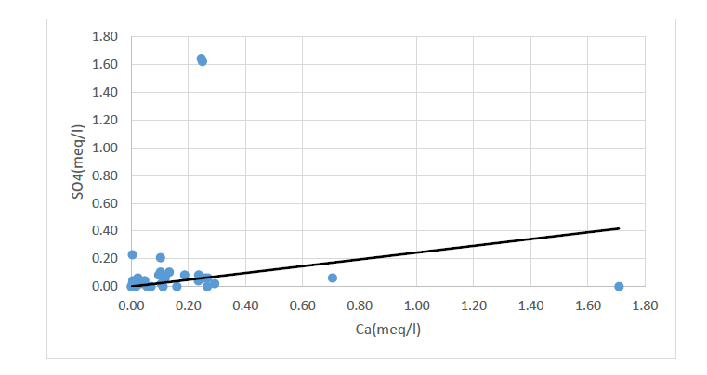
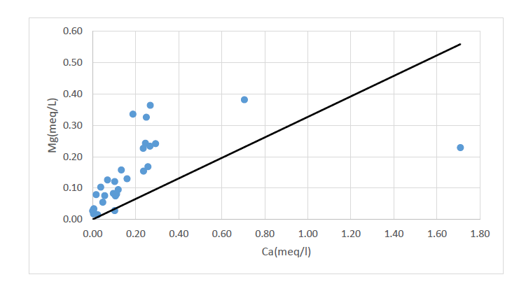
3.4 Hydrochemical processes (Using Scatter plots)

(c)
(a)
(b)

Figure 9: Scatter plots showing relationships between (a) Ca vs SO₄ (b) Ca vs Mg (c) Na vs Cl
(for surface water samples)

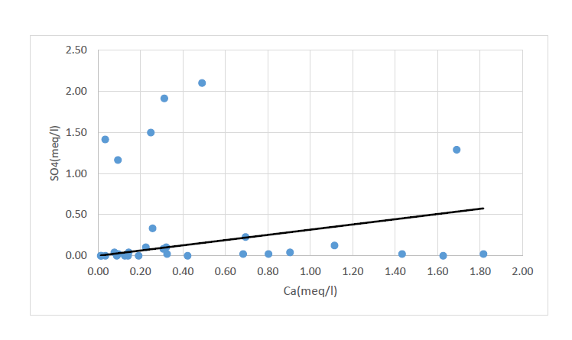
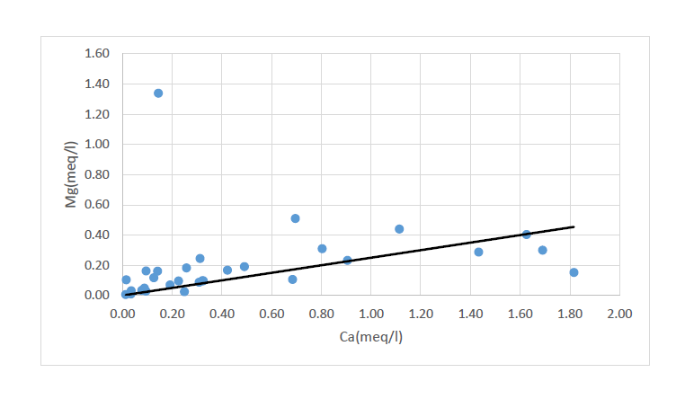
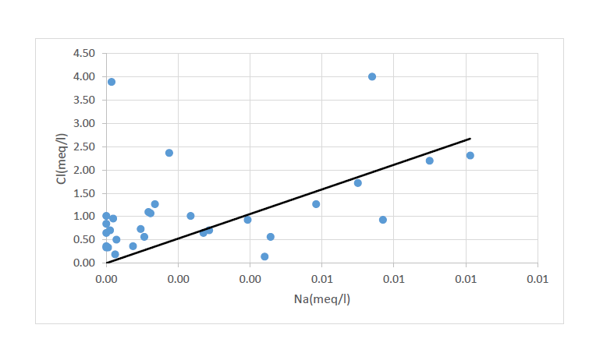
(d)
(e)
(f)

Figure 10: Scatter plots showing relationships between (a) Ca vs SO₄ (b) Ca vs Mg (c) Na vs Cl
(for ground water samples)

From the scatter plots in Figure 9 and 10, it can be seen that only Figure 9(b) shows the absence of significant correlation between the cations.
All points of the samples are plotted on the Ca²⁺ and SO4²⁻ graph (Figure 9(a) and Figure 10(d)), indicating that Ca²⁺ and SO₄²⁻ are the only cause of gypsum breakdown.
$CaSO_{4 →} {Ca}^{2+}+SO_{4}^{2-}$

Most plots are above the straight line in Figure 9(c) and Figure 10(f), showing that Na⁺ is not just derived from halite but also from other minerals or processes such as cation exchange.

$NaCl→Na^{+}+Cl^{-}$

4. Conclusions
In this study, several graphical diagrams and water quality parameters have been used to assess the surface and groundwater suitability. This study effectively used hydrochemical assessment and statistical approaches to quantify water quality variation and identify probable anthropogenic origins of water quality trends at sampling locations. From Collin’s bar diagrams of water samples, it was observed that the region of this study is Si, Na, Cl, HCO3, and Ca dominated as their concentrations were found very high. Surface and groundwater were classified based upon constituent ionic concentrations using Piper's trilinear diagram approach. Most of the soil can be irrigated through ground and surface water, according to the Wilcox diagram and the US salinity diagram. In addition, Sodium Adsorption Ratio (SAR), Soluble Sodium Percentage (SSP), Magnesium Hazard (MH), Residual Sodium Carbonate (RSC), Permeability Index (PI), and Kelly’s ratio (KR) values suggested that the samples (both surface and ground) could be suitable for irrigation. These values are in the permissible range for which the suitability for irrigation uses has been stated theoretically. The Corrosivity Ratio (CR) showed that both surface and groundwater are not suitable for the transmission through pipes as the values exceed the acceptable range.Scientific fertilization techniques should be used in the study area, and the total amount of fertilization should be strictly regulated. Due to the serious health hazards in this region, new centralized water supply sources must be constructed to provide communities with purified groundwater. Monitoring the quality of Groundwater and preserving the sources of water supplies should be improved during this time. The research will make it easier to establish a safe drinking water system and an adequate irrigation system.

References
Agoubi, B., Kharroubi, A., & Abida, H. (2013). Hydrochemistry of groundwater and its assessment for irrigation purpose in coastal Jeffara Aquifer, southeastern Tunisia. Arabian Journal of Geosciences, 6(4), 1163–1172. https://doi.org/10.1007/s12517-011-0409-1
Ahmed, A., Ghosh, P. K., Hasan, M., & Rahman, A. (2020). Surface and groundwater quality assessment and identification of hydrochemical characteristics of a south-western coastal area of Bangladesh. Environmental Monitoring and Assessment, 192(4). https://doi.org/10.1007/s10661-020-8227-0
Arslan, O. (2013). Spatially weighted principal component analysis (PCA) method for water quality analysis. Water Resources, 40(3), 315–324. https://doi.org/10.1134/S0097807813030111
Arumugam, K., & Elangovan, K. (2009). Hydrochemical characteristics and groundwater quality assessment in Tirupur region, Coimbatore District, Tamil Nadu, India. Environmental Geology, 58(7), 1509–1520. https://doi.org/10.1007/s00254-008-1652-y
Assaf, H., & Saadeh, M. (2009). Geostatistical assessment of groundwater nitrate contamination with reflection on DRASTIC vulnerability assessment: The case of the upper litani basin, Lebanon. Water Resources Management, 23(4), 775–796. https://doi.org/10.1007/s11269-008-9299-8
Beamonte Córdoba, E., Casino Martínez, A., & Veres Ferrer, E. (2010). Water quality indicators: Comparison of a probabilistic index and a general quality index. The case of the Confederación Hidrográfica del Júcar (Spain). Ecological Indicators, 10(5), 1049–1054. https://doi.org/10.1016/j.ecolind.2010.01.013
Bhardwaj, V., & Singh, D. Sen. (2011). Surface and groundwater quality characterization of Deoria District, Ganga Plain, India. Environmental Earth Sciences, 63(2), 383–395. https://doi.org/10.1007/s12665-010-0709-x
Boyacioglu, H., & Boyacioglu, H. (2007). Surface Water Quality Assessment by Environmetric Methods. 371–376. https://doi.org/10.1007/s10661-006-9482-4
Brehme, M., Scheytt, T., Çelik, M., & Dokuz, U. E. (2011). Hydrochemical characterisation of ground and surface water at Dörtyol/Hatay/Turkey. Environmental Earth Sciences, 63(6), 1395–1408. https://doi.org/10.1007/s12665-010-0810-1
Cartwright, I., & Weaver, T. R. (2005). Hydrogeochemistry of the Goulburn Valley region of the Murray Basin, Australia: Implications for flow paths and resource vulnerability. Hydrogeology Journal, 13(5–6), 752–770. https://doi.org/10.1007/s10040-003-0318-9
Dev Mudgal, K., Kumari, M., & Sharma, D. K. (2009). Hydrochemical Analysis of Drinking Water Quality of Alwar District, Rajasthan. Nature and Science, 7(2), 30–39.
Dixon, W., & Chiswell, B. (1996). Review of aquatic monitoring program design. Water Research, 30(9), 1935–1948. https://doi.org/10.1016/0043-1354(96)00087-5
Farhad Howladar, M., Deb, P. K., & Huqe Muzemder, A. S. (2017). Monitoring the underground roadway water quantity and quality for irrigation use around the Barapukuria Coal Mining Industry, Dinajpur, Bangladesh. Groundwater for Sustainable Development, 4, 23–34. https://doi.org/10.1016/j.gsd.2016.11.002
Hosseinifard, S. J., & Mirzaei Aminiyan, M. (2015). Hydrochemical Characterization of Groundwater Quality for Drinking and Agricultural Purposes: A Case Study in Rafsanjan Plain, Iran. Water Quality, Exposure and Health, 7(4), 531–544. https://doi.org/10.1007/s12403-015-0169-3
Iwuoha, M. C. O. S. O. U. G. (2011). A Statistical Approach for Evaluation of the Effects of Industrial and Municipal Wastes on Warri Rivers , Niger Delta , Nigeria. 91–99. https://doi.org/10.1007/s12403-011-0046-7
Janardhana Raju, N., & Reddy, T. V. K. (1998). Fracture pattern and electrical resistivity studies for groundwater exploration. Environmental Geology, 34(2–3), 175–182. https://doi.org/10.1007/s002540050269
Jianhua, S., Qi, F., Xiaohu, W., Yonghong, S., Haiyang, X., & Zongqiang, C. (2009). Major ion chemistry of groundwater in the extreme arid region northwest China. Environmental Geology, 57(5), 1079–1087. https://doi.org/10.1007/s00254-008-1394-x
Kallioras, A., Pliakas, F., & Diamantis, I. (2006). Conceptual model of a coastal aquifer system in northern Greece and assessment of saline vulnerability due to seawater intrusion conditions. Environmental Geology, 51(3), 349–361. https://doi.org/10.1007/s00254-006-0331-0
Kortatsi, B. (2009). Groundwater quality in the Wassa West District of the Western Region of Ghana. West African Journal of Applied Ecology, 11(1). https://doi.org/10.4314/wajae.v11i1.45729
Krishna Kumar, S., Hari Babu, S., Eswar Rao, P., Selvakumar, S., Thivya, C., Muralidharan, S., & Jeyabal, G. (2017). Evaluation of water quality and hydrogeochemistry of surface and groundwater, Tiruvallur District, Tamil Nadu, India. Applied Water Science, 7(5), 2533–2544. https://doi.org/10.1007/s13201-016-0447-7
Liao, Y., Xu, J., & Wang, W. (2011). A method of water quality assessment based on biomonitoring and Multiclass Support Vector Machine. Procedia Environmental Sciences, 10(PART A), 451–457. https://doi.org/10.1016/j.proenv.2011.09.074
Liu, J., Gao, Z., Wang, M., Li, Y., Shi, M., Zhang, H., & Ma, Y. (2019). Hydrochemical characteristics and possible controls in the groundwater of the Yarlung Zangbo River Valley, China. Environmental Earth Sciences, 78(3), 1–11. https://doi.org/10.1007/s12665-019-8101-y
Matta, G., Nayak, A., Kumar, A., & Kumar, P. (2020). Water quality assessment using NSFWQI, OIP and multivariate techniques of Ganga River system, Uttarakhand, India. Applied Water Science, 10(9), 1–12. https://doi.org/10.1007/s13201-020-01288-y
Miglietta, P. P., Toma, P., Fanizzi, F. P., De Donno, A., Coluccia, B., Migoni, D., … Serio, F. (2017). A grey water footprint assessment of groundwater chemical pollution: Case study in Salento (Southern Italy). Sustainability (Switzerland), 9(5). https://doi.org/10.3390/su9050799
Mousazadeh, H., Mahmudy-Gharaie, M. H., Mosaedi, A., & Moussavi Harami, R. (2019). Hydrochemical assessment of surface and ground waters used for drinking and irrigation in Kardeh Dam Basin (NE Iran). Environmental Geochemistry and Health, 41(3), 1235–1250. https://doi.org/10.1007/s10653-018-0214-9
O’Shea, D., O’Riain, C., Gupta, M., Waters, R., Yang, Y., Wrench, D., … Fitzgibbon, J. (2009). Regions of acquired uniparental disomy at diagnosis of follicular lymphoma are associated with both overall survival and risk of transformation. Blood, 113(10), 2298–2301. https://doi.org/10.1182/blood-2008-08-174953
Of, C., Stream, C., Ustaoglu, F., Tepe, Y., Aydin, H., & Akbas, A. (2020). EVALUATION OF SURFACE WATER QUALITY BY MULTIVARIATE STATISTICAL ANALYSES AND WQI : 29(01), 167–177.
Pappachan, M. J., Sheela, M., & Aravindan, K. P. (2004). Relation of rainfall pattern and epidemic leptospirosis in the Indian state of Kerala. 1054–1055. https://doi.org/10.1136/jech.2003.018556
Rahman, K. (2018). Surface and Ground Water in the Vicinity of Sylhet City , Bangladesh : Assessment of Quality and Association Based on Multivariate Statistical Techniques SHAHJALAL UNIVERSITY OF SCIENCE AND TECHNOLOGY , Surface and Ground Water in the Vicinity of Sylhet C.
Raju, N. J. (2007). Hydrogeochemical parameters for assessment of groundwater quality in the upper Gunjanaeru River basin , Cuddapah District , Andhra Pradesh , South India. 1067–1074. https://doi.org/10.1007/s00254-006-0546-0
Sakram, G., & Adimalla, N. (2018). Hydrogeochemical characterization and assessment of water suitability for drinking and irrigation in crystalline rocks of Mothkur region, Telangana State, South India. Applied Water Science, 8(5). https://doi.org/10.1007/s13201-018-0787-6
Serio, F., Miglietta, P. P., Lamastra, L., Ficocelli, S., Intini, F., De Leo, F., & De Donno, A. (2018). Groundwater nitrate contamination and agricultural land use: A grey water footprint perspective in Southern Apulia Region (Italy). Science of the Total Environment, 645, 1425–1431. https://doi.org/10.1016/j.scitotenv.2018.07.241
Simeonov, V., Stratis, J. A., Samara, C., Zachariadis, G., Voutsa, D., Anthemidis, A., … Kouimtzis, T. (2003). Assessment of the surface water quality in Northern Greece. Water Research, 37(17), 4119–4124. https://doi.org/10.1016/S0043-1354(03)00398-1
Singh, A. K., Mondal, G. C., Singh, P. K., Singh, S., Singh, T. B., & Tewary, B. K. (2005). Hydrochemistry of reservoirs of Damodar River basin , India : weathering processes and water quality assessment. 1014–1028. https://doi.org/10.1007/s00254-005-1302-6
Singh, K. P., Malik, A., Mohan, D., & Sinha, S. (2004). Multivariate statistical techniques for the evaluation of spatial and temporal variations in water quality of Gomti River (India) - A case study. Water Research, 38(18), 3980–3992. https://doi.org/10.1016/j.watres.2004.06.011
Tiri, A., & Belkhiri, L. (2018). Groundwater for Sustainable Development Evaluation of surface water quality for drinking purposes using fuzzy inference system. 6(December 2016), 235–244. https://doi.org/10.1016/j.gsd.2018.01.006
Tziritis, E. P., Datta, P. S., & Barzegar, R. (2017). Characterization and Assessment of Groundwater Resources in a Complex Hydrological Basin of Central Greece (Kopaida basin) with the Joint Use of Hydrogeochemical Analysis, Multivariate Statistics and Stable Isotopes (Springer Netherlands; Vol. 23). Springer Netherlands. https://doi.org/10.1007/s10498-017-9322-x
Varol, M., & Sen, B. (2009). Assessment of surface water quality using multivariate statistical techniques : a case study of Behrimaz Stream , Turkey. 543–553. https://doi.org/10.1007/s10661-008-0650-6
Wang, J., Liu, G., Liu, H., & Lam, P. K. S. (2017). Multivariate statistical evaluation of dissolved trace elements and a water quality assessment in the middle reaches of Huaihe River, Anhui, China. Science of the Total Environment, 583, 421–431. https://doi.org/10.1016/j.scitotenv.2017.01.088
Yurteri, C., & Simsek, S. (2017). Hydrogeological and hydrochemical studies of the Kaman-Savcili-Büyükoba (Kirsehir) geothermal area, Turkey. Geothermics, 65, 99–112. https://doi.org/10.1016/j.geothermics.2016.09.002
Zahedi, S. (2017). Modification of expected conflicts between Drinking Water Quality Index and Irrigation Water Quality Index in water quality ranking of shared extraction wells using Multi Criteria Decision Making techniques. Ecological Indicators, 83(June), 368–379. https://doi.org/10.1016/j.ecolind.2017.08.017
Zhang, Y., Xu, M., Li, X., Qi, J., Zhang, Q., Guo, J., … Zhao, R. (2018). Hydrochemical characteristics and multivariate statistical analysis of natural water system: A case study in Kangding County, Southwestern China. Water (Switzerland), 10(1). https://doi.org/10.3390/w10010080
Zhu, G. F., Li, Z. Z., Su, Y. H., Ma, J. Z., & Zhang, Y. Y. (2007). Hydrogeochemical and isotope evidence of groundwater evolution and recharge in Minqin Basin, Northwest China. Journal of Hydrology, 333(2–4), 239–251. https://doi.org/10.1016/j.jhydrol.2006.08.013
Zhu, J., Johnson, T. M., Clark, S. K., Zhu, X., & Wang, X. (2014). ScienceDirect Selenium redox cycling during weathering of Se-rich shales : A selenium isotope study. Geochimica et Cosmochimica Acta, 126(46), 228–249. https://doi.org/10.1016/j.gca.2013.11.004

