**Department of Electrical and Computer Engineering**

**North South University, Dhaka-1229, Bangladesh**



BookNerd: An Application to Connect People Based on The Books They Read

Sabbir Mollah (1712490642),

Md. Nazmul Hossain (1631141042),

Abdullah Al Rafi (1731371642)

Submitted to: DR. TANZILUR RAHMAN

Course: CSE299.1

Fall 2019

Abstract

People spending an increasing amount of digital time is becoming an issue toward social interactions and digital wellbeing. Finding true friends and maintaining long-term connections is becoming challenging nowadays. At the same time people have been deviating from books because of the availability of many easily accessible distracting source of entertainment. Reading books is important because it develops our thoughts and it is still one of the best ways to get information. Thus our app focuses on encouraging more people into reading books by connecting them to other people based on their reading preferences. Therefore, we tried to address these issues by developing a smartphone app with the aim to solve these problems. Registered members will be able to add information about the books they are interested to exchange. They will be opted to a swiping-based UI to like or dislike any available books from other users near him. If two users mutually connect each others book they will be connected and they will be able to start chatting through our platform. Connected people will be able to chat and eventually exchange books.

Table of Contents

**1. Introduction** **3**

**1.1 What is BookNerd 3**

**1.2 Recommendation System 3**

**1.3 The Prototype 3**

**2. Background Study** **4**

**3. Methodology** **5**

**3.1 System Design** **5**

**3.2 System Requirement** **7**

**3.3 Data Structure** **8**

**3.4 Adding Books** **9**

**3.5 API Integrations** **9**

**3.6 Connections** **10**

**3.7 Chat 11**

**4. Result** **12**

**4****.1** **Registration Page 12**

**4****.2** **Home Page 13**

**4****.3** **Profile Page 14**

**4****.4** **Add Book 15**

**4.5 Chat 16**

**5. Discussion & Conclusion** **17**

**6. References** **18**

# 

# 1. Introduction

1.1 What is BookNerd

As social beings, we humans crave for making heart to heart connections with others. In this era of digitalization all our lives revolve around technology. We are making a system to help people get connected with each other hypothesizing that people’s characteristics are correlated with the books they read. So we will build a system where people will be able to find books and meet people by exchanging books to read.

1.2 Recommendation System

We will further improve our system with the results from the research. Our inspiration to work on this project was found from some people’s Facebook posts about how much they craved for a social platform to meet new people while not giving up all of their private information. We built the app keeping in mind user interface and user experience.

1.3 The Prototype

We have started by making a prototype. In the future we will have to prove our hypothesis by researching the correlation of people’s characteristics and book preference.

# 2. Background Study

There exist many solutions to both connecting people online and book sharing platforms. For books there is Goodreads, a book review sharing platform by Amazon. To connect with people Facebook is a popular platform while to connect with strangers Tinder is an efficient one.

Goodreads allows users to add books they have read in different bookshelves. Bookshelves are usually named by the genre of the book. By analyzing which bookshelf people have put a particular group, Goodreads figures out the genre of that book. Also by bookshelves activity Goodreads figures out reading pattern of a user which they use to recommend new books to the users. In the future we will also ask our users to categorize books by genre and when a user like a book of a particular genre we will keep track of that and will recommend new books based on that data. [1]

Facebook is a very popular platform for connecting people. By creating Facebook groups users can use it for any purpose. After connecting with someone on Facebook user can communicate with them using Facebook Messenger by its chat feature. We will implement a chat feature for our platform to ease the communication between our users. [2]

Tinder is a swipe based dating app. Here people add their photos to their profile and they are offered with other people’s profile. User can either right swipe or left swipe other users’ profiles, where right swipe means liking the profile and left swipe means passing the profile. If two users mutually like their each-other's profiles they get connected. Similarly, in our platform users will upload their own books and will be offered with other people’s books. If two users mutually likes each-other’s books they will get connected and they will be able to communicate to share their books. [3]

# 3. Methodology

## 3.1 System Design

The application is designed to connect users based on their reading preferences. Fig.1 shows the general use case diagram of the application.

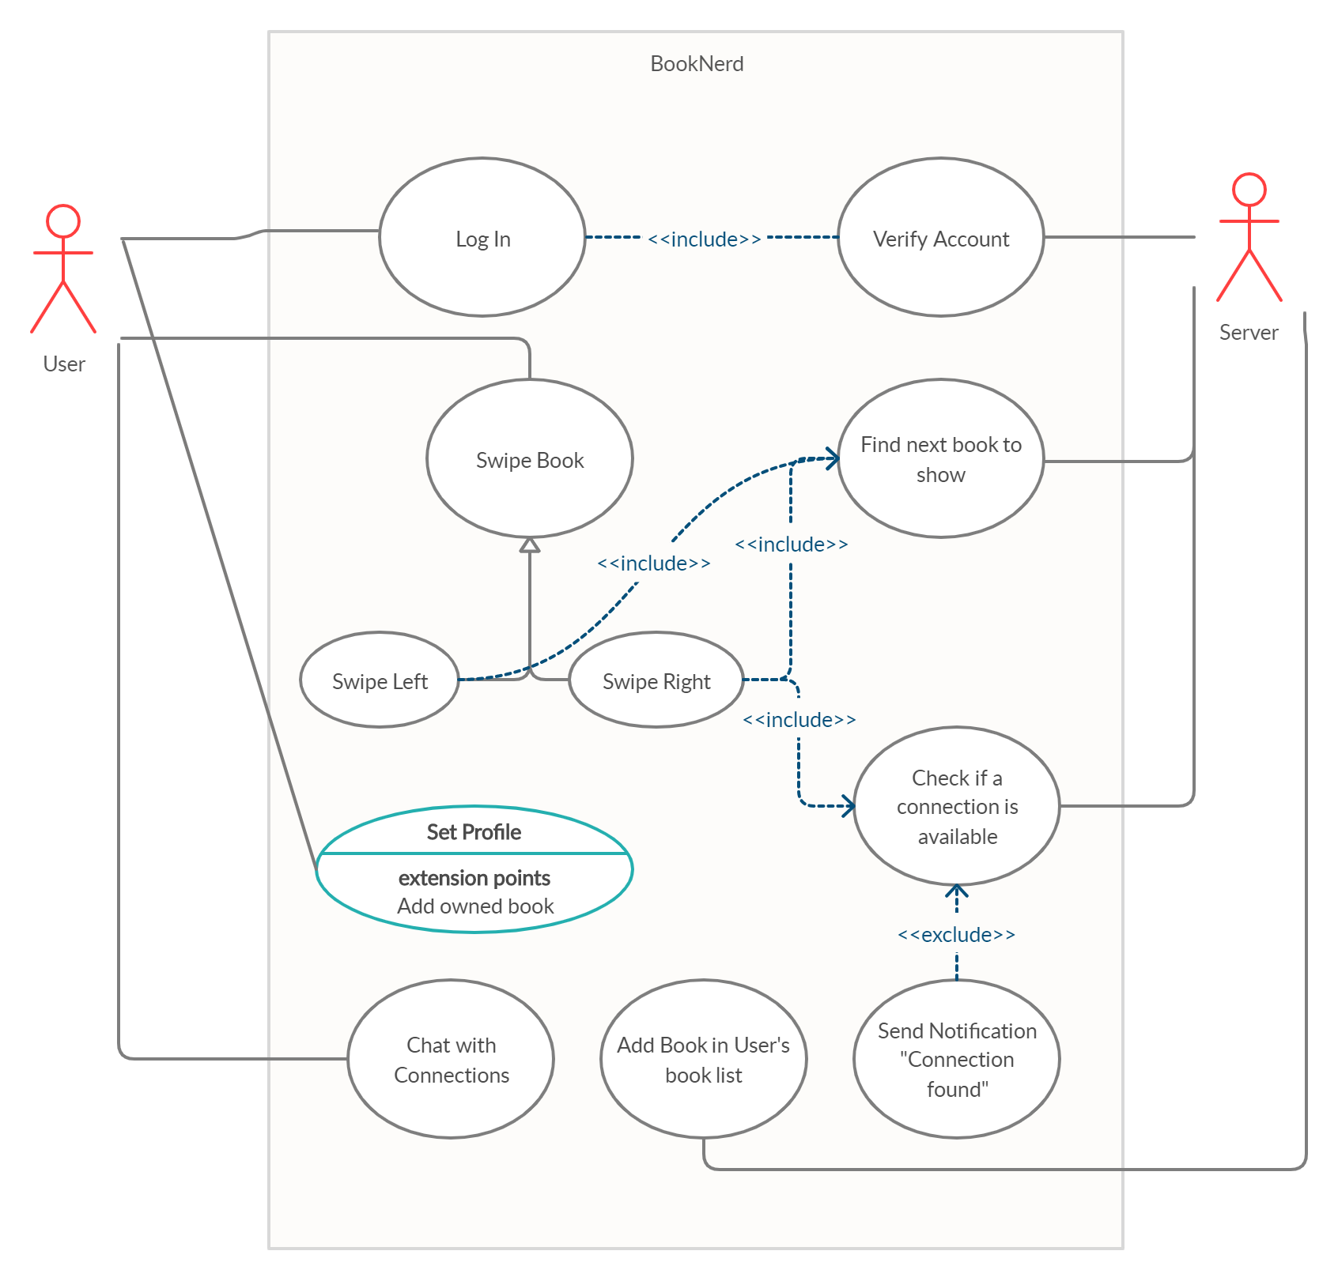

Figure 1. Use case diagram of the system

There are four main pages where a user can mostly interact. The registration or login page only appears during the first installation and whenever the user logs out of our system. The profile creation page allows the user to change their name and update the books they own. They are be able to add, modify or remove a book they own. The Swipe book page is the most important one in our system, since users mostly be spending their time on this page. This page shows a stack of cards which the users will either swipe left or swipe right. If a book is swiped left then the genre of the book gets a demerit in the user’s database. When a book is swiped right the genre of that book gets a merit and the server creates a book request. If some other user owning that book makes a book request that the former user owns then these two users are connected. Figuer 2 shows the process of how a connection is created. Hence, comes the fourth page, chatting. Users will be able to chat with their connections.

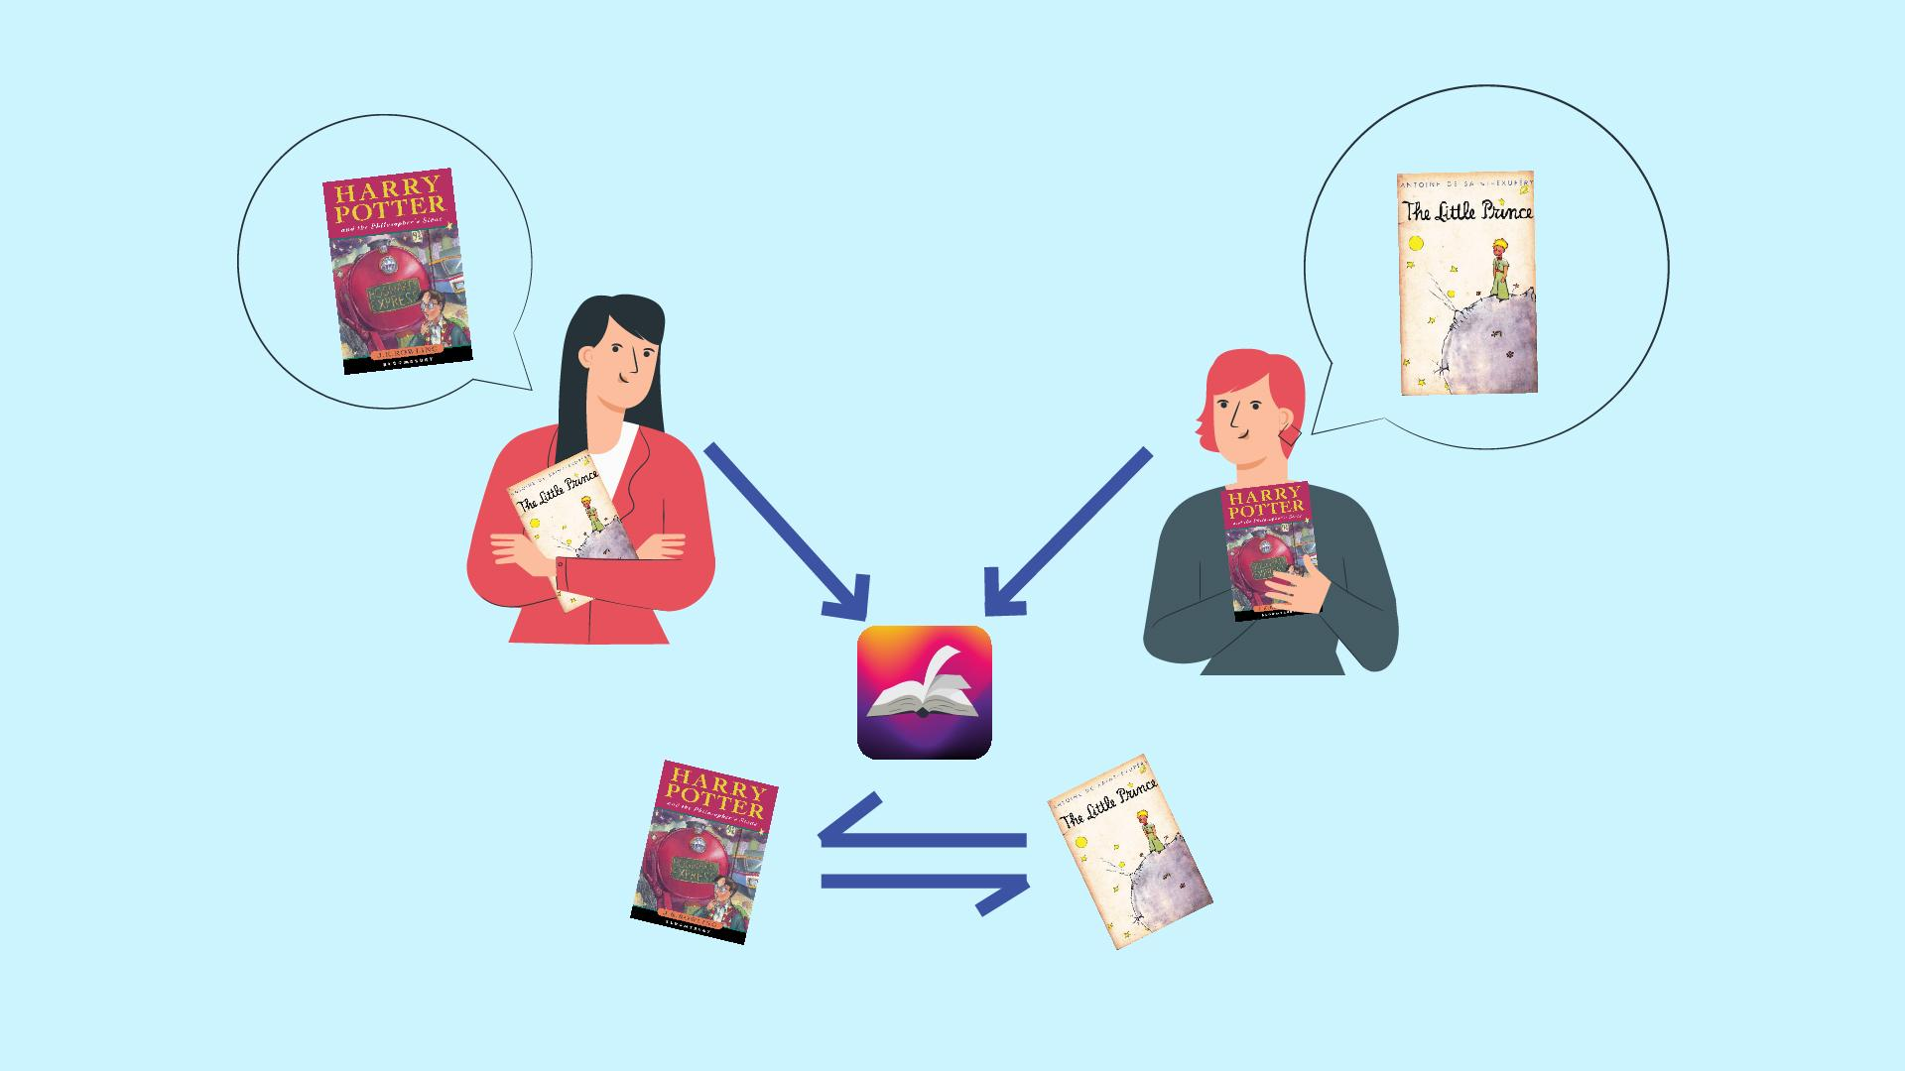

Figure 2. Users get connected through the app

## 

## 3.2 System Requirement

The app is developed using Java in Android Studio to allow native Android features compatibility. Firebase is chosen as the server and authentication provider since it provides easy and fast data management API. Some third party libraries were used to facilitate into building this system.

1. SwipeCards:To implement the card swiping mechanism. [4]
2. Google Books API: To implement add and search book feature. [5]
3. Volley: Make API calls through the internet [6]
4. Firebase: As backend authentication and Database. [7]
5. Gson: To parse JSON files [8]
6. Zxing: Library to process Barcode locally [9]

In future the app will be requiring GPS sensors to track the city of the user, for now it is manually entered by the user.

The recommendation system of the app will be depending on many factors and further research is necessary to come to a conclusion.

## 

## 3.3 Data Structure

We have used Firebase for our project. Reason behind choosing Firebase is the characteristics of our data and the project. Our project requires a realtime database and the arrangement of the data suits good for NoSQL databases. Since Firebase is a realtime NoSQL database we decided to use it as our database for the project.

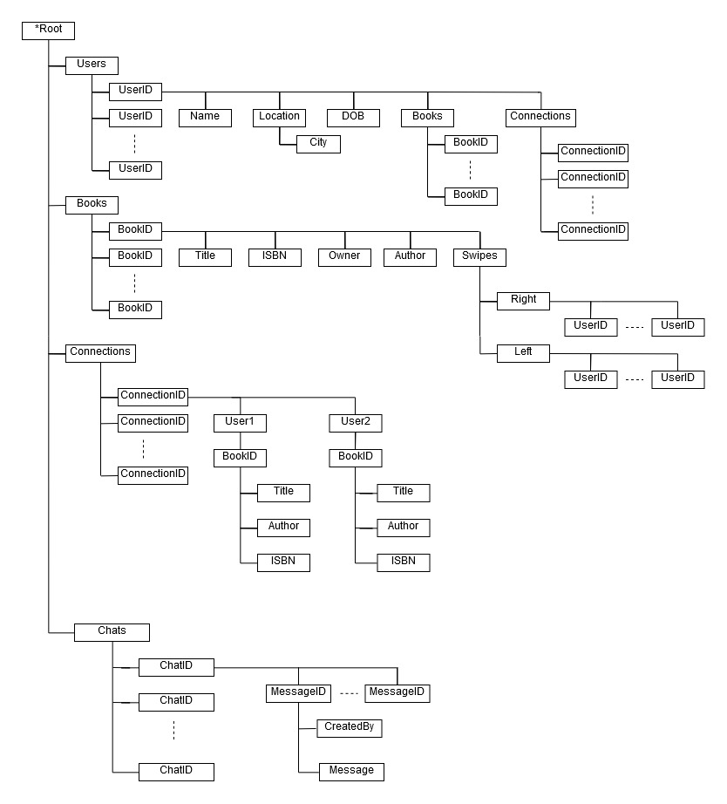

Figure 3. Firebase Data Structure for Booknerd

As it has been shown in Figure 3 the structure of the database, it has 3 main nodes under the **Root**, those are **Users, Books and Connections.**

**Users** node contains information of all the users on the platform. Each node under the **Users** node represents individuals users, and value of the nodes represents users’ ID.

**Books** node contains information of all the books added to the platform. Also there are two nodes for each book to store the information who swiped right or left on that particular book.

**Connection** node contains the information of all the connections between the users of the platform.

**Redundancies:** There are some redundancies in the data structure, which is in the users’ nodes. Each UserID node contain the information of the owned books of the user and all the connections of that user. Those data are also stored in separate nodes. The reason for storing them in the UserID nodes is to reduce time complexity while fetching the information from the app.

## 3.4 Adding Books

Users can add books to the platform using two different methods. One is to manually typing the name of the book and the name of the author. Another way is to scan the ISBN barcode of the book.

We have used **zxing** to process the barcode data. After user grants us the permission to the app to use their phone’s camera, our app can read the barcode using the library and fetch the ISBN number of the book.

After app gets the ISBN number of the book it can fetch other information about the book using Google Books API, which is discussed in details in the next sub-section.

## 3.5 API Integrations

We have used Google Books API in order to match the books. At first, we tried to use [...] but it has some issues regarding matching books. Then we found the Google Books API more subtle and accurate.

Google Books API is directly integrated with Google Books repository. Many reputed websites like GoodReads, WorldCat use this API t o perform queries like full text searches and retrieve book information.

Our app fetches book details from Google books using ISBN number of a book. A http request is made by the api to this url like this:

**https://www.googleapis.com/books/v1/volumes?q=isbn:9780605039070**

And the URL returns a JSON object which looks like this:

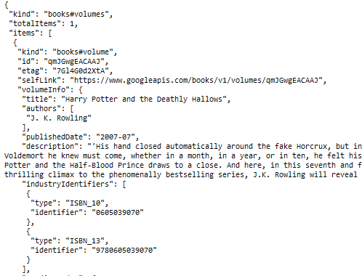

Figure 4: JSON object returned by the http request through the API.

## 3.6 Connections

Connecting users with each other is a vital task for this platform. Whenever a book is swiped right in the platform a subroutine is called to check if a connection should be established between the user who just swiped right and the owner of the book.

The subroutine to establish connection looks for if the owner of the swiped right book has swiped any of the book owned by the currently logged in user, if yes then it establishes a connection between the two users.

3.7 Chat

As shown in Figure.3 the chat feature will be completely based on Firebase Realtime Database. It is implemented through clever use of Firebase push functionalities. By using the push to database, a unique id can be generated. Each “ChatId” refers to each connected pair, whereas the “MessageId” refers to each message or text sent. The chat id is analogous to a chatroom while message id is simply each message. Each message has an attribute for the sending user and an attribute for the text.

# 4. Result

4.1 Registration Page

Booknerd android app at first presents users with a registration form where user has to give their full name, email address, city, gender, date of birth and choose a password to register.

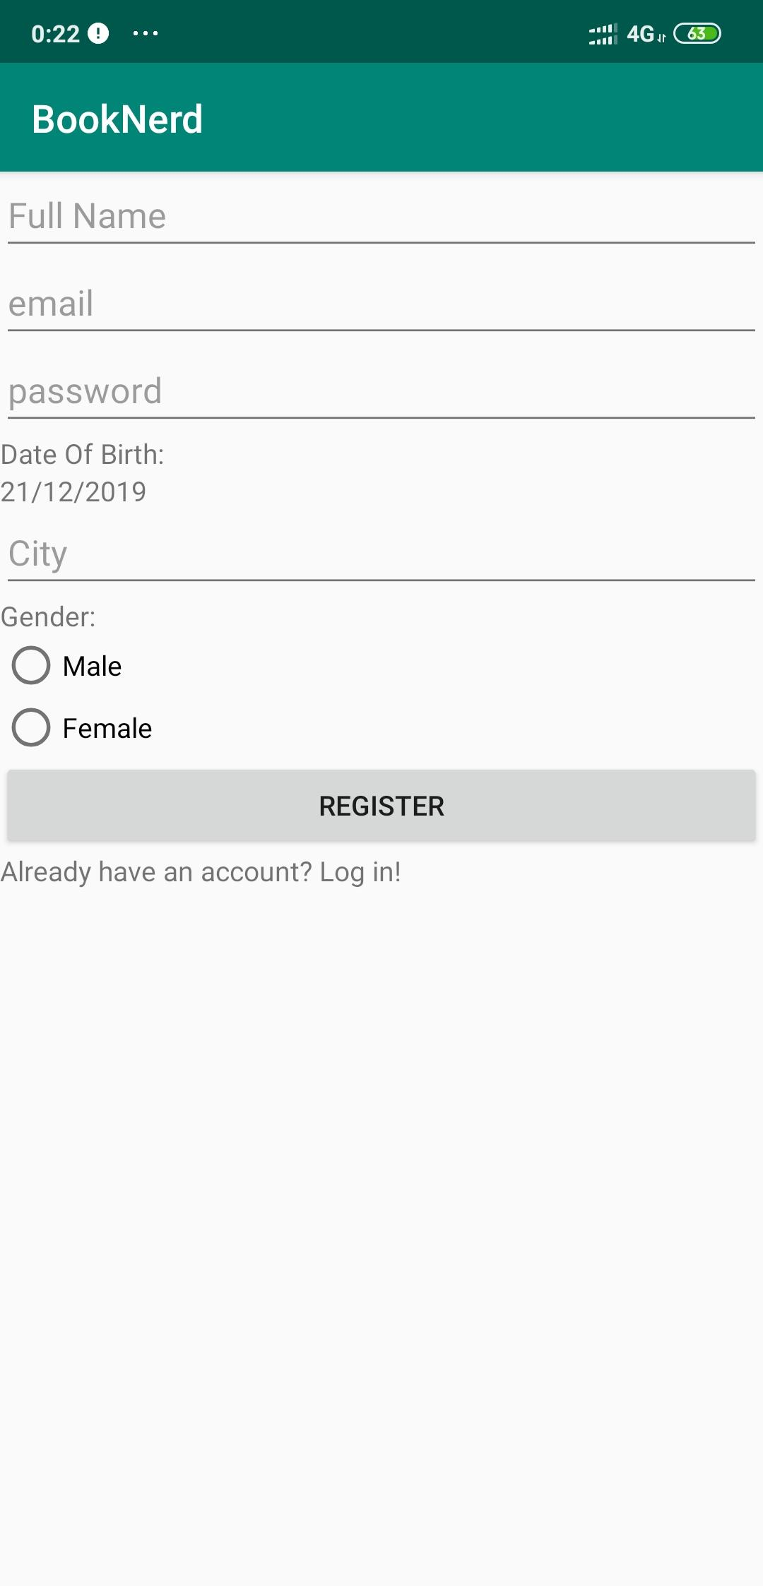

Figure 6: Registration Form

4.2 Home Page

Upon registering the user is taken to the home page. There user can see the available books which they can either swipe right or left. For this study, we have decided to show all the books available in the platform in an array to every user. In the future we will improve this by showing users books near their geo-location and based on their preferences. We also are just showing the book title and author name in the book cards now, our future plan is to add book covers too.

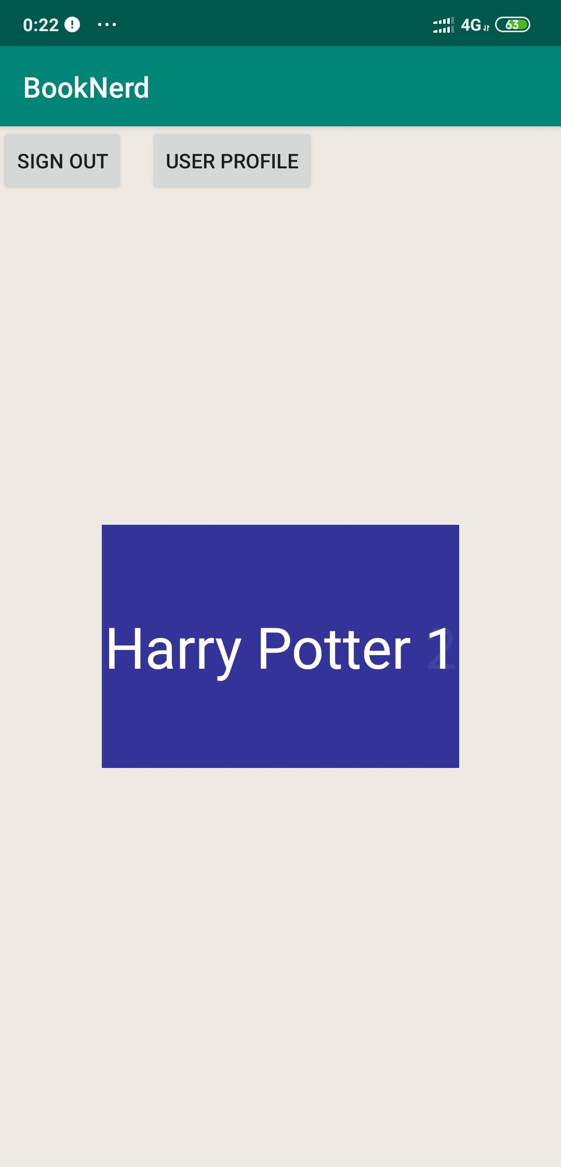

Figure 7: Home Page

Home page also have two other buttons, one to sign out of the logged in account **Sign Out** button, the other one is **User Profile** button, which takes the user to the Profile Page.

4.3 Profile Page

Profile page shows the basic information about the user. Those information are read only in this version of the app. We will add the option to edit them in future. The profile page also hosts the button to see **Owned Books,** a button to **Add Books,** see the **Connections** of the logged in userand the logout button.

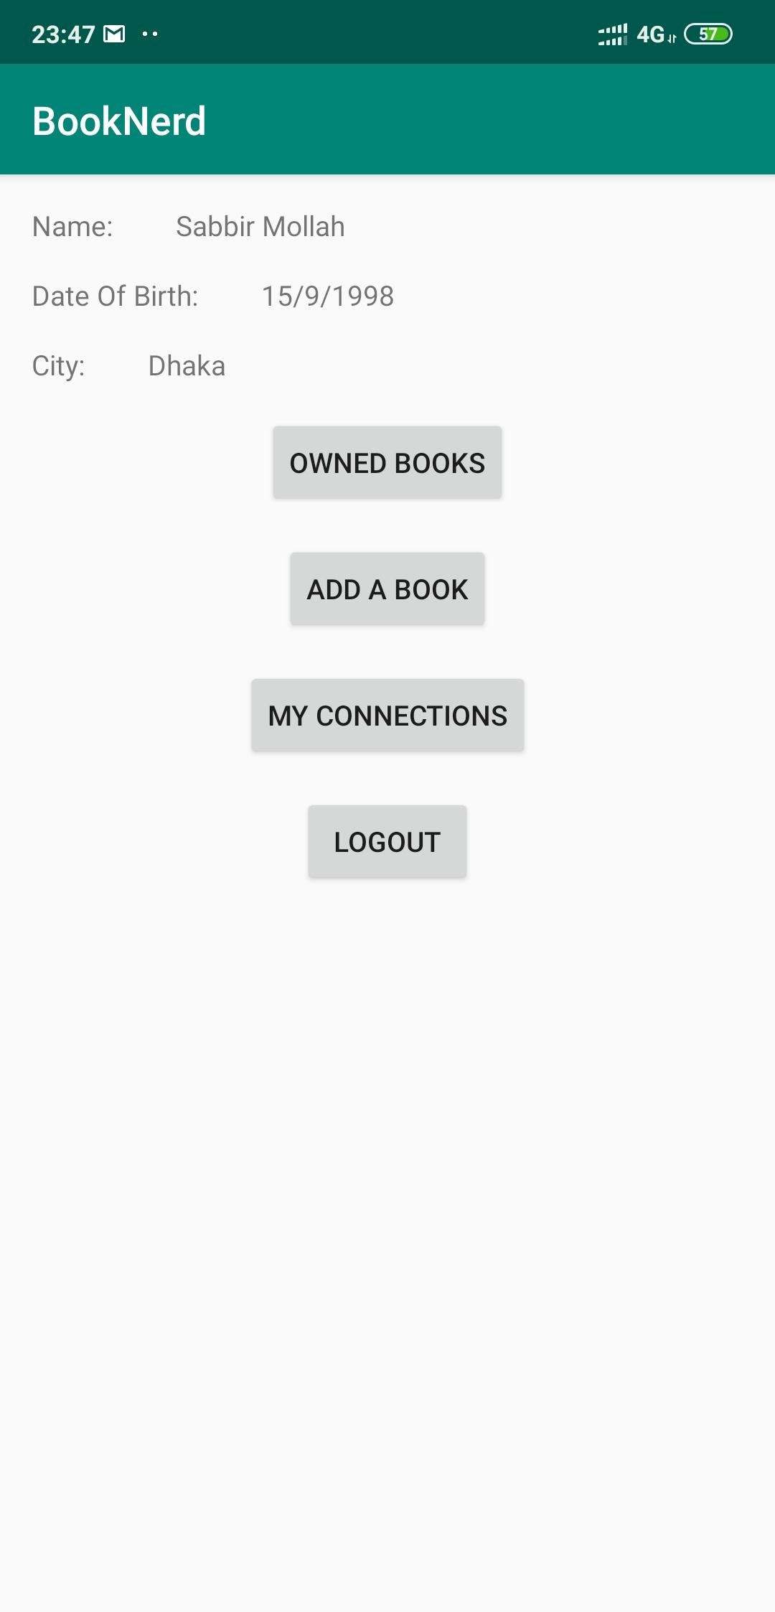

Figure 8: Profile Page

4.4 Add Book Page

There are two ways to add books in our application. Initially we had to add the books manually by adding book’s title, author name and ISBN. To make it more user friendly and efficient, we have added a barcode scanner to scan book’s barcode. So, a user is able to add his book to his profile easily.

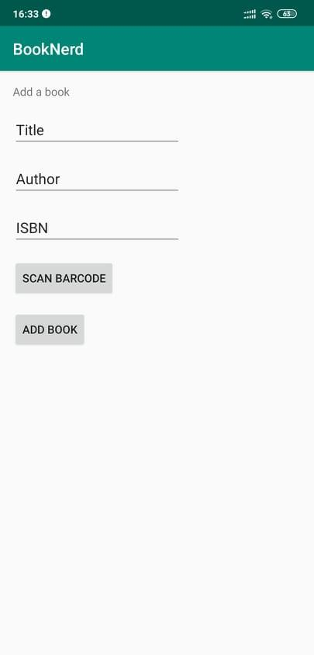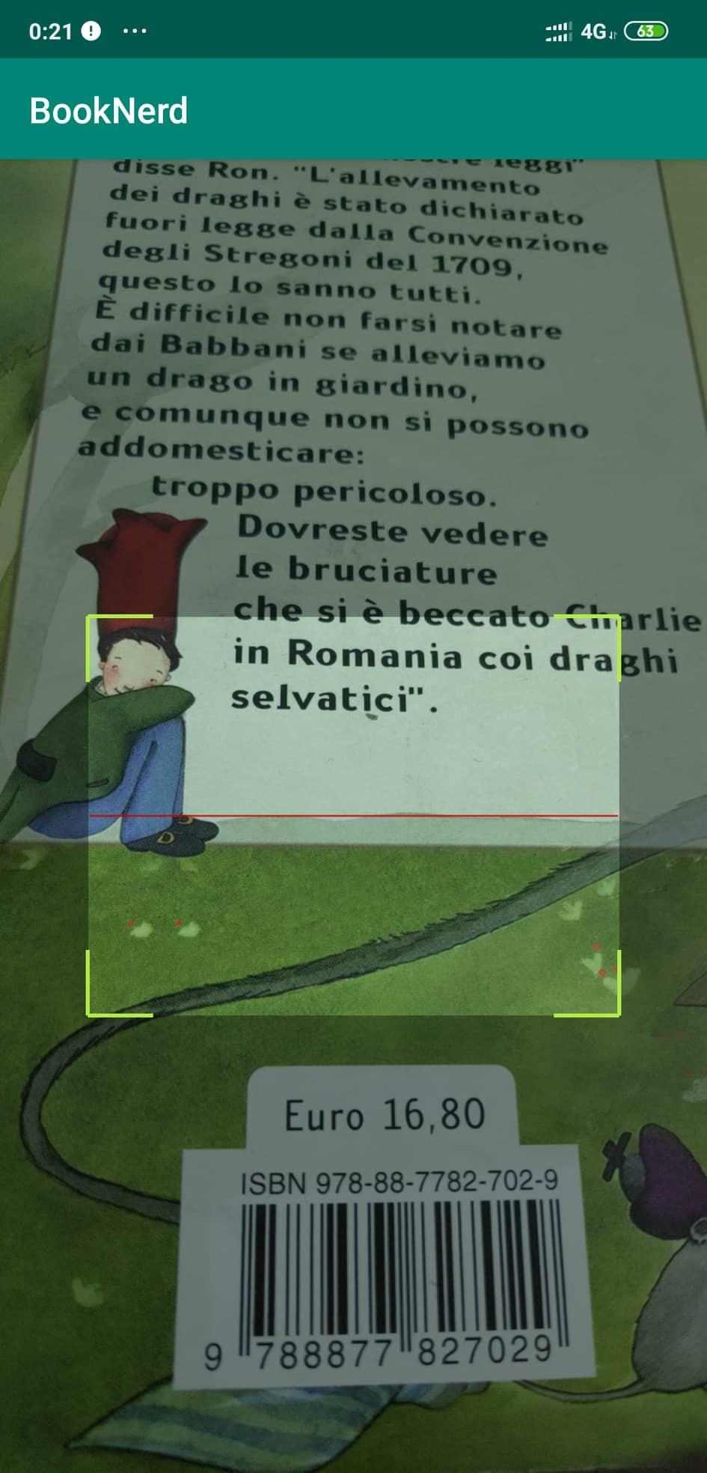

Figure 9: Add Book Options

4.5 Chat

Connected users will be able to send messages to each other through our platform. Each chat room will be unique for each connected pair. The chatting functionality will be an essential part of our platform since it will open up the option for people to talk to each other and get acquainted. They can both accept to exchange their books later on.

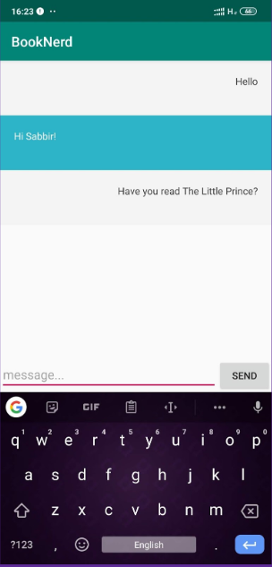

Figure 10: A chat conversation on the app

# 5. Discussion & Conclusion

# In this era of digitalization, it is not easy to connect with other people, let alone strangers. BookNerd was planned to solve this problem initially. It helps to get connected with people who are mutually interested in books.

So far, we have made a prototype using Android and the realtime database of Firebase. Users add books to their profile in order to exchange. After two people right-swipe each others book, they get connected and can contact each other via our chat feature. User can add books in their profile either by adding the title, author name and ISBN or scanning the barcode of the books. If a user scan a book, the data will be filled up automatically.

In future, our recommendation service will be improved on geolocation and age range using machine learning. Also, users have to add cities manually. BookNerd will require GPS sensor for better service. This prototype will need more research & data in order to take it to the next level.

# 

# 6. References

[1] About Goodreads. (2019). Retrieved 23 December 2019, from https://www.goodreads.com/about/us

[2] About Facebook. (2019). Retrieved 23 December 2019, from https://about.fb.com/

[3] What is Tinder?. (2019). Retrieved 23 December 2019, from https://www.help.tinder.com/hc/en-us/articles/115004647686-What-is-Tinder

[4] Diolor/Swipecards. (2019). Retrieved 23 December 2019, from https://github.com/Diolor/Swipecards

[5] Google Books APIs | Google Developers. (2019). Retrieved 23 December 2019, from https://developers.google.com/books

[6] Volley overview | Android Developers. (2019). Retrieved 23 December 2019, from https://developer.android.com/training/volley

[7] Documentation | Firebase. (2019). Retrieved 23 December 2019, from https://firebase.google.com/docs

[8] Google/Gson. (2019). Retrieved 23 December 2019, from https://github.com/google/gson

[9] zxing/zxing. (2019). Retrieved 23 December 2019, from https://github.com/zxing/zxing