3. Methodology
The proposed framework predicts the mechanical properties of carbon nanotube reinforced aluminum (CNT-Al) composites using statistical data driven learning algorithm with physical constraints. The workflow is divided into six sequential steps.
- Raw data acquisition and parsing
- Physics-constrained missing data imputation
- Correlation integrity verification
- Physics informed synthetic data generation
- Multi model development and benchmarking under rigorous cross validation
- Model deployment
The pipeline utilizes a Google Colab environment running Python 3.10 and with various machine learning libraries such as scikit-learn, Numpy, pandas and matplotlib and searborn for data visualization. A fixed random seed (Seed = 42) was applied over the whole pipeline to ensure reproducibility of the stochastic operations over multiple executions. The replacement of global median imputation used in standard machine learning practices physics constrained imputation cascade so that it can maintain the physical feature target correlation is the main innovation of the proposed methodology of this work which the conventional imputation mechanism fails to obtain.

3.1 Dataset Acquisition and Source Description
Experimental data were derived from the works of several studies [1, 2, 3, 4, 5, 6, 7, 8]. The raw dataset contained 203 rows of data values across the complete feature target space. Among those many data values were null which could not be used in a machine learning paradigm.

3.1.1 Raw Features
The dataset contains ten input features and three target variables formatted as the following table as .xlsx file format (In the original dataset the feature and targets are placed in rows meaning that one row has one sample with 10 distinctive features and 3 targets.
Type of Data | Name of the Quantity | Symbol | Unit
Feature Names | CNT Diameter | CNT_{d} | nm
 | CNT Length | CNT_{l} | nm
 | CNT Weight Percentage | CNT wt% | Percentage (%)
 | CNT Volume Fraction | V_{C} | Dimensionless
 | Orientation Factor | OF | Dimensionless
 | Particle Size of Al | d_{Al} | µm
 | Al Weight Percentage | Al wt% | Percentage (%)
 | Interfacial Shear Strength | ISS | MPa
 | Sintering Temperature | T_{sinter} | K
 | Porosity | Porosity | Percentage (%)
Target Names | Yield Strength | σ_{y} | MPa
 | Hardness | Hardness | GPa
 | Ultimate Tensile Strength | σ_{UTS} | MPa

Table 1: Format of the dataset derived from published studies
The orientation factor did not provide any useful information and had no value in any rows and that is why that column was completely dropped from the dataset making the dataset have nine input features and three targets. At this stage the dataset had 203 rows and 12 columns.

3.1.2 Correlation Analysis and Correlation Failure Cause
A diagnosis was performed on the dataset and its target feature space to verify the physical correlation between the target and the input features. The conventional machine learning approach is to fill missing data using the global median imputation. However, since many of the cells had missing values, this approach could not be performed and when performed it lost valuable information and lost the real physical relationships between the targets and the features. This caused correlation to drop almost to zero (around 0.01 to 0.04) making it look like there were no connections between the target and feature values. Thus, a physics constrained imputation was performed to maintain the actual correlation between them which is discussed in detail in section 3.4 which reduced the dataset to 199 usable rows for machine learning approach.

3.2 Data Parsing
All populated cells in the raw dataset were numerical and contained no string format data or any inequality range. Nevertheless, a defensive parsing function was implemented to handle such notations while converting hardness to GPa, resolving relational and inequality bounded values and taking the midpoint of the given ranges. In case future revisions of the dataset include entries of these formats, the parser will still be able to successfully capture data from such datasets as well. For the current dataset, however, parsing was performed by reading the numerical values directly from each cell belonging to individual feature and target space. CNT volume and fraction and Al weight percentage were also parsed directly from every sample and required no mass balance derivation from paired weight fraction. However, there is a dedicated function to the parser that will find the Al weight percentage from paired weight fraction if any of the data was missing. Thus, all the data from the current dataset was directly parsed as they contained numerical data in all the usable rows.

3.3 Missing Data Analysis
Following the string normalization and numerical encoding the missingness profile of the 195 usable rows were computed for all 12 variables as shown in Figure 2.
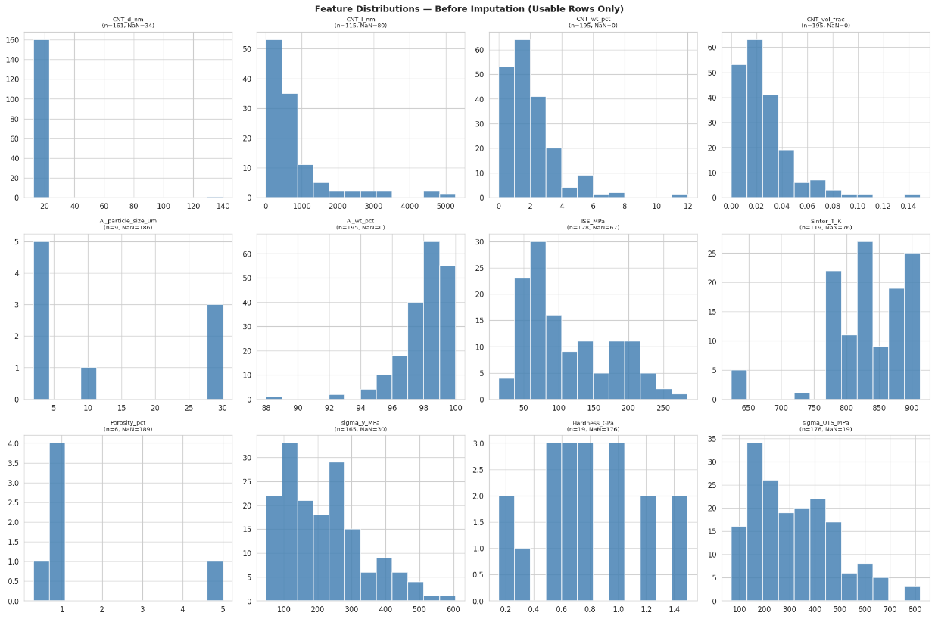
Figure 1: Feature Distribution Before Imputation
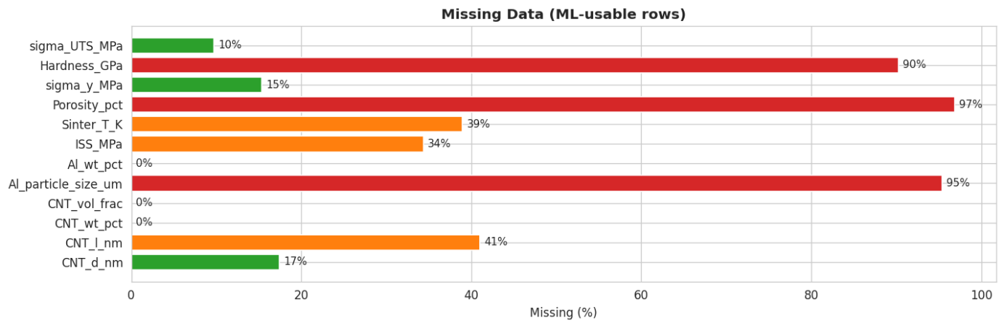
Figure 2: Missingness Profile for the Usable Rows
This analysis showed that many features had missing data up to 97% which is very high for a machine learning algorithm to make predictions based on the trend. The missingness of the targets was also non-trivial and it reflected that highest missingness was around 97% for porosity followed by 95% for Al particle size and 90% for Hardness. If we drop all the missing values from this current dataset then there will be only a few samples left (effectively zero complete case rows) for the complete machine learning approach which is below the widely accepted minimum requirement of 20-30 observations for reliable cross validation in higher dimensional regression as mentioned in the study of Arlot et al. [9] in their survey. So, we need to opt for physics-constrained imputation strategy.

3.4 Physics-Constrained Imputation
The main contribution of this study is the physics constrained imputation method, which is different from conventional statistical approaches such as mean, median, KNN imputation methods. Rather we used prior knowledge of empirical relationships from composite mechanics. The key idea of this method is that any imputed value must be kept consistent with the known monotonic feature-target relationships. Eight such relationships were identified and used for the imputation operation as mentioned in Table 2. These were ensured using a monotonic quantile mapping that is anchored to the sample’s own strength/yield/hardness proxy so that the physical relationships are enforced by construction rather than a prediction or an imputation based on statistical value.
Feature/Target Name | Relation with Target
CNT wt% | σ_{UTS} increases with increasing CNT wt%
CNT length | σ_{UTS} increases with increasing CNT length
CNT diameter | σ_{UTS} increases with decreasing CNT diameter
Porosity | σ_{y} decreases with increasing porosity
Sintering_T | Hardness increases with increasing Sintering T
ISS | σ_{UTS} increases with increasing ISS
σ_{y} | σ_{UTS} increases with increasing σ_{y}
σ_{y} | Hardness increases with increasing σy
Table 2: Physical relationship between various features and targets
Instead of fitting a general statistical model to estimate the values which are missing, each missing cell is filled by using a simple rule: the imputed value must follow the correct physical trend relative to how strong, hard or high yielding the sample already appears to be from its other reported measurements.
In order to do this, first a strength estimate, a yield estimate and a hardness estimate are assigned to each sample built from whichever target values are actually reported for that sample. If a sample contains UTS directly, then it is used as its strength estimate. If not, its yield or hardness value is converted into an equivalent UTS value using the empirical ratios described in Section 3.4.1. This operation is performed on each of the 195 samples and thus each of them ends up with a usable strength/yield/ hardness estimate. These estimates are used only as a guide for imputing missing features and they never replace a value which is actually reported in the dataset.
Each missing feature is then imputed as follows: the sample’s relevant estimate (strength, yield or hardness) is converted into a percentile rank among all samples and that percentile is mapped onto the feature’s own realistic range while maintaining the correct physical direction of the physical relationships. For example, a sample with very high strength estimate will be assigned a small CNT diameter since smaller diameters produce higher strength. This guarantees that every imputed value moves in the correct physical direction within a realistic range for that feature without requiring a fitted regression equation. Six features were imputed this way:
- CNT Diameter: smaller diameter is associated with higher strength. Bounded to [5, 200] nm and 34 of 195 values were imputed.
- CNT Length: longer length is associated with higher strength. Bounded to [100, 50000] nm and 80 of 195 values were imputed.
- Interfacial Shear Strength (ISS): higher ISS is associated with higher strength consistent with the shear lag stress transfer model of Kelly and Tyson [10]. Bounded to [5, 200] MPa and 67 of 195 values were imputed.
- Sintering Temperature: higher sintering temperature is associated with higher hardness. Bounded to [400, 1100] K and 76 of 195 values were imputed.
- Porosity: higher porosity is associated with lower yield strength. Bounded to [0,5] % and 189 of 195 values were imputed.
- Al Particle Size: finer particle size is associated with slightly higher yield strength. Bounded to [0.1, 100] µm and 186 of 195 values were imputed.
CNT volume fraction did not require any imputation as all the required values were directly available for all 195 samples. If it were missing in a future version of a dataset it could be calculated from the reported weight fractions using the mass balance relation described in Section 3.4.1.

3.4.1 Target Cross Imputation and Volume Fraction Derivation from Mass Balance
The three target variables were filled using two empirical ratios from the paired measurements [11].
First, the ratio between UTS and yield strength was calculated from the 161 samples which contain both of the values.
$$r_{UTS/y}=median \left(\frac{σ_{UTS}}{σ_{y}}\right)≈1.581$$
Second, the relation between hardness and yield strength was calculated from the four samples that report both values.
$$H\left[GPa\right]=C_{HY}×σ_{y}×\frac{\left[MPa\right]}{1000}$$
Where C_{HY} is the Hardness to Yield Coefficient calculated from the 4 samples that contain both information and has a value of $C_{HY}=4.273$
However, only four paired values of hardness and yield exist in this dataset so this coefficient should be understood as a value calibrated for this dataset only rather than a general material constant. Using these two relations, missing target values were filled in through a few passes: first yield strength was recovered from either UTS or hardness whichever was available for that sample. Then UTS and hardness values were recovered using the now complete yield strength column. A final pass filled in any values still missing after the two first steps using the median values. This process filled every remaining gap in the three target columns and so no samples were removed for missing targets.
CNT volume fraction V_{C} can be imputed using the mass balance relation from the mixture theory if required:
$$V_{C}= \frac{\frac{W_{CNT}}{ρ_{CNT}}}{\frac{W_{CNT}}{ρ_{CNT}}+\frac{W_{Al}}{ρ_{Al}}}$$
Where $W_{CNT}$ and $W_{Al}$ are weight fractions and $ρ_{CNT}$ = $2.1 {gcm}^{-3}$, $ρ_{Al}$ = $2.7 {gcm}^{-3}$. For the samples where both weight fractions were unavailable a univariate linear regression of $V_{C}$ on $W_{CNT}$ was performed and the fitted line was extrapolated within physical bounds $V_{C} ∈\left[0, 10\right]vol\%$.

3.4.2 Applying Physical Bounds
After all features and targets were imputed, every value was clipped to the physically realistic bounds shown in Table 3. This clipping did not require removing any additional rows since all the cells were filled across the 195 samples following the imputation method in Section 3.4.1. The final dataset used for model training therefore includes all 195 samples of which 1483 cells were original reported values and 857 cells were filled in by the imputation described above.

Feature name | Bound with unit
CNT diameter | [5, 200] nm
CNT length | [100, 50000] nm
Interfacial Shear Strength (ISS) | [5, 200] MPa
Sintering Temperature | [400, 1100] K
CNT weight fraction | [0, 8] wt%
CNT Volume Fraction | [0, 10] vol%
Al Weight Percentage | [90, 100] wt%
Porosity | [0, 5] %
Al Particle Size | [0.1, 100] µm
$$σ_{y}$$ | [50, 800] MPa
Hardness | [0.05, 2.0] GPa
$$σ_{UTS}$$ | [60, 900] MPa
Table 3: Applied Physical Bounds on Features and Targets
After applying bounds a final drop was performed to remove any record where the target variable was still null even after imputation which yielded the final dataset of 195 usable samples with no missing data across 12 variables which is the one we desired for our machine learning algorithm.

3.5 Physical Correlation Verification
Physics relations were validated by computing both Pearson r and Spearman ρ coefficients for all eight relationships on the 195 samples dataset [12], [13]. All eight correlations passed the directional sign test confirming that the imputations were perfectly done while preserving the physical correlations between the targets and the features. The high Spearman values show that the trends are steady and consistent rather than being a random guess and is perfect for machine learning algorithm as it can be seen from Figure 3.
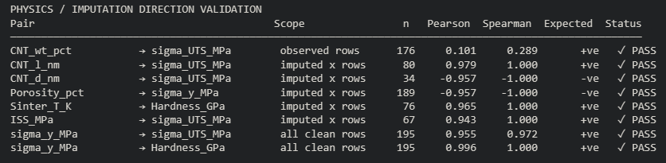
Figure 3: Physics Correlation Verification
The Figure 4 and Figure 5 shows the Pearson’s correlation heatmap post imputation and scatter plots for physical correlations after the imputation respectively.
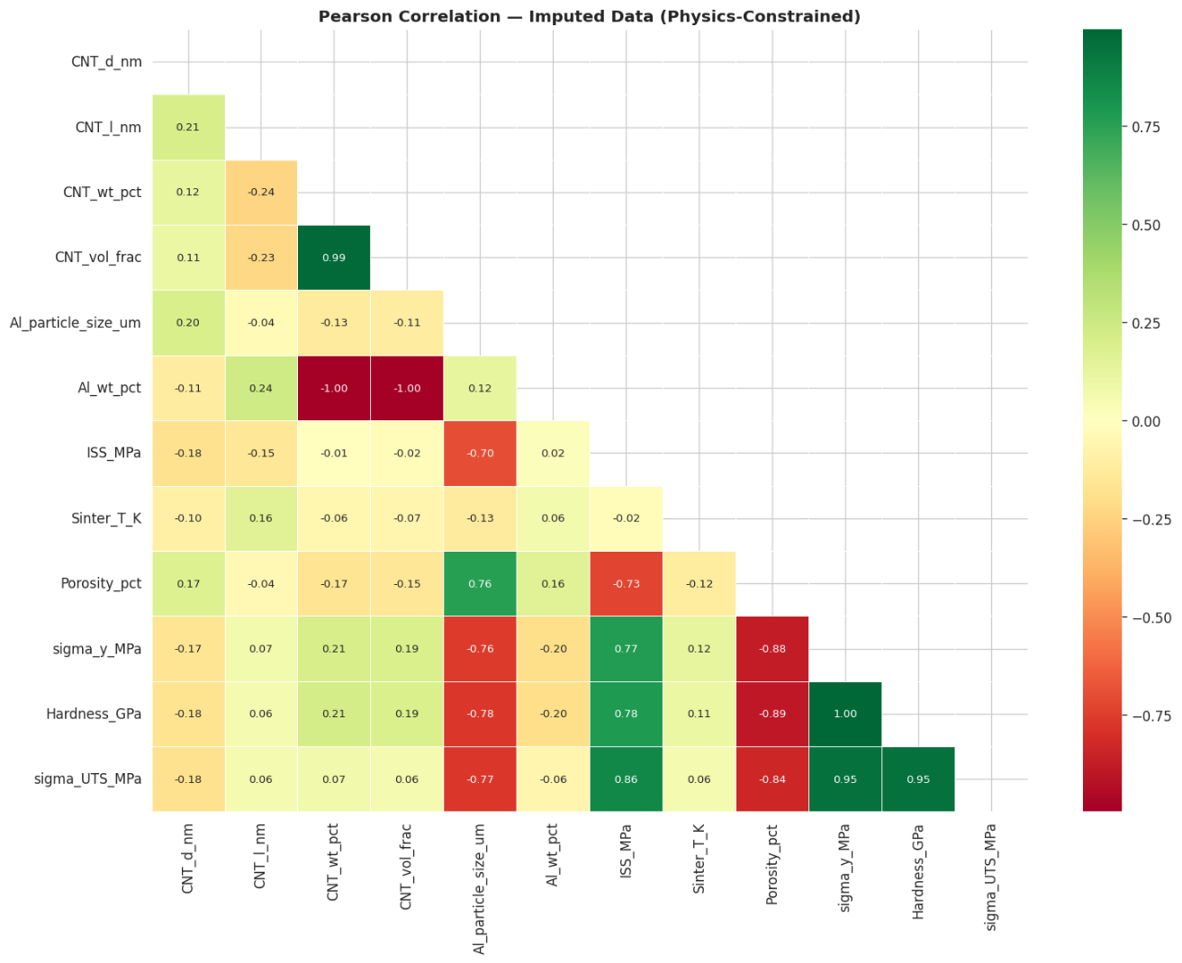
Figure 4: Patterson’s Correlation Heatmap
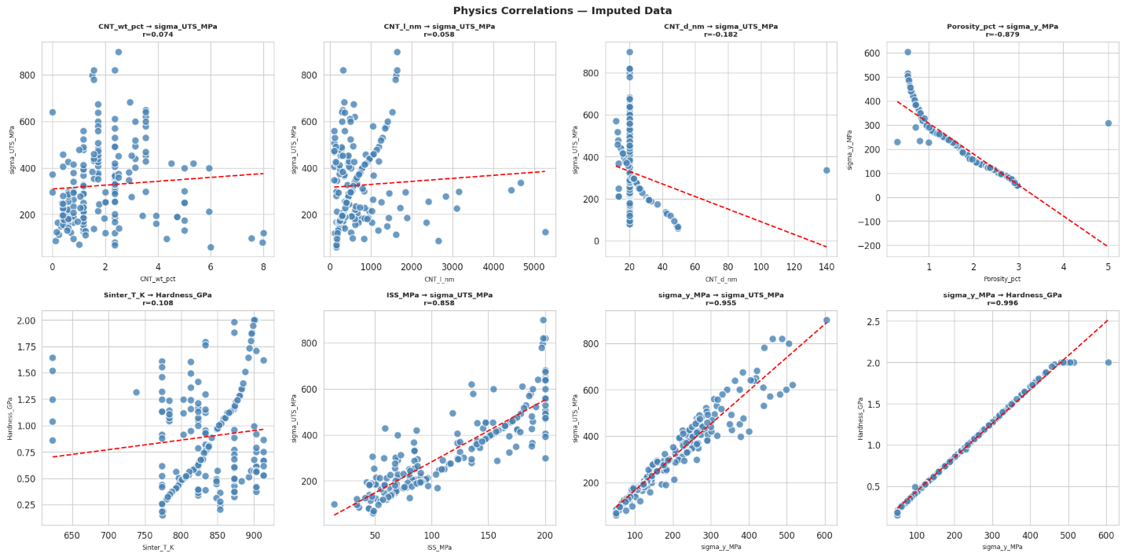
Figure 5: Physical Correlations Scatter Plot and Trend Evaluation

3.6 Synthetic Data Generation
The dataset generated by this method is limited and if we train machine learning models using this dataset, then those models have high risk of overfitting without learning any significant trends or generalizing the patterns. In order to mitigate this issue and to train the model properly with proper trend capturing capabilities synthetic data generation was employed by maintaining the physics informed constraints and correlations to generate 10,000 samples. The approach followed the physics informed data augmentation paradigm as done by Barta et al. and Xu et al. [14], [15] but implemented the physics constraints directly instead of treating them as neural network loss terms.

3.6.1 Generative Physics Model
First the input features were sampled and then it was parameterized from the truncated normal distributions using the mean and $1.5×standard deviation$ of the corresponding feature column. Then they were clipped according to the physical bounds as mentioned in section 3.4.1. Using the mass balance equation of section 3.4.1 the CNT volume fraction was computed analytically from each sampled CNT weight fraction. The yield strength $σ_{y}$ was calculated using following closed form semi-empirical constitutive equation which takes into account five distinct strengthening contributions to ensure the physics informed correlations [16], [17], [18].
$$σ_{y}=65\left(1+k_{wt}\right)e^{-0.10Φ}× \left(1+0.18{ISS}_{norm}\right)×\left(1+0.15T_{norm}\right) ×\left(1+0.12l_{norm}\right)× d_{factor}×ps_{factor}$$
Here, $k_{wt}$ is the load transfer combined strengthening calculated as a saturating function of CNT weight fraction to reflect diminishing returns at higher loading as follows:
$$k_{wt}= \left\{\begin{aligned}0.50×CNT wt\%, for CNT wt\%≤3\% \\ 0.50×3+0.08×\left(CNT wt\%-3\right), for wt\%>3\%\end{aligned}\right.$$
$e^{-0.10Φ}$ is the porosity attenuation term, ISS_{norm}, T_{norm} and l_{norm} are normalized interfacial, thermal and geometric contributions respectively, d_{factor} is the diameter strengthening factor describe by the equation $d_{factor}=1+0.10(1-\frac{d}{200})$ and ps_{factor} is the Al particle size contribution as expressed by the equation $ps_{factor}=1+\frac{0.05}{1+\frac{d_{Al}}{10}}$.
In this equation the baseline tensile strength is exponentially penalized by attenuation term as per Ryshkewitch’s porosity law [16]. The positive scaling parameters act as sensitivity ceilings for the bounded normalized features. These weights are enforced to match the general statistical trends seen in the real experimental samples.
A 4% multiplicative Gaussian noise term was added to the target variables $σ_{y}, σ_{UTS} and Hardness$ to replicate experimental scatter. The $\frac{σ_{UTS}}{σ_{y}}$ ratio was modelled as $r_{UTS/y}= clip(1.35+0.30l_{norm}-\frac{0.12d}{200}+0.18{ISS}_{norm}$; 1.20, 1.95) and Hardness was derived from the calibrated hardness-yield relation of Section 3.4.1 by applying a sintering temperature correction as expressed by the equation $H=\left(\frac{C_{HY}×σ_{y}}{1000}\right)×\left(1+0.04T_{norm}\right)$.

3.6.2 Synthetic Distribution Verification
The 10,000 synthetically generated samples were assessed on three complementary criteria. Firstly, the eight physics correlations were verified for the generated synthetic samples using the same directional sign test as before and all passed the verification with large Pearson r values than even the real data due to having higher number of working samples. Secondly, normalized histograms were generated for all the features and target variables to verify the distribution between real and synthetic data.
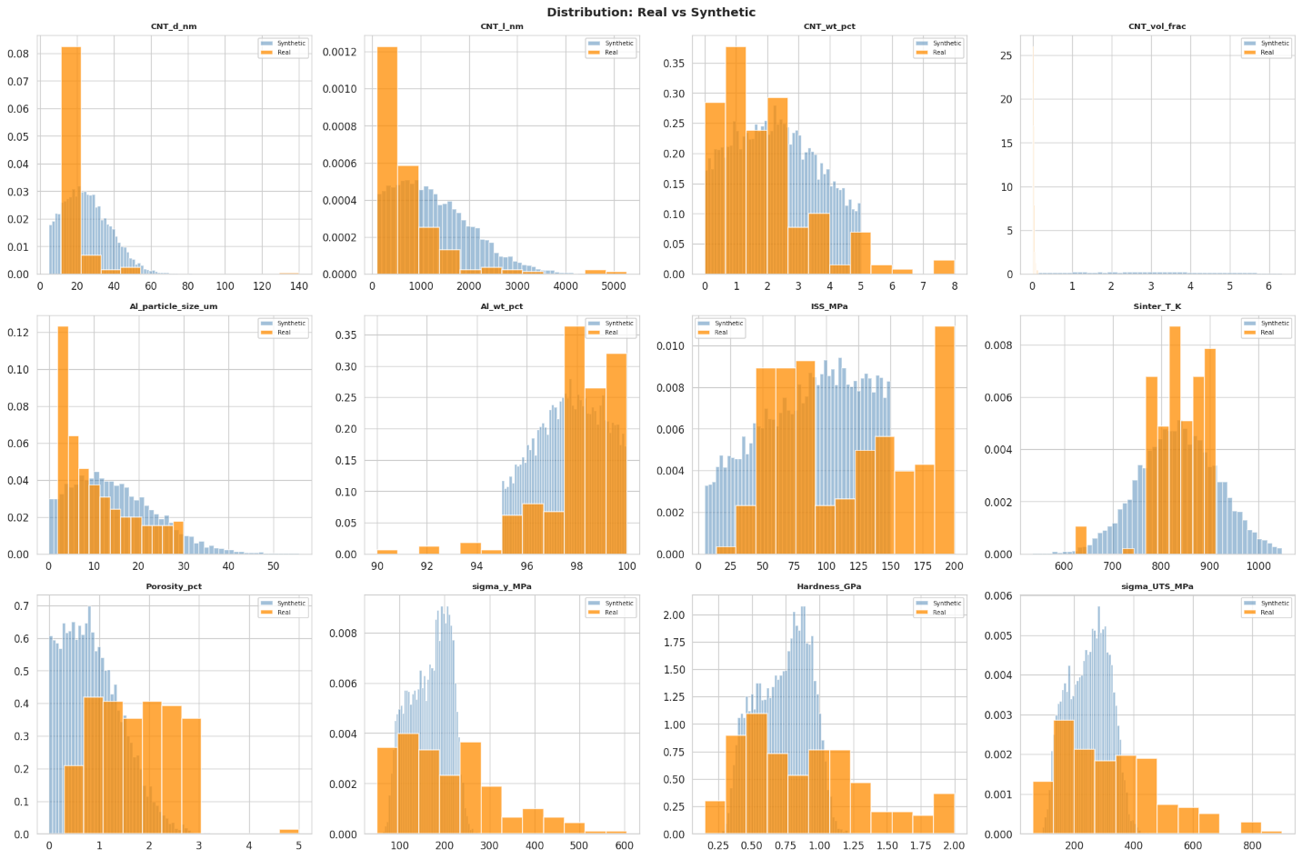
Figure 6: Real vs Synthetic Distribution Comparison

3.7 Machine Learning Framework
The machine learning framework consisted of a total of eleven supervised regression models which were evaluated in two experiments.
- On the real dataset consisting of 195 samples under 5-fold cross validation
- On the synthetic dataset consisting of 10,000 samples under 5-fold stratified cross validation
The regressors were implemented as multi-output regressors that can predict three target variables $σ_{y}, σ_{UTS} and Hardness$. The regressors Linear Regression, Ridge, Lasso, ElasticNet, KNN, Random Forest, SVR (RBF), Gradient Boost, Extra Trees, MLP, XGBoost were used directly as they can be directly implemented to predict multiple outputs whereas the SVR and Gradient Boosting regressors require single target training and thus they were modified using scikit-learn’s MultiOutputRegressor meta-estimator to support multiple target prediction.

3.7.1 Feature Engineering and Normalization
The input features were standardized to zero mean and unit variance to avoid one feature having higher weights due to having high values using the StandardScaler of the scikit-learn library. The dataset was split into training and test data before doing the standardization to prevent leakage of information of the test data which would give the model information about the previous data. Thus, for each loop of cross-validation the dataset was first split into training and testing data and then the scaling was fitted on the training data using zero mean and unit variance and then that exact calibrated scaling was later applied to test data separately to avoid the information leaking issue [19]. To avoid selection bias no feature selection was applied and instead all nine features were retained during the training. A separate StandardScalar was fitted for the synthetic experiments to the target matrix Y to enable the MLP and gradient boosted models to converge efficiently on heterogeneous output scales.

3.7.2 Cross Validation Method
For the real dataset, the cross validation strategy is selected based on sample size: Leave-One-Out Cross-Validation (LOO-CV) is used only when the sample count falls below the threshold n=30 [9], otherwise 5-fold cross validation with shuffling is used. Since the physics constrained imputed dataset according to Section 3.4 contains 195 usable samples, 5-fold cross validation with shuffle was performed on the real dataset rather than LOO-CV.
For the synthetic dataset with 10,000 samples 5-fold cross validation with shuffle was performed to estimate the performance with low variations.
In both cases, to avoid upward bias arising from averaging per-fold $R^{2}$ values [19], [20], [21], model predictions were accumulated across all folds before computing global $R^{2}$ and RMSE metrics.

3.7.3 Model Configurations and Hyperparameters
The eleven models evaluated on the real dataset used the configurations in Table 4a.
Model | Hyperparameters | Other Configurations
Linear Regression | Default model from scikit-learn | OLS baseline
Ridge | $$α=1.0$$ | L₂ regularization
Lasso | $α=0.1$, max_iter = 5000 | L₁ regularization
ElasticNet | $α=0.1$, max_iter = 5000, l1_ratio = 0.5 | L₁+ L₂ Regularization
SVR (RBF) | C = 100, $ε=0.1$, kernel = rbf | MultiOutputWrapper
KNN | k = 5, Euclidean distance | Uniform weights
Random Forest | n_trees = 200, SEED = 42 | Gini impurity
Extra Trees | n_trees = 200, SEED = 42 | Extreme randomization
Gradient Boost | n = 200, lr = 0.05, SEED = 42 | MultiOutputWrapper
MLP | Hidden_layer_sizes: (128, 64, 32), max_iter = 1000 | Adam Optimizer
XGBoost | n = 200, lr = 0.05, tree_method = hist, SEED = 42
Table 4a: Model Configurations for Real Dataset
The six models evaluated on the synthetic dataset used a separate, independently tuned configuration given in Table 4b. Since the much larger sample size (10,000) permits deeper and more expressive models without overfitting risk, the models were tuned accordingly. The other 5 models were dropped as they did not perform well on the real dataset.
Model | Hyperparameters | Other Configurations
Ridge | $$α=1.0$$ | L₂ regularization
Random Forest | n_trees = 300, max_depth = 15, SEED=42 | Gini impurity
Extra Trees | n_trees = 300, max_depth=15, SEED = 42 | Extreme randomization
Gradient Boost | n=200, lr=0.05, max_depth = 5, SEED = 42 | MultiOutputWrapper
MLP | Hidden_layer_sizes:(256, 128, 64, 32) max_iter - 1000 | Adam Optimizer
XGBoost | n=300, lr = 0.05, tree method = hist, SEED = 42
Table 4b: Model Configurations for Synthetic Dataset

3.7.4 Evaluation Metrics
Two metrics were computed separately for each target variable and as a mean across all three target variables to evaluate the performance of the models.
Metric | Formula | Interpretation
Coefficient of Determination ${(R}^{2})$ | $$R^{2}=1-\frac{\sum_{i=1}^{n}{{\left(y_{i}-\hat{y_{i}}\right)}^{2}}}{\sum_{i=1}^{n}{{\left(y_{i}-\overline{y_{i}}\right)}^{2}}}$$ | - Measures the proportion of variance in the target variables.  - $R^{2}$ = 1 means perfect prediction for every single data point  - The higher the value than 0 the better it is
RMSE | $$RMSE= \sqrt{\frac{\sum_{i=1}^{n}{{\left(y_{i}-\hat{y_{i}}\right)}^{2}}}{n}}$$ | - Calculates the root mean square error of prediction.  - The lower the score the better the model.
Table 5: Model Evaluation Metrics
Here, $y_{i}$ = Actual value
$\hat{y_{i}}$ = Predicted value
$\overline{y_{i}}$ = Mean of the actual values
n = Number of data points

3.8 Evaluation and Model Deployment
After the models are trained and evaluated on the synthetic dataset, the best performing model was retrained on the complete 10,000 samples and then evaluated on the 195 real samples as an independent held-out test set. This ensures whether the model has learnt the physics correlations of the features and targets by learning from the synthetic dataset. This also ensures that it matches real world values. The best performing model was then saved along with its feature scaler and target scalar including the supplementary meta data of the model such as feature names, target names, training ranges, normalization parameters, the empirical $\frac{σ_{UTS}}{σ_{y}}$ ratio and the best cross validation $R^{2}.$ Then this model was deployed to make inference based on given data on a full web based interactive user interface inside the Google Colab environment.
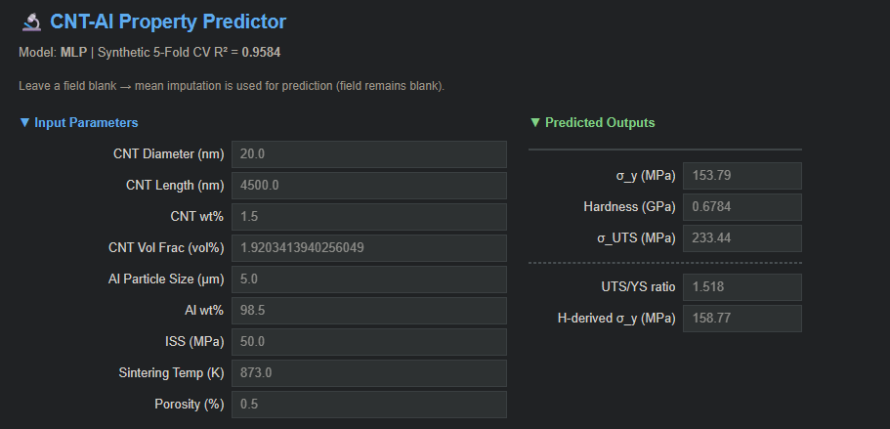
Figure 7: CNT-Al Property Predictor GUI
Later, a sensitivity analysis was conducted to verify that the deployed model preserved the eight physics relationships in the inference mode. To verify this, each input feature was varied across its full training range independently while all other features remained constant at their reference values and thus the predicted outputs produced the trajectories which were inspected to determine the monotonic relationship across the features and targets. This provided a model level consistency verification which is similar to the data level correlation verification providing complete assurance that the model operates within physically meaningful bounds.

4. Results, Analysis and Evaluation
This section evaluates the complete CNT-Al composite ML pipeline developed as mentioned in the methodology chapter across four dimensions.
- Supervised learning performance on the real dataset with 195 physics constrained samples under 5-Fold Cross Validation.
- The evaluation of physics constrained imputation method based on the capability of recovering the correlations
- The performance of the models on the synthetic dataset containing 10,000 physics-informed samples.
- Sensitivity analysis of the deployed model to verify physics correlation preservation.
The results are derived sequentially as mentioned in chapter 3 where we logically explained experimental approaches which were designed to achieve better performance and estimation while maintaining real world physics constraints. All cross-validation reports here are computed globally over the full accumulated fold wise predictions so that the upward bias arising from per fold averaging can be avoided during calculating coefficients of determination [20].

4.1 Machine Learning Benchmark on Real Dataset (5-Fold Cross Validation)
Eleven regression models were evaluated on the real dataset containing 195 samples using the 5-fold cross validation. The performance metrics of the models across all three targets are summarized in Table 6.
Model | $$R^{2}$$ | RMSE
Linear Regression | -2.648 | 157.442
MLP | 0.158 | 64.681
Lasso | 0.753 | 44.590
Ridge | 0.769 | 44.229
ElasticNet | 0.776 | 42.577
KNN | 0.820 | 40.828
SVR (RBF) | 0.873 | 36.718
Random Forest | 0.938 | 25.708
XGBoost | 0.941 | 24.840
Gradient Boost | 0.950 | 22.803
Extra Trees | 0.956 | 21.740
Table 6: Performance of Regressor Models on Real Dataset
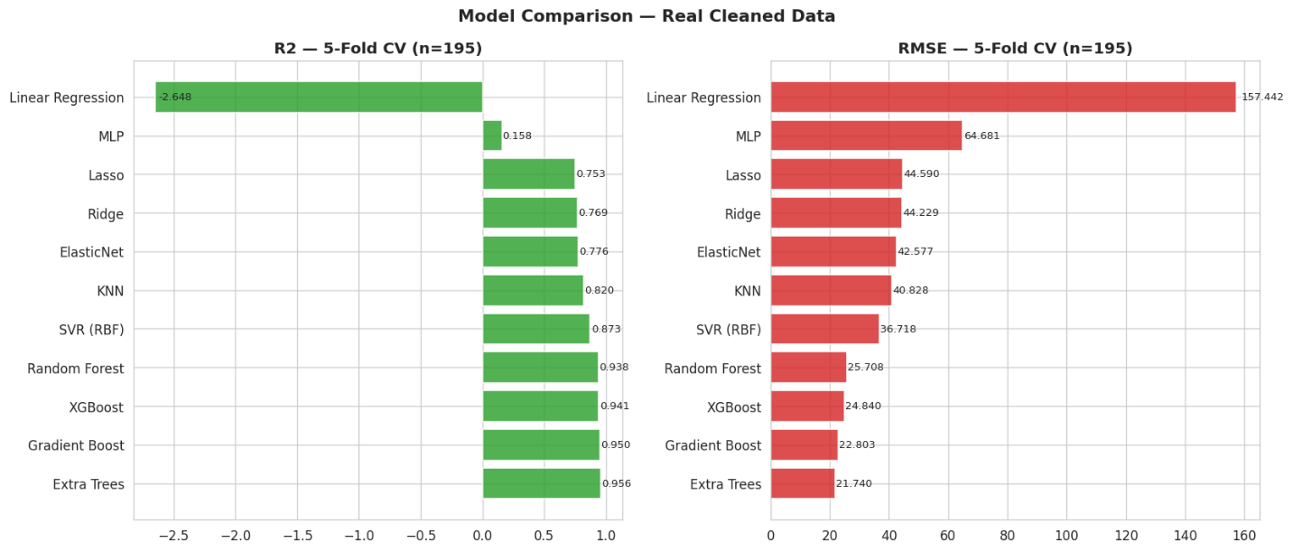
Figure 8: Model Comparison Bar Chart Based on $R^{2}$ and RMSE Values
From Table 6 and Figure 8 it can be seen that the linear models (Ridge, Lasso, ElasticNet) achieved reasonably higher $R^{2}$ values closer to 1 meaning that they learnt the patterns to properly predict the three targets. However, plain Linear Regression could not able to recover the feature target correlations compared to its regularized counterparts.
The ensemble methods (Random Forest, Extra Trees, Gradient Boost, XGBoost) occupied the top positions in terms of performance which is consistent with the established better efficiency of ensemble models over linear models in non-linear and multi-colinear materials property prediction tasks as mentioned by Murdock et al. and Tshitoyan et al. in their respective works [22], [23].
One notable thing is that Linear Regression achieved an $R^{2}$ value of -2.648 which is even worse than a flat horizontal line representing the average value of the target data. It is the worst performing model among the eleven models we trained. This is likely due to the inability to handle multicollinearity among the physics constrained features by the unregularized Linear regression which caused it to fit unstable and extreme coefficients rather than finding the genuine underlying relationships. On the other hand, its regularized counterparts (Ridge, Lasso, ElasticNet) avoided this failure mode. MLP is the second worst performing model mainly due to having lower sample size of 195 which could not give it enough data to learn the pattern and thus overfitted.
On the other hand, the best performing model was Extra Trees achieving the highest $R^{2}$ value of 0.956 and the lowest RMSE error of 21.740. Thus, this model learnt the complex patterns required to recover the target-feature correlations.

4.1.1 Per-Target Decomposition
Decomposing the mean $R^{2}$ values among per target variables using the best model which is the Extra Trees model shows that $Hardness$ is the most predictable target with a value of $R^{2}=0.9704$ followed by $σ_{y}$ with a value of $R^{2}=0.9636$ and $σ_{UTS}$ with a value of $R^{2}=0.9328$ as shown in Figure 9 and in Table 7.
Model | $$R_{avg}^{2}$$ | $$R^{2}\left(σ_{y}\right)$$ | $$R^{2}\left(Hardness\right)$$ | $$R^{2}\left(σ_{UTS}\right)$$
Extra Trees | 0.9556 | 0.9636 | 0.9704 | 0.9328
Gradient Boost | 0.9498 | 0.9611 | 0.9633 | 0.9249
XGBoost | 0.941 | 0.9578 | 0.9579 | 0.9072
Random Forest | 0.9383 | 0.9547 | 0.9595 | 0.9007
SVR (RBF) | 0.8728 | 0.8809 | 0.9162 | 0.8213
KNN | 0.82 | 0.828 | 0.8336 | 0.7982
ElasticNet | 0.7761 | 0.7704 | 0.7489 | 0.809
Ridge | 0.7688 | 0.7454 | 0.7631 | 0.7979
Lasso | 0.7533 | 0.7395 | 0.7246 | 0.7957
MLP | 0.1577 | 0.4889 | -0.5654 | 0.5494
Linear Regression | -2.6478 | -4.0392 | -3.2148 | -0.6894
Table 7: Per-Target Decomposition of $R^{2}$ values for each model
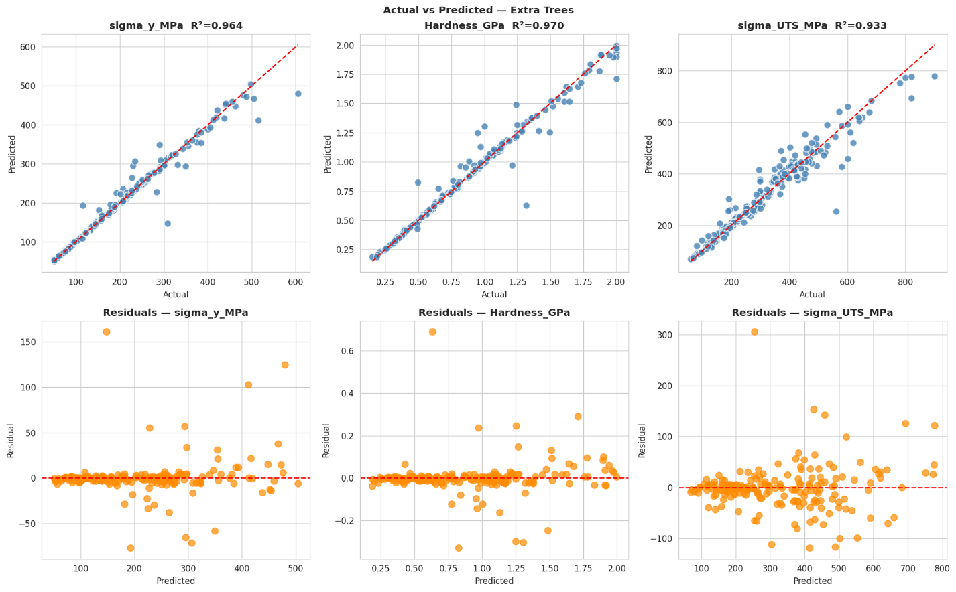
Figure 9: Decomposition of $R^{2}$ values across 3 targets for XGBoost

4.1.2 Best Model Residual Analysis
The best model Extra Trees was subjected to residual analysis as shown in Figure 9. Actual vs predicted scatter plots for all three targets show that tight clustering around the 1:1 line. Predicted vs Residual plots show only a few outliers are present across all three targets which have extremely high or low values.

4.1.3 Feature Importance Analysis
The feature importance analysis done on the Extra Trees model as shown in Figure 10 shows that only three features have the most dominating importance and they are Al particle size, ISS and Porosity and the rest have little importance on the final predictions. The three dominating features collectively have a feature importance of more than 90%.
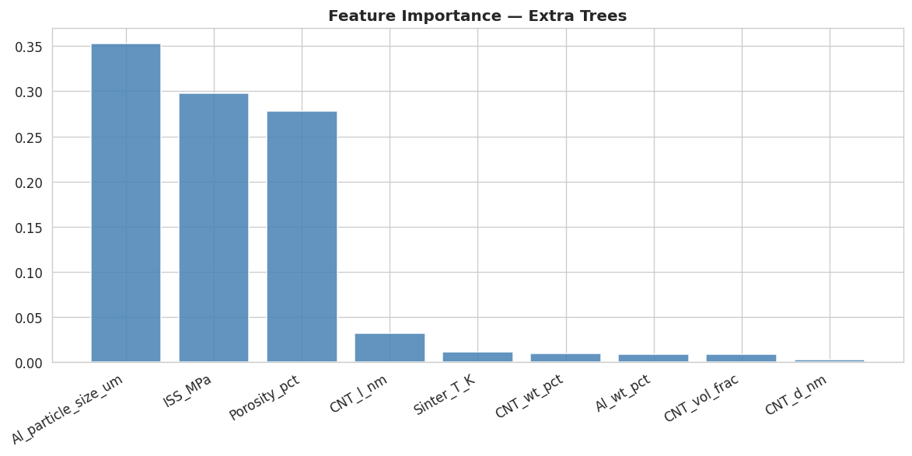
Figure 10: Feature Importance Analysis of XGBoost Model on Real Dataset

4.2 Physics Correlation Recovery
In order to make the predictions align with real world physics of CNT-Al composites the physics correlations needed to be verified before running model training on them. Both the real and synthetic dataset were evaluated to verify that physics correlation were maintained after imputation on the real dataset and after generation of synthetic samples in the synthetic dataset.

4.2.1 Verification of Physics Correlations on the Real Dataset
The novelty of this approach was to create a physics informed imputation method so that the physical correlation between the various features and targets remain intact even after imputation. After the imputation all eight correlations were verified and each of them passed the evaluation meaning that each of the eight correlations were recovered even after imputation as it can be seen from the Figure 3.

4.2.2 Verification of Physics Correlations on the Synthetic Dataset
After generating the synthetic dataset with 10,000 samples the same evaluation was done on the synthetic dataset to verify its ability to maintain the physics correlations. This was done in the same way as mentioned in section 3.5 in the methodology chapter and even this showed excellent performance as every single of the eight correlations passed the verification showing that even after generating 10,000 synthetic samples the physics correlations could be recovered from the synthetic dataset as shown in Figure 11.
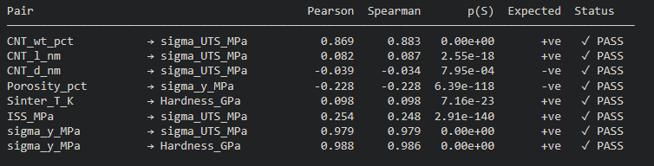
Figure 11: Verification of Physical Correlations on the Synthetic Dataset

4.4 Machine Learning Benchmark on Synthetic Dataset (5-Fold CV)
For the synthetic dataset six regression models were trained and evaluated on 10,000 samples under 5-fold cross-validation. The performance metrics of them are as shown in Figure 12 and Table 8.
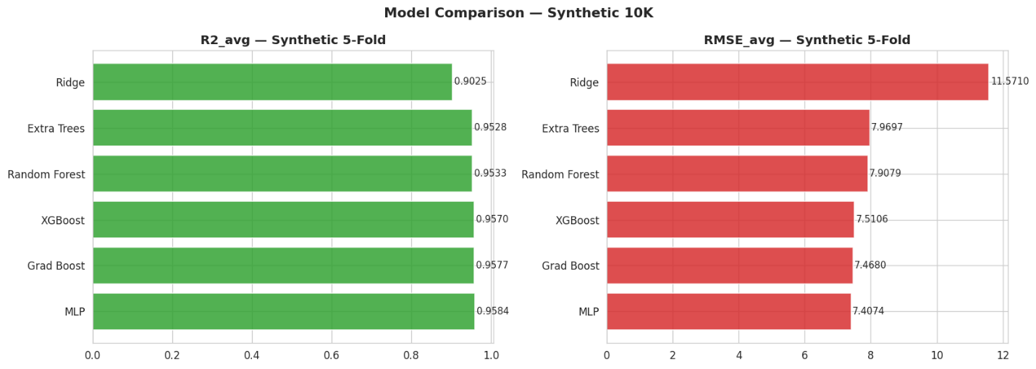
Figure 12: Model Comparison Based on Average $R^{2}$ and RMSE Values
Model | $$R^{2}$$ | RMSE
Ridge | 0.9025 | 11.5710
Extra Trees | 0.9528 | 7.9697
Random Forest | 0.9533 | 7.9079
XGBoost | 0.9570 | 7.5106
Gradient Boost | 0.9577 | 7.4680
MLP | 0.9584 | 7.4074
Table 8: Model Performance Metrics on the Synthetic Dataset
Here we can see that MLP is the best performing model among all which is contrary to the performance of MLP on the real dataset. Here due to having high number of samples the MLP model did not overfit and learnt complex patterns to make predictions with higher accuracy and that is why the $R^{2}$ value was so close to 1. However, Gradienty Boost and XGBoost again did well but barely got beaten by the MLP model.

4.4.1 Best Synthetic Model Analysis
We then proceeded to analyze the performance of the best synthetic model which is the MLP model and performed per-target decomposition analysis with actual vs predicted and residual plots as shown in Figure 13 and in Table 9.
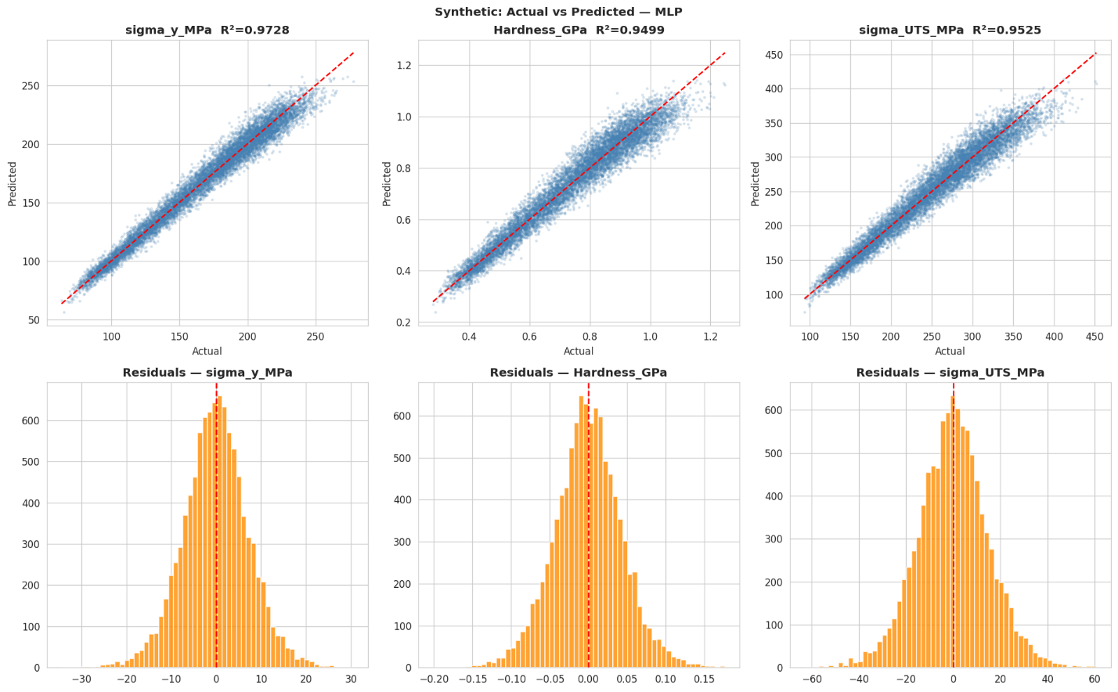
Figure 13: MLP Model Performance Analysis on the Synthetic Dataset
Model | $$R_{avg}^{2}$$ | $$R^{2}\left(σ_{y}\right)$$ | $$R^{2}\left(Hardness\right)$$ | $$R^{2}\left(σ_{UTS}\right)$$
MLP | 0.9584 | 0.9728 | 0.9499 | 0.9525
Gradient Boost | 0.9577 | 0.9729 | 0.9488 | 0.9512
XGBoost | 0.957 | 0.9725 | 0.9478 | 0.9507
Random Forest | 0.9533 | 0.9696 | 0.9451 | 0.9454
Extra Trees | 0.9528 | 0.9696 | 0.9447 | 0.9441
Ridge | 0.9025 | 0.9161 | 0.8939 | 0.8976
Table 9: Per-Target $R^{2}$ Value Decomposition for the Models Trained on Synthetic Dataset
The per-target decomposition of $R^{2}$ values shows that the MLP model has a higher accuracy in predicting all three targets having $R^{2}$ values of 0.9728, 0.9499 and 0.9525 for $σ_{y}, Hardness and σ_{UTS}$ respectively. So, the model is mostly accurate in predicting the trend and the values for each sample. From the residual plots for all three targets, we can see that the residual histograms are well approximated by Gaussian distributions centered at zero with standard deviations of approximately 15 MPa, 0.1 GPa and 30 MPa for $σ_{y}, Hardness and σ_{UTS}$ respectively because 95% of residuals lie within the $2σ$ ranges for these values.
Also, a close inspection of the actual vs predicted plots show that the MLP model can properly predict the targets as the best fit line falls mostly near to most of the target values meaning that the regressor MLP model has the ability to almost perfectly predict the values in most cases.

4.5 Sensitivity Analysis on the Deployed Model
Previously we verified the data level physics consistency to make sure all eight physical correlations were verified for both imputation on the real dataset and synthetic data generation for the synthetic dataset. Now we are interested in verifying model level physics consistency. This was done by varying each of the eight input features that were correlated to the targets across their full range while holding the values of other features constant at their reference values. The result of the sensitivity analysis is as shown in Figure 14.
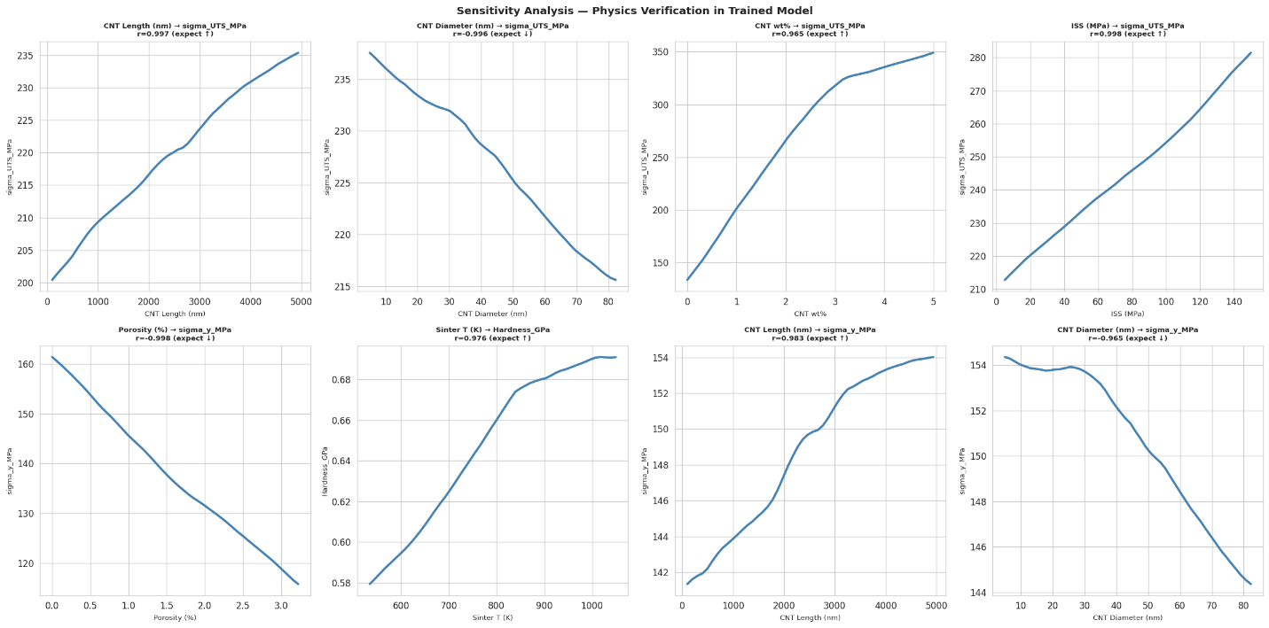Figure 14: Sensitivity Analysis on the Deployed Model
From the figure we can see that the sensitivity curves of all eight correlations expect the desired monotonic directions as which is further summarized in Table 10.

Feature Varied | Output Monitored | Expected | Observed Trend
CNT length | $$σ_{UTS}$$ | +ve | +ve
CNT diameter | $$σ_{UTS}$$ | -ve | -ve
CNT wt% | $$σ_{UTS}$$ | +ve | +ve
ISS | $$σ_{UTS}$$ | +ve | +ve
Porosity | $$σ_{y}$$ | -ve | -ve
Sinter_T | Hardness | +ve | +ve
CN length | $$σ_{y}$$ | +ve | +ve
CNT diameter | $$σ_{y}$$ | -ve | -ve
Table 10: Sensitivity Analysis for Each Physics Correlation for the Best Performing MLP Model
Here although the sensitivity curves are not linear, they have the same monotonic trend as expected and are seen from the physics correlations of Figure 5. Thus, we can say that, even in the model level, the physics correlations were maintained, and the models have a high accuracy in predicting the three target values while preserving the physics correlations.

Conclusion
This study developed a complete machine learning pipeline for predicting the mechanical properties of CNT-Al composites using while addressing a critical failure point of data preprocessing that can lead to mismatches in real world physics correlations of the features and targets. By applying a physics informed imputation as well as maintaining constraints the study successfully preserved the eight feature-target correlations in both data level and model level while achieving high accuracy having an $R^{2}=0.9556$on the real dataset under 5-fold cross validation using the Extra Trees model and an $R^{2}=0.9584$ on the synthetic dataset under 5-fold CV using the MLP model. The study also provides a deployed model as a direct tool to predict the targets based on given inputs with an interactive web-based UI. Thus, the study offers a complete CNT-Al prediction pipeline with a transferable framework for any small dataset in which physics can be encoded directly into the preprocessing and data generation stages and preserved even after training the model.

References
- J.G. Park, D.H. Keum, Y.H. Lee, Strengthening mechanisms in carbon nanotube-reinforced aluminum composites, Carbon 95 (2015) 690–698. https://doi.org/10.1016/j.carbon.2015.08.112
- M. Jagannatham, P. Chandran, S. Sankaran, P. Haridoss, N. Nayan, S.R. Bakshi, Tensile properties of carbon nanotubes reinforced aluminum matrix composites: A review, Carbon 160 (2020) 14–44. https://doi.org/10.1016/j.carbon.2020.01.007
- X. Nie, A. Bahrami, Effect of carbon nanotubes on mechanical properties of aluminum matrix composites: A review, Sci. Eng. Compos. Mater. 31 (2024) 20240009. https://doi.org/10.1515/secm-2024-0009
- C. Yuan, Z. Tan, G. Fan, M. Chen, Q. Zheng, Z. Li, Fabrication and mechanical properties of CNT/Al composites via shift-speed ball milling and hot-rolling, J. Mater. Res. (2019). https://doi.org/10.1557/jmr.2019.219
- D.H. Nam, J.H. Kim, S.I. Cha, S.I. Jung, J.K. Lee, H.M. Park, H.D. Park, S.H. Hong, Hardness and wear resistance of carbon nanotube reinforced aluminum-copper matrix composites, J. Nanosci. Nanotechnol. 14 (2014) 9134–9138. https://doi.org/10.1166/jnn.2014.10084
- J. Pan, L. Zou, Z. Liao, Z. Lin, J. Chen, Study on the properties of carbon nanotube (CNTs) reinforced AlSi10Mg composites fabricated by powder metallurgy, Materials 16 (2023) 3905. https://doi.org/10.3390/ma16113905
- I. Tajzad, E. Ghasali, Production methods of CNT-reinforced Al matrix composites: A review, J. Compos. Compd. 2 (2020) 1–9. https://doi.org/10.29252/jcc.2.1.1
- Nurguzhin, M., Janikeyev, M., Omarbayev, M., Yermakhanova, A., Meiirbekov, M., Zhumakhanov, M., Keneshbekova, A., Atamanov, M., Akylbayeva, A., Lesbayev, A., & Yerezhep, D. (2025). Structure and properties of Al–CNT-based composites manufactured by different methods: A brief review. Materials, 18(1), Article 214. https://doi.org/10.3390/ma18010214
- Arlot, S., & Celisse, A. (2010). A survey of cross-validation procedures for model selection. Statistics Surveys, 4, 40–79. https://doi.org/10.1214/09-ss054
- Kelly, A., & Tyson, W. R. (1965). Tensile properties of fibre-reinforced metals: Copper/tungsten and copper/molybdenum. Journal of the Mechanics and Physics of Solids, 13(6), 329–350. https://doi.org/10.1016/0022-5096(65)90035-9
- Tabor, D. (1951). The Hardness of Metals. Clarendon Press.
- Pearson, K. (1895). Note on regression and inheritance in the case of two parents. Proceedings of the Royal Society of London, 58, 240–242. https://doi.org/10.1098/rspl.1895.0041
- Spearman, C. (1904). The proof and measurement of association between two things. The American Journal of Psychology, 15(1), 72–101. https://doi.org/10.2307/1412159
- Batra, R., Wood, B., Pillai, S. G., & Ramprasad, R. (2021). Physics-informed data augmentation for accelerating materials discovery. npj Computational Materials, 7(1), 1–9. https://doi.org/10.1038/s41524-021-00624-y
- Xu, H., Zhou, P., Tan, R., & Li, M. (2022). Practically adopting human activity recognition: Physics-informed data augmentation. Proceedings of the ACM on Interactive, Mobile, Wearable and Ubiquitous Technologies, 6(4), 1–25. https://doi.org/10.1145/3569484
- Karunarathne, A., Jodha, K. S., Priyadarshan, G., Griggs, J. A., & Gladden, J. R. (2019). Low pressure dependent elasticity of porous ceramics. Journal of the American Ceramic Society, 103(2), 1312–1320. https://doi.org/10.1111/jace.16751
- Mokdad, F., Chen, D. L., Liu, Z. Y., Xiao, B. L., Ni, D. R., & Ma, Z. Y. (2016). Deformation and strengthening mechanisms of a carbon nanotube reinforced aluminum composite. Carbon, 104, 64–77. https://doi.org/10.1016/j.carbon.2016.03.038
- So, K. P., Kushima, A., Park, J. G., Liu, X., Keum, D. H., Jeong, H. Y., Yao, F., Joo, S. H., Kim, H. S., Kim, H., Li, J., & Lee, Y. H. (2018). Intragranular dispersion of carbon nanotubes comprehensively improves aluminum alloys. Advanced Science, 5(5), Article 1800115. https://doi.org/10.1002/advs.201800115
- Cawley, G. C., & Talbot, N. L. (2010). On over-fitting in model selection and subsequent selection bias in performance evaluation. Journal of Machine Learning Research, 11(70), 2079–2107. http://jmlr.org/papers/v11/cawley10a.html
- Bzdok, D., Altman, N., & Krzywinski, M. (2018). Statistics versus machine learning. Nature Methods, 15(4), 233–234. https://doi.org/10.1038/nmeth.4642
- Formanus, B., & Hastie, T. (2018). A review of cross-validation techniques for evaluation and model selection in data-driven engineering. International Journal of Data Science and Analytics, 5(4), 231–245. https://doi.org/10.1007/s41060-018-0112-y
- Murdock, R., Kauwe, S., Wang, A., & Sparks, T. (2020). Is domain knowledge necessary for machine learning materials properties?. ChemRxiv. https://doi.org/10.26434/chemrxiv.11879193.v1
- Tshitoyan, V., Dagdelen, J., Weston, L., Dunn, A., Rong, Z., Kononova, O., Persson, K. A., Ceder, G., & Jain, A. (2019). Unsupervised word embeddings capture latent knowledge from materials science literature. Nature, 571(7763), 95–98. https://doi.org/10.1038/s41586-019-1335-8

