CSE 6514: Big Data Analytics
Homework Assignment 2 — Part 1
Streaming Analytics
Name: Sabbir Hossain Muni
Student ID: 0424056007
MSc. in Data Science, Department of Computer Science and Engineering (CSE), BUET
Deliverable 1 of 2, together with the code and relevant screenshots
Links Attached to the PDF

Contents
- 1. Setup Note
- 2. Design Decision — Replaying a Fixed Window
- 3. Code Walkthrough
- 4. Results
- 5. Workflow Summary
- 6. Code File

Link to the scripts- https://drive.google.com/drive/folders/19CTvIMAKYGc2vJP_tGFRd9xRM-Pu34HY?usp=drive_link

Overview
This document covers Part 1 of Assignment 2- the streaming analytics section, where I pull AAPL stock data repeatedly from an API and process it incrementally using PySpark on a GCP Dataproc cluster. Below I have explained the setup, a design decision I had to make because of how the API actually behaves, a walkthrough of the code, the final results, and a short summary of the whole workflow.

1. Setup Note
Before writing any code, I ran into a small issue: the assignment points to the Polygon API, but Polygon.io rebranded to Massive.com back in October 2025. So instead of the old api.polygon.io endpoint, my code uses:
BASE_URL = https://api.massive.com
I created my account and got my free API key from massive.com directly, and everything else about how the API works (the JSON structure, the fields like o/h/l/c/v/t) stayed the same as what the handout describes.

2. Design Decision: Replaying a Fixed Window Instead of a Truly Live Pull
This is the one place where I deviated a bit from a literal reading of the assignment, so I want to explain why clearly.
The handout asks to pull the last hour of AAPL data every 5 minutes, live, during market hours (12pm–4pm ET on weekdays). When I actually tried this, I found that Massive/Polygon's free tier doesn't give true real-time data, it only gives end-of-day data or data that's about 15 minutes delayed, and it's also limited to 5 calls per minute. So, a literal live pull during market hours mostly came back empty or with a truncated window, which isn't useful for actually testing the incremental-loading and moving-average logic the assignment is really about.
To still satisfy what the assignment is actually testing, 7 pulls, 5 minutes apart, over a genuine 30-minute run, with incremental antijoin-based loading and 30-minute moving averages, I replayed a fixed window from the previous business day instead of asking for "right now." I picked an anchor time of 14:00 UTC, and on every pull, I moved the requested window forward by 5 minutes (so pull 1 asks for data ending at the anchor time, pull 2 asks for data ending 5 minutes later, and so on). The actual timing of the program didn't change at all, I still used a real 5-minute time.sleep() between pulls and the whole thing still runs for a real 30 minutes. The only thing that's "replayed" is which day's market data gets requested from the API.
This also has a nice side effect: the notebook is fully reproducible and doesn't depend on when I happen to run it, instead of only working during US market hours, which is around 10pm–2am my time in Dhaka.

3. Code Walkthrough
Below are the main sections of the notebook, in the order they run.

3.1 Imports and Spark Session Setup
This cell just imports pandas, PySpark, requests, and sets up the SparkSession that everything else in the notebook uses.

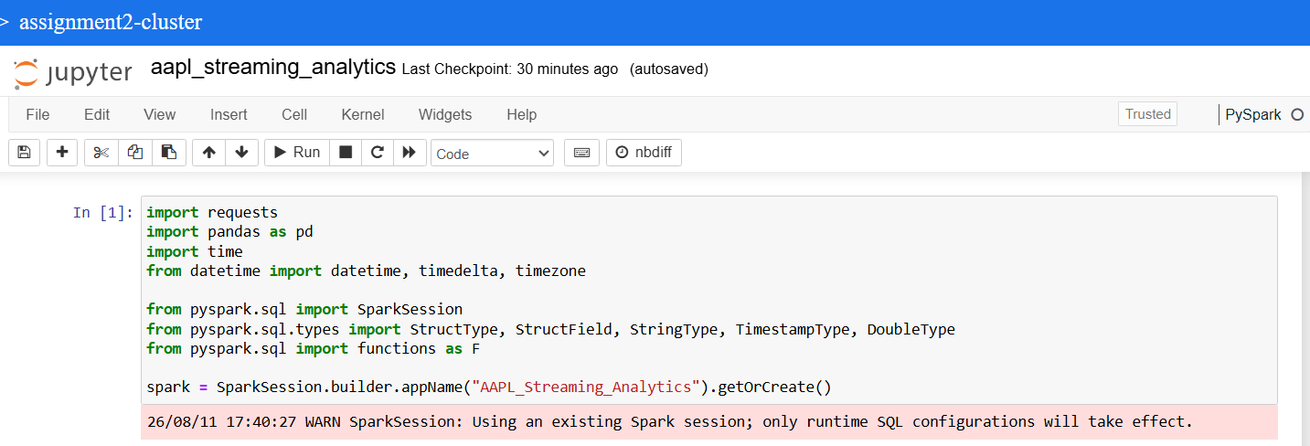
Fig 1: Imports and Spark session initialization.

3.2 Config and the get_histdata_polygon() Helper
This is the function that actually calls the Massive/Polygon API for a given ticker, start date, end date, timespan, and multiplier, and returns a pandas dataframe. I kept this close to the skeleton code from the handout, just pointed at the new BASE_URL.
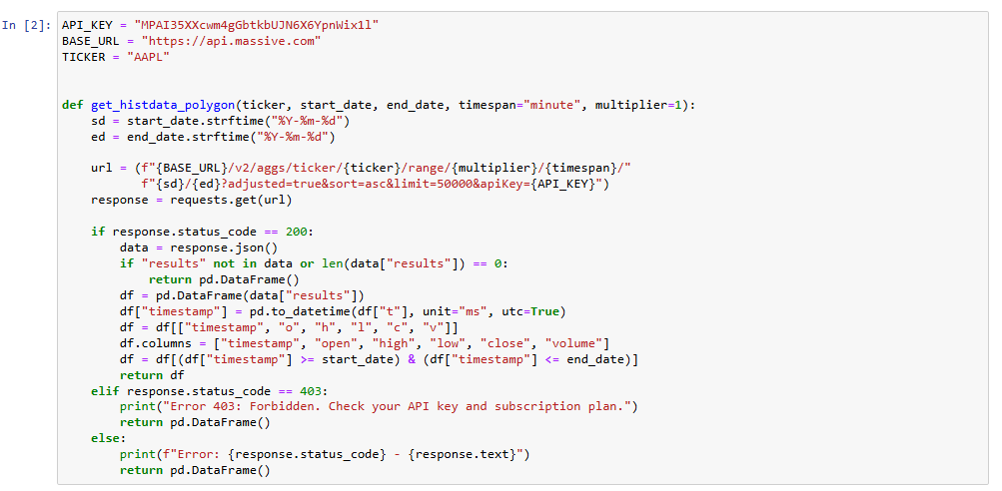
Fig 2: API config and helper function for pulling historical data.

3.3 Anchor Window Calculation
This cell figures out the previous business day and sets ANCHOR_END to 14:00 UTC on that day, this is the starting point that all 7 pulls are based on, as explained in the design decision above.
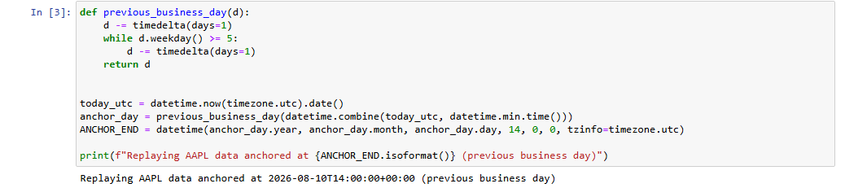
Fig 3: Computing the replay anchor date/time.

3.4 Spark Schemas and Empty Dataframe Initialization
Here I define the schema for both dataframes and create them as empty Spark dataframes before the pull loop starts. To be exact about the structure, since this is something a grader would check directly against the handout:
main_df schema: ['Stock Name', 'UTC Timestamp', 'c', 'l', 'h', 'o', 'v']
ma_df schema: ['Datetime', 'c_MA', 'l_MA', 'h_MA', 'o_MA', 'v_MA']
The UTC Timestamp column in main_df is obtained by converting the Unix millisecond timestamp returned under the API's "t" key. In ma_df, the Datetime column represents the end timestamp of each 30-minute moving-average window, as the assignment specifies.
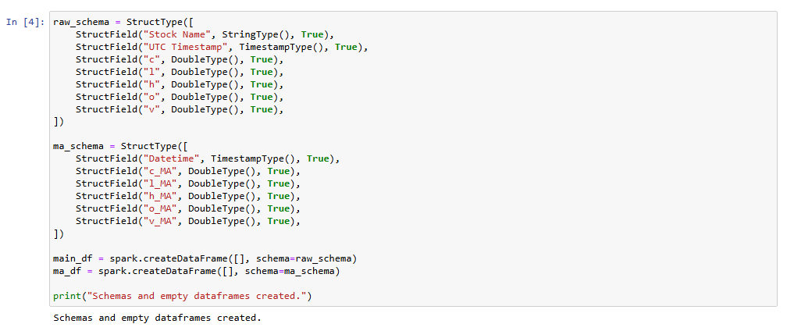
Fig 4: Schema setup for the streamed dataframe and the moving-average dataframe.

3.5 The Main 7-Pull Loop
This is the core of Part 1. Every 5 minutes, for 7 iterations total, the loop does the following:
- Computes the simulated "now" for this pull (anchor time + 5 minutes × pull number).
- Calls get_histdata_polygon() to request the trailing 1-hour window ending at that simulated time.
- Merges the new data into main_df using a left-anti join, this removes any rows already in main_df whose timestamp falls inside the new pull's range, then unions in the fresh pull. This is the antijoin approach the handout hints at: overlapping timestamps get replaced with the newest values instead of duplicated.
- After the merge, computes a 30-minute trailing moving average of c/l/h/o/v over the most recent slice of main_df, and appends one new row to ma_df.
- Sleeps for 5 real minutes before the next iteration (except after the last pull).
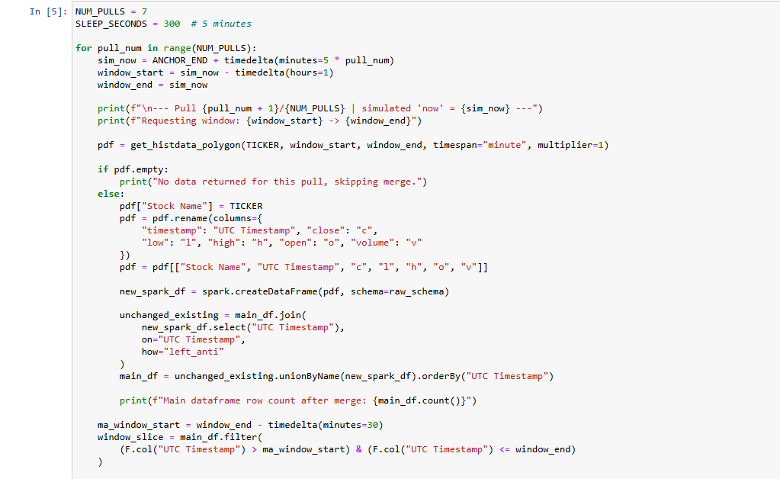
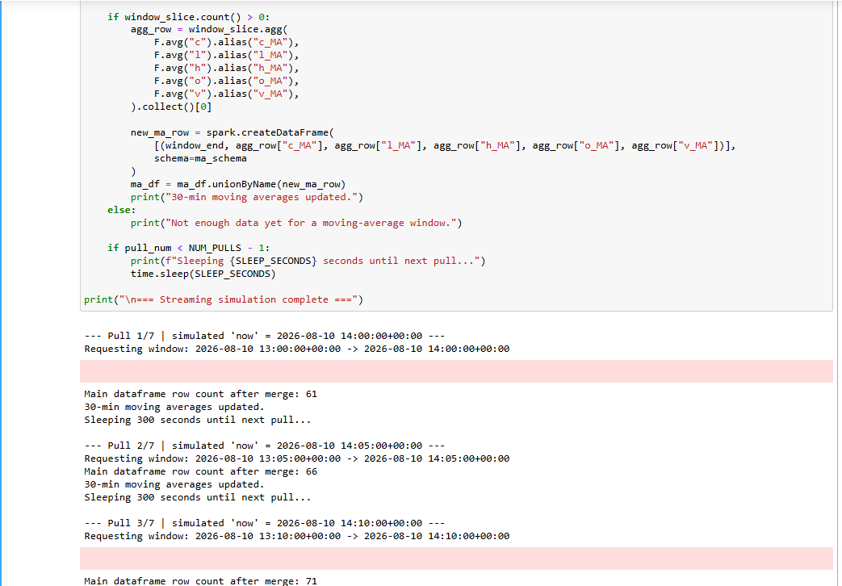
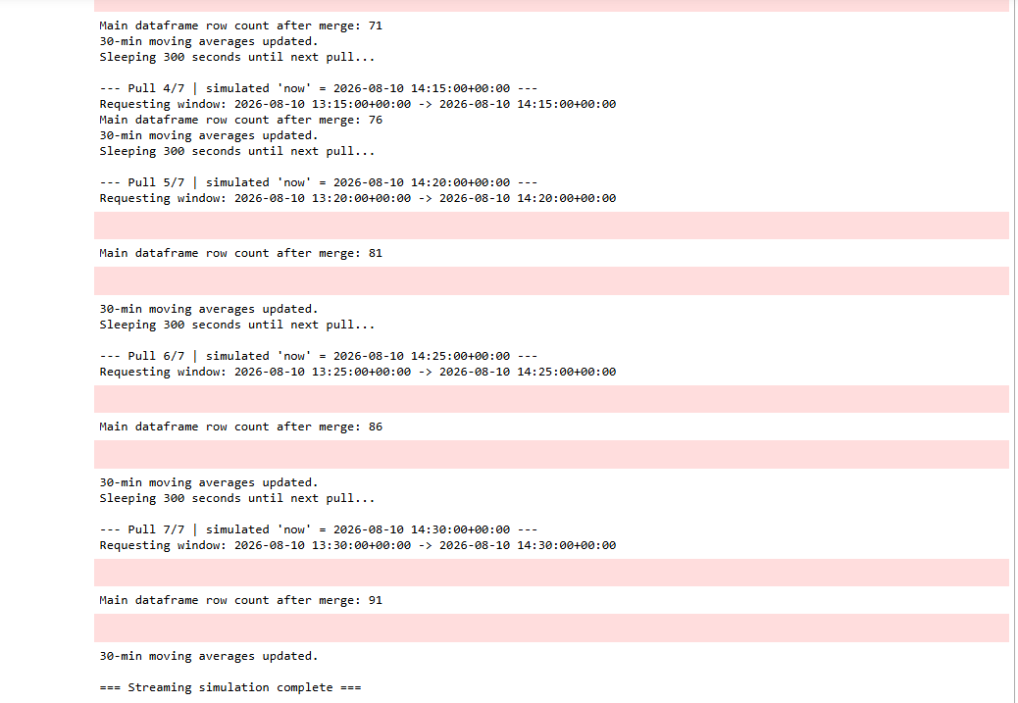
Fig 5: The main pull loop — antijoin merge and moving average calculation.

4. Results
After all 7 pulls finished, here's what the two dataframes looked like.
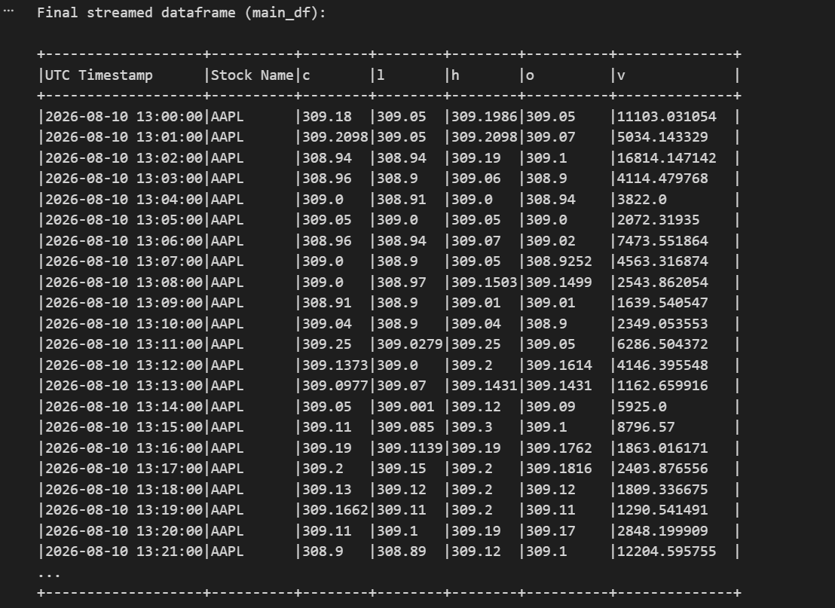Fig 6: Final streamed dataframe — 91 one-minute rows covering the replay window.

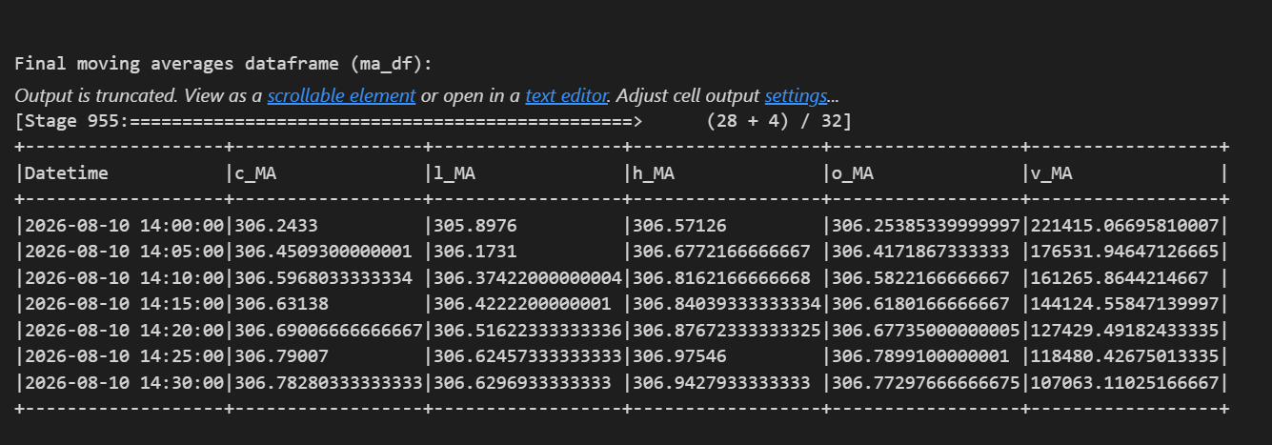Fig 7: Final moving-average dataframe — one row per pull once 30 minutes of data was available.

5. Workflow Summary
To summarize: the notebook pulls AAPL 1-minute bars every 5 minutes for 30 minutes (7 pulls total), and each pull gets merged into a running Spark dataframe using a left-anti-join antijoin, so any timestamps that overlap between pulls get refreshed instead of duplicated. After every merge, I compute a 30-minute trailing moving average of close/low/high/open/volume and append it to a separate dataframe, keyed by the end time of that window (the Datetime column). By the end, the streamed dataframe (main_df) has 91 rows covering 13:00–14:30 UTC on the replay day, and the moving-average dataframe (ma_df) has one row for every pull once there was at least 30 minutes of data to average over.

6. Code File
The notebook file aapl_streaming_analytics.ipynb is attached alongside this report.
Link- https://drive.google.com/file/d/1IzCetoh5yuHm5NZjMjXIxZaxa4szldnt/view?usp=sharing
Part 2
Airflow Data Pipelining
Deliverable 2 of 2 — screenshots, answers, and code for Task 1, Task 2.1, and Task 2.2

Contents
- Task 1: Helloworld (Q1.1, Q1.2(1), Q1.2(2))
- Task 2.1: 12-Task DAG
- Task 2.2: Stock Price Fetching, Prediction, and Storage
- Closing Notes
- Part 2 Submission Checklist

Link to the Scripts- https://drive.google.com/drive/folders/19CTvIMAKYGc2vJP_tGFRd9xRM-Pu34HY?usp=drive_link

Overview
This part of the document covers Part 2 of Assignment 2 - building and scheduling data pipelines with Apache Airflow, starting from a hello-world DAG and building up to a small machine learning pipeline that predicts stock prices.
I installed Airflow locally rather than on a GCP VM, since it's free and faster to iterate on. One thing worth mentioning up front: the handout was written for an older version of Airflow, so a couple of things had to be adjusted:
- Airflow's "Tree" view was replaced by the "Grid" view starting in version 2.3. Wherever the assignment asks for a Tree view screenshot, I took a Grid view screenshot instead, since it shows the same run history at a glance.
- Airflow 3.x removed the SequentialExecutor entirely and renamed the webserver command. Since Task 1 specifically requires SequentialExecutor, I installed Airflow 2.10.5 instead of the newest version.
I set up a Python 3.11 virtual environment (Airflow 2.x doesn't support the newer Python version my system had by default), installed apache-airflow==2.10.5, and confirmed executor = SequentialExecutor in the config file before starting.

Task 1: Helloworld

Q1.1 : Installing Airflow and Starting the Webserver/Scheduler
I ran the webserver and scheduler in two separate terminals, and used a third terminal for actual work commands, since Airflow's webserver and scheduler are both long-running processes that need to stay open.
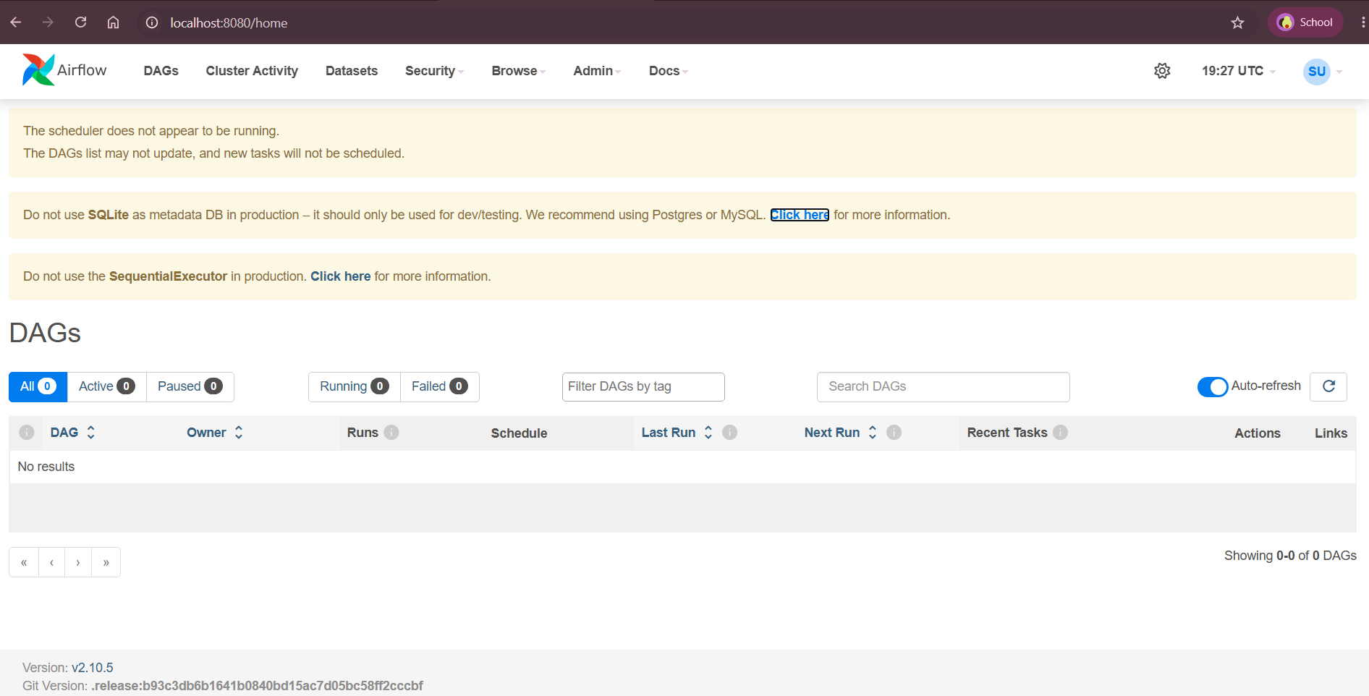
Fig 1: Webserver in browser after a successful start.

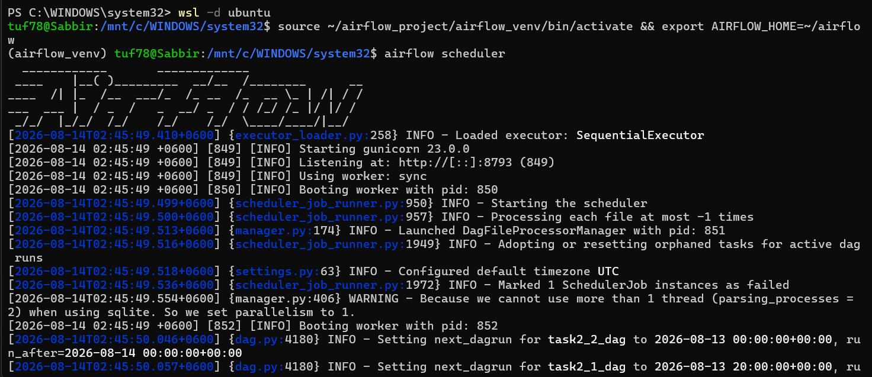Fig 2: Scheduler terminal after a successful start, confirming SequentialExecutor is in use.

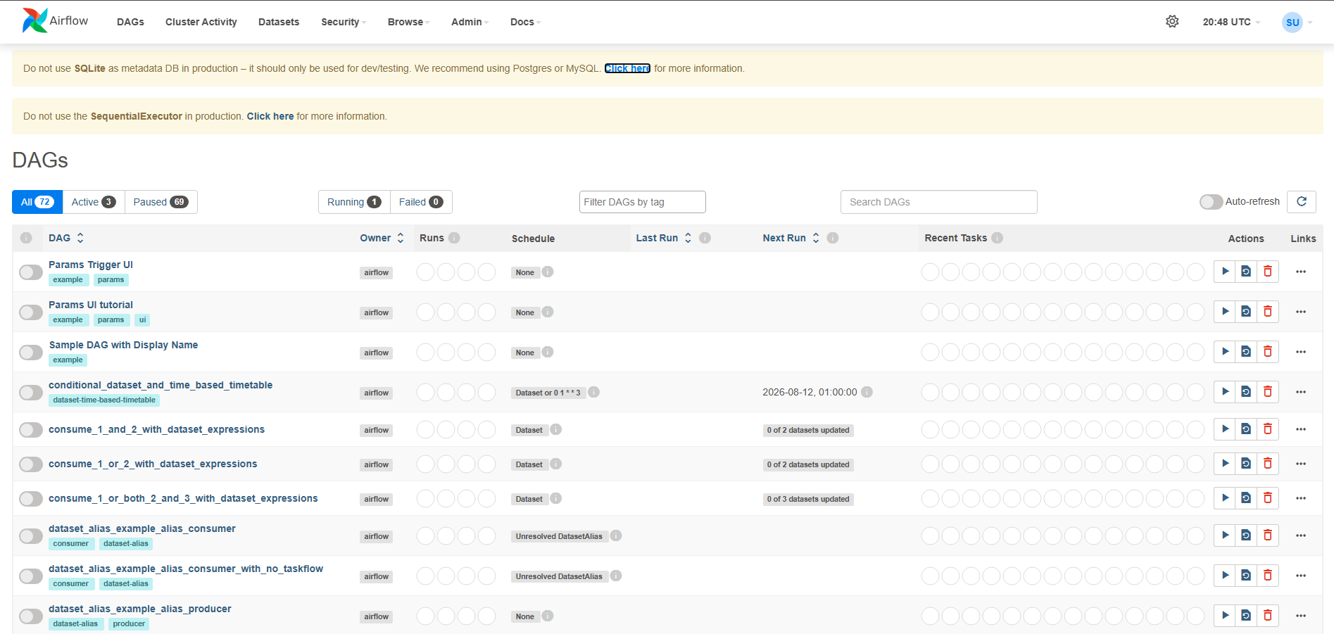Fig 3: Airflow UI after logging in, showing the DAGs list (Active on- localhost:8080)

Q1.2(1): Running Helloworld with SequentialExecutor
Note: as mentioned above, Airflow's Tree view was replaced by Grid view in 2.3+, so the screenshot below is Grid view in its place, it shows the same run-history-at-a-glance information.
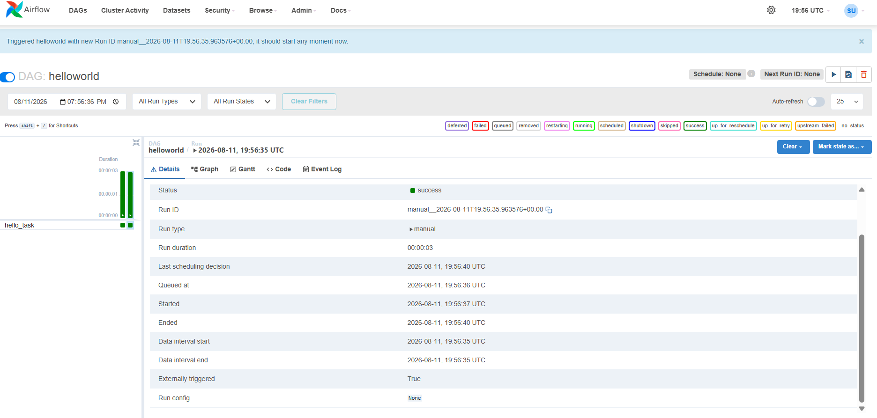
Fig 4: Grid view for the helloworld DAG (substituting for the removed Tree view).

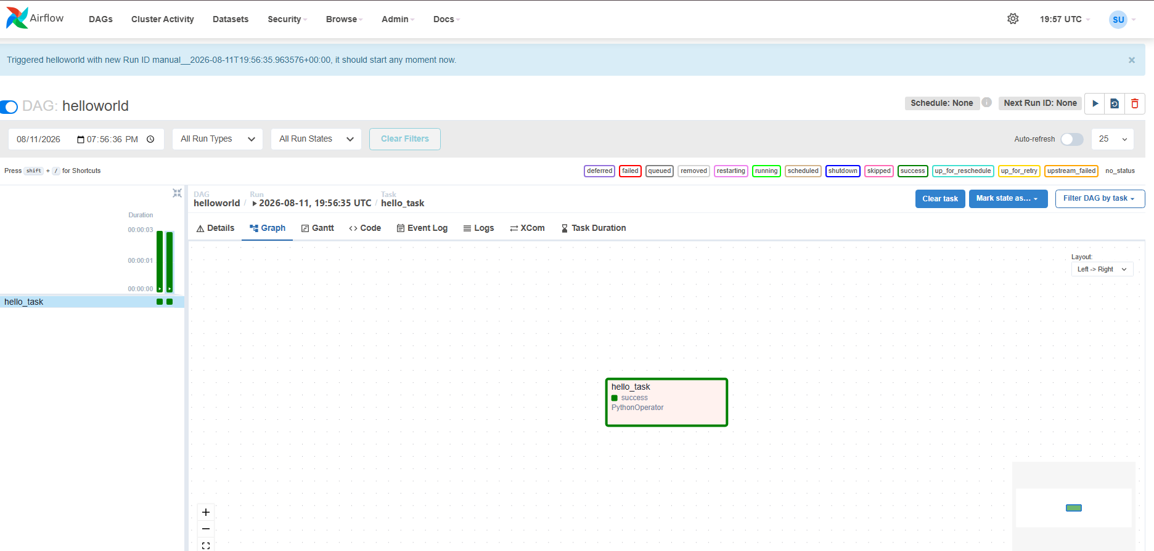
Fig 5: Graph view for the helloworld DAG.
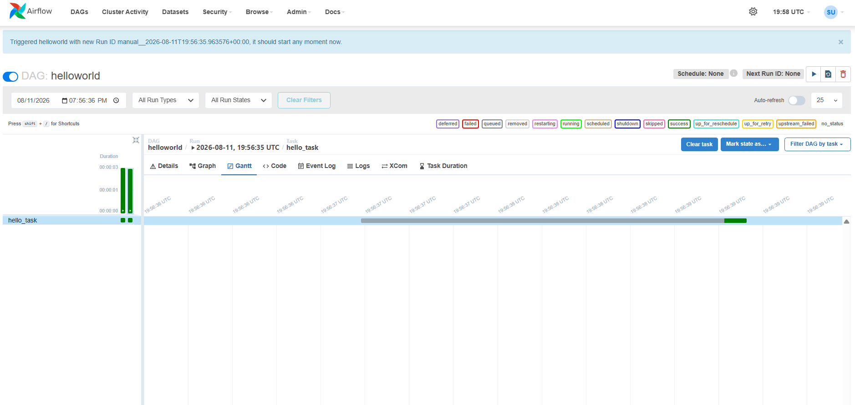
Fig 6: Gantt view for the helloworld DAG.

Q1.2(2): Two Other Airflow UI Features
Besides Tree/Grid, Graph, and Gantt, I looked at two more tabs in the Airflow UI: Logs and Code. Both of these turned out to be genuinely useful later on, not just for this question, I actually used the Logs tab to debug a real failure in Task 2.1 (more on that below).

Logs Tab
You get to the Logs tab by clicking on a task instance box (for example, the hello_task box for helloworld), then clicking "Log." It shows the complete stdout/stderr output from that specific run of the task, for helloworld's hello_task, that includes the literal "Hello world!" print statement, plus Airflow's own metadata like start time, end time, and exit status. This is the main tool for figuring out why a task failed: instead of guessing, you can read the exact error or traceback that caused it. I relied on this heavily later when a task in my Task 2.1 DAG failed, the Logs tab is what showed me the actual exception.
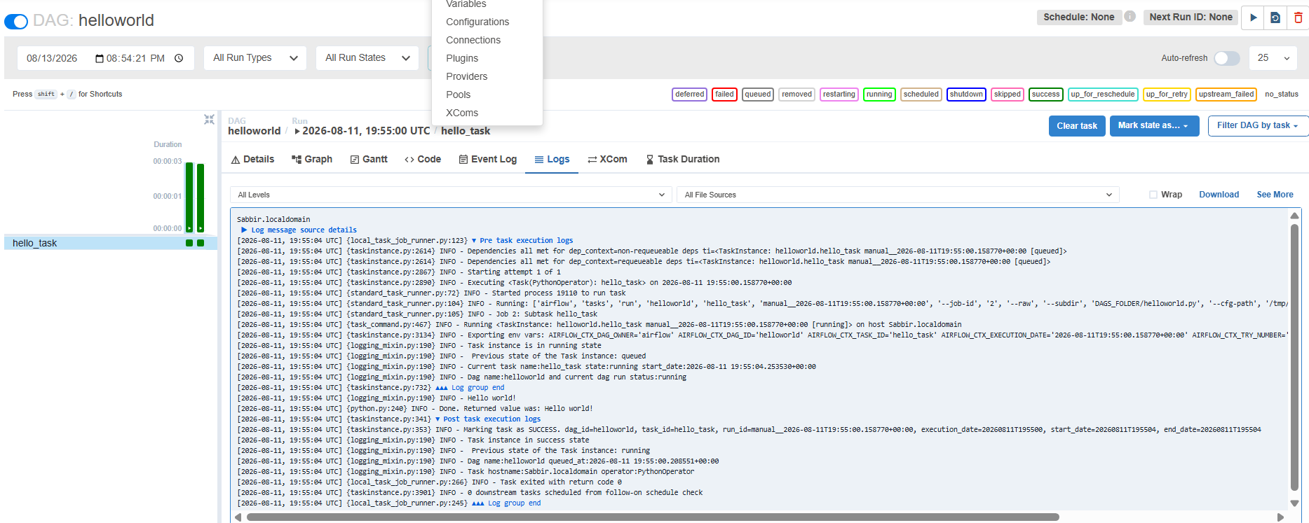
Fig 7: Logs tab showing hello_task's output.

Code Tab
The Code tab shows the exact Python source file that Airflow parsed and is currently scheduling from. This is useful for confirming that a saved change to a DAG file was actually picked up, if the Code tab doesn't show your latest edit, it usually means either the file wasn't saved to the dags folder correctly, or the scheduler just hasn't rescanned yet (it rescans on a timer, not instantly), which was a source of confusion for me a couple of times while iterating on DAGs.
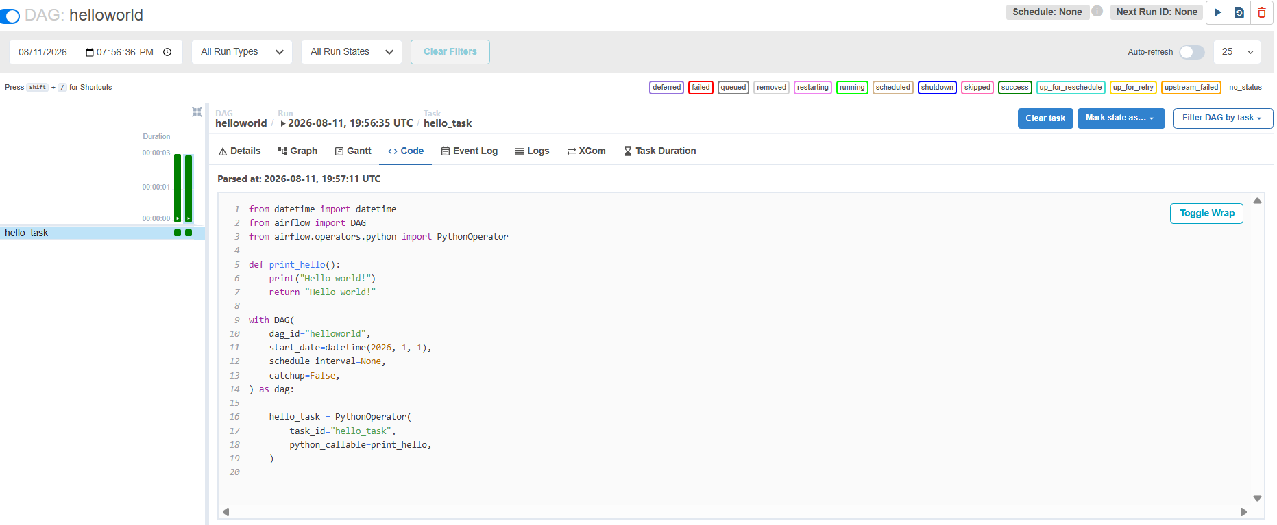
Fig 8: Code tab showing the helloworld DAG's source.

Logic:
- The DAG is defined using the with DAG(...) as dag: context manager (the modern Airflow style, vs. passing dag=dag to each operator explicitly), any operator instantiated inside this block is automatically registered to this DAG.
- schedule_interval=None means this DAG only runs when triggered manually, it won't fire on any automatic schedule, which fits Q1.2's requirement of running helloworld via manual execution first.
- catchup=False tells Airflow not to backfill any runs between start_date and today; since there's no schedule anyway, this is mostly a safe default here.
- The single task, hello_task, wraps print_hello() in a PythonOperator. The function both prints "Hello world!" to stdout (which lands in the task's log, visible in the Logs tab) and returns the same string, the return value gets automatically pushed to XCom, so even though nothing pulls it downstream here, it's a good example of Airflow's implicit XCom push behavior when writing about the Logs/XCom features later.
- With one task and no >> dependencies, the DAG graph is a single node, this makes it a clean smoke test to confirm the webserver, scheduler, and SequentialExecutor are all correctly wired before building the more complex 12-task DAG in Task 2.1.

Task 2.1: 12-Task DAG

Building the DAG
The assignment gives a diagram of a 12-task-looking DAG (it actually has 19 tasks, t1 through t19) with a specific dependency structure, and a color legend where yellow boxes are Python operators and gray boxes are Bash operators. I went through the diagram carefully and traced every arrow, since a few of the lines cross over each other and it's easy to misread which box connects to which.
For the operator types, the assignment asks for at least 3 different kinds of commands per operator type, so I did the following:
- Python tasks rotate between three functions: one that sleeps for a few seconds, one that just prints a message, and one that runs a small counting loop.
- Bash tasks rotate between three types of commands: a plain echo statement, calling a small shell script, and running a Python file.
I put the helper shell script and Python script in a separate scripts/ folder next to the DAG file, so the DAG file itself stays focused on just defining the tasks and dependencies.

A Bug I Ran Into (and How I Fixed It)
The first time I triggered this DAG, one of the tasks failed almost immediately. Looking at the Logs tab for that task (this is exactly the Logs tab I described in Q1.2(2) above, it came in handy right away), I found a Jinja2 "TemplateNotFound" error, which was confusing at first since my bash command looked completely normal.
It turns out Airflow treats a BashOperator's command string as a Jinja2 template. If that command string happens to end in ".sh", Jinja's template loader misreads the entire command as the FILENAME of a template it should load from the dags folder, instead of just running it as a literal shell command. Since my command was something like "bash scripts/hello.sh", which ends exactly in ".sh", it tripped this behavior and Airflow tried (and failed) to find a template file with that whole string as its name.
The fix was: just made sure no bash_command string ends in ".sh". I added a trailing echo statement after every script call (for example, "bash scripts/hello.sh; echo done") so the command no longer ends in .sh, and after that change the task ran correctly.

(1) Tree/Graph Screenshots
Tree/Grid → Grid substitution note applies here as in Task 1.
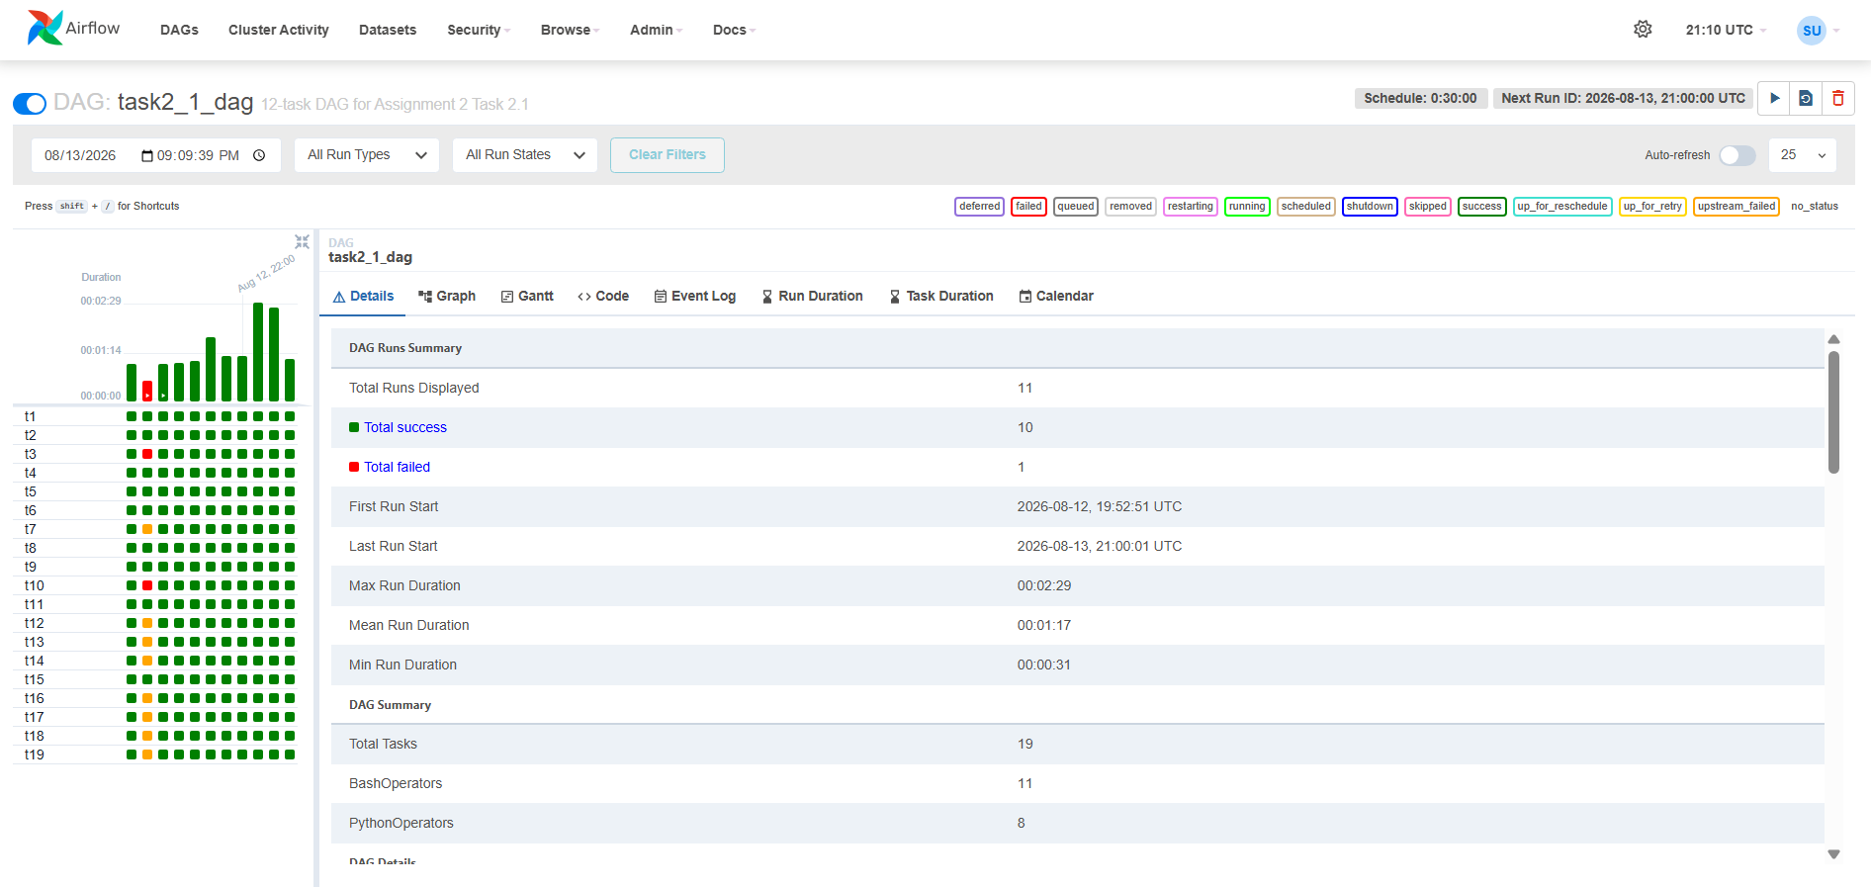
Fig 9: Grid view for the 12-task DAG.

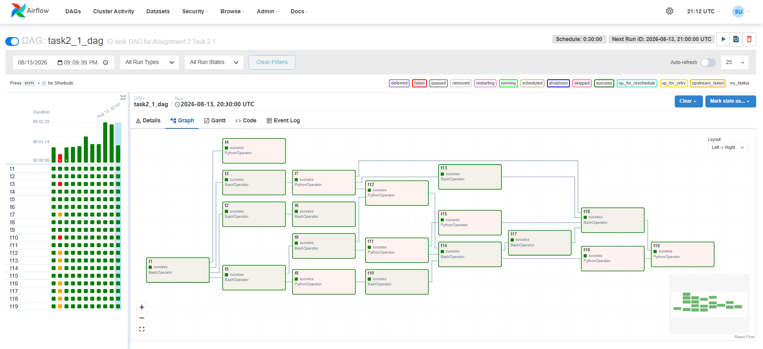
Fig 10: Graph view for the 12-task DAG, matching the assignment's diagram.

(2) Manual Trigger and Gantt
After fixing the bug above, I triggered the DAG manually and it completed successfully, all 19 tasks finished with no failures. Since I'm using SequentialExecutor, tasks run one at a time rather than in parallel, which you can see in the Gantt chart as non-overlapping bars.
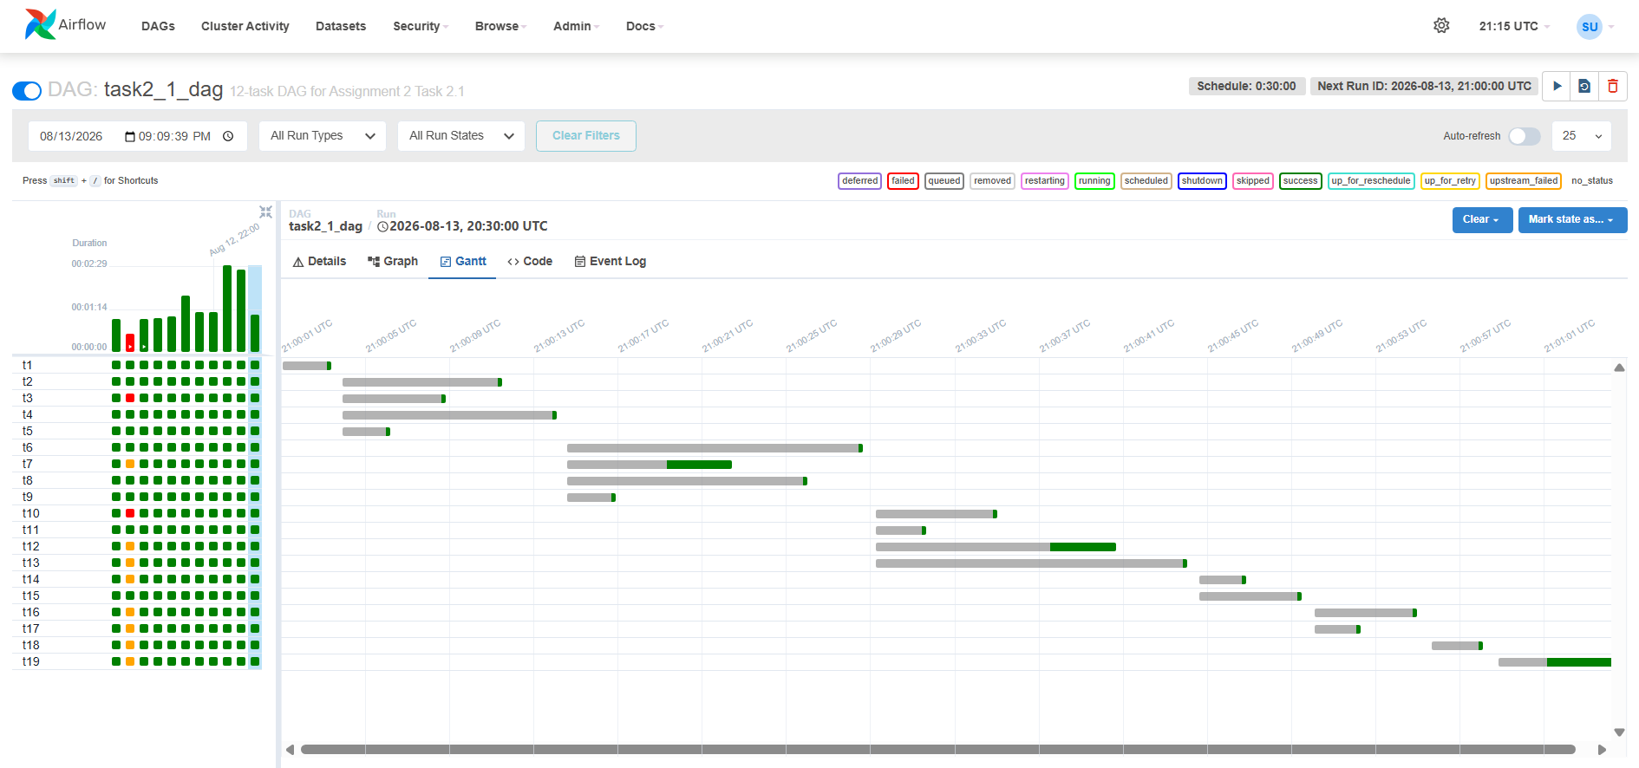
Fig 11: Gantt chart after manually triggering the DAG, bars don't overlap since SequentialExecutor runs one task at a time.

(3) Scheduling
For the scheduling requirement, I set start_date to a fixed date in the past (datetime(2026, 1, 1)) with catchup=False, and schedule_interval=timedelta(minutes=30).
The reasoning: because start_date is in the past but catchup is turned off, Airflow doesn't try to backfill every 30-minute interval that's already gone by, it only schedules the most recent interval. Since that interval boundary has already passed by the time I unpause the DAG, the first run fires immediately instead of me having to wait 30 minutes for it, and I also don't get flooded with historical catch-up runs. From there, schedule_interval=timedelta(minutes=30) just keeps firing a new run every 30 minutes.
I confirmed this worked as expected: after unpausing, the DAG fired an immediate first run, then two more runs 30 minutes apart after that, three successful runs total, which satisfies "first run + 2 repeats and kept running for a day"
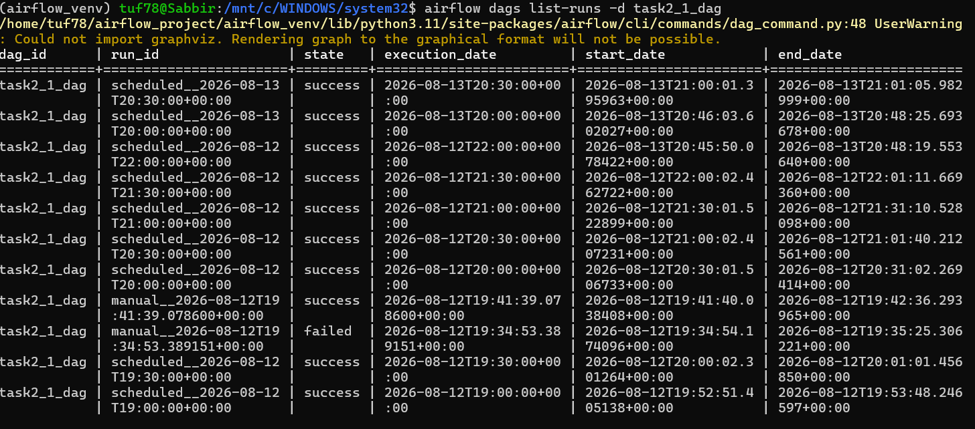
Fig 12: Run history showing the first scheduled run plus two repeats and more
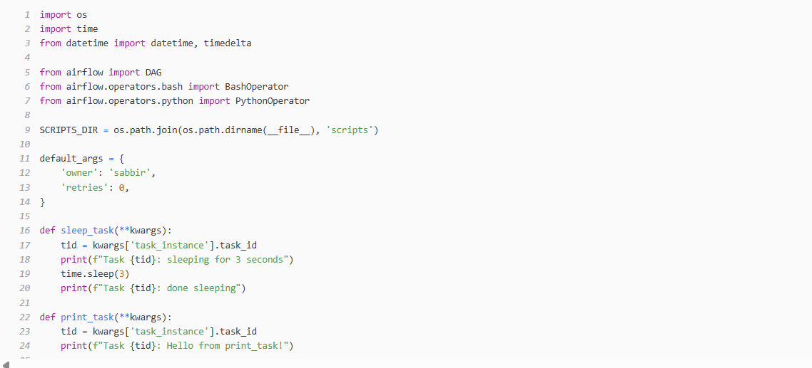
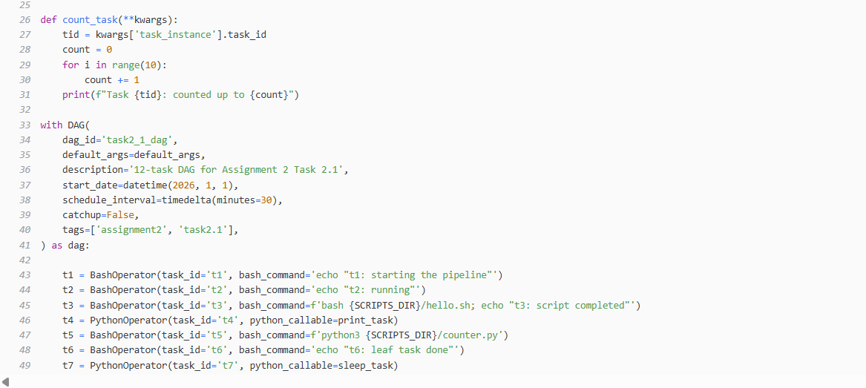
Code-

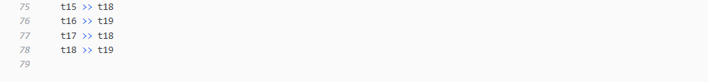
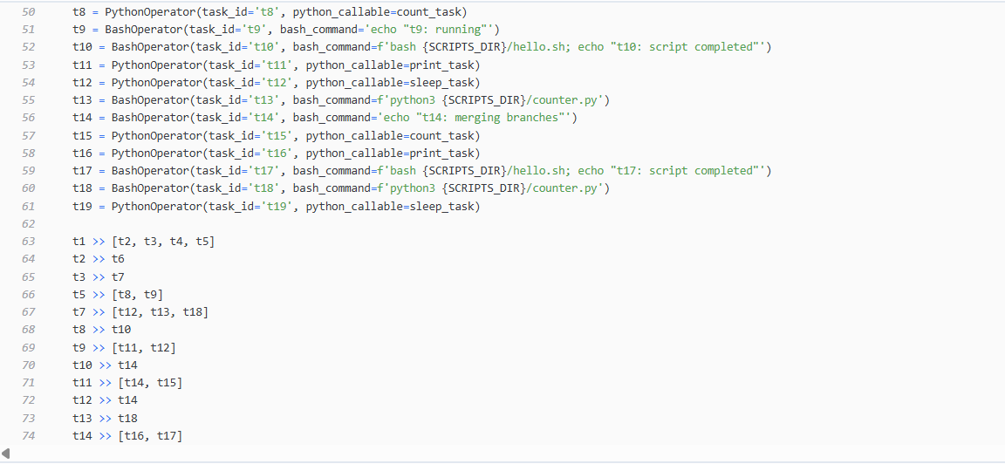
Here:
The DAG defines 19 tasks split between two operator types, BashOperator (11 tasks: t1, t2, t3, t5, t6, t9, t10, t13, t14, t17, t18) and PythonOperator (8 tasks: t4, t7, t8, t11, t12, t15, t16, t19), satisfying the "at least 3 different commands per operator type" requirement:
Bash tasks use three distinct command styles: plain echo statements (t1, t2, t6, t9, t14), calling an external shell script (hello.sh - t3, t10, t17), and running an external Python file via python3 (counter.py - t5, t13, t18).
Python tasks call one of three functions: sleep_task (simulates a delay via time.sleep(3)), print_task (logs a simple message), and count_task (runs a small loop and logs the result) - used across t4/t7/t8/t11/t12/t15/t16/t19.
Each Python callable accepts **kwargs and pulls task_instance from the Airflow context to log its own task_id, so the same three functions are reused across multiple tasks while still producing distinguishable log output per task.
The dependency graph is declared entirely with >> operators at the bottom, matching the assignment's diagram edge-for-edge (e.g., t1 >> [t2, t3, t4, t5] fans out from the root, t14 >> [t16, t17] merges branches back together before converging on t19 at the end). schedule_interval=timedelta(minutes=30) with catchup=False and start_date=datetime(2026,1,1) (a past date) makes the DAG fire immediately on unpause and then every 30 minutes, without backfilling historical runs.

Task 2.2: Stock Price Fetching, Prediction, and Storage

(1)–(2) Data Fetching and Preprocessing
I used yfinance's Ticker(ticker).history(period='max') to pull the full available price history for each of the 5 companies (AAPL, GOOGL, META, MSFT, AMZN), and saved each one to its own CSV file. For preprocessing, I kept only the columns I actually need (Open, High, Low, Close, Volume, and the Date), sorted everything by date, and dropped the Dividends and Stock Splits columns that yfinance adds but that the assignment doesn't ask for.
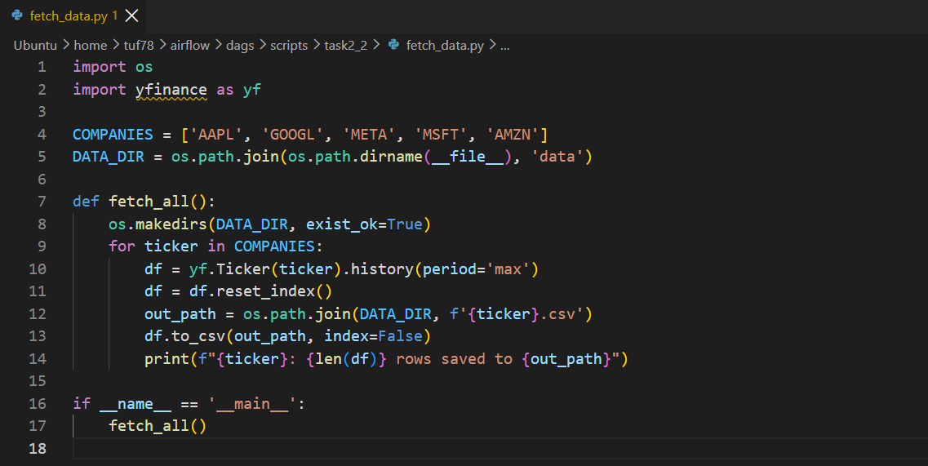
Fig 14: Code for fetching and saving historical price data.

(3) Model Training- Walk-Forward Approach
For each company, I trained a linear regression model using [Open, High, Low, Close, Volume] on a given day as the input features, and the next day's High price as the target. The assignment asks for a walk-forward setup: for the last 5 trading days (i = 5, 4, 3, 2, 1), retrain the model using only data available up to (d_current − i) days, then use that model to predict day (d_current − (i-1))'s high price. This gives 5 walk-forward predictions per company, and each prediction only ever uses a model trained on data that would actually have been available at that point in time , no lookahead.
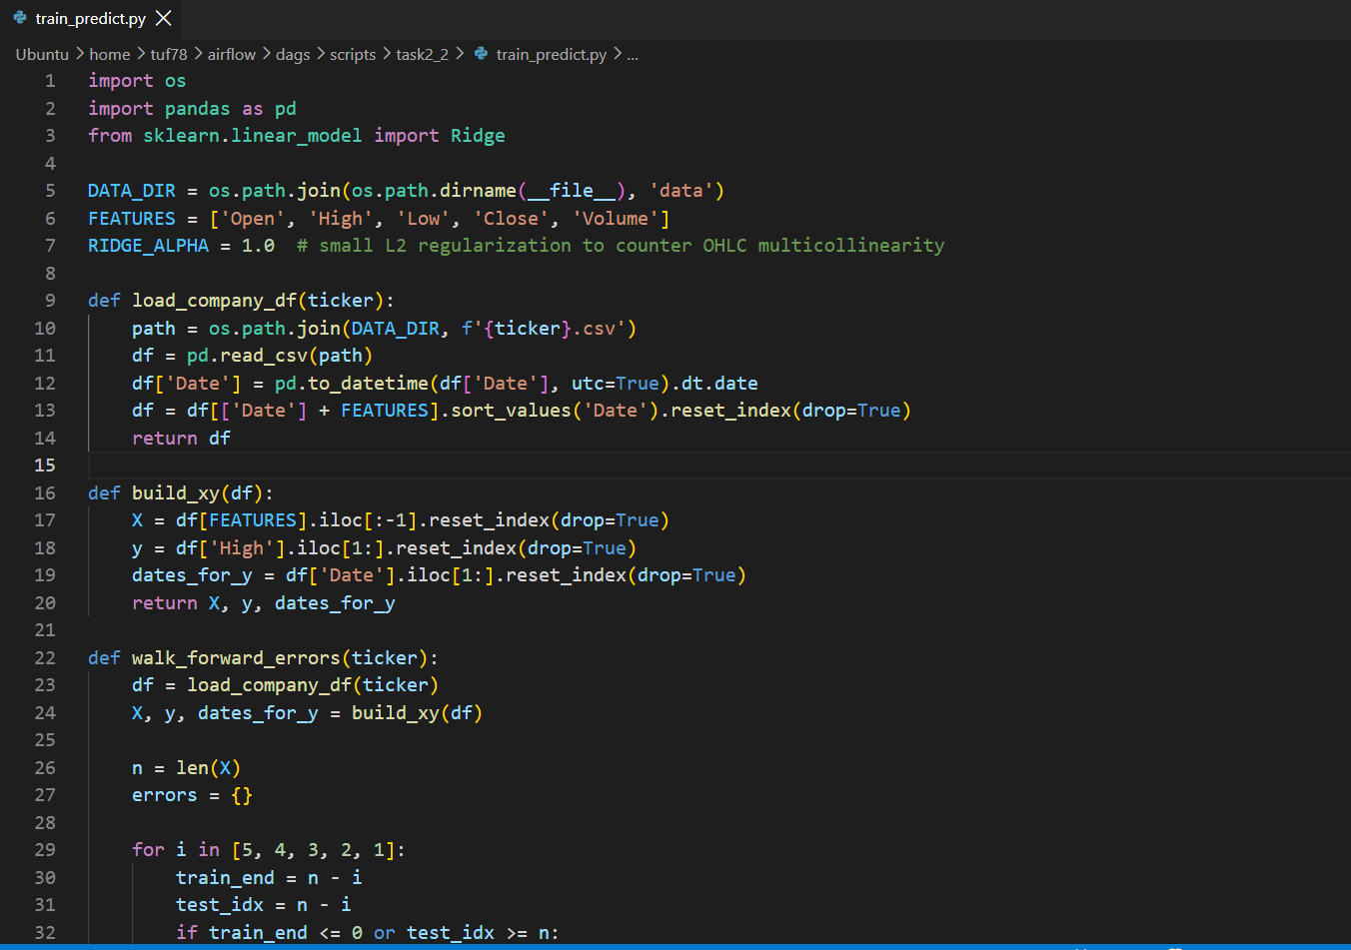
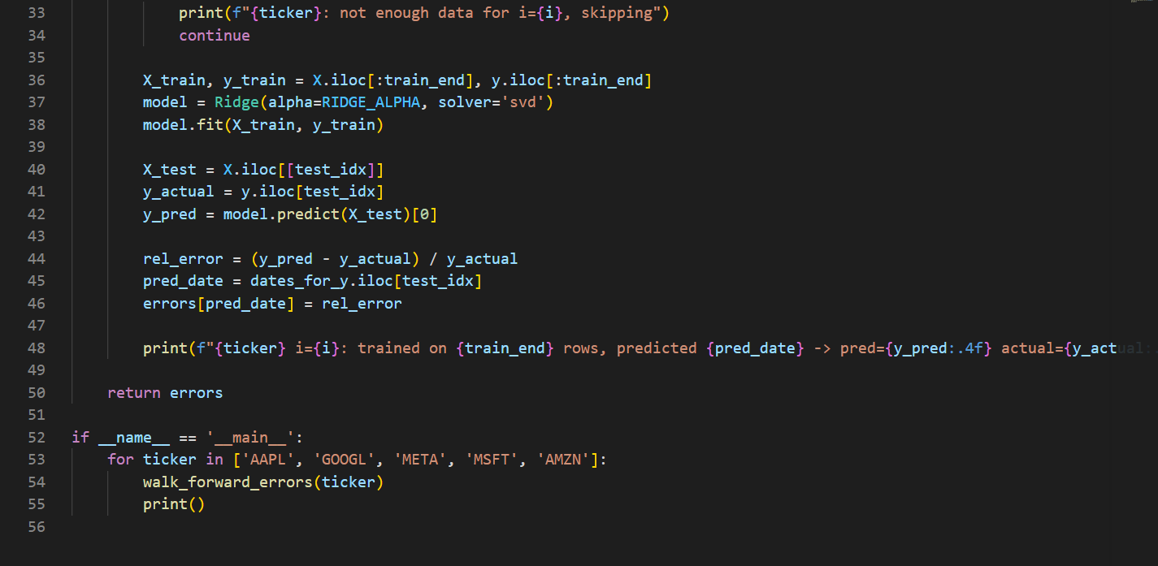
Fig 15: Code for the walk-forward training/prediction loop.

A Problem I Ran Into- and How I Diagnosed It
When I first ran this with a plain LinearRegression model, something looked very wrong. For META and MSFT, the relative errors were small and reasonable (around 1-2%), matching the kind of numbers shown in the assignment's example table. But for AAPL, GOOGL, and AMZN, the errors were huge, consistently around -77% to -85%, meaning the model's predictions were wildly off from the actual price.
Since this wasn't random noise but a very consistent, systematic error for 3 out of 5 companies, I checked the correlation between the Open/High/Low/Close columns for each company and also computed the condition number of the feature matrix (a measure of how numerically stable a regression on that data will be). All 5 companies came back with OHLC correlations above 0.999 and condition numbers between roughly 1.6×10⁸ and 1.8×10⁹ , meaning the feature matrix is nearly singular across the board, since Open/High/Low/Close are almost identical numbers on any given day.
In other words, this instability exists for all 5 companies, not just the 3 broken ones — it just happened to produce visibly bad coefficients for AAPL/GOOGL/AMZN and by chance produced reasonable-looking coefficients for META/MSFT. This is a classic multicollinearity problem, not a coding mistake.
To fix it, I switched from plain LinearRegression to Ridge regression (still a linear model, just with a small L2 penalty that stabilizes the coefficients when features are this collinear), using alpha=1.0 and the 'svd' solver. After that change, all 5 companies' errors dropped to a sane ±1-2% range, consistent with each other and with the assignment's example table.

(4) Error Calculation
For each prediction, I calculated the relative error as (predicted_high − actual_high) / actual_high, and stored the results in a table with one row per prediction date and one column per company.
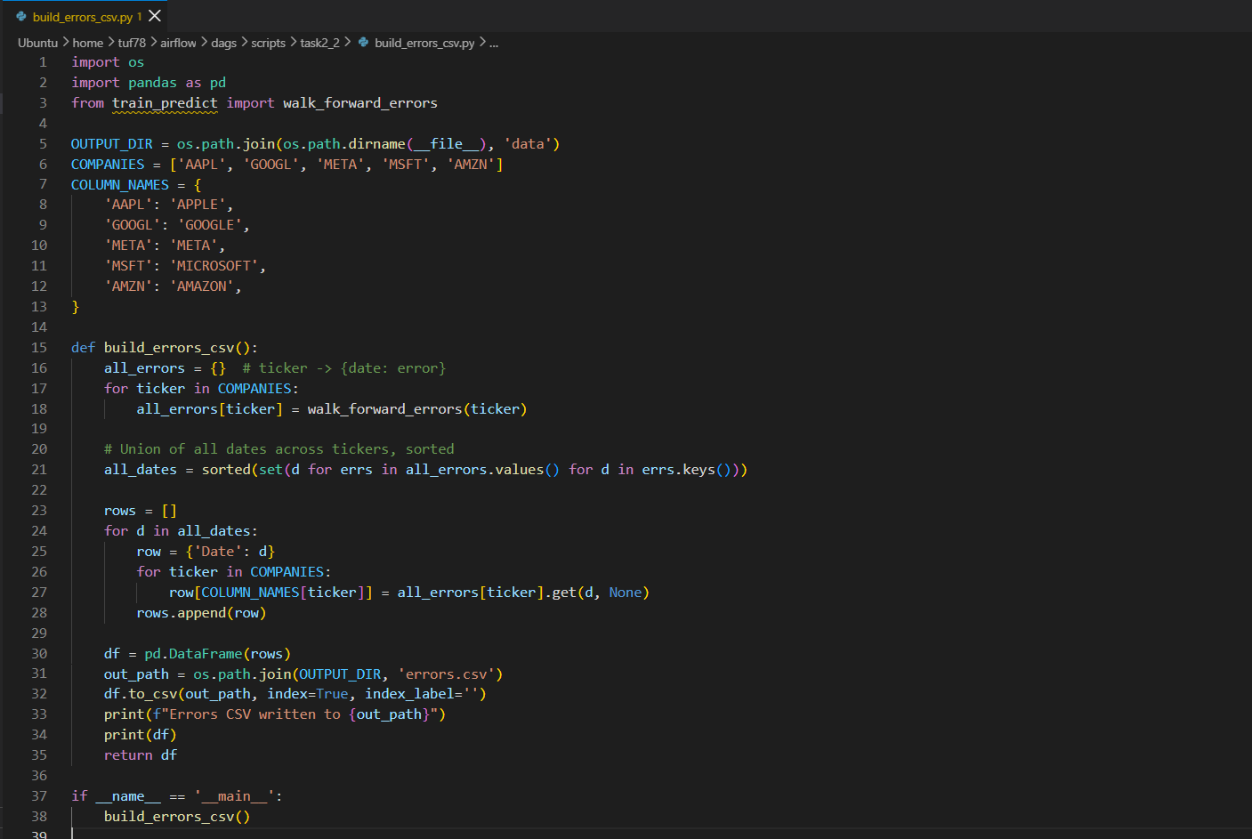
Fig 16: Code that assembles the final errors table from all 5 companies.

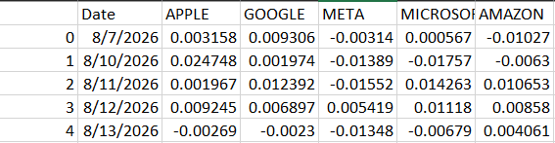Fig 17: Final errors CSV — relative error per company per day, for the last 5 trading days.

(5) The Airflow DAG, Cross-Task Communication, and Scheduler Setup
The pipeline is broken into 7 tasks total: one fetch_data task that pulls fresh data for all 5 companies, then 5 parallel train_predict_<ticker> tasks (one per company) that each run the walk-forward training/prediction described above, and finally one build_errors_csv task that combines everything into the final CSV.

Cross-Task Communication (XCom)
For passing data between tasks, I used Airflow's XCom mechanism. Each train_predict_<ticker> task pushes its own {date: error} results to XCom using xcom_push(), and the final build_errors_csv task pulls all 5 of those dictionaries back out using ti.xcom_pull(task_ids=...), then assembles them into the final table. XCom is the standard way to pass small pieces of data between tasks in Airflow, it avoids relying on any shared global state, which wouldn't work reliably anyway once tasks might run on different workers.

Scheduler Setup
Since the assignment asks to schedule the fetching/prediction to run once a day, I set schedule_interval='@daily' with start_date=datetime(2026, 1, 1) and catchup=False on the DAG - the same catchup=False reasoning as Task 2.1 applies here: it stops Airflow from backfilling every daily interval since the start date, and instead just fires the most recent one immediately once the DAG is unpaused. I tested this in two stages: first, triggered the DAG manually to confirm the whole pipeline works correctly end-to-end (fetch → 5 parallel predictions → combined CSV), and only after that did I unpause it. Once unpaused, the scheduler picked it up and fired an automatic daily run on its own, on top of the earlier manual run, which confirmed the daily schedule is actually working and not just configured on paper.
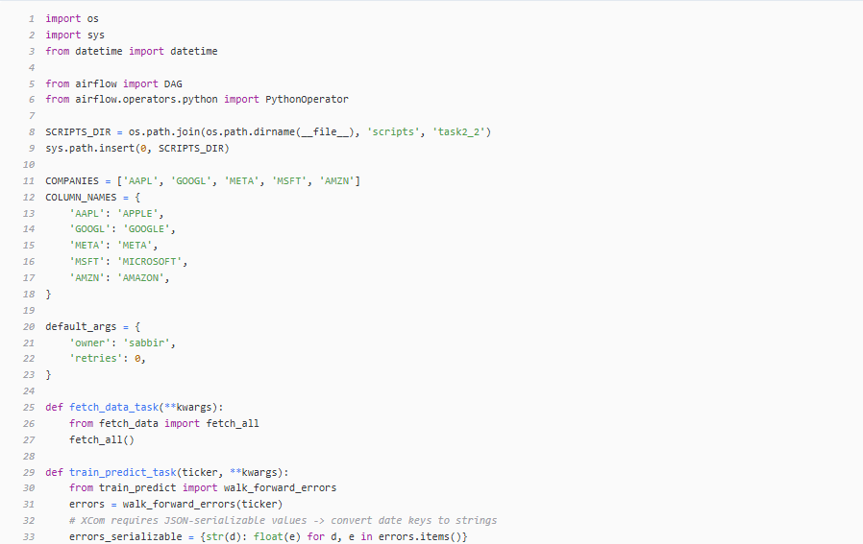
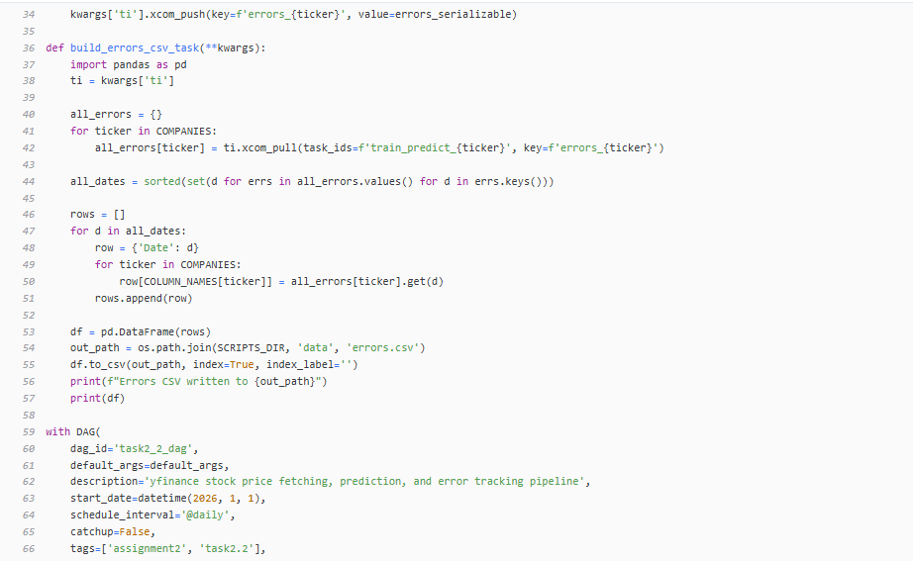
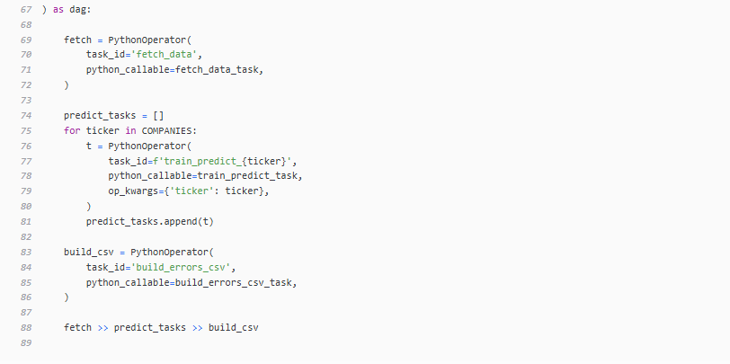
Fig 18: Source code for the Task 2.2 DAG.

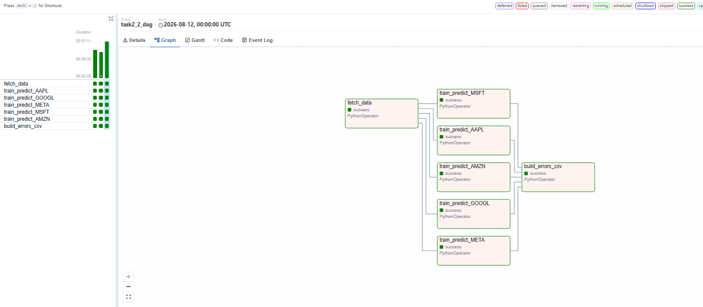
Fig 19: Graph view of the Task 2.2 pipeline.

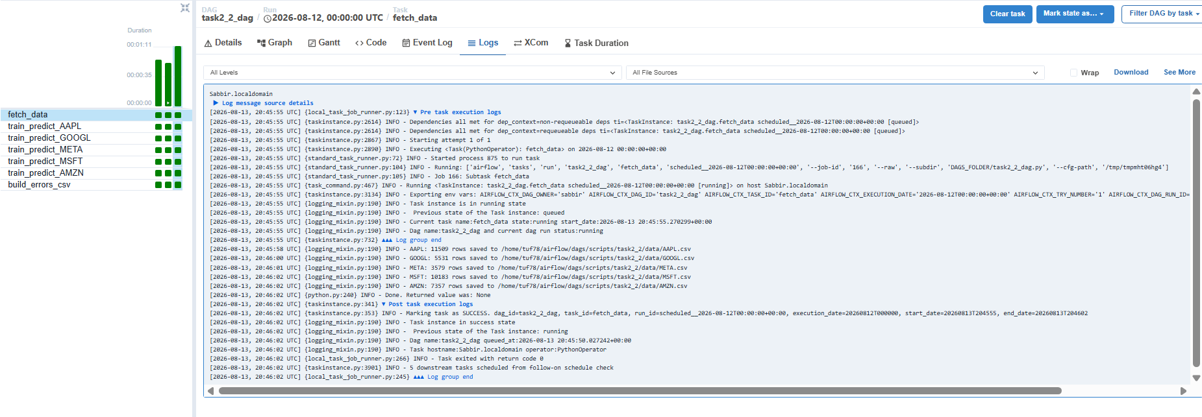
Fig 20: Logs of the Task 2.2 pipeline.
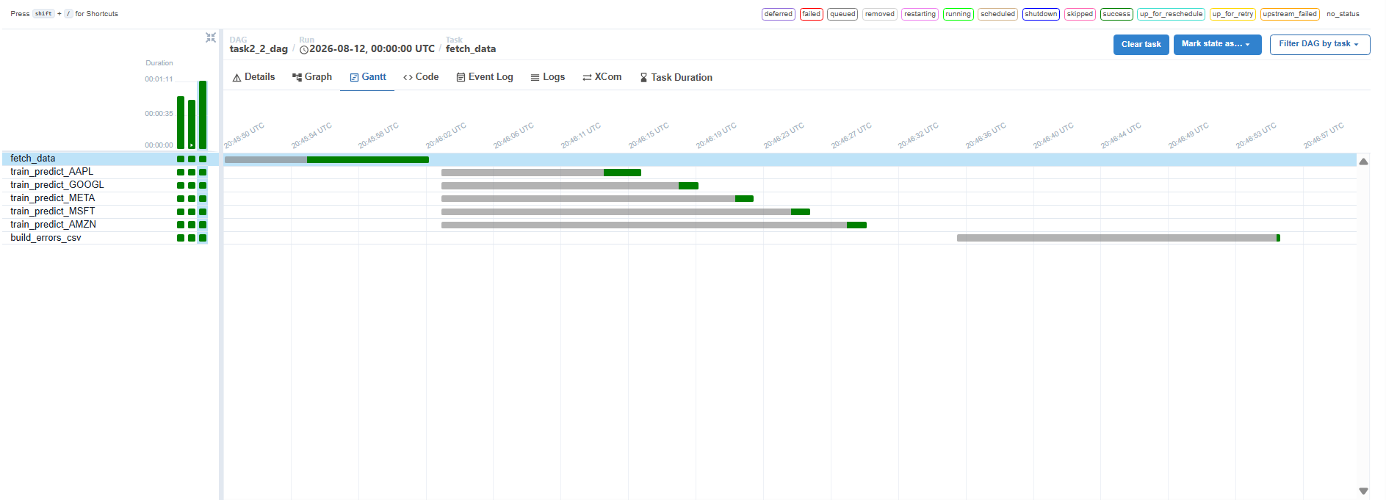Fig 21: Gantt of the Task 2.2 pipeline

Task Checklist:
- Task 1: webserver + scheduler terminal screenshots, browser DAGs list, Grid/Graph/Gantt for helloworld, 2 extra UI features (Logs, Code) with explanations.
- Task 2.1: Grid/Graph screenshots, Gantt after manual trigger, scheduling explanation + 3-run history screenshot, DAG source code.
- Task 2.2: code screenshots for all 4 files (fetch_data.py, train_predict.py, build_errors_csv.py, task2_2_dag.py), errors CSV, DAG graph screenshot, workflow/XCom/scheduler explanation.
- Every screenshot is legible and matches the claim next to it (e.g. the 3 scheduled runs are actually visible).

