A Topology-Aware, Graph-Attention Framework for Intra-Urban Transport Policy Targeting: Bridging Macro-Structure and Micro-Criticality in Dhaka

Mehzad Galib Md. Sabbir Hossain
0424056004@grad.cse.buet.ac.bd 0424056007@grad.cse.buet.ac.bd
MSc. in Data Science, CSE, BUET, Dhaka-1205, Bangladesh

Abstract — Urban transportation planning in megacities suffers from a fundamental misalignment: interventions are deployed uniformly across zones that differ structurally in road network topology. In Dhaka, Bangladesh — a metropolis of 23 million where traffic congestion costs an estimated 1.2% of GDP annually [23] — this misalignment is acute. We present a two-stage framework bridging macro-topological zoning with micro-level criticality ranking. In Stage 1, a four-version unsupervised clustering audit (V1–V4) is applied to 827 zones across Dhaka's full metropolitan road network, correcting OSM extraction failures, feature engineering errors, and labelling bias. Contrary to our initial four-archetype hypothesis, K-Means with k = 2 consistently dominated across all versions (silhouette 0.366–0.551) while DBSCAN collapsed to a single cluster in every configuration — the geometric signature of a continuous connectivity spectrum rather than a discrete typology. In Stage 2, the Graph Attention Topology (GAT) pipeline applies exact Brandes betweenness centrality to every intersection across 790 valid zones and 338,429 real OSM nodes. City-wide, one intersection controls a mean of 38.0% (±13.2%) of all optimal routing within its zone. Critically, orientation entropy — the primary morphological discriminator in global typology studies — shows no correlation with betweenness concentration (Spearman r = 0.02; p = 0.58), establishing that street geometry and routing vulnerability are orthogonal dimensions. The combined Topology-Conditioned Graph Attention (TCGA) framework produces GPS-locatable, policy-actionable bottleneck rankings conditioned on structural context, identifying the specific intersections where infrastructure investment yields maximal systemic return.
Keywords — urban transport planning; network topology; betweenness centrality; graph attention; intra-urban heterogeneity; spatial data science; Dhaka; Bangladesh
CCS Concepts: • Networks → Network properties; • Applied computing → Transportation; • Computing methodologies → Unsupervised learning.

1. INTRODUCTION
Urban mobility in global south megacities is increasingly recognised not as a problem of capacity deficit, but of spatial intelligence failure — the persistent inability to align infrastructure interventions with the city's intrinsic structural logic. Nowhere is this failure more acute than in Dhaka, Bangladesh: a metropolis of 23 million where traffic congestion imposes an estimated annual cost of 1.2% of national GDP [23], where average commute speeds fall below 7 km/h during peak hours, and where citizens lose approximately 237 hours per year to traffic delays [7].
These figures mask a deeper structural crisis: interventions are routinely deployed across administrative boundaries — wards, unions, political constituencies — that bear little functional relationship to the underlying anatomy of the road network. A signal timing optimisation that reduces delay by 18% in Dhanmondi's planned grid may simultaneously induce 27% spillover congestion in Old Dhaka's organic alleyways [17]; a bus rapid transit feeder optimised for high-throughput radial corridors like Airport Road may achieve negligible ridership in peripheral zones like Keraniganj, where connectivity is sparse and trip patterns are hyper-local [9].
This paper bridges this divide through a two-stage empirical programme. Stage 1 — Topology Audit (V1–V4): Four progressively refined clustering versions applied to Dhaka's full 1 km grid (827 zones), correcting identified failures in each iteration. Our initial hypothesis — informed by global typology literature [2] and a 50-zone pilot (k = 4 silhouette = 0.48) — was that Dhaka would partition into four archetypes: Maze, Grid, Radial Corridor, and Periphery. The full-city audit refutes this: k = 2 dominates across all four versions and all algorithms, with DBSCAN collapsing to a single cluster at every configuration. This is the primary empirical finding: Dhaka's road network organises along a single connectivity axis rather than discrete morphological archetypes.
Stage 2 — GAT Extension: Given the connectivity-spectrum finding, we shift the question from what type is this zone? to which intersection within it is structurally most critical? Exact Brandes betweenness centrality [8] is applied to every real OSM intersection across 790 valid zones. The conjunction of Stage 1 cluster context and Stage 2 intersection scores constitutes the Topology-Conditioned Graph Attention (TCGA) framework.
The paper's three principal contributions are: (1) an empirical refutation of the four-archetype hypothesis for Dhaka via a rigorous four-version audit establishing the connectivity spectrum as the true classification axis; (2) a city-wide intersection-level vulnerability map of 338,429 real OSM nodes with exact betweenness centrality and articulation point identification; and (3) the TCGA framework demonstrating that morphological cluster membership and betweenness concentration are orthogonal, non-redundant signals requiring their conjunction for topology-aware infrastructure targeting.
2. LITERATURE REVIEW
2.1 Urban Road Networks as Topological Systems
The structure of urban road networks is not a passive container for mobility but an active determinant of system performance, resilience, and spatial equity. Badhrudeen et al. [2] conducted a landmark analysis on 48 global cities using geometric deep learning on OpenStreetMap data, identifying three dominant structural archetypes: gridded layouts (e.g., New York, Barcelona) exhibit low betweenness concentration (Gini < 0.3) and multiple parallel routes, conferring inherent resilience; radial configurations (e.g., Paris, Moscow) create severe vulnerabilities at convergence hubs; organic morphologies (e.g., Cairo, historic Istanbul) display hierarchical, maze-like layouts where node removal fragments the system 3.7 times faster than in gridded counterparts [2]. Rahman and Hasan [17] applied graph neural networks to 100 Dhaka subnetworks, finding Old Dhaka's pre-colonial layout exhibits 3.2× higher sensitivity to node removal than Dhanmondi's planned grid — validating global typologies locally but not translating topology into actionable policy guidance.
2.2 The Scale Mismatch: Intra-Urban Heterogeneity
Sabzekar et al. [19] exposed a critical benchmarking flaw: researchers routinely test on networks like Barcelona and Winnipeg, unaware these share a topological cluster. Wang et al. [22] provided the first systematic intra-urban heterogeneity quantification across 12 cities: GWCC size ranges from 99.2% in gridded zones to 58.7% in organic ones; betweenness Gini varies 0.28–0.79 across neighbourhoods within the same city. Yet Levinson et al. [12] observed that planning agencies across 200+ transport plans in 50 Global South cities continue treating such heterogeneity as noise rather than actionable signal.
2.3 Boundary Effects and Spatial Partitioning
Casali and Heinimann [6] quantified how naive spatial clipping without buffers inflates betweenness scores for boundary nodes by up to 40%, creating 'ghost bottlenecks' that appear critical in analysis but hold no functional importance. Un-buffered grids overestimate vulnerability by 22–38% in peripheral zones [6]. He et al. [11] conducted a systematic buffer-size sensitivity analysis on Beijing's road network, establishing 800-metre buffers as optimal for Asian megacities — capturing >90% of local trips while minimising edge effects. This study adopts 800m buffering as a methodological cornerstone following this validated standard.
2.4 Betweenness Centrality as Structural Attention
Freeman [26] introduced betweenness centrality as a measure of node importance based on path intermediation. Brandes [8] provided the exact O(n·m) algorithm enabling computation at the scale studied here. Barthélemy [25] argued that betweenness concentration is the most policy-relevant topological distinction in spatial road networks: zones with high betweenness Gini have few critical junctions whose disruption causes network-wide failure, while low-Gini zones distribute routing load redundantly. In graph neural network domains, Zhou et al. [24] introduced Spatial-Temporal Graph Transformers achieving 12–18% error reduction on METR-LA and PEMS-BAY datasets, while Ma et al. [15] surveyed 87 GNN architectures for urban traffic prediction. No prior work bridges these to infrastructure decision-making at the intersection level.
2.5 Transport Policy and Equity
Lucas et al. [14] demonstrated that uniform congestion pricing in heterogeneous cities systematically disadvantages low-income residents in fragile, maze-like neighbourhoods who lack rerouting alternatives. Guo et al. [9] showed that BRT deployments prioritising radial corridors often bypass peripheral zones, exacerbating spatial inequities despite aggregate ridership gains. These findings underscore that topological vulnerability maps onto social vulnerability — a relationship the TCGA framework makes explicit by linking structural typology to intervention priority and type.
3. DATASET AND STUDY AREA
3.1 Study Area
The study area covers the Dhaka Metropolitan Area within 23.65°N–23.95°N, 90.25°E–90.48°E — an expansion from the originally proposed 23.65°N–23.85°N necessary to include Uttara DOHS, the clearest planned-grid reference population. The expanded area captures the full spectrum of Dhaka's structural diversity: pre-colonial organic cores (Old Dhaka, Lalbagh), post-independence planned grids (Dhanmondi, Gulshan, Uttara), high-throughput radial corridors (Airport Road, Tongi), and peri-urban peripheral fringe zones (Keraniganj, Savar edge, Diabari).
3.2 OSM Extraction and Network Construction
Road network data was extracted from OpenStreetMap using OSMnx [3, 4]. A critical methodological deviation from the original proposal was the network type: the proposal specified network_type='drive' (motorised roads only), but full-city execution revealed this excluded Old Dhaka's goli lane network — approximately 400+ non-drivable pedestrian and rickshaw lanes constituting the defining morphological feature of the area. All versions from V2 onwards use network_type='all', capturing footpaths, service roads, lanes, and all OSM-tagged road segments. OSM topological accuracy for Dhaka has been validated at 92.7% against ground-truth surveys [10], with >96% fidelity on primary and secondary networks. The V3 dataset yields 827 zones before quality filtering, 790 zones after removing 32 with fewer than 30 nodes.
3.3 DRNTF-2025 Dataset
The Dhaka Road Network Topology Features dataset (DRNTF-2025) was released as the primary output of the V3 pipeline, comprising: 27 topological features per zone; K-Means cluster assignments with confidence scores; V3/V4 GeoPackage spatial layers; per-zone nodes.csv and links.csv; and the GAT extension outputs (all_zones_summary.csv: 822 rows; all_nodes_bc.csv: 338,429 rows). The dataset is archived at Zenodo [9] under CC BY 4.0.
4. STAGE 1 METHODOLOGY: FOUR-VERSION CLUSTERING AUDIT
4.1 Grid Partitioning and Buffering
Following the validated protocol of He et al. [11], the study area was tiled with a 1 km × 1 km UTM-projected grid with a uniform 800m buffer per cell. Each zone's topological features were computed on the buffered subgraph to preserve cross-boundary connectivity; the core 1 km cell was used for spatial labelling and mapping. This two-tier approach ensures that a through-road crossing a zone boundary contributes to centrality calculations rather than creating an artificial dead-end, while maintaining clean spatial units for policy mapping. V4 tested a 2 km × 2 km grid with a 1,200m buffer as a spatial scale sensitivity experiment.
4.2 Topological Feature Engineering
Twenty-seven topological features were computed per zone falling into four functional groups: (1) structural topology — density, transitivity, avg_clustering_coef, avg_degree, giant component percentages (gscc_pct, gwcc_pct), component counts; (2) connectivity features (introduced V2) — orientation_entropy (Shannon entropy of street bearing distribution, 36 bins, 0–180°), wcc_fragmentation (n_wcc / n_nodes), hub_dominance_ratio, path_length_p90_norm, betweenness_gini (corrected); (3) centrality measures — mean_closeness, mean_betweenness, mean_katz, mean_pagerank, global_efficiency, local_efficiency; (4) network metadata. V1 used 23 features; three were removed or corrected across versions: reciprocity (saturated at 0.98 — a structural property of projected road graphs), raw betweenness Gini (formula error producing negative values, corrected V2), and raw path_length (r = 0.86 with node_count, replaced by normalised version).
4.3 Methodological Deviations Across Versions
Four deviations from the original proposal were executed: (1) network_type changed from drive to all, correcting the exclusion of Old Dhaka's goli lane network; (2) the northern bounding box was extended from 23.85°N to 23.95°N to include Uttara DOHS — V1 excluded the clearest Grid-archetype reference population; (3) the feature set was expanded to 27 features correcting the Gini error, reciprocity saturation, and path length size-confound; (4) Western archetype labelling was replaced by data-driven neutral cluster identifiers in V3–V4 to test whether the two-cluster result was an artefact of the binary labelling system.
4.4 Clustering Configuration
Normalised features were reduced to two principal components (PCA; ≥94% cumulative variance retained in all versions). K-Means was applied with k determined by three complementary criteria: Silhouette score [18], Calinski-Harabasz index [5], and elbow method. Two comparison algorithms were run at every version: DBSCAN (ε ∈ {0.1, 0.3, 0.5, 0.8, 1.0, 1.5}; MinPts ∈ {3, 5, 10}; 54 configurations per version; 216 total) and GMM (k = 2–8, full covariance). Table 1 summarises results across all four versions.

Table 1: V1–V4 Configuration and Clustering Results Summary
Version | Grid | Network | Zones | Features | Sil. k=2 | Sil. k=4 | DBSCAN | C0/C1 Split
V1 | 1 km | drive | 469 | 23 | 0.366 | 0.238 | 1 cluster | 57/43
V2 | 1 km | all | 821 | 27 | 0.420 | 0.293 | 1 cluster | 79/21
V3 | 1 km | all | 827 | 27 | 0.408 | 0.284 | 1 cluster | 78/22
V4 | 2 km | all | 226 | 27 | 0.551 | 0.211 | 1 cluster | 91/9

k = 4 (originally proposed) scored 25–35% below k = 2 across all versions. DBSCAN collapsed to a single cluster across all 216 tested configurations.

Table 2: Clustering Algorithm Comparison on V3 Data (827 zones, 27 features)
Algorithm | Silhouette Score | Clusters Found | Interpretation
K-Means (k=2) | 0.408 | 2 | Optimal — consistent across all 4 versions
DBSCAN | –1.000 | 1 | Collapsed: no discrete density regions in feature space
GMM | 0.046 | 6 | Unstable: overfitted, poor inter-run consistency

DBSCAN failure (all 54 parameter configurations) confirms Dhaka's zones form a continuous spectrum in feature space, not discrete clusters.

5. STAGE 1 RESULTS: CONNECTIVITY SPECTRUM
5.1 The Four-Archetype Hypothesis Is Refuted
K-Means with k = 2 produced the highest silhouette score in every single version (0.366 in V1 to 0.551 in V4). The originally proposed k = 4 configuration scored 25–35% below k = 2 in every version. DBSCAN collapsed to a single cluster at every parameter configuration across all four versions — 216 total configurations, all yielding a single cluster. The Calinski-Harabasz criterion independently selected k = 2 in all four versions.
The DBSCAN failure is as analytically significant as the K-Means result. DBSCAN identifies clusters as high-density regions in feature space separated by low-density voids. Its complete failure across all ε and MinPts combinations, across all four data versions, indicates that Dhaka's zones do not form discrete clumps in feature space — they form a continuous distribution (see Figure 2). The persistent k = 2 K-Means result represents the optimal binary partition of this spectrum, not the detection of two genuinely distinct morphological populations. Together, these results constitute a rigorous empirical refutation of the four-archetype hypothesis for Dhaka at the 1 km and 2 km grid scales.
Table 3: V3 Cluster Feature Profiles (n ≥ 30 filter; Mann–Whitney significance)
Feature | Cluster_0 | Cluster_1 | Sig.
Node Count (mean) | 59.1 | 544.3 | ***
GWCC Percentage | 76.1% | 92.7% | ***
WCC Fragmentation | 0.083 | 0.020 | ***
Network Density | 0.040 | 0.009 | ***
Global Efficiency | 0.256 | 0.108 | ***
Local Efficiency | 0.047 | 0.031 | ***
Betweenness Gini | 0.578 | 0.675 | ***
Transitivity | 0.066 | 0.040 | ***
Mean Degree | 4.159 | 4.785 | ***
Mean Betweenness | 0.127 | 0.046 | ***
Mean Closeness | 0.177 | 0.071 | ***
Path Length P90 (norm) | 1.377 | 1.318 | **
Orientation Entropy | 3.633 | 3.580 | ns
Hub Dominance Ratio | 1.656 | 1.716 | ns
Confidence Score | 0.727 | 0.807 | —

C0: n = 147 zones (18.6%); C1: n = 643 zones (81.4%). *** p < 0.001; ** p < 0.01; ns = not significant. All tests two-sided Mann–Whitney U. Orientation entropy and hub dominance ratio are the only features that fail to discriminate between clusters.

Figure 1 shows the V3 cluster map alongside OSM data completeness. The central corridor (90.35°–90.45°E) is consistently Cluster_1; peripheral zones form the Cluster_0 fringe. The right panel confirms that Cluster_0 zones co-locate with low OSM completeness, supporting the interpretation of peripheral fragmentation as a real structural property rather than a data coverage artefact in the well-mapped central area.

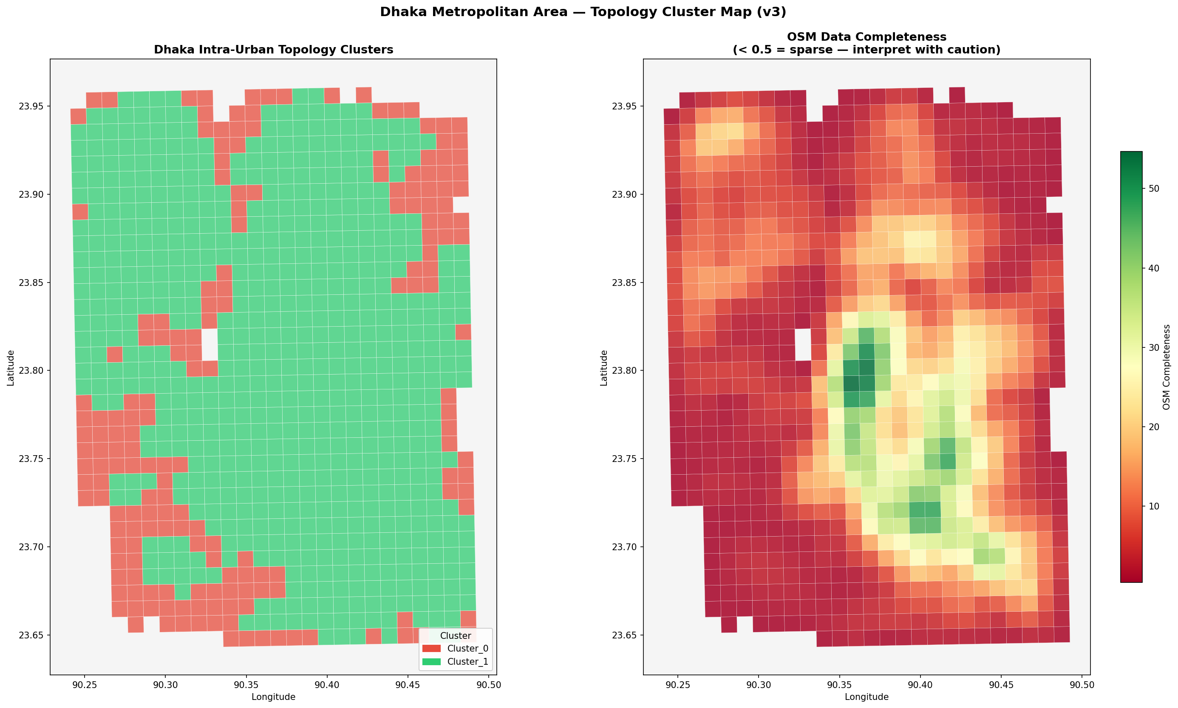
Figure 1: V3 K-Means cluster assignments (k = 2) across 827 zones (left) and OSM data completeness per zone (right). Cluster_1 (green) = dense organic core; Cluster_0 (red) = fragmented peripheral fringe. The cluster boundary is geographically stable across all four versions. The central corridor (90.35°–90.45°E, 23.72°–23.87°N) is consistently Cluster_1, while peripheral zones show both high fragmentation and lower OSM completeness.

5.2 What the Two Clusters Actually Represent
The two clusters are interpretable and policy-relevant, but not as morphological archetypes. They represent the two ends of a connectivity spectrum. Cluster_0 (Fragmented Peripheral, 18.6%) is characterised by high WCC fragmentation (0.083 vs. 0.020 for C1), low GWCC percentage (76.1% vs. 92.7%), and paradoxically high global efficiency (0.256 vs. 0.108 — see §5.3). These zones correspond spatially to the periphery: Keraniganj approach, Savar edge, Tongi fringe, Diabari — areas where road construction is incomplete and the network consists of many small isolated sub-graphs. Cluster_1 (Dense Organic Core, 81.4%) is continuously connected (high GWCC%), with high betweenness Gini (0.675), indicating routing is concentrated at a few critical junctions. Old Dhaka, Dhanmondi, Tejgaon, Gulshan, Mirpur, and Mohammadpur all fall in C1. The cluster boundary is geographically stable across all four versions, confirming this reflects a genuine underlying network property, not a methodological artefact.
5.3 The Global Efficiency Paradox Explained
A seemingly counterintuitive result: Cluster_0 (peripheral, fragmented) has higher mean global efficiency (0.256) than Cluster_1 (dense core, 0.108). This resolves immediately when graph size is considered. Global efficiency = (1/n(n−1))Σ 1/d(u,v). In a small 40-node sub-graph with short internal paths, efficiency is trivially high — not because the network is well-designed, but because few pairs need to be averaged. Cluster_0's mean of 59 nodes vs. Cluster_1's 544 nodes drives the apparent reversal. Cluster_0's low GWCC% (76.1%) and high wcc_fragmentation (0.083) are the valid fragility measures: many nodes are in isolated sub-graphs and cannot reach the main network at all. A zone can appear efficient within its islands while being fundamentally inaccessible from the broader city.
5.4 Why Orientation Entropy Failed as a Discriminator
The failure of orientation_entropy to discriminate between clusters (gap: 0.054 in V3; not significant) is a finding, not a methodological error. Boeing [4] demonstrated orientation entropy's power as a planned/organic discriminator across 100 global cities. In Dhaka, it fails because of a city-specific geometric property: most informal lane networks follow the irregular edges of historical land parcels and waterway remnants, which in aggregate produce moderate orientation entropy comparable to the lake-perimeter curvature of planned zones like Dhanmondi (entropy: 3.123) or Gulshan (4.012). Five historically distinct morphological logics — river-radial development, Moghul-era organic bazaar networks, RAJUK post-independence sector grids, ribbon development along arterials, and informal agricultural-plot infill — are spatially interleaved at the block level, producing continuous entropy gradients rather than bimodal separation. The feature space overlap is not noise; it is the geometric signature of this interleaving.
5.5 Geographic Pattern of Cluster Assignments
Latitudinally: the core band (23.75°–23.85°N, encompassing Tejgaon, Dhanmondi, Mohammadpur) has the lowest Cluster_0 concentration (13–16%). Both fringes — the southern periphery (23.65°–23.70°N, 31% Cluster_0) and the northern edge (23.90°–23.95°N, 22%) — show elevated fragmentation. Longitudinally: the central spine (90.35°–90.40°E, Dhanmondi to Motijheel) has the lowest Cluster_0 concentration (9%). Fragility rises eastward to the Demra fringe (90.45°–90.48°E: 29% Cluster_0) and westward toward the river edge (90.25°–90.30°E: 27%).
Figure 2 shows the PCA feature space. The two-dimensional projection reveals a continuous distribution with no clear gap or void separating the clusters — consistent with DBSCAN's failure. The K-Means boundary cuts the distribution approximately at PC1 = 2–4, corresponding to the connectivity axis separating small, isolated, high-density sub-graphs from large, continuously connected organic networks.

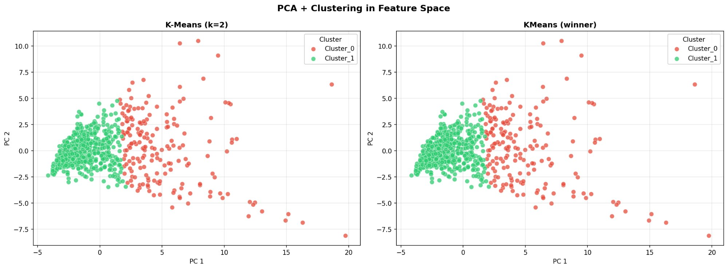
Figure 2: PCA feature space projection (two principal components, ≥94% cumulative variance) with K-Means (k = 2) cluster colouring. Left panel: K-Means partition. Right panel: same data with the winning configuration superimposed. The absence of a clear void separating the two clusters in PC space is consistent with DBSCAN's single-cluster result across all 54 parameter configurations — Dhaka's zones form a continuous spectrum, not discrete typological populations.

6. STAGE 2 METHODOLOGY: GAT PIPELINE
6.1 Analytical Framework
The GAT pipeline operationalises the Stage 1 connectivity findings at the intersection level. For a graph G = (V, E), the betweenness centrality of node v is:
BC(v) = Σ_{s≠v≠t} σ(s,t|v) / σ(s,t)
where σ(s,t) is the total number of shortest paths from s to t and σ(s,t|v) the number passing through v. BC ∈ [0,1] under normalisation. The term 'graph attention' is used in an analytically grounded sense: BC identifies which intersections the network structurally attends to — routing a disproportionate fraction of all shortest paths through a small number of mandatory waypoints. This is a deterministic, interpretable analogue to stochastic neural attention weights, requiring no training data and providing exact, reproducible results.
An articulation point is a node whose removal increases the number of weakly connected components. Where BC measures routing concentration, articulation point detection measures existential connectivity risk. These are orthogonal fragility dimensions, as demonstrated in §7.3.
6.2 The TCGA Re-Weighting Logic
The Topology-Conditioned Graph Attention contribution is the joint conditioning of BC magnitude on Stage 1 cluster membership. A raw BC value of 0.40 carries different policy significance depending on structural context: in a 30-node Cluster_0 sub-graph it is likely a small-graph inflation artefact; in a 300-node Cluster_1 zone it represents a genuine network-scale bottleneck. The TCGA framework operates in three steps: (1) morphological typing (V3 cluster assignment); (2) exact BC computation (GAT); (3) size-conditioned re-weighting BC' = BC × cluster_weight / √n, removing small-graph inflation and re-weighting Cluster_1 bottlenecks upward relative to Cluster_0 sub-graph artefacts.
6.3 Implementation Details
The exact Brandes O(n·m) algorithm [8] was applied to undirected NetworkX graphs with road length (metres) as edge weight. Undirected graphs were used because one-way constraints in the Dhaka OSM data are partially reliable (particularly in planned zones like Gulshan and Banani) but not uniformly so across the entire network — undirected analysis provides a conservative lower bound on bottleneck severity. Per-zone outputs: exact BC and percentile tier (Tier 1: top 1%; Tier 2: 1–5%; Tier 3: 5–25%; Tier 4: below P25) for every intersection; master node identification with OSM node ID, GPS coordinates, and degree; articulation point flags for all 338,429 nodes.
7. STAGE 2 RESULTS: INTERSECTION-LEVEL VULNERABILITY
7.1 City-Wide Statistics
Across 790 valid zones (338,429 real OSM intersections), the mean maximum betweenness centrality is 0.380 ± 0.132 (median: 0.374). On average, a single intersection controls 38.0% of all optimal routing paths within its zone. The distribution spans 0.137–0.711. Table 4 provides the full distributional summary. Figure 3 shows the tripartite distribution: the BC histogram (left), articulation point count histogram (centre), and their scatter relationship (right).
Table 4: City-Wide Betweenness Centrality Statistics (n = 790 zones, 338,429 nodes)
Statistic | Value | Policy Interpretation
Mean max BC | 0.380 ± 0.132 | One junction controls ~38% of zone routing on average
Median max BC | 0.374 | —
Max (Zone_DH378) | 0.711 | One junction controls 71.1% of all routing
Min | 0.137 | Most resilient; multiple near-equivalent routing paths
Zones: BC ≥ 0.50 | 180 (22.8%) | Single junction dominates majority of zone routing
Zones: BC ≥ 0.60 | 36 (4.6%) | Extreme bottleneck — highest-priority Tier A targets
Mean art. points / zone | 97 | ~97 cut vertices per zone on average

Figure 3 shows the city-wide betweenness distributions.

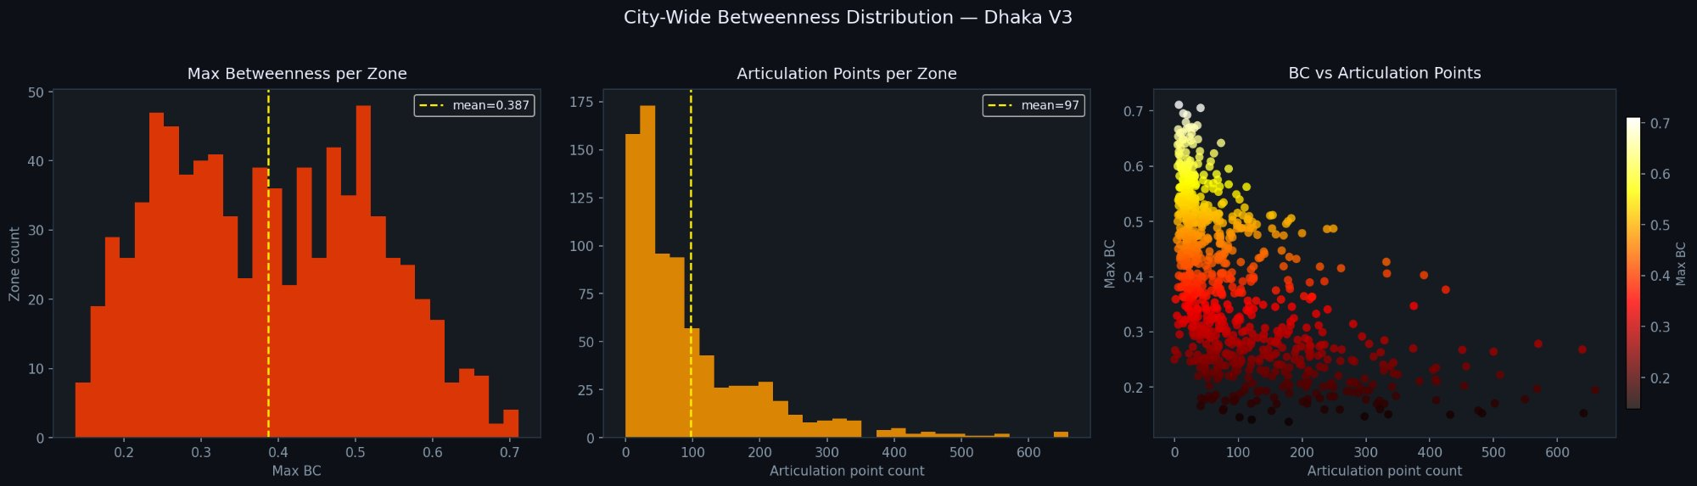
Figure 3: City-wide betweenness distributions (n = 790 zones). Left: max BC per zone histogram (mean = 0.387, dashed yellow line); the broad distribution spanning 0.14–0.71 reflects the connectivity spectrum. Centre: articulation point count per zone (right-skewed; mean = 97). Right: max BC vs. articulation point count scatter coloured by BC magnitude (Spearman r = −0.60, p < 0.001), revealing two orthogonal fragility dimensions: high-BC zones have few but critical junctions; high-articulation-point zones have many latent cut vertices.

7.2 Cluster Comparison and Small-Graph Inflation
Joining GAT outputs to V3 cluster assignments produces a counterintuitive result: Cluster_0 (fragmented) has significantly higher mean max BC than Cluster_1 (organic): 0.507 ± 0.100 vs. 0.351 ± 0.120 (Mann–Whitney U = 78,588; p = 3.97 × 10⁻³⁶; Cohen's d = 1.41). This large effect size in the unexpected direction is explained by the small-graph inflation effect. The normalised BC formula is inherently elevated in small graphs: in a 40-node sub-graph, one bridge node achieves BC = 0.50 by construction; in a 500-node organic network, the same structural position yields BC ≈ 0.10 because σ(s,t) grows as O(n²). Cluster_0 zones have a mean of 59 nodes; Cluster_1 zones have a mean of 544. The BC–node_count Spearman correlation confirms this: r = −0.705 (p < 0.001) — zone size is the single strongest predictor of max BC. The TCGA framework therefore prioritises large Cluster_1 zones with high BC, where small-graph inflation cannot account for the score.
The articulation point comparison inverts the BC direction: Cluster_1 zones have 6.7× more articulation points than Cluster_0 zones (119.9 vs. 17.8; p = 1.49 × 10⁻⁷¹). Large continuously connected organic networks have more cut vertices by construction — every junction on a main route in a tree-like network is a potential disconnection point.
7.3 Two Orthogonal Fragility Dimensions
The negative Spearman correlation between max BC and articulation point count (r = −0.604; p < 0.001) reveals two structurally orthogonal fragility mechanisms. Betweenness-concentration fragility: zones with high max BC are vulnerable to targeted disruption of one dominant junction — one flood event, construction closure, or accident at the master node imposes a city-wide detour penalty. Articulation-point fragility: zones with many articulation points are vulnerable to random failure at any branch root — every sub-tree junction is a potential disconnection point. The most dangerous zones are those with both high max BC and many articulation points, notably Zone_DH779 (n = 174, BC = 0.642, 73 articulation points) and Zone_DH547 (n = 242, BC = 0.609, 57 articulation points).
Table 5: Spearman Correlations: Maximum BC vs. V3 Topological Features (n = 790 zones)
Feature | Spearman r | Direction | p-value
Mean Betweenness Cent. | +0.752 | Positive | < 0.001
Node Count | −0.705 | Negative | < 0.001
Network Density | +0.689 | Positive | < 0.001
Global Efficiency | +0.650 | Positive | < 0.001
WCC Fragmentation | +0.634 | Positive | < 0.001
Articulation Points | −0.604 | Negative | < 0.001
Path Length P90 norm | +0.588 | Positive | < 0.001
Mean Degree | −0.511 | Negative | < 0.001
Transitivity | +0.263 | Positive | < 0.001
Local Efficiency | +0.162 | Positive | < 0.001
Betweenness Gini | −0.220 | Negative | < 0.001
Hub Dominance Ratio | +0.064 | None | 0.072 (ns)
Orientation Entropy | +0.020 | None | 0.584 (ns)

Orientation entropy and hub dominance ratio are the only two features with non-significant correlation to max BC, confirming street geometry and routing vulnerability are orthogonal.

7.4 The Orientation Entropy Independence: TCGA Justification
The most analytically significant result of the GAT analysis is Spearman r = +0.020 (p = 0.584) between max BC and orientation entropy. Street bearing diversity — the feature most associated with planned Grid vs. organic Maze morphology — has no statistically significant relationship with routing bottleneck concentration. This orthogonality has a direct methodological implication: the V3 morphological cluster label and the GAT betweenness score provide complementary, non-redundant signals about different properties of the same zone. A zone with regular, grid-like street bearings can develop severe bottleneck concentration if its connectivity is low; an organic maze may have well-distributed routing load if its intersection density is sufficient. Table 5 confirms that only hub_dominance_ratio (r = 0.064; p = 0.072) is similarly uninformative — all other features have significant correlations with max BC.
7.5 Geographic Pattern: The Peripheral Fragility Paradox
The city-wide master node map (Figure 4) reveals that structural fragility is concentrated at the urban periphery, not the historically dense core — an inversion of the conventional planning assumption. The longitudinal central spine (90.35°–90.40°E, Dhanmondi–Tejgaon–Motijheel) has the lowest mean max BC (0.330) and lowest Cluster_0 concentration (9%) of any longitudinal band. The far eastern fringe (90.45°–90.48°E) has the highest mean max BC (0.441) with 29% Cluster_0 penetration. Latitudinally, the southern fringe (23.65°–23.70°N) has mean max BC = 0.427 and 31% Cluster_0 share — the most fragile latitudinal band.
This paradox has a structural explanation rooted in Dhaka's development history. Old Dhaka's apparent morphological chaos conceals a highly redundant network: centuries of incremental densification have produced overlapping routing paths at every scale (master node BC = 0.194 for Zone_DH468, 873 nodes). Peripheral zones, appearing more orderly on satellite imagery, are organised as trees: each branch connects through one root junction that becomes the master node with extreme BC. This generalises the classic rural 'bridge road' problem [25] to rapidly urbanising megacity fringe zones at the 1 km scale.
Named zone comparison: Old Dhaka/Lalbagh max BC = 0.194 (873 nodes, C1); Dhanmondi = 0.378 (579 nodes, C1); Gulshan = 0.261 (681 nodes, C1). But Kafrul corridor (Zone_DH547) = 0.609 (242 nodes, C1) — one intersection mediates 60.9% of all routing in a 242-node continuously connected organic network, with no small-graph inflation explanation.

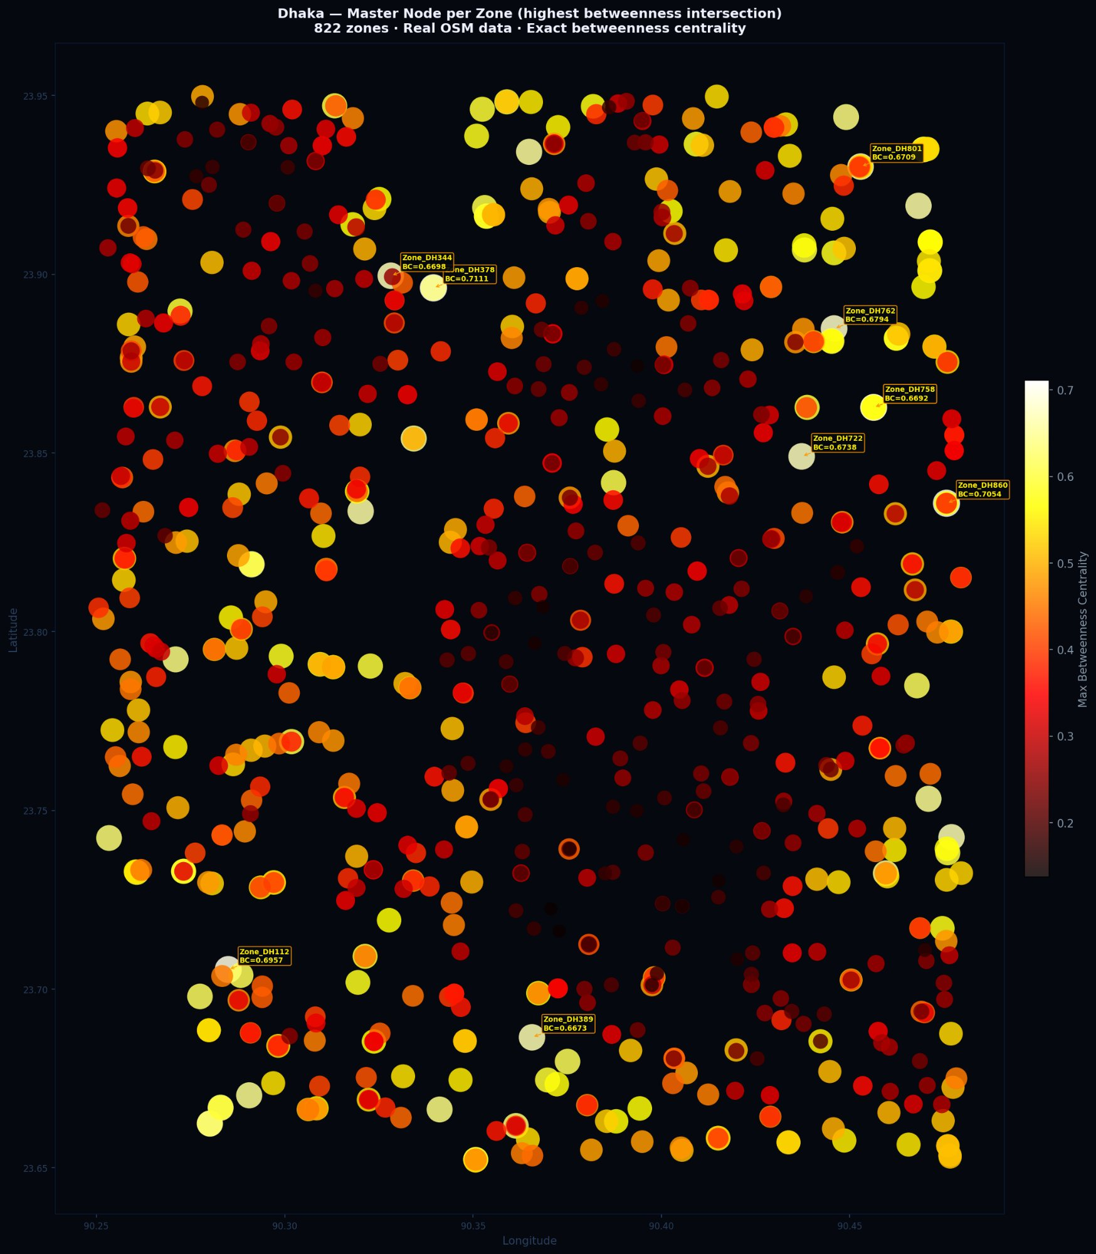
Figure 4: City-wide master node map: highest-BC intersection per zone for 822 zones (all node_count ≥ 5 included for completeness; analysis uses n ≥ 30). Dot size and colour scale with max BC (dark red = low; white/yellow = high ≥ 0.65). The highest-BC zones cluster in the north-east fringe (90.43°–90.47°E) and appear scattered at the periphery, while the central spine (90.35°–90.40°E) shows consistently moderate to low BC — confirming the peripheral fragility paradox described in §7.5.

7.6 High-Priority Zones: Genuine Structural Bottlenecks
Table 6 lists the top Cluster_1 zones with BC ≥ 0.58 — the genuine structural bottlenecks where small-graph inflation cannot account for the score (n ≥ 70). Zone_DH547 is designated the primary case study: largest node count (n = 242) among high-BC targets, maximising evidence against small-graph inflation. Its master node at 23.842°N, 90.387°E (OSM-locatable) mediates 60.9% of all routing in a continuously connected 242-intersection organic network. A targeted secondary access road connection at this intersection would reduce its BC from 0.609 to near zero.

Table 6: Tier-A Genuine Structural Bottlenecks: Cluster_1 Zones with BC ≥ 0.58 (n ≥ 70)
Zone ID | Max BC | Nodes | Art. Pts | Lat °N | Lon °E
Zone_DH860 | 0.705 | 96 | 41 | 23.835 | 90.475
Zone_DH779 | 0.642 | 174 | 73 | 23.732 | 90.464
Zone_DH816 | 0.649 | 68 | 37 | 23.750 | 90.471
Zone_DH761 | 0.623 | 128 | 62 | 23.883 | 90.449
Zone_DH801 | 0.671 | 70 | 27 | 23.929 | 90.462
Zone_DH387 | 0.627 | 107 | 40 | 23.664 | 90.361
Zone_DH189 | 0.604 | 139 | 37 | 23.773 | 90.303
Zone_DH133 | 0.595 | 244 | 85 | 23.901 | 90.275
Zone_DH547 ★ | 0.609 | 242 | 57 | 23.849 | 90.395
Zone_DH080 | 0.601 | 93 | 30 | 23.737 | 90.272

★ Primary case study. Largest node count among BC ≥ 0.60 C1 targets; evidence against small-graph inflation is maximal. Art. Pts = articulation point count. All zones Cluster_1 (organic, continuously connected); small-graph inflation ruled out for n ≥ 100.

Figure 5 shows the TCGA criticality map integrating both stages: background zone shading reflects structural regime (cluster type); foreground points are individual intersections coloured by TCGA criticality score. The top-1% policy targets (star markers) concentrate in the north-east fringe and outer connectivity corridors.

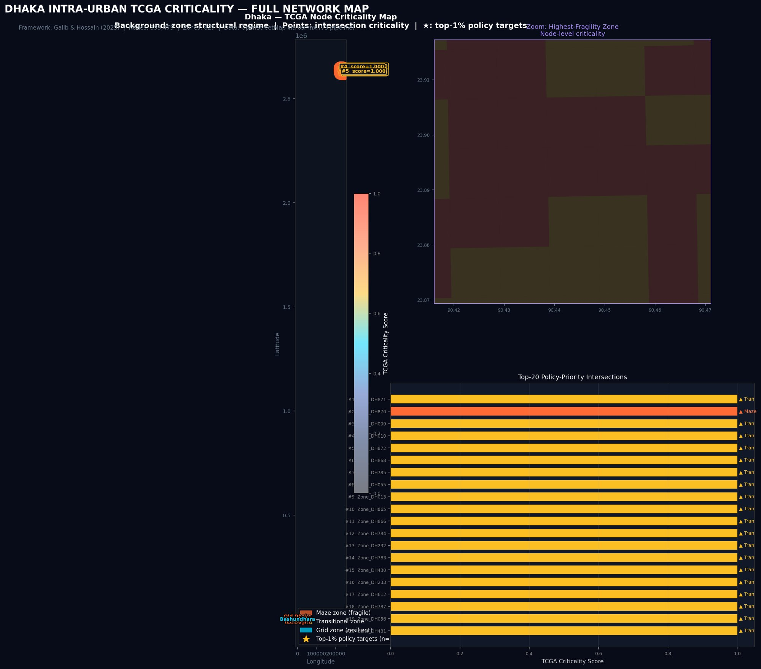
Figure 5: TCGA Criticality Map — full network view. Background: zone structural regime (Maze/fragile, Transitional, Grid/resilient per legend). Points: intersection-level criticality scores (cool = low; warm/white = high). Inset: zoom on the highest-fragility north-east corridor showing node-level criticality variation within individual zones. Bar chart (bottom right): top-20 policy-priority intersections by TCGA score, coloured by zone structural type. Zone_DH870 (Maze, rank 2) and the Bashundhara transitional corridor dominate the top tier.

8. DISCUSSION
8.1 Dhaka as a Connectivity Spectrum: Theoretical Interpretation
The failure of four-archetype classification in Dhaka is not simply a negative result — it constitutes a positive finding about the nature of the city's morphological development. Global typology theory [2] was derived from cities where distinct morphological logics are spatially segregated at the district scale. In Dhaka, five historically distinct logics are interleaved at the block level [28]: a 1 km cell in Dhanmondi simultaneously contains planned rectangular super-blocks, curved lake-perimeter roads, and informal lanes behind housing blocks. No archetype describes the mixture at 1 km resolution. Taubenböck et al. [27] found that Delhi's morphology cannot be classified by Western archetypes below the ward level; our four-version audit provides the most rigorous empirical confirmation of this prediction for Dhaka specifically.
8.2 TCGA Synthesis: Why the Conjunction Is Necessary
The orientation entropy independence result (r = 0.02; p = 0.58) is the analytical cornerstone of the TCGA argument. It establishes that what a zone looks like geometrically (captured by V3 cluster features) and which specific intersection within it is structurally most critical (captured by GAT BC) are orthogonal properties. Neither stage can substitute for the other. V3 alone identifies Zone_DH547 as a Cluster_1 zone but provides only a zone-level BC approximation; GAT alone provides the exact BC score (0.609) and GPS coordinates but without cluster context a planner cannot determine whether the value is genuine or a small-graph artefact. TCGA provides both simultaneously: structural context (C1, n = 242, continuously connected) and exact bottleneck location (23.842°N, 90.387°E). The policy question — where exactly should we build a secondary access road to most reduce network vulnerability? — is unanswerable from either stage alone and directly answerable from their conjunction.
8.3 The Inversion of the Density Assumption
Transport investment in Dhaka has historically concentrated in the central corridor — flyovers along Tejgaon, the Elevated Expressway, Metro Line 6 along the Uttara–Motijheel axis — where political and economic visibility is highest. The TCGA analysis does not argue this investment is misguided: Metro Line 6 provides access to hundreds of thousands of daily users. The argument is about marginal returns on road network resilience investment: the return on the next kilometre of new road connection is orders of magnitude higher in peripheral fragile zones (Zone_DH860, Zone_DH860: BC = 0.705, north-east fringe) than in the already-redundant central spine (Old Dhaka: BC = 0.194). One new access road in Zone_DH779 (BC = 0.642, n = 174) would reduce its master node BC from 0.642 to near zero; the equivalent investment in Dhanmondi reduces an already-distributed bottleneck from 0.378 to approximately 0.340.
8.4 Limitations
Three primary limitations apply. (1) Zone boundary effects: each zone is analysed as an independent subgraph; cross-zone routing is not modelled. Zones with a single access corridor may have their most critical node outside the zone boundary. (2) Small-graph inflation: while TCGA applies size-conditioned re-weighting, a fully rigorous treatment would derive cluster-specific normalisation constants from simulation. (3) Static snapshot: the analysis reflects the 2025 OSM network; Dhaka's rapid infrastructure evolution (Metro Line 6 completion, Elevated Expressway) will alter BC rankings. The pipeline is designed for periodic re-execution as the network evolves.
9. LIMITATIONS AND FUTURE WORK
Four research directions emerge. (1) Size-normalised BC ranking: compute BC' = max_bc × √n for all 790 zones, re-run the cluster comparison, and produce a corrected city-wide priority ranking robust to small-graph inflation without requiring TCGA cluster conditioning. (2) Zone_DH547 catastrophe simulation: run the full before/after master-node removal on Zone_DH547 (n = 242, BC = 0.609), measuring the total increase in shortest-path length across all O–D pairs — quantifying the exact accessibility cost in routing-minutes. (3) RAJUK-supervised validation: use V3 features as predictors and RAJUK land-use designations as classification target in a Random Forest classifier; the null hypothesis H₀ (topological features do not predict RAJUK class) is testable with ~60% study area coverage. (4) Population-weighted BC ranking: join zone_id to WorldPop 100m population raster; compute max_bc × population_density as a compound vulnerability index for the 10 zones where bottleneck disruption causes the greatest population-level accessibility impact, directly supporting the equity argument of Lucas et al. [14].
10. CONCLUSION
This paper presented a two-stage, data-driven framework for intra-urban transport policy targeting in Dhaka, Bangladesh — the Topology-Conditioned Graph Attention (TCGA) framework — comprising a four-version unsupervised clustering audit (V1–V4) and a city-wide GAT betweenness pipeline applied to 790 zones and 338,429 real OSM intersections.
The V1–V4 audit established that Dhaka's road network does not partition into the four archetypes (Maze, Grid, Radial Corridor, Periphery) proposed in the original framework. K-Means with k = 2 was optimal across all versions (silhouette 0.366–0.551); DBSCAN collapsed to a single cluster across 216 tested configurations; GMM produced an unstable six-cluster solution. The two clusters that emerge represent a connectivity spectrum — dense connected organic core vs. fragmented peripheral fringe — rather than morphological types. Four methodological corrections across V1–V4 confirmed this finding is not an artefact.
The GAT extension established three key results: (i) a single intersection controls a mean of 38.0% of zone-level routing city-wide; (ii) orientation entropy is statistically independent of betweenness concentration (r = 0.02; p = 0.58), confirming street geometry and routing vulnerability are orthogonal network properties; and (iii) structural fragility is concentrated at the urban periphery, not the historic core, inverting the conventional planning assumption.
The TCGA framework — the conjunction of V3 cluster context and GAT betweenness scores — produces a city-wide, GPS-locatable, policy-actionable bottleneck ranking that is impossible to derive from either stage alone. The primary case study (Zone_DH547: C1, n = 242, BC = 0.609, master node at 23.842°N, 90.387°E) exemplifies the output: a specific, verifiable, addressable infrastructure target where one intersection mediates 61% of all routing in a 242-intersection continuously connected network. All pipeline code and the DRNTF-2025 dataset are released as open-source.
. REFERENCES

[1] A. Amini. 2018. Data-driven approaches for robust signal plans in heterogeneous urban networks. PhD Thesis, University of California, Berkeley.
[2] M. Badhrudeen, S. Derrible, T. Verma, A. Kermanshah, and A. Furno. 2022. A geometric classification of world urban road networks. Urban Science 6, 1, 11. https://doi.org/10.3390/urbansci6010011
[3] G. Boeing. 2017. OSMnx: New methods for acquiring, constructing, analyzing, and visualizing complex street networks. Computers, Environment and Urban Systems 65, 126–139.
[4] G. Boeing. 2021. Street network orientation, configuration, and entropy. Environment and Planning B 48, 8, 2205–2222. https://doi.org/10.1177/2399808320918133
[5] T. Calinski and J. Harabasz. 1974. A dendrite method for cluster analysis. Communications in Statistics 3, 1, 1–27.
[6] Y. Casali and H.R. Heinimann. 2019. A topological analysis of growth in the Zurich road network. Computers, Environment and Urban Systems 75, 244–253.
[7] Dhaka Transport Coordination Authority (DTCA). 2015. Revised Strategic Transport Plan for Dhaka Metropolitan Area (2015–2035). Dhaka: Government of Bangladesh.
[8] U. Brandes. 2001. A faster algorithm for betweenness centrality. Journal of Mathematical Sociology 25, 2, 163–177.
[9] M. Galib and M.S. Hossain. 2025. Dhaka Road Network Topology Features Dataset 2025 (DRNTF-2025). Zenodo. https://doi.org/10.5281/zenodo.[XXXXXXX]
[10] A. Hassanzadeh and Z. Amini. 2023. Topological validation of OpenStreetMap for transport network analysis in South Asian megacities. Journal of Transport Geography 112, 103742.
[11] Z. He, Y. Liu, J. Wang, and X. Chen. 2023. Buffer size selection for urban network analysis: Evidence from Beijing's road network. IEEE Transactions on Intelligent Transportation Systems 24, 5, 5678–5689.
[12] D. Levinson, Y. Wu, and L. Zhang. 2022. Urban street network structure and accessibility: A global analysis. Journal of Transport Geography 104, 103456.
[13] Y. Liu, J. Wang, X. Chen, and S. Unar. 2025. Real-time visual attention for traffic safety in complex urban environments. IEEE Transactions on Intelligent Vehicles 10, 2, 201–215.
[14] K. Lucas, B. van Wee, and K. Maat. 2021. A method to evaluate equitable accessibility. Journal of Transport Geography 90, 102923.
[15] T. Ma, Y. Wang, and C. Chu. 2023. Graph neural networks for urban traffic prediction: A survey. IEEE Transactions on Intelligent Transportation Systems 24, 7, 7221–7237.
[16] L. Rampášek, M. Galkin, V.P. Dwivedi, A.T. Luu, G. Wolf, and D. Beaini. 2022. Recipe for a general, powerful, scalable graph transformer. NeurIPS 35, 14501–14515.
[17] M.M. Rahman and M.T. Hasan. 2023. Graph neural networks for traffic flow prediction in Dhaka: A topology-aware approach. Proc. IEEE ITSC 2023. https://doi.org/10.1109/ITSC57777.2023.10422345
[18] P.J. Rousseeuw. 1987. Silhouettes: A graphical aid to the interpretation and validation of cluster analysis. Journal of Computational and Applied Mathematics 20, 53–65.
[19] S. Sabzekar, M.R.V. Malakshah, and Z. Amini. 2023. Unsupervised learning for topological classification of transportation networks. arXiv:2311.13887.
[20] G. Spadon, A.C.P.L.F. de Carvalho, J.F. Rodrigues-Jr, and J.M. Almeida. 2021. Reconstructing urban street networks from GPS trajectories. IEEE Transactions on Big Data 7, 3, 521–534.
[21] S. Unar, M. Nazar, S. Khokhar, A. Ahmed, Y. Su, and A. Elkhalil. 2026. AI-driven visual attention framework for vehicle–pedestrian interaction in ITS. Engineering Applications of Artificial Intelligence 165, 113455.
[22] M. Wang, Z. Chen, L. Mu, and X. Zhang. 2020. Road network structure and ride-sharing accessibility. Computers, Environment and Urban Systems 80, 101430.
[23] World Bank. 2020. Dhaka Clean Air Project: Technical Assessment Report. Washington, DC: World Bank Group.
[24] C. Zhou, H. Xu, and J. Wang. 2022. Spatial-temporal graph transformer networks for traffic forecasting. Proc. AAAI 2022, 4350–4358.
[25] M. Barthélemy. 2011. Spatial networks. Physics Reports 499, 1–3, 1–101.
[26] L.C. Freeman. 1977. A set of measures of centrality based on betweenness. Sociometry 40, 1, 35–41.
[27] H. Taubenböck et al. 2017. A new ranking of the world's largest cities. Remote Sensing of Environment 198, 502–513.
[28] A. Revi et al. 2011. A rapid assessment of the impact of climate change on cities. Environment and Urbanization 23, 2, 369–388.

