A Topology-Aware, Graph-Attention Framework for
Intra-Urban Transport Policy Targeting in Dhaka
Mehzad Galib | Md. Sabbir Hossain
MSc. Data Science · CSE, BUET, Dhaka-1205, Bangladesh · March 2026
Abstract
We present the Topology-Conditioned Graph Attention (TCGA) framework for intra-urban transport policy targeting in Dhaka, Bangladesh. In Stage 1, a four-version unsupervised clustering audit (V1–V4) applied to 827 zones systematically corrects OSM extraction failures, feature engineering errors, and labelling bias in each iteration. The originally hypothesised four-archetype structure (Maze, Grid, Radial Corridor, Periphery) is not supported: K-Means with k = 2 dominates across all versions (silhouette 0.366–0.551) while DBSCAN collapses to a single cluster across all 216 tested configurations, indicating a continuous connectivity spectrum rather than discrete typology. In Stage 2, the Graph Attention Topology (GAT) pipeline applies exact Brandes betweenness centrality to 338,429 real OSM nodes across 790 valid zones. One intersection controls a mean of 38.0% (±13.2%) of all optimal routing per zone. Orientation entropy shows no correlation with betweenness concentration (Spearman r = 0.02; p = 0.58), establishing that street geometry and routing vulnerability are orthogonal. TCGA produces GPS-locatable, policy-actionable bottleneck rankings conditioned on structural context, identifying specific intersections where infrastructure investment yields maximal return.
Keywords: urban transport planning · network topology · betweenness centrality · graph attention · intra-urban heterogeneity · Dhaka · Bangladesh

1. Introduction
Urban mobility in global south megacities is increasingly recognised as a problem not of capacity deficit but of spatial intelligence failure — the inability to align interventions with the city's intrinsic structural logic. In Dhaka (23 million residents), traffic congestion costs 1.2% of national GDP annually [23], average speeds fall below 7 km/h during peak hours, and citizens lose approximately 237 hours per year to delays [7]. Interventions are routinely deployed across administrative boundaries — wards, unions, political constituencies — that bear no functional relationship to the road network. A signal timing optimisation that reduces delay by 18% in Dhanmondi's planned grid may simultaneously induce 27% spillover in Old Dhaka's organic alleyways [17]; a BRT feeder optimised for Airport Road may achieve negligible ridership in Keraniganj, where connectivity is sparse and trips are hyper-local [9].
We address this with a two-stage programme. Stage 1 (V1–V4 audit): four progressively corrected clustering versions applied to 827 zones. Our initial hypothesis — four archetypes (Maze, Grid, Radial Corridor, Periphery), supported by a 50-zone pilot (k = 4, silhouette = 0.48) — is refuted by the full-city data: k = 2 dominates every version, DBSCAN collapses to one cluster in every configuration. This is the primary empirical finding: Dhaka organises along a single connectivity axis, not discrete archetypes. Stage 2 (GAT pipeline): exact Brandes betweenness centrality on every intersection across 790 zones, producing GPS-locatable master nodes and per-zone vulnerability rankings. The conjunction — TCGA — answers: which specific intersection, in what structural context, should be the infrastructure priority?
Three contributions: (1) empirical refutation of four-archetype classification for Dhaka via a four-version methodological audit; (2) a city-wide intersection-level vulnerability map of 338,429 OSM nodes with exact betweenness and articulation point data; (3) the TCGA framework demonstrating that morphological cluster type and betweenness concentration are orthogonal signals requiring their conjunction for topology-aware infrastructure targeting.
2. Related Work
Badhrudeen et al. [2] classified 48 global cities into three structural archetypes using geometric deep learning: gridded (Gini < 0.3, high resilience), radial (hub vulnerability), and organic (3.7× faster fragmentation under node removal). Rahman and Hasan [17] validated these in Dhaka — Old Dhaka shows 3.2× higher sensitivity to node removal than Dhanmondi — but did not translate topology into policy guidance. Sabzekar et al. [19] exposed benchmarking flaws at the inter-city scale; Wang et al. [22] quantified intra-urban heterogeneity across 12 cities (GWCC 58.7–99.2%; Gini 0.28–0.79 within one city); yet Levinson et al. [12] found that planners across 200+ Global South transport plans treat this heterogeneity as noise.
On spatial partitioning: Casali and Heinimann [6] showed naive clipping inflates boundary-node betweenness by up to 40%; He et al. [11] established 800m buffers as optimal for Asian megacity analysis (>90% local trip capture). Boeing [3, 4] demonstrated buffered grids outperform administrative units for topology analysis. On betweenness as structural attention: Freeman [26] introduced the measure; Brandes [8] provided the exact O(n·m) algorithm; Barthélemy [25] argued it is the most policy-relevant topological property in road networks. GNN-based traffic prediction work [15, 24] achieves strong forecasting but does not identify which physical intersections to upgrade. On equity: Lucas et al. [14] and Guo et al. [9] show topological vulnerability maps directly onto social disadvantage — fragile maze zones carry the heaviest burden from pricing and routing policies.
3. Dataset and Study Area
The study area spans 23.65°N–23.95°N, 90.25°E–90.48°E (~306 km²), extended north from the proposed 23.85°N to include Uttara DOHS. OSM data was extracted via OSMnx with network_type='all' (changed from 'drive' in V2 to capture Old Dhaka's goli lane network). Grid tiling: 1 km × 1 km UTM cells with 800m buffers [11]; features computed on buffered subgraphs, spatial labels on core cells. V3 yields 827 zones; 790 remain after removing 32 with < 30 nodes. OSM accuracy validated at 92.7% for Dhaka [10]. The DRNTF-2025 dataset [9] — 27 features per zone, cluster assignments, and all GAT outputs (all_zones_summary.csv: 822 rows; all_nodes_bc.csv: 338,429 rows) — is archived at Zenodo under CC BY 4.0.
4. Stage 1: Clustering Audit Methodology
4.1 Feature Engineering
Twenty-seven features per zone in four groups: structural topology (density, transitivity, avg_degree, gwcc_pct, n_wcc, gscc_pct); connectivity (orientation_entropy, wcc_fragmentation, hub_dominance_ratio, path_length_p90_norm, betweenness_gini — all introduced in V2); centrality (mean_betweenness, mean_closeness, mean_katz, mean_pagerank, global_efficiency, local_efficiency); metadata. Three V1 features were removed or corrected: reciprocity (saturated at 0.98 — not discriminative), raw Gini (formula error, corrected V2), raw path_length (r = 0.86 with node_count, replaced by normalised version).
4.2 Clustering Configuration
PCA reduction to two components (≥94% cumulative variance). K-Means k selected by Silhouette [18], Calinski-Harabasz [5], and elbow method. Comparison algorithms: DBSCAN (54 parameter configurations per version, 216 total) and GMM (k = 2–8). Table 1 summarises all four versions and the algorithm comparison.

Table 1: V1–V4 Configuration and Algorithm Comparison
Version | Grid | Network | Zones | Sil. k=2 | Sil. k=4 | DBSCAN | Split C0/C1
V1 | 1 km | drive | 469 | 0.366 | 0.238 | 1 cluster | 57 / 43
V2 | 1 km | all | 821 | 0.420 | 0.293 | 1 cluster | 79 / 21
V3 ★ | 1 km | all | 827 | 0.408 | 0.284 | 1 cluster | 78 / 22
V4 | 2 km | all | 226 | 0.551 | 0.211 | 1 cluster | 91 / 9

★ Production version. k = 4 scored 25–35% below k = 2 in every version. DBSCAN collapsed to one cluster across all 216 configurations. GMM produced 6 unstable clusters (silhouette 0.046).
5. Stage 1 Results: Connectivity Spectrum
5.1 Four-Archetype Hypothesis Refuted
K-Means with k = 2 produced the highest silhouette in every version (0.366–0.551). The proposed k = 4 scored 25–35% below k = 2 in every version. DBSCAN's complete failure across 216 configurations is the clearest evidence: Dhaka's zones form a continuous distribution in feature space (visible in Figure 2), not discrete high-density clumps separated by voids. The persistent k = 2 result represents the optimal binary cut of this spectrum, not evidence of two distinct morphological populations. Four methodological corrections across V1–V4 confirm the finding survives every adjustment.
5.2 Cluster Profiles: What the Two Ends of the Spectrum Look Like
Table 2 shows the full V3 cluster profiles with Mann–Whitney significance tests.

Table 2: V3 Cluster Feature Profiles — Key Features (n ≥ 30; Mann–Whitney significance)
Feature | Cluster_0 | Cluster_1 | Sig. | Interpretation
Node Count (mean) | 59.1 | 544.3 | *** | C0: small sub-graphs; C1: large connected nets
GWCC % | 76.1% | 92.7% | *** | C0: ~24% of nodes cannot reach main net
WCC Fragmentation | 0.083 | 0.020 | *** | C0: high isolation; C1: near fully connected
Global Efficiency | 0.256 | 0.108 | *** | Apparent paradox — small-graph artefact (§5.3)
Betweenness Gini | 0.578 | 0.675 | *** | C1: routing concentrated at key junctions
Transitivity / Mean Degree | 0.066 / 4.16 | 0.040 / 4.79 | *** | —
Orientation Entropy | 3.633 | 3.580 | ns | Fails to discriminate — see §5.4
Confidence Score | 0.727 | 0.807 | — | C1 zones more cleanly separated

C0: n = 147 (18.6%). C1: n = 643 (81.4%). *** p < 0.001; ns = not significant. Two-sided Mann–Whitney U. Italicised features fail to discriminate.

Cluster_0 (fragmented peripheral fringe) consists of small isolated sub-graphs — incomplete road construction at the urban edge. Cluster_1 (dense organic core) is continuously connected, with routing concentrated at a few key junctions (high Gini). Old Dhaka, Dhanmondi, Tejgaon, Gulshan, Mirpur, and Mohammadpur all fall in Cluster_1.
5.3 The Global Efficiency Paradox
Cluster_0 shows higher global efficiency (0.256 vs. 0.108) despite being the fragmented cluster. This resolves immediately: global efficiency = (1/n(n−1))Σ 1/d(u,v) is trivially high in a 40-node sub-graph with short paths. Cluster_0's mean of 59 nodes vs. Cluster_1's 544 drives the reversal. The meaningful fragility measures for C0 are GWCC% (76.1%) and wcc_fragmentation (0.083): a quarter of nodes are in isolated sub-graphs with no path to the main network.
5.4 Why Orientation Entropy Failed
Boeing [4] demonstrated orientation entropy's power across 100 global cities where planned grids produce low entropy and organic cities produce high entropy with clear bimodal separation. In Dhaka, five historical morphological logics are spatially interleaved at the block level. A 1 km cell in Dhanmondi contains planned super-blocks, curved lake-perimeter roads, and informal lanes simultaneously — producing entropy (3.123) comparable to Old Dhaka (3.356) or Gulshan (4.012). This overlap is not noise; it is the geometric signature of Dhaka's layered development history.
5.5 Geographic Pattern
The cluster boundary is geographically stable across all four versions (Figure 1). The central spine (90.35°–90.40°E) has the lowest Cluster_0 concentration (9%); the eastern fringe (90.45°–90.48°E) the highest (29%). Latitudinally, the southern periphery (23.65°–23.70°N) is the most fragmented band (31% C0). OSM completeness co-localises with Cluster_0, confirming peripheral fragmentation is structural, not a mapping gap (Figure 1, right panel).

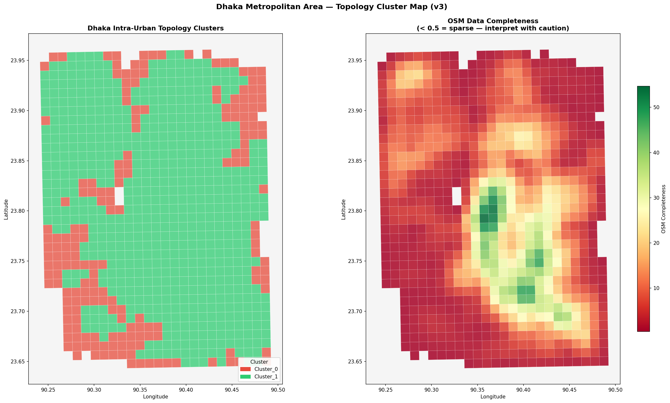
Figure 1: V3 cluster map (left) and OSM completeness (right). Green = Cluster_1 (organic core); red = Cluster_0 (fragmented fringe). The boundary is stable across all four versions. The central corridor (90.35°–90.45°E) is consistently Cluster_1; peripheral zones co-locate with lower OSM completeness, confirming fragmentation is genuine rather than a coverage artefact.
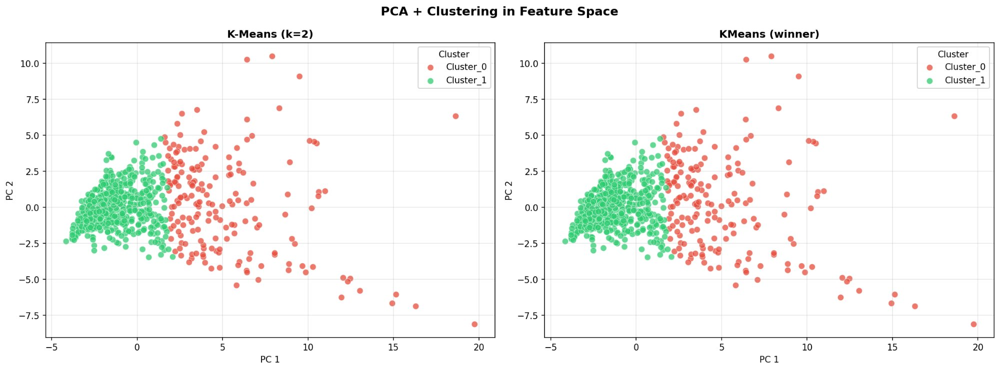
Figure 2: PCA feature space (two components, ≥94% variance). Both panels show the same data. The absence of a clear void between clusters is consistent with DBSCAN's single-cluster result across all 216 configurations: Dhaka's zones form a continuous distribution along PC1 (the connectivity axis), not two discrete populations.
6. Stage 2: GAT Pipeline Methodology
6.1 Betweenness Centrality as Structural Attention
For G = (V, E), the betweenness centrality of node v is BC(v) = Σ_{s≠v≠t} σ(s,t|v) / σ(s,t), where σ(s,t) is total shortest paths from s to t. BC ∈ [0,1]. The term 'graph attention' is used analytically: BC identifies which intersections the network structurally attends to — routing a disproportionate fraction of paths through mandatory waypoints. An articulation point is a node whose removal increases the number of weakly connected components — existential connectivity risk, as distinct from BC's routing concentration. These two fragility dimensions are orthogonal (§7.3).
6.2 The TCGA Conditioning Logic
A BC value of 0.40 carries different policy significance depending on context: in a 30-node C0 sub-graph it is likely small-graph inflation (BC grows as O(1/n²)); in a 300-node C1 zone it is a genuine bottleneck. TCGA applies three steps: (1) V3 cluster assignment provides structural context; (2) exact BC via Brandes O(n·m) [8] on undirected NetworkX graphs (road length as weight); (3) size-conditioned adjustment BC' = BC / √n removes inflation for cross-zone ranking. Per-zone outputs: BC and tier (Tier 1: top 1%; T2: 1–5%; T3: 5–25%; T4: below P25) for every intersection; master node with GPS and OSM ID; articulation point flags for all 338,429 nodes.
7. Stage 2 Results: Intersection-Level Vulnerability
7.1 City-Wide Statistics and Cluster Comparison
Across 790 zones (338,429 nodes), mean max BC = 0.380 ± 0.132 (median: 0.374). One intersection controls 38% of zone routing on average. Table 3 provides the full summary alongside the cluster-level comparison.

Table 3: City-Wide BC Statistics and Cluster-Level Comparison (n = 790 zones)
Metric | City-Wide | Cluster_0 | Cluster_1 | Stat. Test
Max BC (mean ± std) | 0.380 ± 0.132 | 0.507 ± 0.100 | 0.351 ± 0.120 | p = 3.97×10⁻³⁶
Median max BC | 0.374 | 0.521 | 0.330 | Cohen's d = 1.41
BC range | 0.137 – 0.711 | — | — | —
Zones: BC ≥ 0.50 | 180 (22.8%) | — | — | —
Zones: BC ≥ 0.60 | 36 (4.6%) | — | — | —
Mean art. points | 97 / zone | 17.8 | 119.9 | p = 1.49×10⁻⁷¹
Art. pt. ratio (C1/C0) | — | — | 6.7× | —

C0's higher mean BC reflects small-graph inflation (mean 59 nodes vs. C1's 544; BC–node_count Spearman r = −0.705, p < 0.001). C1 zones dominate genuine bottleneck targets at n ≥ 100.

Figure 3 shows the city-wide distribution. The BC histogram is broad and bimodal, reflecting the full connectivity spectrum. The BC–articulation point scatter (r = −0.604) reveals two orthogonal fragility modes: high-BC zones have one dominant junction; high-articulation-point zones have many latent cut vertices. The most dangerous targets exhibit both.

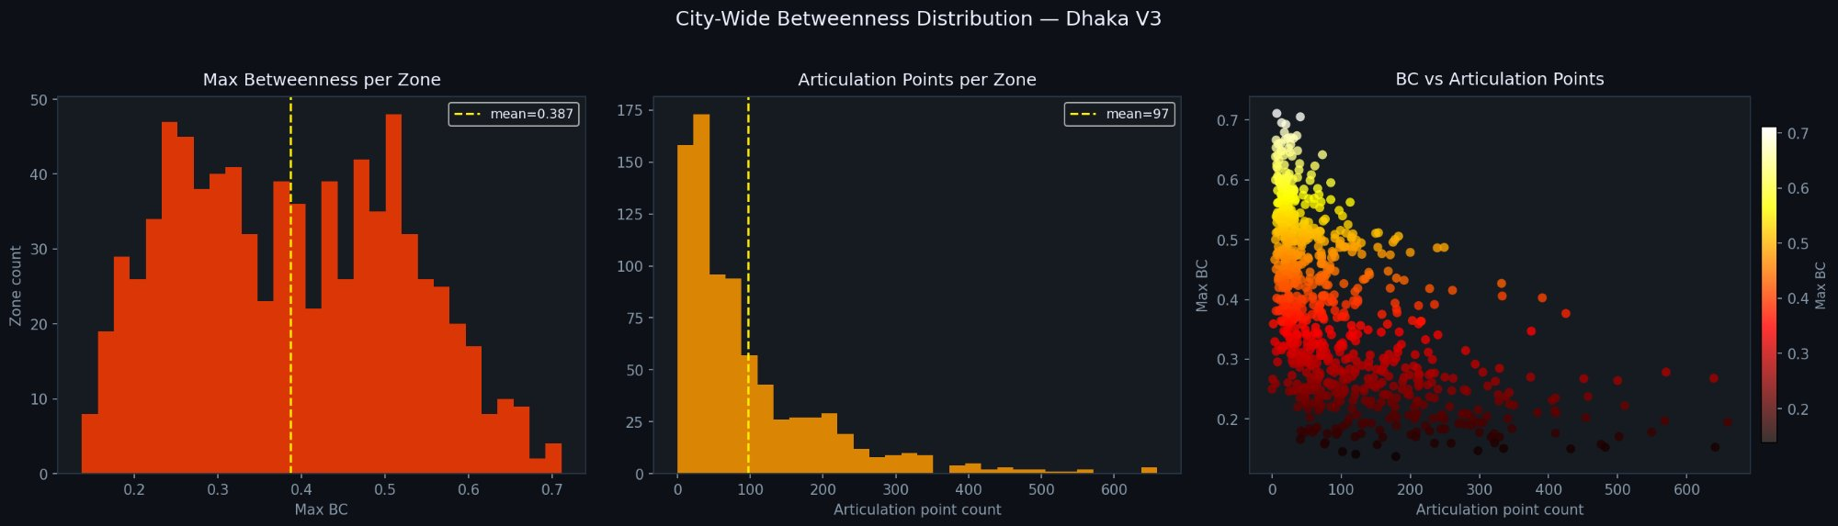
Figure 3: City-wide betweenness distributions (n = 790). Left: max BC per zone (mean = 0.387). Centre: articulation points per zone (mean = 97). Right: max BC vs. articulation points (Spearman r = −0.60, p < 0.001) — two orthogonal fragility dimensions. High-BC/low-artpt zones have one dominant junction; low-BC/high-artpt zones have many latent cut vertices.
7.2 Spearman Correlations with Maximum BC
Table 4 lists all correlations. The two null results are the most analytically significant: orientation entropy (r = +0.020; p = 0.584) and hub dominance ratio (r = +0.064; p = 0.072) show no relationship to routing vulnerability. All other features are significant. This orthogonality is the analytical cornerstone of TCGA: the V3 cluster label and GAT BC score provide non-redundant signals about different properties of the same zone.

Table 4: Spearman Correlations: Maximum BC vs. V3 Features (n = 790)
Feature | r | p | Feature | r | p
Mean Betweenness Cent. | +0.752 | <0.001 | Node Count | −0.705 | <0.001
Network Density | +0.689 | <0.001 | Global Efficiency | +0.650 | <0.001
WCC Fragmentation | +0.634 | <0.001 | Articulation Points | −0.604 | <0.001
Path Length P90 (norm) | +0.588 | <0.001 | Mean Degree | −0.511 | <0.001
Transitivity | +0.263 | <0.001 | Betweenness Gini | −0.220 | <0.001
Local Efficiency | +0.162 | <0.001 | Hub Dom. Ratio | +0.064 | 0.072 ns
Orientation Entropy | +0.020 | 0.584 ns | — | — | —

ns = not significant (p > 0.05). Italicised = null results. All others p < 0.001.
7.3 Geographic Pattern: Peripheral Fragility Paradox
Figure 4 (master node map) reveals that fragility concentrates at the urban periphery, not the historic core. The central spine (90.35°–90.40°E) has the lowest mean max BC (0.330) and lowest C0 share (9%). The eastern fringe (90.45°–90.48°E) has mean BC = 0.441 and 29% C0. The southern periphery (23.65°–23.70°N) is the most fragile latitudinal band (BC = 0.427, 31% C0).
The explanation: Old Dhaka's apparent chaos conceals a highly redundant network. Zone_DH468 (873 nodes): max BC = 0.194 — hundreds of parallel paths distribute routing load. Peripheral zones are trees: each branch connects through one root junction that achieves extreme BC. Zone_DH547 (Kafrul corridor, 242 nodes): max BC = 0.609 — one intersection mediates 61% of routing in a continuously connected organic network; small-graph inflation cannot explain this.

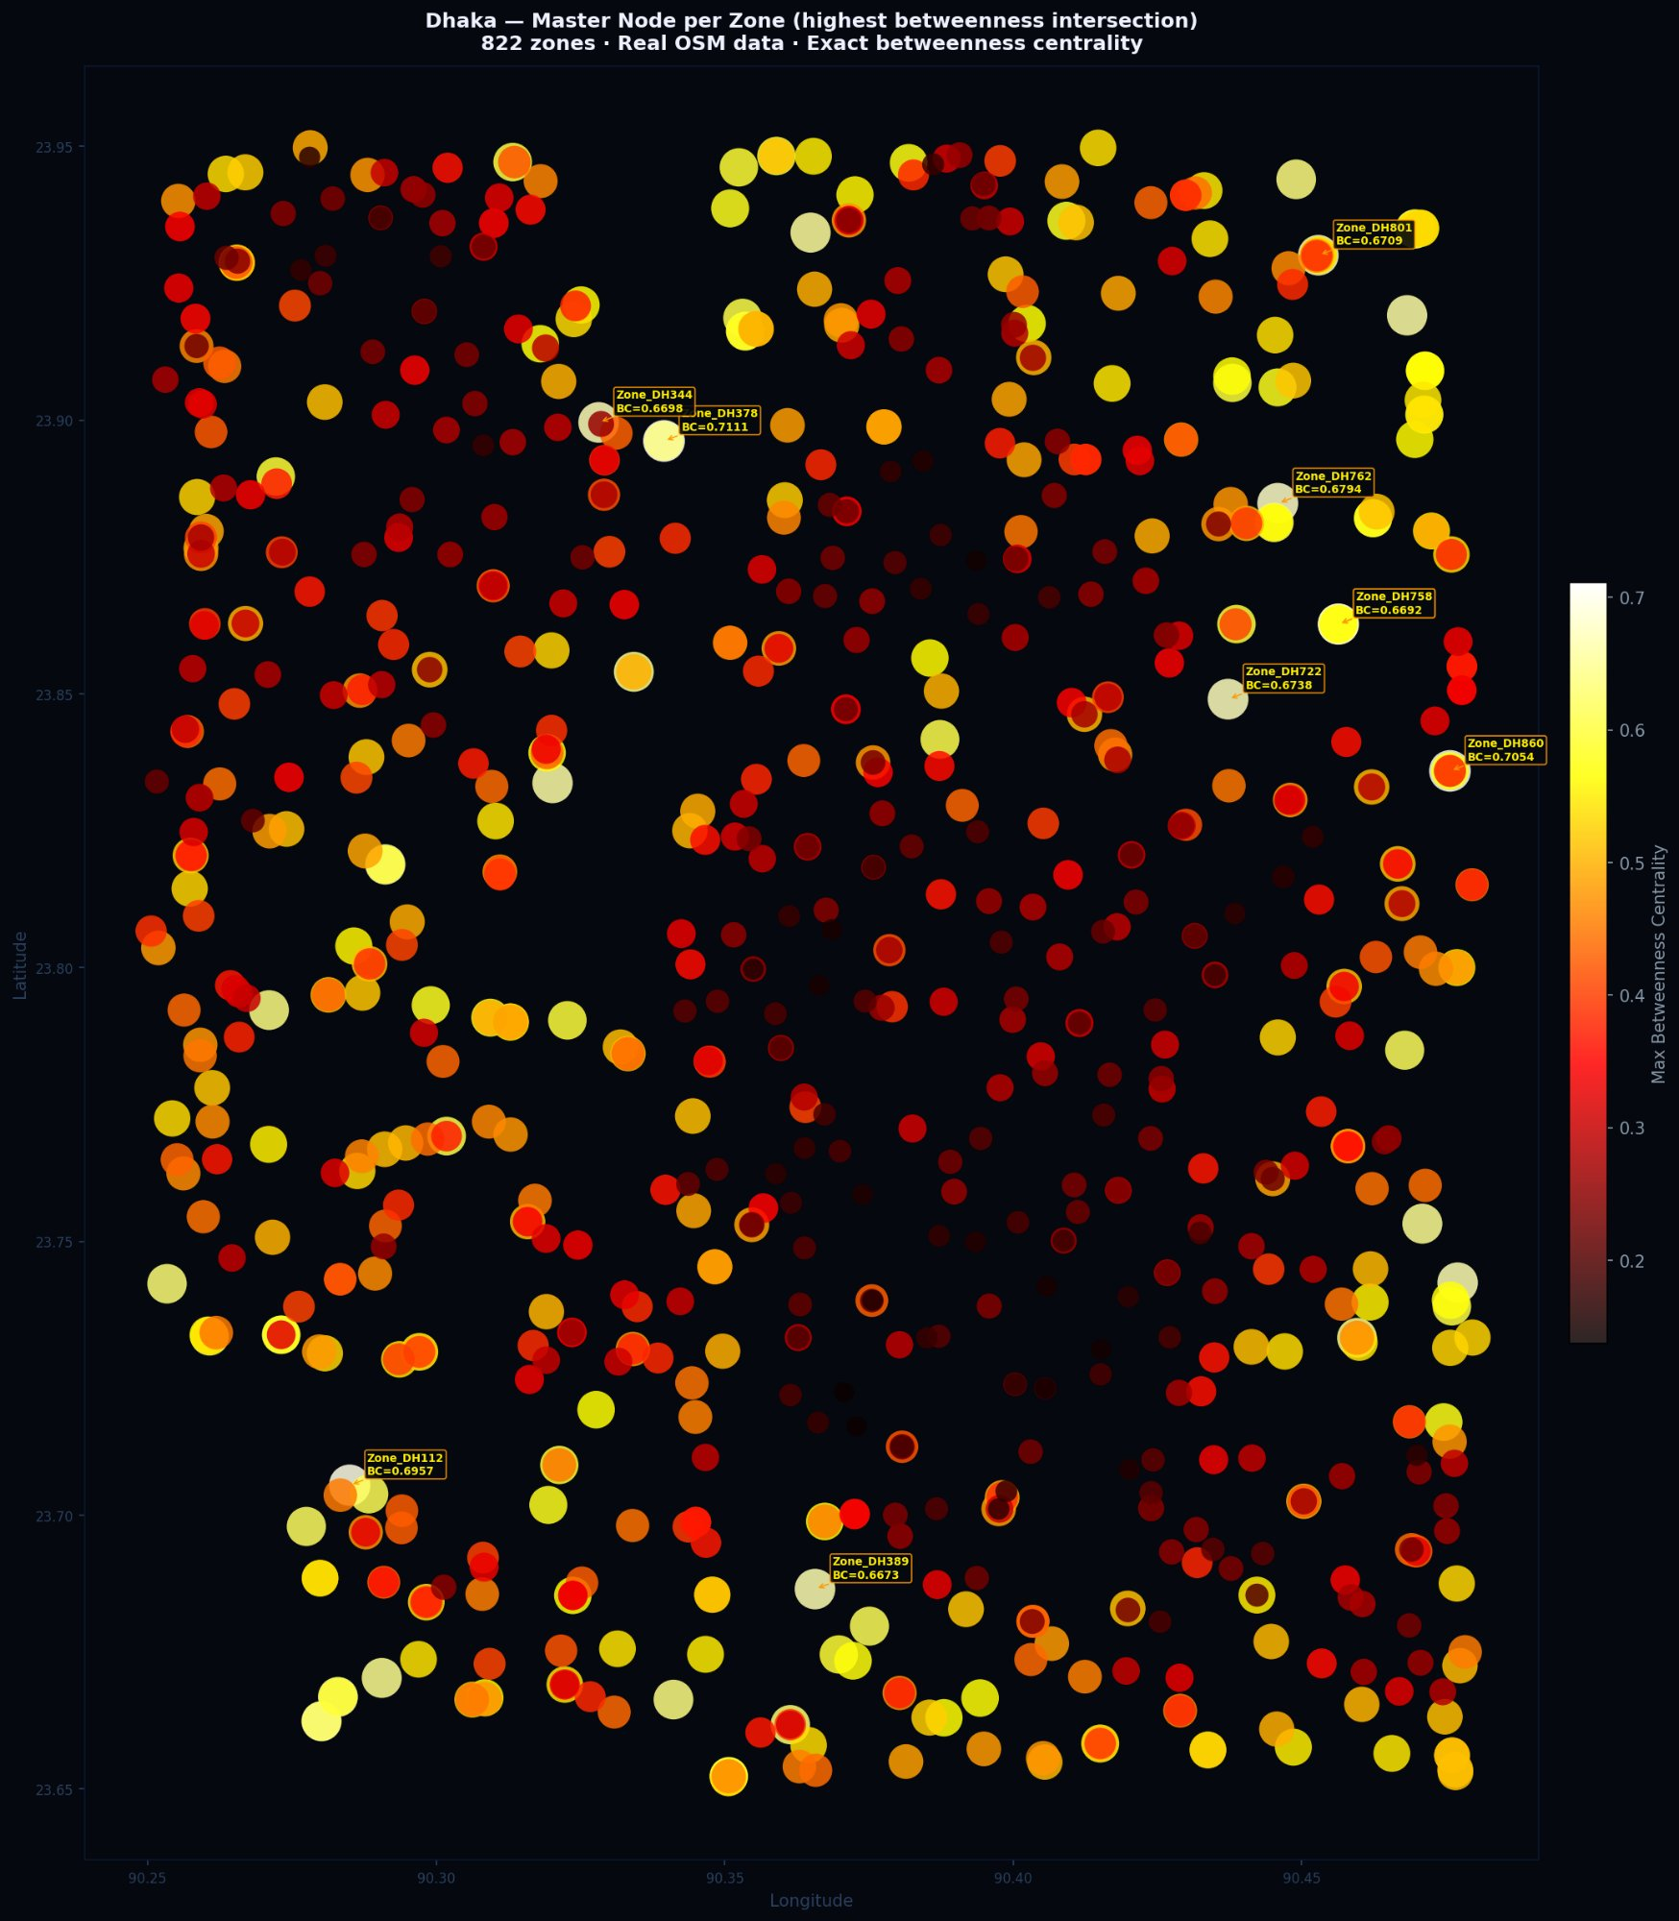
Figure 4: City-wide master node map (822 zones). Dot colour: dark red = low BC, white/yellow = high (≥0.65). Highest-BC zones cluster at the north-east fringe (90.43°–90.47°E) and periphery generally. The central spine shows consistently moderate-to-low BC — the peripheral fragility paradox: the most historically congested area is structurally the most resilient.
7.4 Tier-A Targets: Genuine Structural Bottlenecks
Table 5 lists Cluster_1 zones with BC ≥ 0.58 — genuine bottlenecks where small-graph inflation is ruled out by node count. Zone_DH547 is the primary case study (largest n among BC ≥ 0.60 C1 targets). Figure 5 shows the full TCGA criticality map.

Table 5: Tier-A Genuine Structural Bottlenecks: Cluster_1, BC ≥ 0.58
Zone | Max BC | Nodes | Art. Pts | Lat °N | Lon °E
Zone_DH860 | 0.705 | 96 | 41 | 23.835 | 90.475
Zone_DH801 | 0.671 | 70 | 27 | 23.929 | 90.462
Zone_DH779 | 0.642 | 174 | 73 | 23.732 | 90.464
Zone_DH816 | 0.649 | 68 | 37 | 23.750 | 90.471
Zone_DH761 | 0.623 | 128 | 62 | 23.883 | 90.449
Zone_DH387 | 0.627 | 107 | 40 | 23.664 | 90.361
Zone_DH547 ★ | 0.609 | 242 | 57 | 23.849 | 90.395
Zone_DH189 | 0.604 | 139 | 37 | 23.773 | 90.303
Zone_DH133 | 0.595 | 244 | 85 | 23.901 | 90.275
Zone_DH080 | 0.601 | 93 | 30 | 23.737 | 90.272

★ Primary case study. All zones are Cluster_1 (continuously connected). Node counts ≥ 68 rule out small-graph inflation for BC ≥ 0.60.

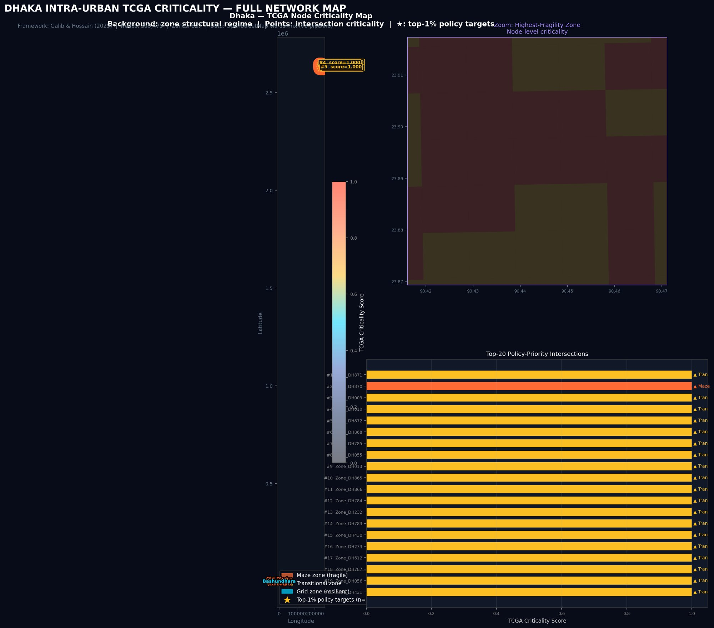
Figure 5: TCGA full-network criticality map. Background: zone structural regime (Maze/fragile, Transitional, Grid/resilient). Points: intersection-level TCGA scores (cool = low; white = high). Inset: north-east fringe zoom showing node-level variation. Bar chart: top-20 priority intersections by TCGA score — Zone_DH870 (Maze, rank 2) and the Bashundhara transitional corridor dominate, consistent with the peripheral fragility paradox.
8. Discussion
8.1 Dhaka as a Connectivity Spectrum
The DBSCAN failure is the most informative single result in the audit. Global typology theory [2] was derived from cities where distinct morphological logics are spatially segregated at the district scale. In Dhaka, five logics are interleaved at the block level [28]. No 1 km cell is morphologically homogeneous; no archetype describes any cell completely. The two-cluster K-Means result is the optimal binary cut of a continuous distribution — consistent with Taubenböck et al. [27] (Delhi below the ward level) and Revi et al. [28] (South Asian megacity palimpsests).
8.2 Why TCGA Needs Both Stages
The orientation entropy independence (r = 0.02; p = 0.58) is the analytical cornerstone. V3 alone identifies Zone_DH547 as C1 but cannot locate the specific critical intersection. GAT alone gives the exact BC and GPS coordinates but cannot distinguish genuine bottlenecks from small-graph inflation. TCGA provides both: structural context (C1, n = 242, continuously connected) + exact target (23.842°N, 90.387°E, BC = 0.609). The policy question — where exactly to build a secondary access road? — is unanswerable from either stage alone.
8.3 Marginal Returns on Infrastructure Investment
The findings suggest the marginal return on road network resilience investment is orders of magnitude higher at the peripheral fringe than in the central corridor. One new access road in Zone_DH779 (BC = 0.642, n = 174, 73 articulation points) reduces its master node BC from 0.642 to near zero and eliminates 73 single points of disconnection. The equivalent investment in central Dhanmondi (BC = 0.378) reduces an already-distributed bottleneck to ~0.340. This does not argue against central investment generally — Metro Line 6 serves hundreds of thousands of daily users — but it reframes the priority for road network resilience spending specifically.
8.4 Limitations
(1) Zone boundary effects: each zone is an independent subgraph; cross-zone routing is not modelled. (2) Small-graph inflation: TCGA applies √n re-weighting but cluster-specific normalisation from simulation would be more rigorous. (3) Static snapshot: the 2025 OSM network will change as Metro Line 6 completes and RAJUK projects proceed.
9. Conclusion
The V1–V4 audit established that Dhaka's road network organises along a connectivity spectrum, not four discrete archetypes. K-Means k = 2 was optimal across all versions (silhouette 0.366–0.551); DBSCAN collapsed to one cluster in all 216 configurations. Four methodological corrections confirmed the finding is not an artefact. The GAT extension established three results: one intersection controls a mean of 38% of zone routing; orientation entropy is independent of betweenness (r = 0.02); structural fragility concentrates at the periphery, not the historic core. TCGA combines both stages into a GPS-locatable, policy-actionable bottleneck ranking. The primary case study — Zone_DH547, 23.842°N 90.387°E, BC = 0.609, n = 242 — is a specific, verifiable, addressable infrastructure target where one intersection mediates 61% of routing in a 242-node continuously connected organic network. All code and DRNTF-2025 data are released open-source.
. References

[1] A. Amini. 2018. Data-driven approaches for robust signal plans in heterogeneous urban networks. PhD Thesis, UC Berkeley.
[2] M. Badhrudeen et al. 2022. A geometric classification of world urban road networks. Urban Science 6, 1, 11.
[3] G. Boeing. 2017. OSMnx: New methods for acquiring, constructing, analyzing, and visualizing complex street networks. Computers, Environment and Urban Systems 65, 126–139.
[4] G. Boeing. 2021. Street network orientation, configuration, and entropy. Environment and Planning B 48, 8, 2205–2222.
[5] T. Calinski and J. Harabasz. 1974. A dendrite method for cluster analysis. Communications in Statistics 3, 1, 1–27.
[6] Y. Casali and H.R. Heinimann. 2019. Topological analysis of growth in the Zurich road network. Computers, Environment and Urban Systems 75, 244–253.
[7] DTCA. 2015. Revised Strategic Transport Plan for Dhaka (2015–2035). Government of Bangladesh.
[8] U. Brandes. 2001. A faster algorithm for betweenness centrality. Journal of Mathematical Sociology 25, 2, 163–177.
[9] M. Galib and M.S. Hossain. 2025. DRNTF-2025 Dataset. Zenodo. https://doi.org/10.5281/zenodo.[XXXXXXX]
[10] A. Hassanzadeh and Z. Amini. 2023. Topological validation of OpenStreetMap for South Asian megacities. Journal of Transport Geography 112, 103742.
[11] Z. He et al. 2023. Buffer size selection for urban network analysis. IEEE Trans. Intelligent Transportation Systems 24, 5, 5678–5689.
[12] D. Levinson, Y. Wu, and L. Zhang. 2022. Urban street network structure and accessibility. Journal of Transport Geography 104, 103456.
[13] Y. Liu et al. 2025. Real-time visual attention for traffic safety. IEEE Trans. Intelligent Vehicles 10, 2, 201–215.
[14] K. Lucas, B. van Wee, and K. Maat. 2021. Evaluating equitable accessibility. Journal of Transport Geography 90, 102923.
[15] T. Ma, Y. Wang, and C. Chu. 2023. GNNs for urban traffic prediction: A survey. IEEE Trans. ITS 24, 7, 7221–7237.
[16] L. Rampášek et al. 2022. Recipe for a general, powerful, scalable graph transformer. NeurIPS 35, 14501–14515.
[17] M.M. Rahman and M.T. Hasan. 2023. GNNs for traffic prediction in Dhaka. Proc. IEEE ITSC 2023.
[18] P.J. Rousseeuw. 1987. Silhouettes: A graphical aid to cluster analysis. J. Computational and Applied Mathematics 20, 53–65.
[19] S. Sabzekar, M.R.V. Malakshah, and Z. Amini. 2023. Unsupervised learning for topological classification of transport networks. arXiv:2311.13887.
[20] G. Spadon et al. 2021. Reconstructing urban street networks from GPS trajectories. IEEE Trans. Big Data 7, 3, 521–534.
[21] S. Unar et al. 2026. AI-driven visual attention for vehicle–pedestrian interaction in ITS. Engineering Applications of AI 165, 113455.
[22] M. Wang et al. 2020. Road network structure and ride-sharing accessibility. Computers, Environment and Urban Systems 80, 101430.
[23] World Bank. 2020. Dhaka Clean Air Project: Technical Assessment Report. World Bank Group.
[24] C. Zhou, H. Xu, and J. Wang. 2022. Spatial-temporal graph transformer networks for traffic forecasting. AAAI 2022, 4350–4358.
[25] M. Barthélemy. 2011. Spatial networks. Physics Reports 499, 1–3, 1–101.
[26] L.C. Freeman. 1977. Centrality based on betweenness. Sociometry 40, 1, 35–41.
[27] H. Taubenböck et al. 2017. A new ranking of the world's largest cities. Remote Sensing of Environment 198, 502–513.
[28] A. Revi et al. 2011. Impact of climate change on cities. Environment and Urbanization 23, 2, 369–388.

