TIme_sheet
Database Creation and Data Visualization
Sabbir Rahman
Sbrahman94@gmail.com
Abstract
This Project it is to create a period sheet for a small company to keep track to the employee salary in a weekly basis with a period of 4 weeks.

Contents
1 Creation of Employer details 2
1.2 Concatenate 2
2. Timesheet creation 3
2.1 Dropdown List 3
2.3 VLOOKUP 4
2.4 IF & Date 5
2.5 Multiplication 6
2.7 6
2.8 7
3 Budgeting 8
3.1 Substruction 8
5 Creation of New Sheets 9
6. Period Report 10
6.1 Various Functions for Tables 10
6.2 Weekly Tables 12
6.3 Period Review 12
6.4 Budgeting Table 13
7 Dashboard 13

1 Creation of Employer details

In the employee sheet we have the detail of the worker with their name, surname, work email, Job role and their current hourly rate.

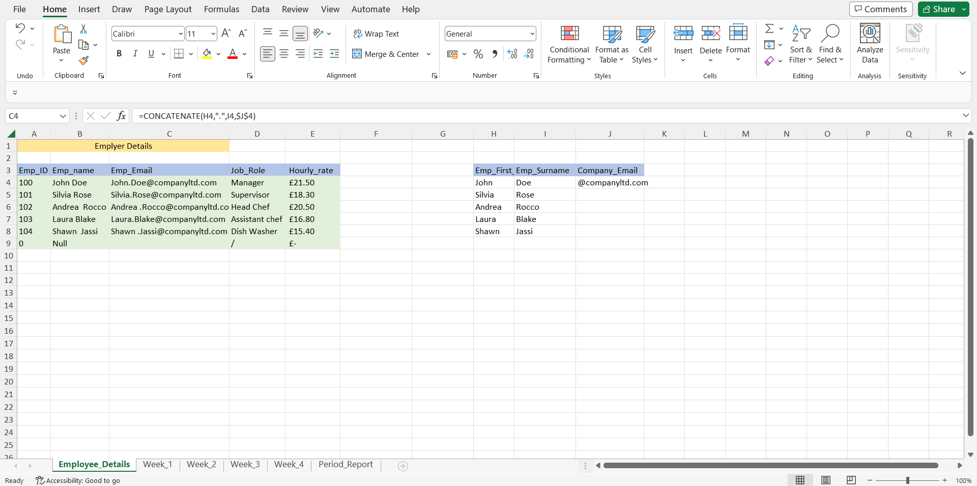

1.2 Concatenate

To create the email the function which has been used is Concatenate.

2. Timesheet creation

A sheet “Week_1” with relevant functions has been created.

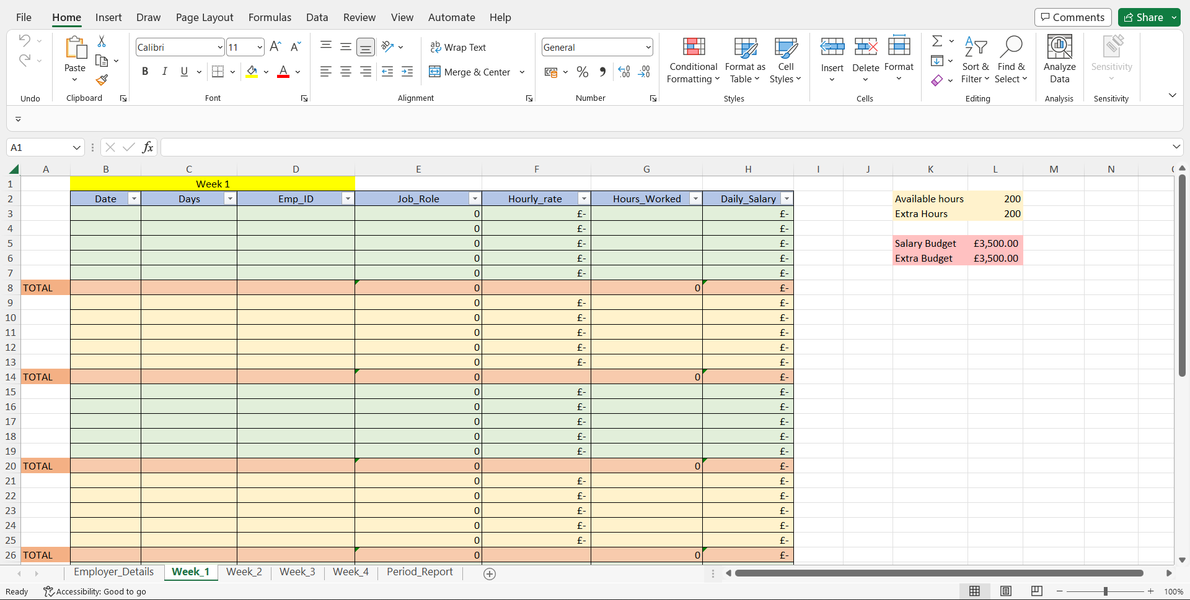

2.1 Dropdown List
The column of Emp_ID is a drop-down list which connect to Employee_details sheet with the relevant column.

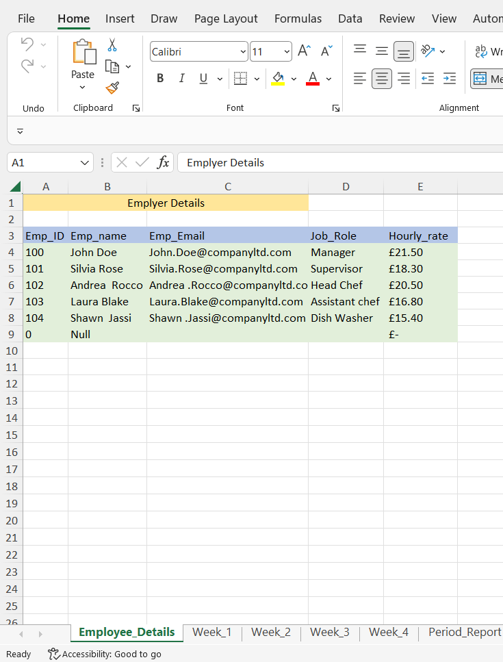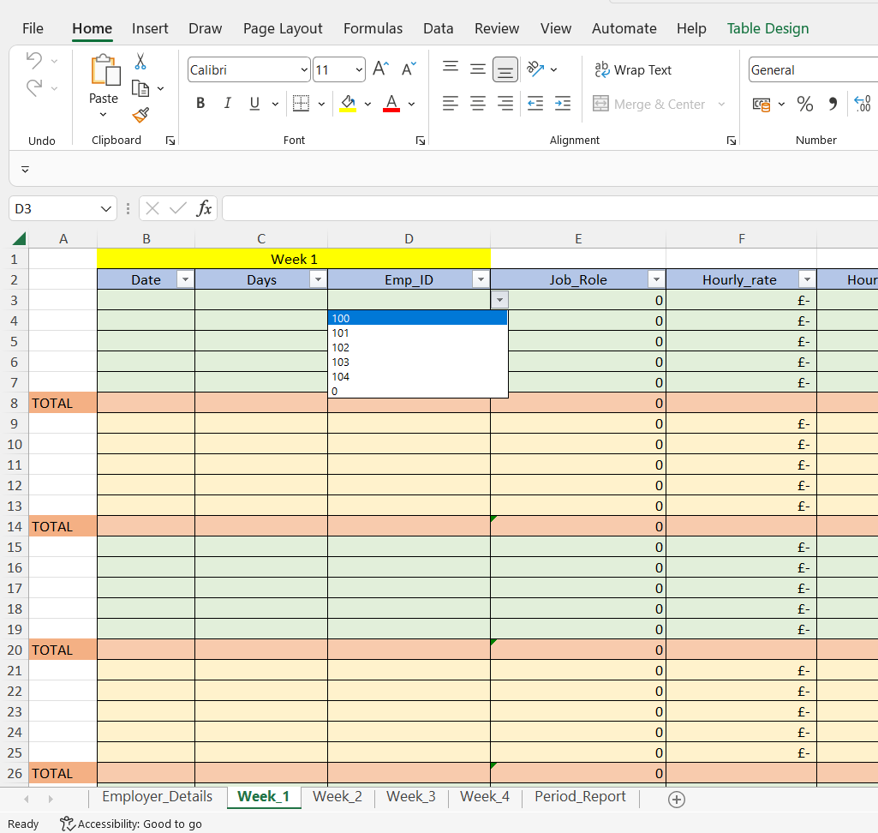

2.3 VLOOKUP
The column of Job_Role and Hourly_Rate have been connected to Emp_ID with VLOOKUP which were connected to the Emplyee_Details sheet with their relevant information’s, in this way one only information to input was the employee ID with the drop down menu and the Job_Role and Hourly_rate of relevant individual would appear automatically.

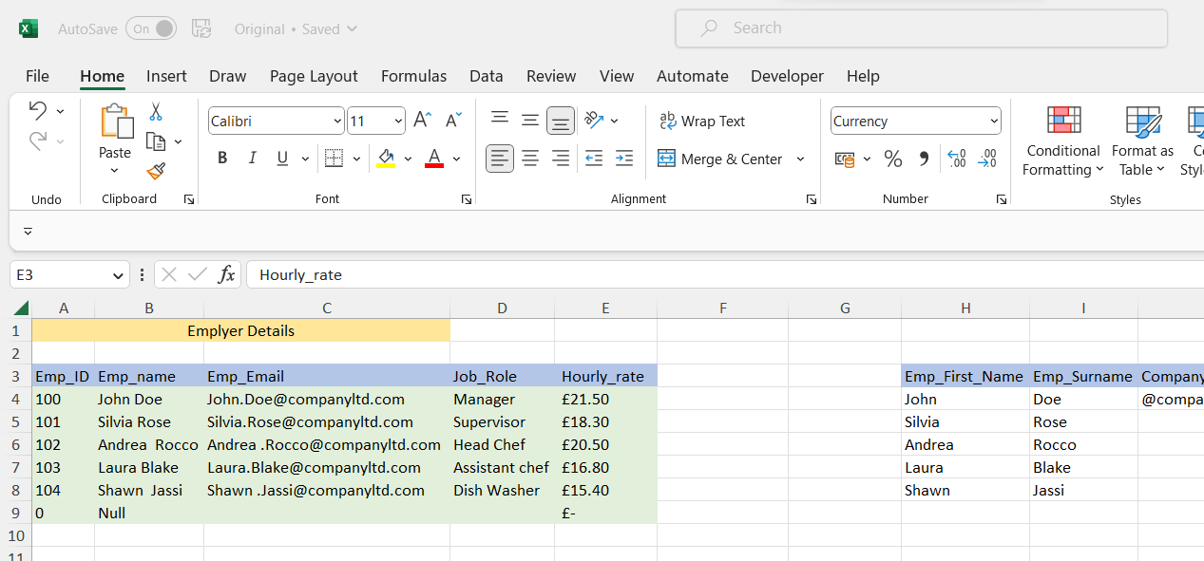

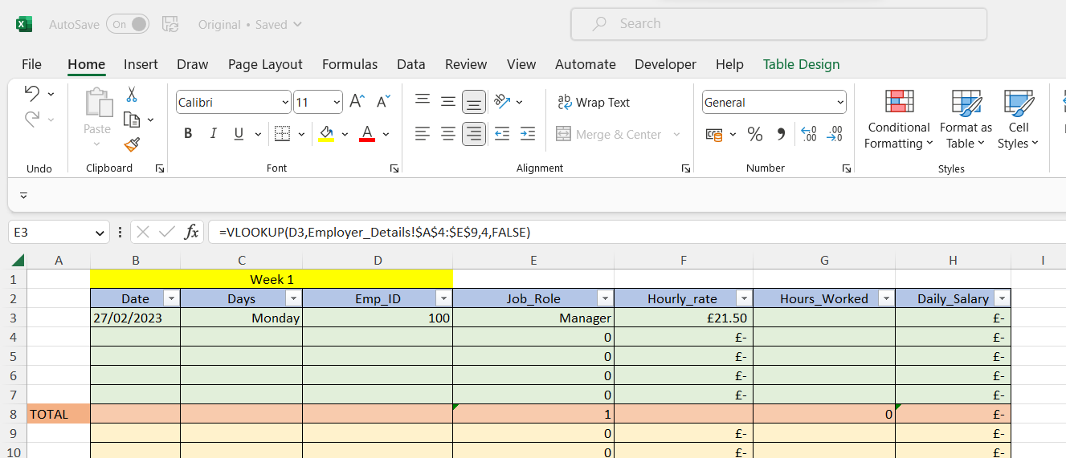

VLOOKUP Code
Code for Hourly_rate VLOOKUP =VLOOKUP(D3,Employer_Details!$A$4:$E$9,5,FALSE)

2.4 IF & Date
For the dates to appear automatically a combination of “IF” & “NOW” functions has been used.

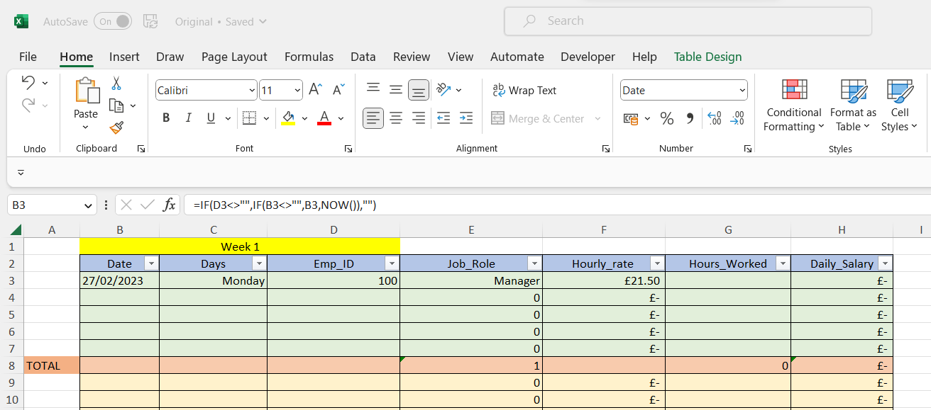

Code Format

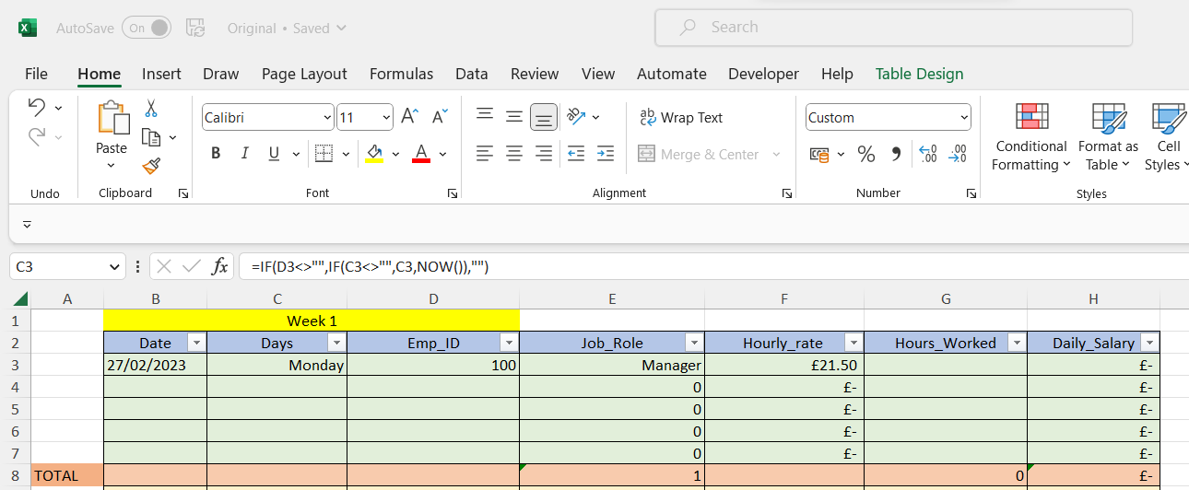

Code

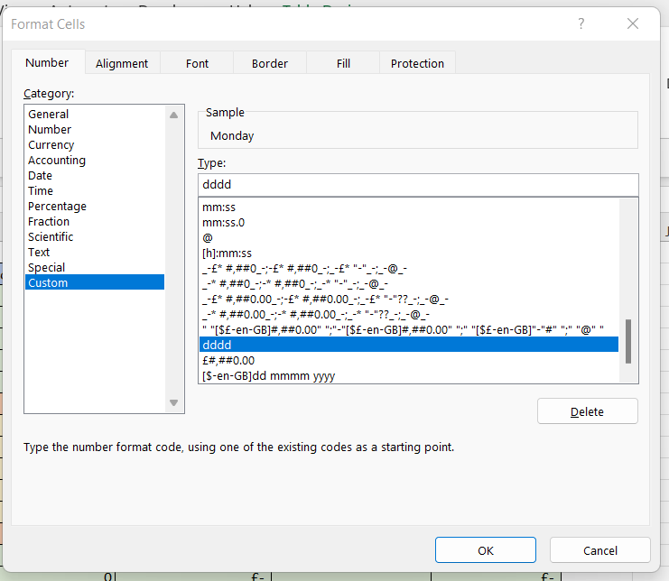

2.5 Multiplication
The only input to enter manually in the full Time_Sheet is the hours worked by Employer and all the data will be calculated automatically.
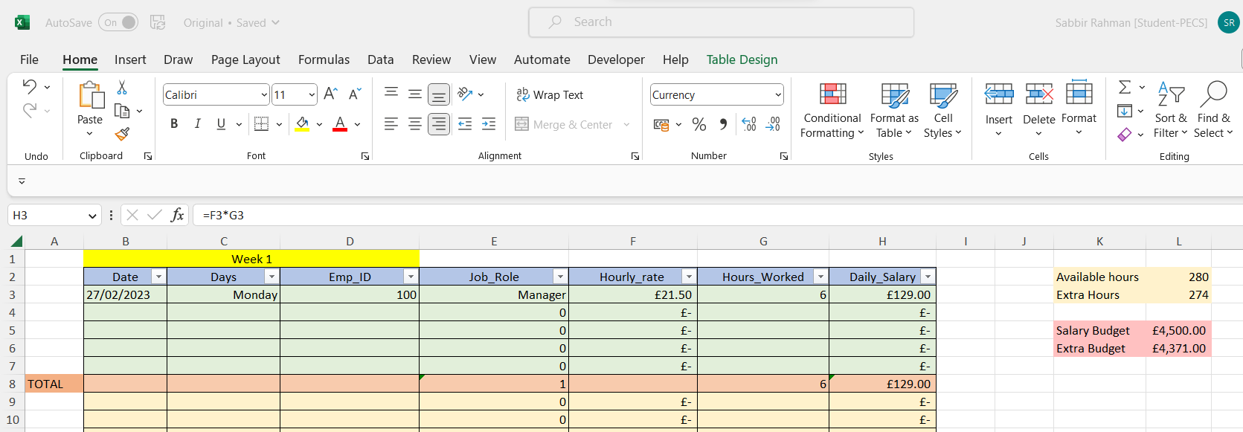

Code for Daily_Salary Manual Input
Daily_Salary Calculated using Code

[For better visual representation a Time_Sheet with dummy Data has been created. ]

2.7 SUM & COUNTIF
The following Functions has been used to create the end of the day:

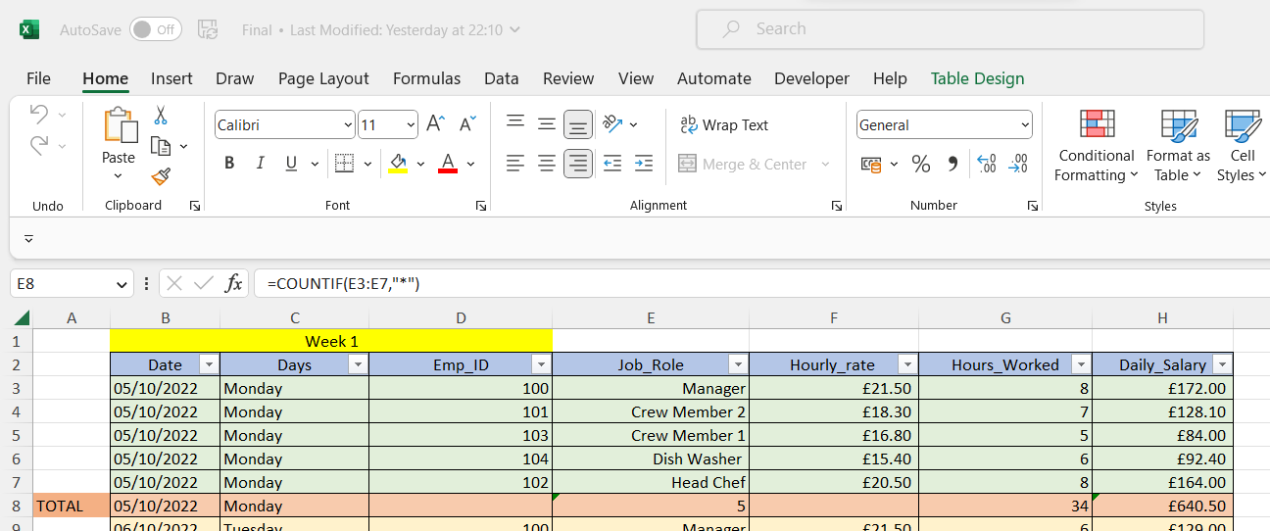
=COUNTIF for Staffs for amount of staffs
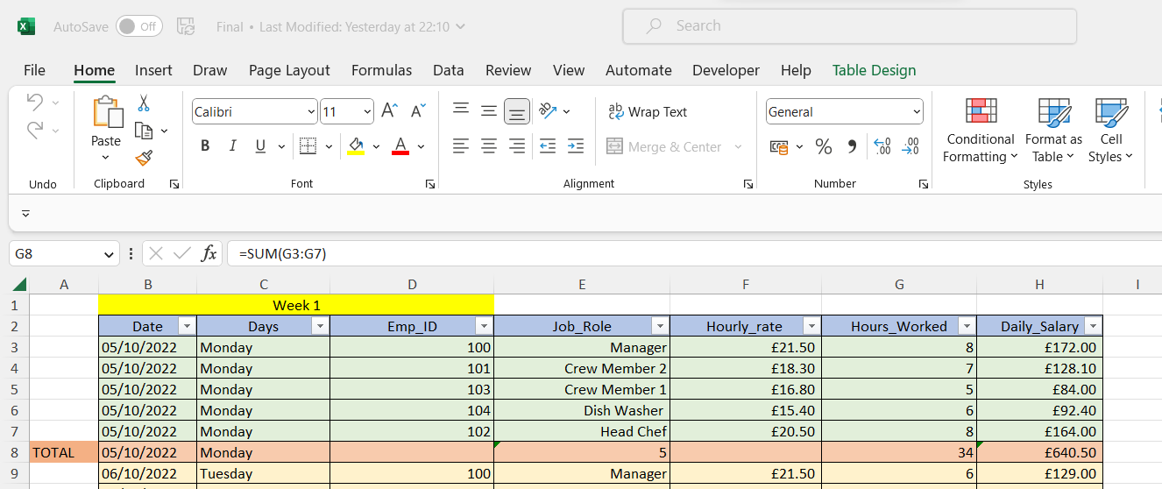
=SUM for used Hours total
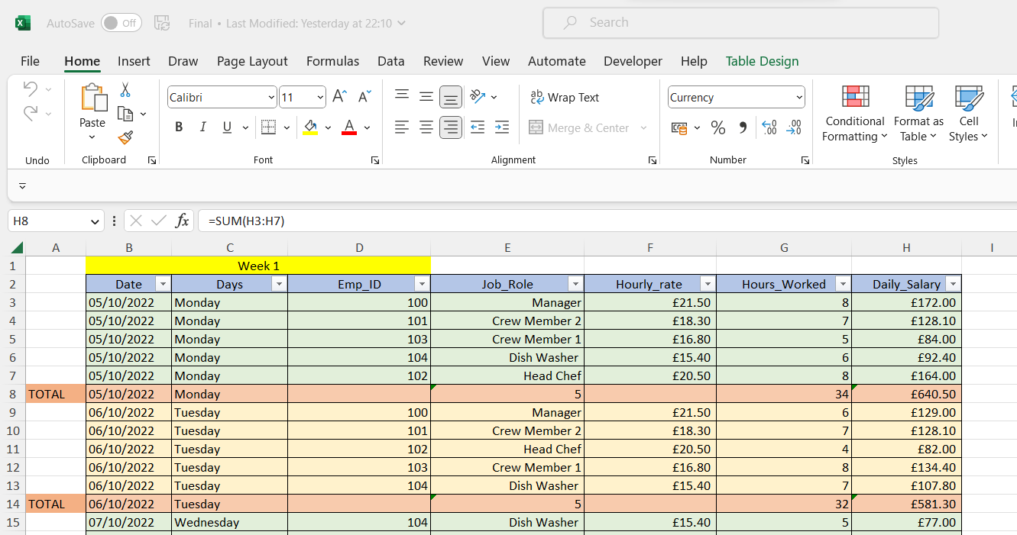
=SUM for total Salary of the day

2.8 Average

The following Functions has been used to create the end of the Week:

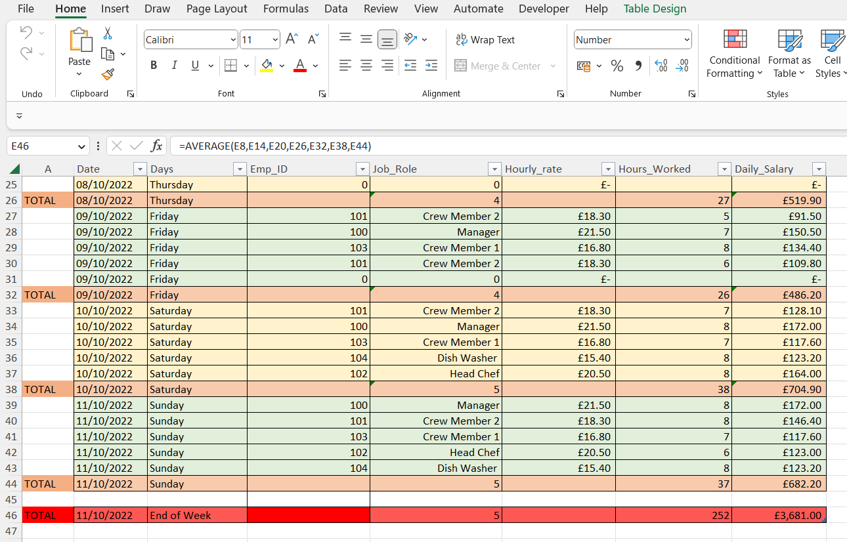
=AVERAGE has bee used to calculate an estimation of staffs who worked during the week

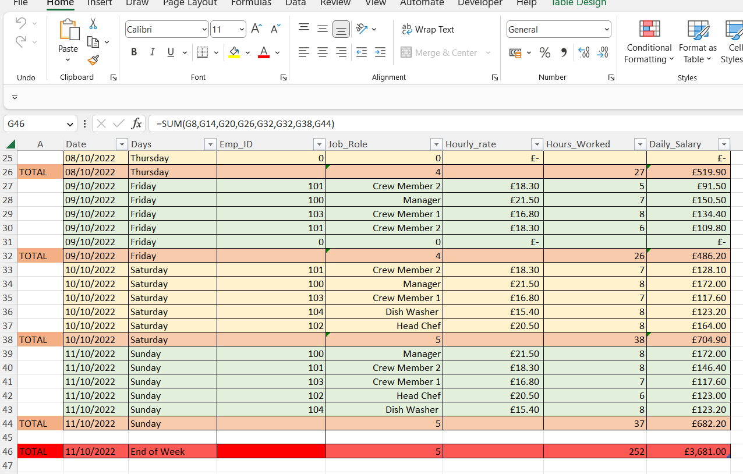
=SUM has been used to calculate the total Hours used during the week
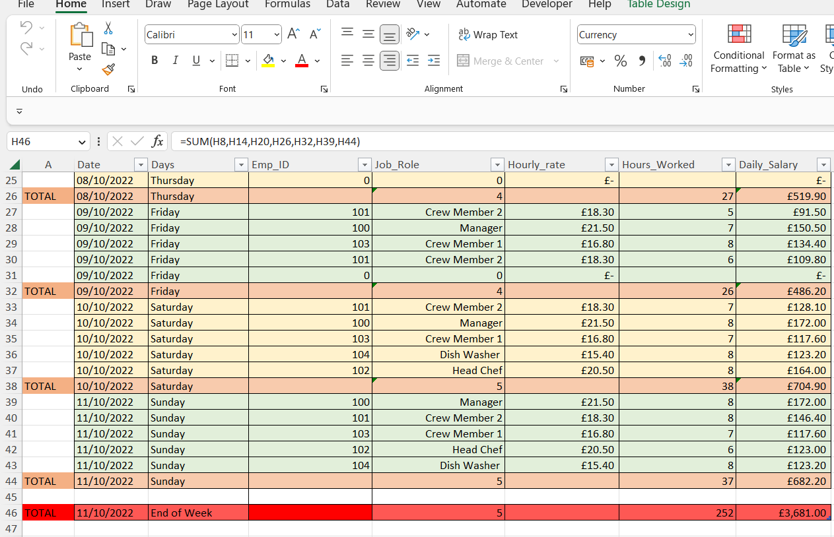
= SUM has been used to calculate the total Salary used during the week

3 Budgeting

3.1 Substruction

A Budgeting table has been created to keep track of Hours & Salary

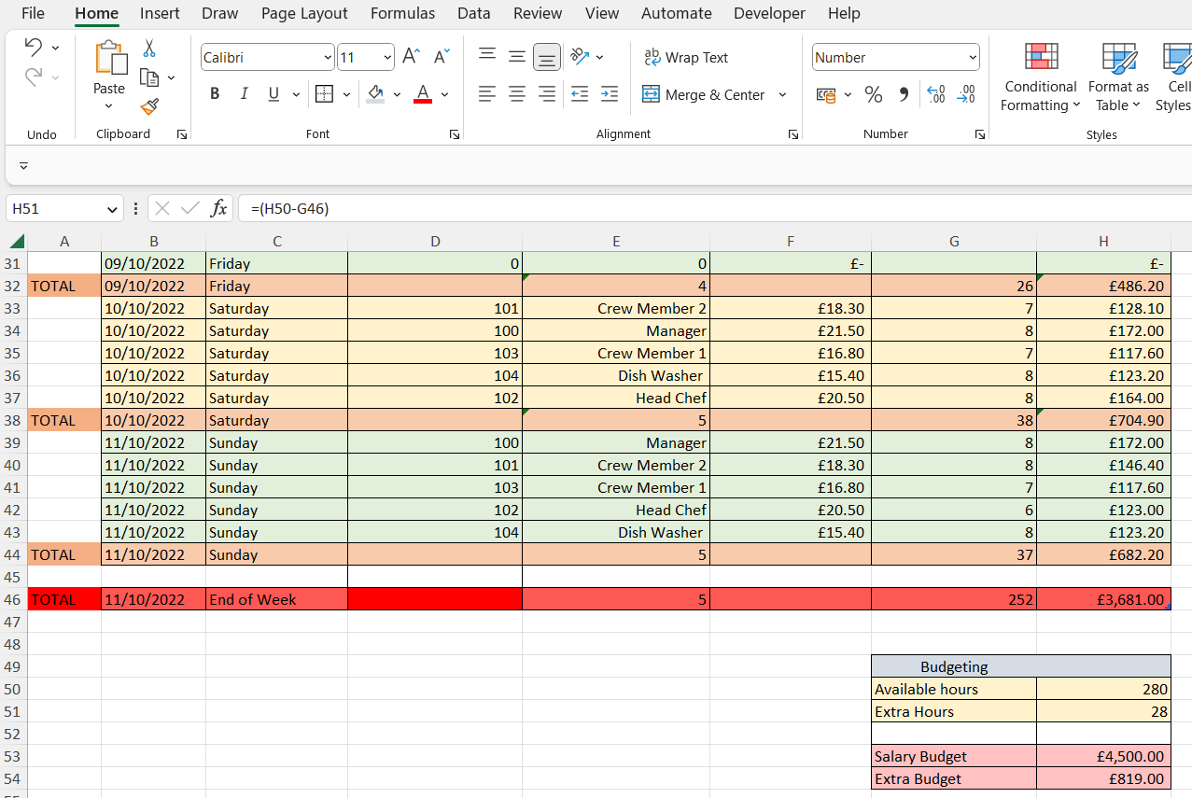
Available Hours Minus Used Hours

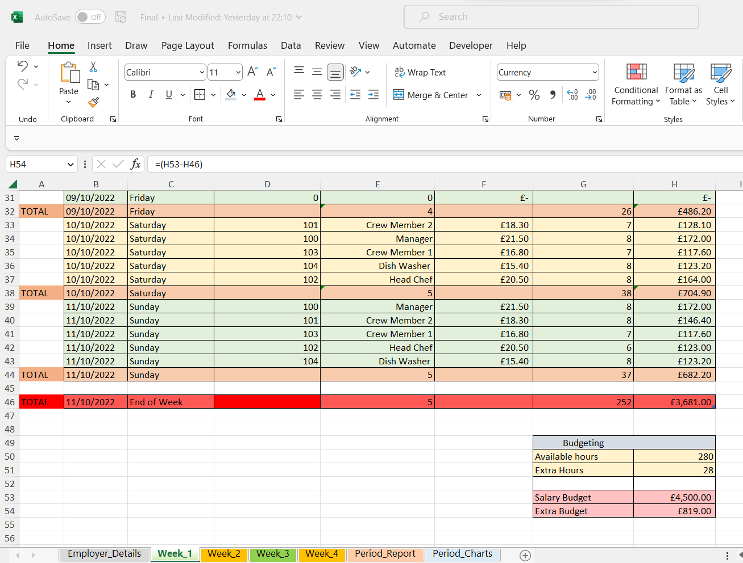
Available Salary Minus Used Salary

5 Creation of New Sheets

Duplicate of the Week_1 has been created to create Week_2, Week_3 & Week_4

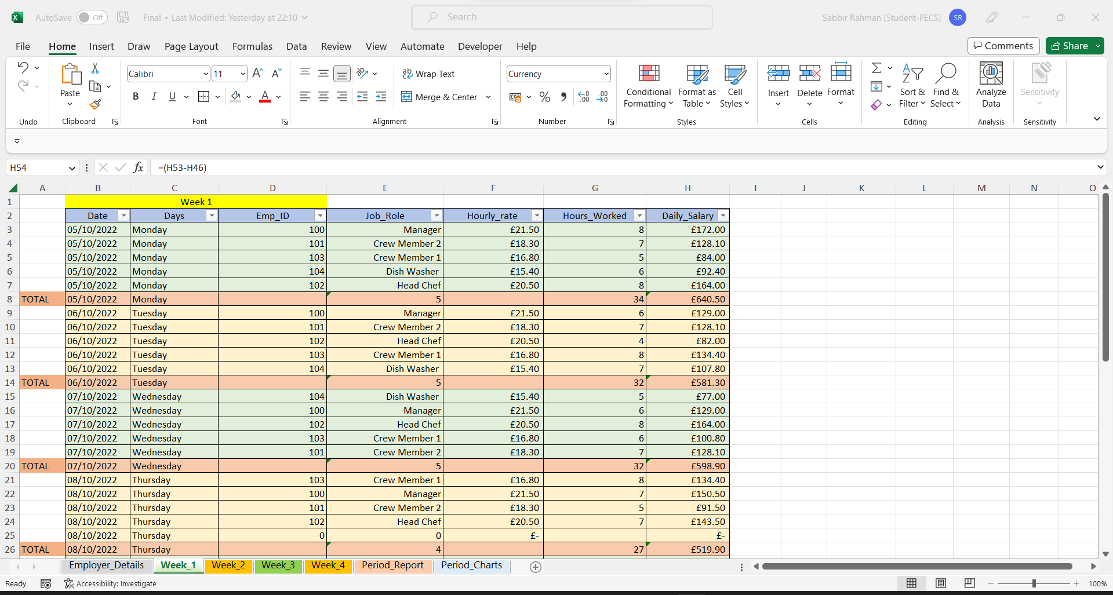

Duplicates

6. Period Report

By the end of the 4 weeks a Period_Report Sheet has been created which has been connected the weekly sheets to retrieve and calculate the interested Data need to create charts.

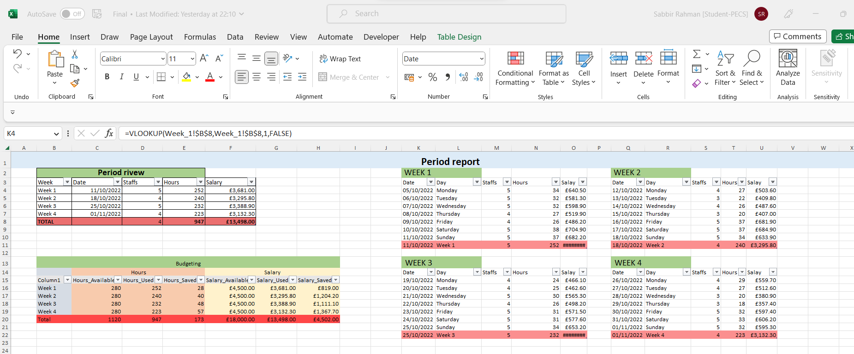

6.1 Various Functions for Tables

Various functions has been used to create the Period_Report sheet, mostly used VLOOKUP to report the right data from the Weekly Sheet.
As follow the different Code for the tables:

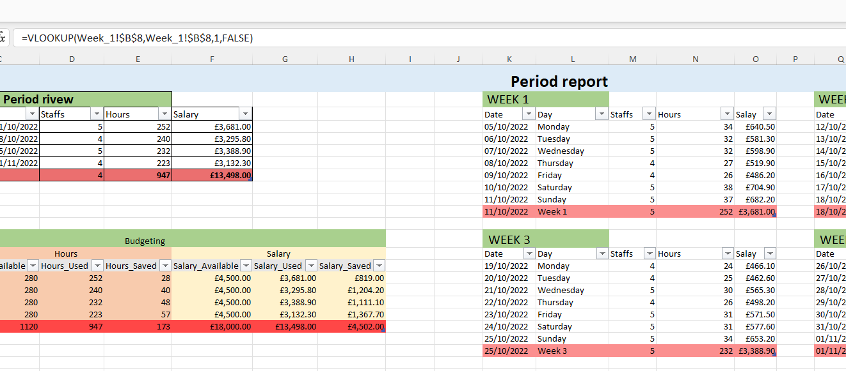

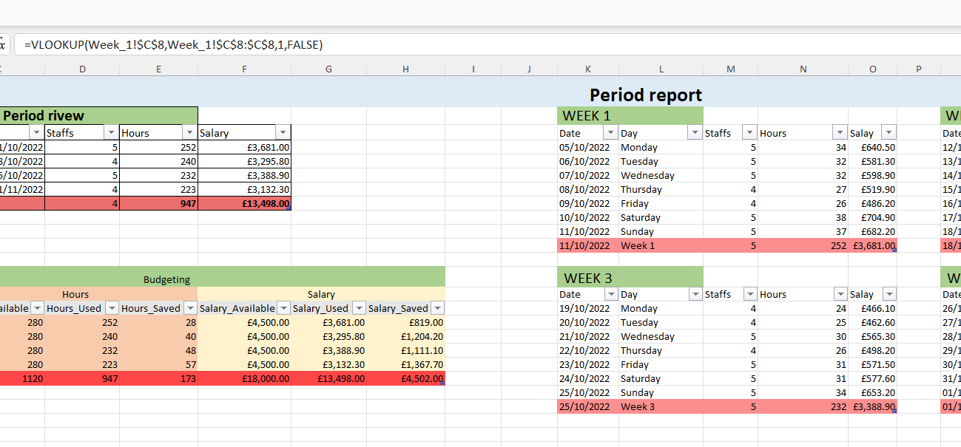

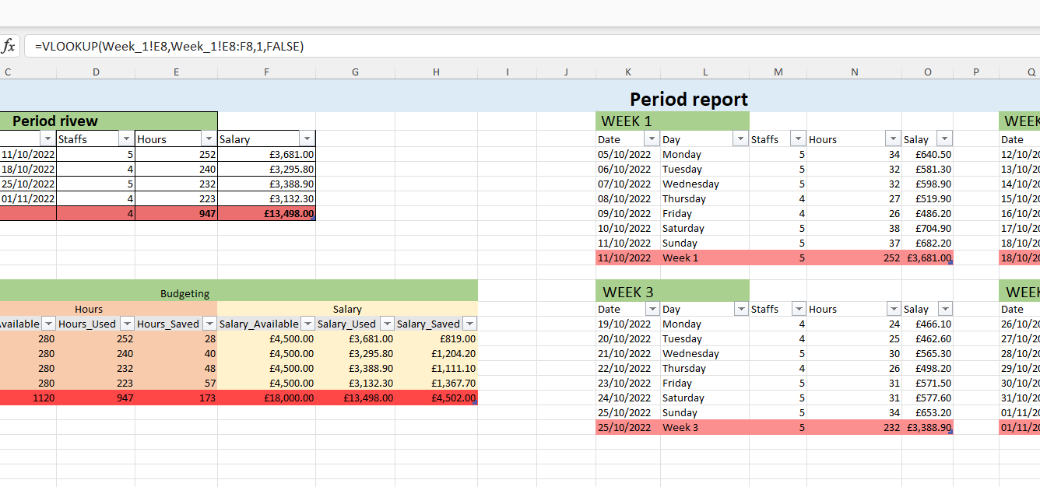
`
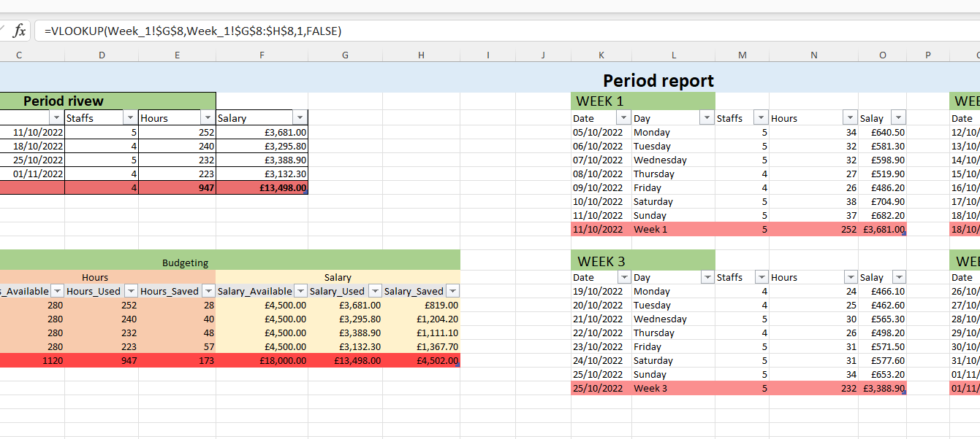

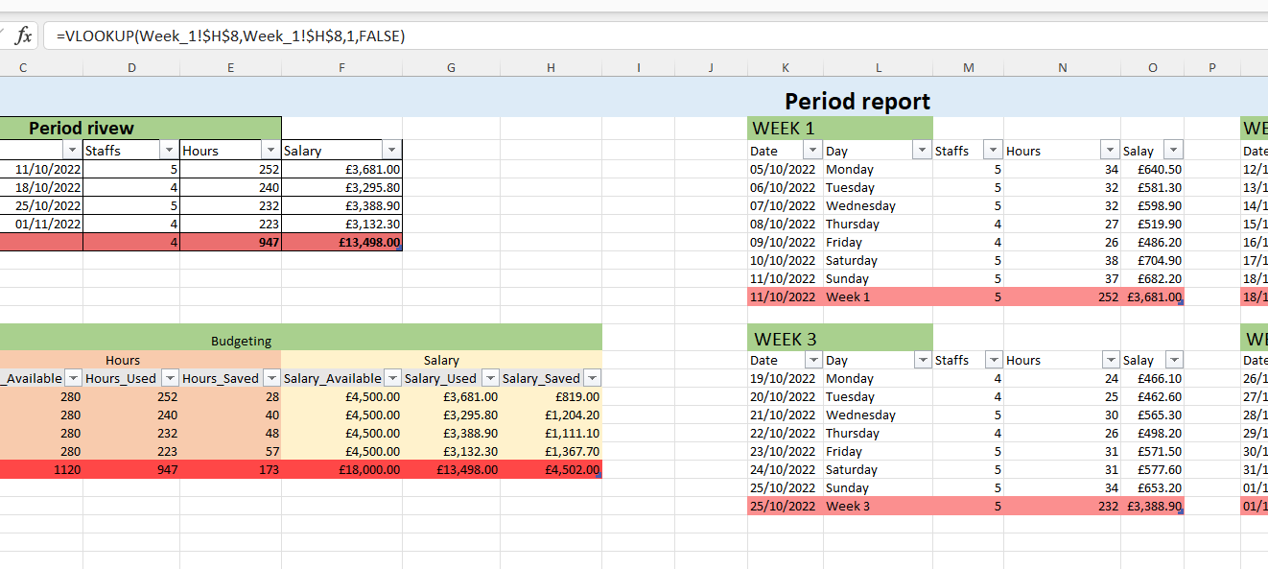

6.2 Weekly Tables

The same procedures has been done for the tables of WEEK 1, WEEK 2, WEEK 3 & WEEK 4.

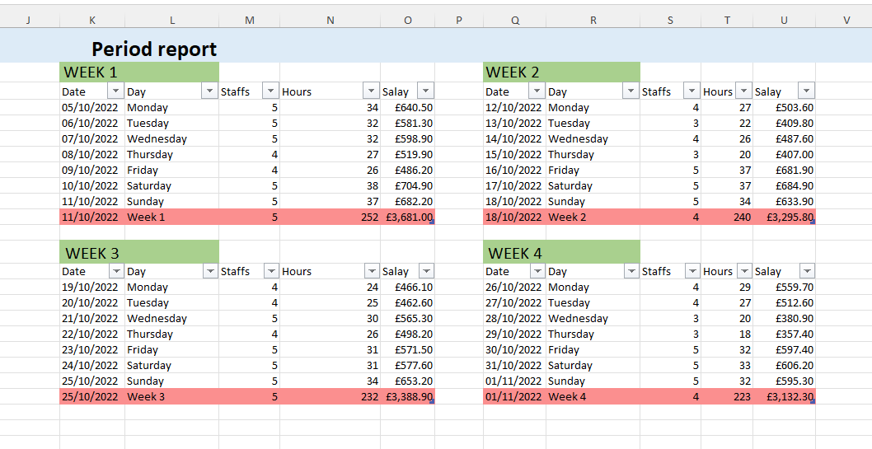

6.3 Period Review

The Period Review table has been created with VLOOKUP & Various calculations to retrieve the relevant data.
(Download and check the full Excel file to check full codes)

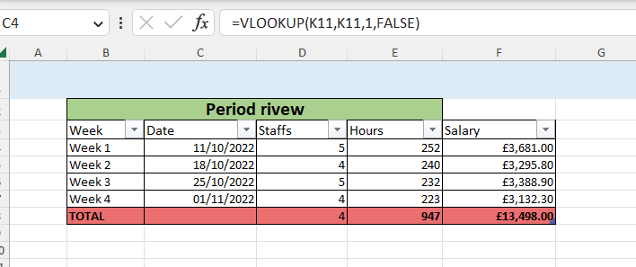

6.4 Budgeting Table

The Budgeting table has been created with VLOOKUP and various calculations to retrieve the relevant data.
(Download and check the full Excel file to check full codes)

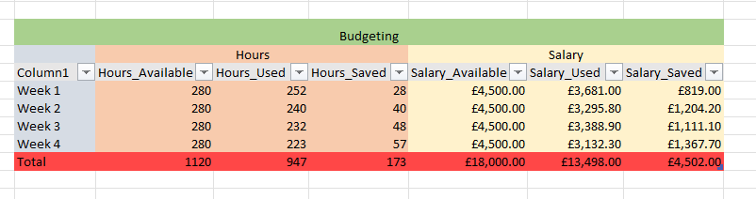

7 Dashboard

A Period_Chart sheet has been created with relevant charts to analyse the period.

