Game Design Document

Fill up the following document

1. Write the title of your project.

Dogfight 1945

1. What is the goal of the game?

To help a pilot fly down his plane amidst the enemy fires and survive

1. Write a brief story of your game.

You take control of the pilot of a WW2 plane, which is assigned to eliminate all the hostile forces in the air in order to help the military below fight without the constant threat of being bombed.

However, the sooner the pilot gets to his job that he realizes his plane is among the weakest force in the sky, so he must be very careful. Though he may not run out of ammunition so easily, his plane can get destroyed pretty easily, failing the mission. Help the pilot avoid enemy fire, while destroying all the hostile forces meanwhile.

1. Which are the playing characters of this game?

* Playing characters are the ones who respond to the user based on the input from the user.
* Cars, monkeys, dinos, wizards, etc., are the playing characters in the game.

|  |  |  |
| --- | --- | --- |
| Number | Character Name | What can this character do? |
| 1 | B-17 | Fire bullet, launch missiles |
| 2 | BF-109E | Fire primary bullet, secondary bullet |
| 3 | Blenheim | Fire bullet, launch missiles, shoot fireballs |
| 4 | TBM-3 | Fire bulles, launch missiles |
| 5 |  |  |
| 6 |  |  |
| 7 |  |  |
| 8 |  |  |

1. Which are the Non-Playing Characters of this game?

* Non-Playing characters are the ones that don't have an action or behavior when the user interacts with the game.
* Hurdles, stones, bananas, coins, etc., are non-playing characters in the game.

|  |  |  |
| --- | --- | --- |
| Number | Character Name | What can thise character do? |
| 1 | Bullet | Move vertically |
| 2 | Missile | II |
| 3 | Fireball | II |
| 4 |  |  |
| 5 |  |  |
| 6 |  |  |
| 7 |  |  |
| 8 |  |  |

Draw your imagination of this game. What does this game look like?

* Draw the game either on your computer or on paper.
* Add images of the game scenes to show each of the playing and non-playing characters at least once.

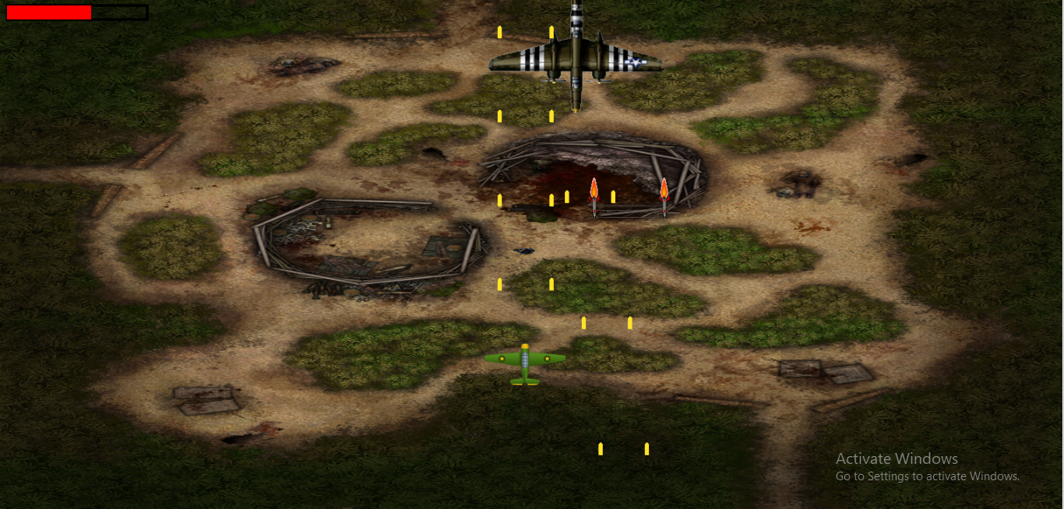

Project in Alpha

How do you plan to make your game engaging?

By making the game challenging for anyone daring to play, so they don’t quit the game out of sheer boredom, and not even too hard lest someone quit it for being overwhelming. All in all, making a game that requires efforts to master, perseverance to complete.