**Sabeeh Khan & Nick Kiesel**

**ECE 312-01**

**Project 2: Packet Encapsulation**

**Figure 1: Send of 3 Types of Packets and Results**

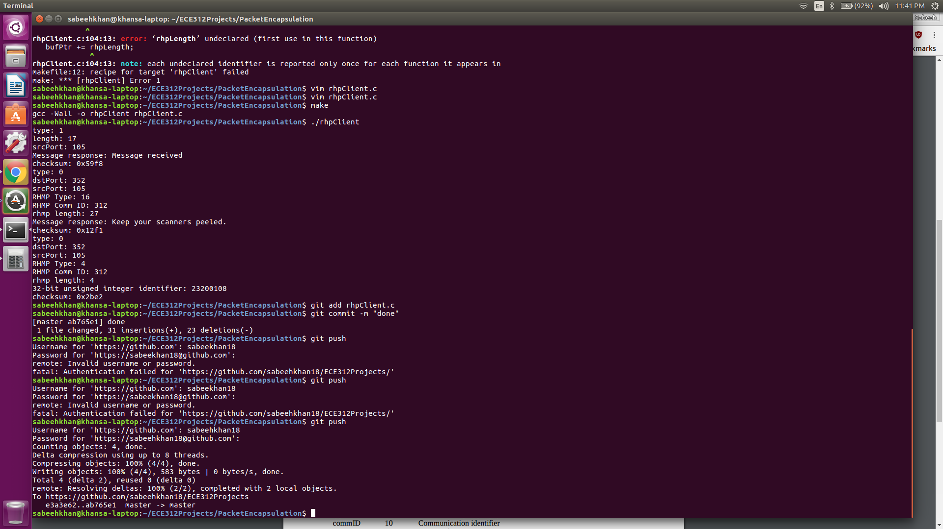

**Code for rhpClient.c:**

/************* UDP CLIENT CODE *******************/

#include <stdio.h>

#include <sys/socket.h>

#include <arpa/inet.h>

#include <string.h>

#include <unistd.h>

#define SERVER "137.112.38.47"

#define MESSAGE "hello"

#define PORT 1874

#define BUFSIZE 1024

uint16_t getChecksum(char* data, int numBytes) {

uint16_t* checkPtr = (uint16_t*) data;

uint32_t sum = 0;

for (int i = 0; i < numBytes/2; i++) {

sum += *checkPtr;

if (sum >= 0x10000) {

sum = sum & 0xFFFF;

sum += 1;

}

checkPtr++;

}

return (0xFFFF - (uint16_t)sum);

}

int recvRHP(int socket) {

char buffer[BUFSIZE];

int nBytes, pad = 0;

uint8_t* bufPtr;

uint8_t type, rhmpLength;

uint16_t rhpLength;

memset(buffer, 0, BUFSIZE);

/* Receive message from server */

nBytes = recvfrom(socket, buffer, BUFSIZE, 0, NULL, NULL);

uint16_t recvChecksum = *((uint16_t*)(buffer+nBytes-2));

uint16_t calcChecksum = getChecksum(buffer, nBytes-2);

if (recvChecksum != calcChecksum) {

printf("CHECKSUM MISMATCH\n");

return 1;

}

bufPtr = (uint8_t*) buffer;

printf("type: %d\n", *bufPtr);

type = *bufPtr;

bufPtr++;

if (type == 1) {

rhpLength = *((uint16_t*)bufPtr);

printf("length: %d\n", *((uint16_t*)bufPtr));

}

else

printf("dstPort: %d\n", *((uint16_t*)bufPtr));

if (type == 1) {

if (*((uint16_t*)bufPtr) % 2 == 0) {

pad = 1;

printf("adding buffer on received data\n");

}

} else {

bufPtr+=6;

rhmpLength = *bufPtr;

if (rhmpLength % 2 != 0)

pad = 1;

bufPtr-=6;

}

bufPtr+=2;

printf("srcPort: %d\n", *((uint16_t*)bufPtr));

bufPtr += 2;

if (type == 0) {

uint16_t rhmpTypeCommID;

memcpy(&rhmpTypeCommID, bufPtr, 2);

uint8_t rhmpType = (rhmpTypeCommID & 0x003F);

printf("RHMP Type: %d\n", rhmpType);

uint16_t commID = (rhmpTypeCommID & 0xFFC0) >> 6;

printf("RHMP Comm ID: %d\n", commID);

bufPtr+=2;

printf("rhmp length: %d\n", rhmpLength);

bufPtr++;

if (rhmpType == 1) {

} else if (rhmpType == 2) {

} else if (rhmpType == 4) {

uint32_t num = *((uint32_t*)bufPtr);

printf("32-bit unsigned integer identifier: %d\n",num);

bufPtr+=4;

} else if (rhmpType == 8) {

} else {

printf("Message response: %s\n",bufPtr);

bufPtr += rhmpLength;

}

} else {

printf("Message response: %s\n", bufPtr);

bufPtr += rhpLength;

}

bufPtr += pad;

printf("checksum: 0x%04x\n", *((uint16_t*)bufPtr));

return 0;

}

int sendRHP(int socket, uint8_t type, char* toSend, uint32_t length) {

char buffer[BUFSIZE];

uint16_t dstPort_Length = 0;

int includePad = 0;

struct sockaddr_in serverAddr;

memset(buffer, 0, BUFSIZE);

uint8_t* bufPtr = (uint8_t*) buffer;

*bufPtr = type;

bufPtr++;

if (type == 0) {

dstPort_Length = 105;

} else {

dstPort_Length = length;

}

memcpy(bufPtr, &dstPort_Length, 2);

bufPtr += 2;

uint16_t srcPort = 352;

memcpy(bufPtr, &srcPort, 2);

bufPtr+=2;

memcpy(bufPtr, toSend, length);

bufPtr+=length;

includePad = 0;

if (length % 2 == 0) {

includePad = 1;

bufPtr++;

}

uint16_t checksum = getChecksum(buffer, 5+length+includePad);

memcpy(bufPtr, &checksum, sizeof(checksum));

/* Configure settings in server address struct */

memset((char*) &serverAddr, 0, sizeof (serverAddr));

serverAddr.sin_family = AF_INET;

serverAddr.sin_port = htons(PORT);

serverAddr.sin_addr.s_addr = inet_addr(SERVER);

memset(serverAddr.sin_zero, '\0', sizeof serverAddr.sin_zero);

/* send a message to the server */

if (sendto(socket, buffer, 7+length+includePad, 0,

(struct sockaddr *) &serverAddr, sizeof (serverAddr)) < 0) {

perror("sendto failed");

return 1;

}

return 0;

}

int main() {

int clientSocket, result;

char buffer[BUFSIZE] = {0};

struct sockaddr_in clientAddr;

/*Create UDP socket*/

if ((clientSocket = socket(AF_INET, SOCK_DGRAM, 0)) < 0) {

perror("cannot create socket");

return 0;

}

/* Bind to an arbitrary return address.

* Because this is the client side, we don't care about the address

* since no application will initiate communication here - it will

* just send responses

* INADDR_ANY is the IP address and 0 is the port (allow OS to select port)

* htonl converts a long integer (e.g. address) to a network representation

* htons converts a short integer (e.g. port) to a network representation */

memset((char *) &clientAddr, 0, sizeof (clientAddr));

clientAddr.sin_family = AF_INET;

clientAddr.sin_addr.s_addr = htonl(INADDR_ANY);

clientAddr.sin_port = htons(0);

if (bind(clientSocket, (struct sockaddr *) &clientAddr, sizeof (clientAddr)) < 0) {

perror("bind failed");

return 0;

}

// send RHP with hello

do {

result = sendRHP(clientSocket, 1, "hello\0", 6);

} while ((result = recvRHP(clientSocket)) != 0);

memset(buffer, 0, BUFSIZE);

uint32_t data = 8;

data = data | (312 << 6);

memcpy(buffer, &data, 3);

// send RHMP with message request

do {

result = sendRHP(clientSocket, 0, buffer, 3);

} while ((result = recvRHP(clientSocket)) != 0);

data = 2;

data |= (312 << 6);

memset(buffer, 0, BUFSIZE);

memcpy(buffer, &data, 3);

// send RHP with ID request

do {

sendRHP(clientSocket, 0, buffer, 3);

} while (recvRHP(clientSocket) != 0);

return 0;

}