**Measure Of Central Tendency Report**

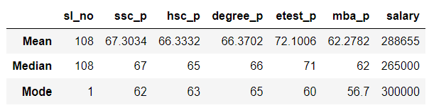

**MEAN:**

Mean of the **ssc_p** is **67.3034**.The Performance of the Students in the Given Dataset are Above Average .They getting Average marks in their SSLC Board Examination.

Mean of the **hsc_p** is **66.3332.** So the Students are getting Above Average marks in their Higher Secondary Board Examination.

Mean of the **degree_p** is **66.3702**. Students are getting Above Average marks in their Under Graduate Degree Examination.

Mean of the **etest_p** is **72.1006.T**he Students are getting Good marks in the Entrance Examination.

Mean of the **mba_p** is **62.2782**. Once Again the Students Performance Gets down .They are getting Average marks in their Post Graduate Degree Examination.

Mean of the **salary** is **288655**. The Students are getting Job with Average Salary Package from the Companies.

**MEDIAN:**

Median of the **ssc_p** is **67**.The Performance of the Students in the Given Dataset are Above Average .They getting Average marks in their SSLC Board Examination.

Median of the **hsc_p** is **65.** So the Students are getting Average marks in their Higher Secondary Board Examination.

Median of the **degree_p** is **66**. Students are getting Above Average marks in their Under Graduate Degree Examination.

Median of the **etest_p** is **71.T**he Students are getting Good marks in the Entrance Examination.

Median of the **mba_p** is **62**. Once Again the Students Performance Gets down .They are getting Average marks in their Post Graduate Degree Examination.

Median of the **salary** is **265000**. The Students are getting Job with Average Salary Package from the Companies.

**MODE:**

Mode of the **ssc_p** is **62**. Many of the Students Scored this Average marks in their SSLC Board Examination.

Mode of the **hsc_p** is **63.** Many Students got Average marks in their Higher Secondary Board Examination.

Mode of the **degree_p** is **65**. Students Repeatedly Scored this Average marks in their Under Graduate Degree Examination.

Mode of the **etest_p** is **60**.A Lot of the Students gets this marks in the Entrance Examination.

Mode of the **mba_p** is **56.7**. They are getting Average marks in their Post Graduate Degree Examination.

Mode of the **salary** is **300000.** Many Students gets this Amount as this Salary Package

From this Report I Concluded that The Students in the Dataset are Average Performers.