**Swarm Plot**

**Swarm Plot: Definition:**

A **swarm plot** is a type of data visualization that displays individual data points for a categorical variable, allowing viewers to see the distribution and density of the data. Unlike traditional box plots or scatter plots, swarm plots show each data point as a separate entity, preventing overlaps and providing a clearer view of the data distribution.

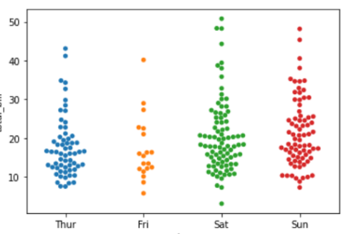

**Working Principle:**

1. **Data Input**: The swarm plot takes in a dataset typically consisting of one categorical variable and one quantitative variable.
2. **Positioning**: Data points are positioned along the categorical axis (e.g., x-axis) based on their corresponding values in the quantitative variable (e.g., y-axis).
3. **Jittering**: To prevent overlapping points, a jittering algorithm adjusts the position of the data points slightly along the categorical axis. This makes it easier to see how many points exist at each level of the categorical variable.
4. **Visualization**: The final output displays all data points, providing a comprehensive view of the data distribution and density across categories.

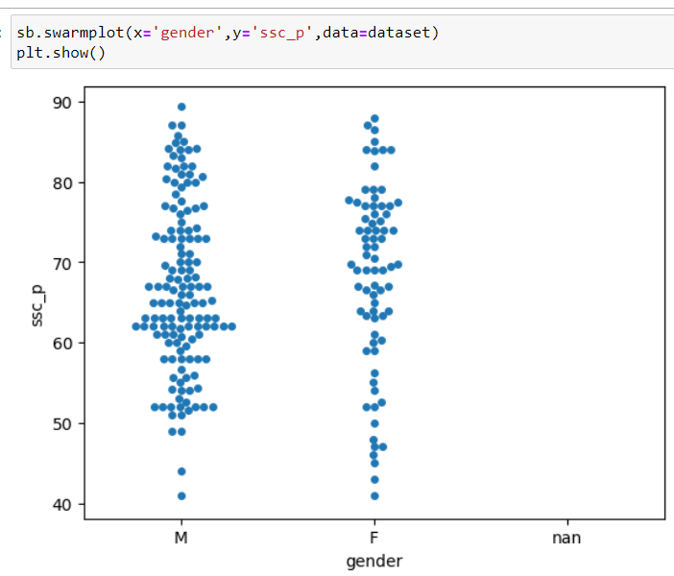

**Key Features:**

* **Individual Data Points**: Each point represents a single observation, making it easy to see the full dataset.
* **No Overlaps**: The jittering technique minimizes overlaps, enhancing clarity.
* **Categorical Representation**: Ideal for comparing distributions across different categories.
* **Customization Options**: Can be adjusted for color, size, and transparency based on additional variables.

**Advantages:**

* **Detailed Distribution Insight**: Allows for a detailed understanding of the distribution of data points within each category.
* **Easy Detection of Outliers**: Outliers are easily identifiable as individual points, which might be obscured in other plots.
* **Visual Clarity**: Combines the benefits of scatter and box plots, providing both individual data representation and categorical comparison.
* **Flexible and Informative**: Can be combined with other plots (e.g., box plots) for enhanced information.

**Disadvantages:**

* **Scalability**: Swarm plots can become cluttered with large datasets, making them difficult to read.
* **Jittering Bias**: The method of jittering can sometimes mislead interpretations if not properly understood.
* **Limited to Categorical Data**: Best suited for data with a clear categorical structure, less effective for continuous variables.
* **Software Limitations**: Not all data visualization tools support swarm plots, which may limit their accessibility.

**Conclusion:**

Swarm plots are a powerful visualization tool for exploring the distribution of categorical data. While they have several advantages at the same time, their effectiveness can be compromised with larger datasets or when misinterpreted.