**Sabeen Zafar**

**00407636**

**Day2_Marketplace_Technical_Foundation**

1. E-commerce website:

An **e-commerce website** is a digital platform that allows businesses to sell products or services online and enables customers to browse, select, and purchase items from the comfort of their devices. It serves as a virtual storefront where businesses showcase their offerings through detailed listings, including descriptions, prices, and images. Customers can explore the site, add items to a virtual shopping cart, and complete transactions using secure payment gateways. E-commerce websites often include features like user accounts, product search and filtering, order tracking, and customer support to enhance the shopping experience. These platforms eliminate geographical barriers, operate 24/7, and provide businesses with tools to manage inventory, analyze sales data, and reach a global audience efficiently.

* Frontend Requirement

User-friendly interface for browsing products.

Responsive design for mobile and desktop users.

Essential pages: Home, Product listing, Product details, cart, checkout and order confirmation.

* Backend as Sanity CMS:

Use Sanity CMS to manage product data, Customer details and order records.

Sanity acts as the database for your marketplace

Focus on designing schemas in Sanity to align with the business goals.

* Third-Party APIs:

Integrate APIs for shipment tracking, payment gateways and other required backend services.

Ensure APIs provide the necessary data for fronted functionality.

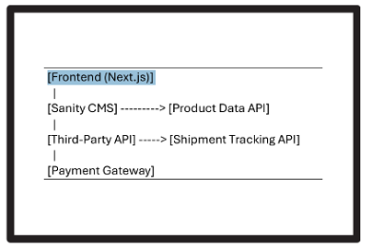

Installation:

* Nodejs
* Vscode
* Nextjs
* Typescript (in nextjs)
* Tailwind CSS
* Sanity.io
* Shadcn.ui(for components)
* React icons
* Lucide-react icons
* Stripe
* Axios
* Any library for animation

User Interface

* Home page
* Product Listing page
* Product detail page
* Shop page
* About page
* Contact page
* FAQs page
* Cart page / slide bar
* Wishlist page
* Success page

Functionalities

* Product browsing
* Add to cart
* Add to Wishlist
* Checkout
* Shipping tracker
* Inventory
* Real time update in inventory

DATA FLOW

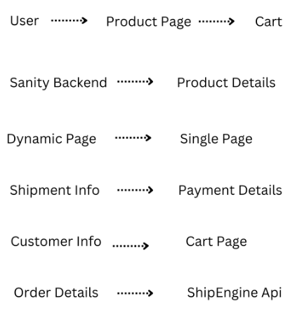

Sanity Schema:

export default {

name: 'clothes',

title: 'Clothes',

type: 'document',

fields: [

{

name: 'name',

title: 'Name',

type: 'string',

description: 'The name of the clothing item.',

validation: (Rule) => Rule.required(),

},

{

name: 'slug',

title: 'Slug',

type: 'slug',

options: {

source: 'name',

maxLength: 96,

},

validation: (Rule) => Rule.required(),

},

{

name: 'category',

title: 'Category',

type: 'reference',

to: [{ type: 'category' }],

description: 'Category this item belongs to (e.g., shirts, pants, etc.).',

validation: (Rule) => Rule.required(),

},

{

name: 'description',

title: 'Description',

type: 'text',

description: 'A short description of the clothing item.',

},

{

name: 'price',

title: 'Price',

type: 'number',

description: 'The price of the clothing item.',

validation: (Rule) => Rule.required().min(0),

},

{

name: 'sizes',

title: 'Available Sizes',

type: 'array',

of: [{ type: 'string' }],

options: {

list: [

{ title: 'XS', value: 'XS' },

{ title: 'S', value: 'S' },

{ title: 'M', value: 'M' },

{ title: 'L', value: 'L' },

{ title: 'XL', value: 'XL' },

],

},

},

{

name: 'colors',

title: 'Available Colors',

type: 'array',

of: [{ type: 'string' }],

},

{

name: 'images',

title: 'Images',

type: 'array',

of: [{ type: 'image' }],

options: {

hotspot: true,

},

},

{

name: 'stock',

title: 'Stock',

type: 'number',

description: 'Number of items available in stock.',

validation: (Rule) => Rule.required().min(0),

},

{

name: 'isFeatured',

title: 'Featured Item',

type: 'boolean',

description: 'Mark if this item should be featured on the homepage.',

},

],

};